Foster Mentor
Manual
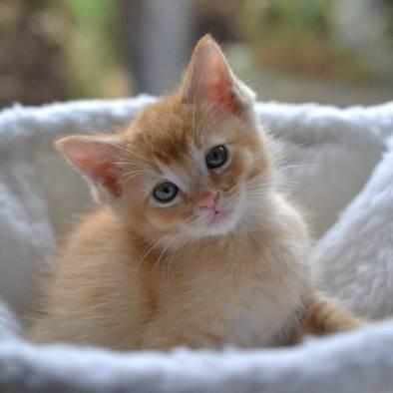

Photo by Cassidy Devore

14175 SW Galbreath Dr, Sherwood, OR 97140 ▪ (503) 925-8903 ▪ www.catadoptionteam.org

Cat Adoption Team
FOSTER MENTOR MANUAL
Table of Contents

Welcome, Mentors!
Position Description: Volunteer Foster Mentor
Competencies of a Mentor
How Often Should You Contact Your Foster Parents?
Reading Body Language
TAIL
VOICE
Maternity Foster Home Guidelines
Mother Cat Health Check
AN ILL MOTHER
LIMITED MILK
Kitten Health Check
CHECKING YOUR KITTENS
EARLY HANDLING
TEETHING KITTENS
DROOLING
SENSE OF SMELL
EARS AND HEARING
EYE COLOR AND SIGHT DEVELOPMENT
FEET AND PAWS
TOOTH DEVELOPMENT
MORTALITY RATE OF KITTENS IN FOSTER CARE
Determining the Sex of a Kitten
General Weight Guidelines
Heating Devices
Syringe Feeding
Orphaned Kittens
HOUSING
Photo by Debbie Brusius
POTTY TRAINING
CRYING AT NIGHT
FOOD
BABY FOOD
WEIGHT GUIDELINES
BOTTLE FEEDING
TUBE FEEDING
Vaccination Chart
Kittens and Vaccinations
Vaccines, Deworming and Flea Treatment Protocol
VACCINES
DEWORMING
FLEA TREATMENT
When a Foster Parent Calls
TEMPERATURE
EATING
DRINKING/Dehydration
PLAYING
FECAL AND URINE
EYES
NOSE
EARS
MEDICATION
VOMIT
BODY
FUR
GUMS
Signs of Ill Health
When Is It an Emergency?
Emergency Call Sheet
Quick Treatment Reference
Dosing Medication
MEDICATION DOSING GUIDE
GIVING MEDICATION
Medications and Commonly Used Remedies
A&D OINTMENT
AMOXICILLIN
BABY FOOD
BUPRENORPHINE
CESTEX
CLAVAMOX
DOXYCYCLINE
DRONCIT Injection
DRONTAL
ERYTHROMYCIN EYE OINTMENT
FORTIFLORA/CALMING CARE
KARO SYRUP
KITTEN LYTE
MARQUIS PASTE (PONAZURIL)
METRONIDAZOLE
NURTURE MATE COLOSTRUM SUPPLEMENT
PANACUR (FENBENDAZOLE)
STRONGID (PYRANTEL)
TOBRAMYCIN EYE DROPS
VITAMIN SUPPLEMENT
ZYLKENE OR COMPOSURE PRO
Anemia
Anorexia/Losing Weight
Blood in Urine
Cerebellar Hypoplasis (CH)
Chin Acne
Coccidia
Conjunctivitis
Constipation
Coughing
Dehydration
Diabetes
Diarrhea
DIARRHEA PROTOCOL
Failure to Thrive
Esophagostomy Feeding Tubes
Feline Infectious Peritonitis (FIP)
Hernia
Hookworms
Hypothermia
Lethargy
Lice
Limping/Lameness
Mastitis
Panleukopenia
Ringworm
Roundworms
Seizures
Spay/Neuter Incision Issues
Suckling on Littermates
Tapeworms
Upper Respiratory Infection (URI)
HERPES VIRUS (FELINE RHINOTRACHEITIS VIRUS)
CALICIVIRUS
Vomiting
Cat and Kitten Restraint Basics
FVRCP Vaccine Administration
SAFETY
PROCEDURE
Subcutaneous Fluids (Sub-Q Fluids)
SUPPLIES NEEDED
ADMINISTRATION OF SUB-Q FLUIDS FOR A KITTEN
ADMINISTRATION OF SUB-Q FLUIDS FOR AN ADULT CAT:
Rescue Disinfectant
Emergency Contacts
ON-CALL LEAD MENTORS
ON-CALL DOCTORS/MANAGERS
MENTORS
MENTOR ASSISTANTS
Mentee List

Welcome, Mentors!

Welcome to CAT’s mentor team! The purpose of CAT’s mentor program is to provide support to our foster parents. Our volunteer mentors are talented people with a great variety of skills and knowledge - sometimes being able to find a way to get a kitten to eat something can require a little creativity. Simply put, mentors provide the invaluable service of helping foster families with questions and supportive care when the shelter is closed. Thank you for joining the team, and we look forward to working with you!

The following guide for becoming a mentor was compiled from the knowledge and wisdom of experienced staff and fellow mentors within the foster program at CAT.

Mentors are the extension of our hospital and the foster program and must follow all directions and guidelines given. This includes helping new foster parents understand what the policies are and why we have them.

As a mentor, your responsibilities will include:

- Calling new foster families and letting them know you are available to help with questions or concerns.
- Familiarizing yourself with the Kitten Foster Manual and Adult Cat Foster Manual. Read and reread them! Many answers to questions are already there but can be forgotten in the excitement of new cats and kittens.
- Familiarizing yourself with this manual and referring to it often!
- Answering questions to the best of your ability in regards to the cats/kittens in their care.
- Referring your foster families to other sources if you don’t know the answers to their questions.
- Checking in with your active foster families every couple of weeks if you have not heard from them on whether they need any help or support.
- Vaccinating kittens on time and helping foster parents with deworming.

Position Description: Volunteer Foster Mentor

Title: Foster Mentor

Reports to: Admissions/Foster Program Supervisor

Purpose of Position: Provide support to foster families and act as a liaison between foster parents and the shelter/hospital.

Duties and Responsibilities:
- Ensure foster rooms are set up properly and in accordance with program guidelines. Be able to offer suggestions for improving foster room setup.
- Ensure that foster cats/kittens are being vaccinated, dewormed, and medicated on time and that all are being posted to Google Form so the shelter can maintain up-to-date records.
- Encouraging foster families to submit pictures and bios of their kittens to the Petfinder team when they are ready for pre-adoption/adoption.
- Be a resource for questions regarding behavior issues that may arise for foster families.
- Field calls and emails from foster parents regarding the foster cats/kittens.
- Counsel foster families through difficult situations involving foster cats/kittens. Preparing fosters for the possibility of the death of a foster cat/kitten, and helping them to cope with the loss if it occurs.

Qualifications: One to two years of experience as a foster parent for cats/kittens with CAT or a similar organization. Demonstrated knowledge of CAT’s foster program protocols. Willingness to travel to foster parents’ homes to give routine vaccinations and check on sick kittens.
Training Requirements: Kitten Foster Training and shadowing of a current mentor and/or attend mentor training. Adoption counselor training is not required but it is a bonus.
Time Commitment: About 2-5 hours per week—varies depending on the time of year and how many foster families you assist.
Benefits to Volunteer: See cats/kittens find forever homes. Work with foster families and CAT’s staff. Opportunities to attend workshops on cat-related topics as offered by CAT. Advanced volunteer opportunity with room for growth

Competencies of a Mentor

What attributes should a mentor have?

APPROACHABILITY
- Easy to approach and talk to
- Spends the time and makes the extra effort to put others at ease
- Warm, pleasant, and gracious
- Sensitive and patient
- Builds rapport
- Good listener

Why is approachability important? All mentors are volunteers, and we recognize that you have many responsibilities beyond taking calls from foster parents. But, if your foster parent does not feel like they can call because they might be interrupting you, then things can become worse for the kitten. It is very important that you set clear boundaries with your foster parents. For example, establishing when they should call you and when they should email. Keeping open communication by email for non-emergency needs allows for communication as it fits your schedule.

COMPASSION
- Genuinely cares about people and kittens
- Concerned about fostering and non-fostering problems, if it impacts fostering
- Available and ready to help
- Sympathetic when dealing with the death of an animal
- Demonstrates real empathy with the joys and pains of others

Compassion is the second part of approachability. In your experiences as a foster parent, your own mentor in all likelihood displayed great compassion as you talked over some situations. When you had those tough litters, your mentor was there to support you through those tough times. Foster parents feel like their foster cats/kittens are an extension of their families and they may find it hard to send them back to CAT. This tends to happen more with new foster parents, and they may look to you for support and guidance.

COMPOSURE
- Cool under pressure
- Does not become defensive or irritated when times are tough
- Mature
- Can be counted on to hold things together during stressful times
- Handles stress well
- Not knocked off balance by the unexpected
- Does not show frustration when issues seem to be ongoing

Composure can play a big role in being a mentor. At times, situations can be very stressful; for example, when you get a phone call about a kitten who is found unconscious on the floor, and is now lethargic and appears to be on the brink of death. You are the one who helps foster parents through these tough times. You are going to need to be able to get information from a stressed and panicked foster parent. Remaining calm as the medical staff tries different treatments for a sick cat/kitten helps maintain a less stressful atmosphere. How you respond to these situations can make a huge difference to your foster parents. It is okay to shed a tear and show empathy, but at that moment it’s most helpful to remain calm and not escalate anxiety.

DIRECTING OTHERS
- Good at establishing clear directions
- Sets fostering objectives (fostering within a household’s limits)
- Describes how to identify a sick cat/kitten
- Lays out work in a well-planned and organized manner
- Maintains two-way dialogue with foster parents
- Brings out the best in people
- Clear communicator

Mentors need to be able to communicate clearly when instructing foster parents. For example, if a foster cat/kitten is sneezing but not showing signs of a URI, the manner in which a mentor tells a foster parent what symptoms to be on the lookout for needs to be clear, and give them specific symptoms and behaviors to look for. It is also important to let foster parents know what to do if further symptoms develop. Simply saying, “wait three days and let me know how it’s going” is very frustrating to a foster parent who wants to provide the best care possible for the kittens and may not have encountered kitten illness before. Clear direction keeps the guesswork out of the hands of the foster parent, and makes foster parents feel supported.

Setting realistic fostering expectations with foster parents can be a challenge, as they want to save the world! Some foster parents are best with small groups, and then after time can work up to more challenging groups.

LISTENING
- Practices attentive and active listening
- Patient when hearing people out
- Accurately restate the opinion of a foster parent even when he/she disagrees
- Listen for what is not addressed and ask questions to find answers

As a mentor, you will be contacted about a wide range of questions. Each of these competencies will play a part in your ability to help your foster parents. Besides giving clear instructions, listening is another challenge. What did the foster parent mean by “gooey eyes”? Is the kitten just cuddly? As you listen, you need to confirm with the foster parent what you are hearing. You are the eyes and ears for our foster and hospital staff!

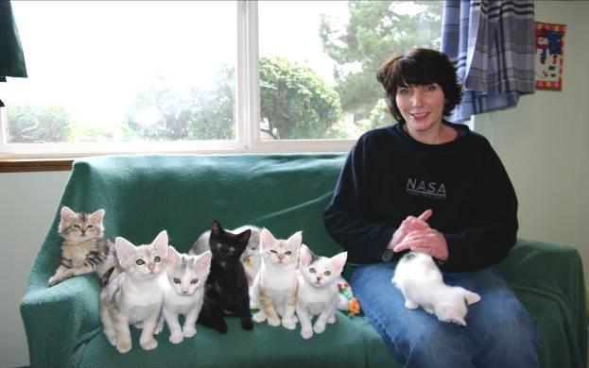

How Often Should You Contact Your Foster Parents?

You should contact your foster family as soon as they are assigned to you and again when they take a cat or kittens home. If you have not been to their home, we ask that you make an appointment to meet with them to put a face with a name and to help kitten-proof their foster room. This meeting is meant to be fun, not an opportunity to be critical of the foster family. If you have serious concerns about a foster family, please contact the foster department. You should continue to check in with your foster parents every one to two weeks.

For new foster families, you may want to consider sending them our Foster Check-in Questionnaire weekly. You can just copy the questions and send them in the body of an email. This will help make sure they know what to look for and when to come to you with concerns. Once you know your foster family well, you likely won’t need to send this anymore.

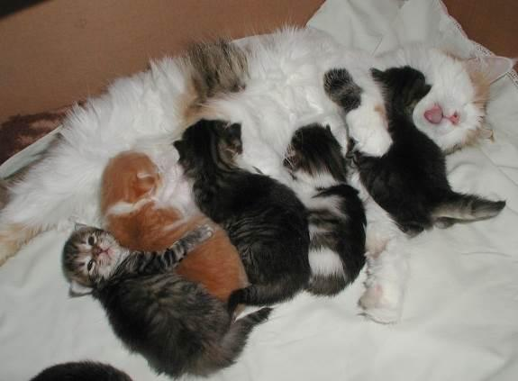

Reading Body Language

TAIL

- Erect, like a flagpole = friendly, content, ready to interact
- Hairs on end (piloerection) = heightened anxiety, passive aggressive
- Wrapped somewhat tightly around body = wants to be alone, possibly fearful
- Inverted U = defensive aggression (but in kittens can signal play)
- Curled very tightly around body = threatened
- Arched over back with piloerection = defensive aggression (may lower tail if other animal doesn’t back off)
- Arched over back without piloerection = interested, aroused
- Thumping = conflicted, frustrated, irritated; may attack

VOICE

- Chattering = excitement when seeing prey but unable to get to it
- Chirp = expecting something desirable like a treat or meal; mother cats to kittens
- Growl = offensive or defensive low-pitch sound
- Hiss = open-mouthed snakelike sound, usually defensive
- Meow = greeting just for people
- Mew = identify and locate another cat
- Moan = a long, sad sound made just before vomiting, when disoriented (in senior cats), or when wanting to be let inside or outside of a space
- Murmur = soft, closed-mouth sound used as a greeting, can accompany purring
- Purr = contentment, anxiety (a stress-relief mechanism), or self-soothing when ill or injured
- Shriek = harsh, high-pitched sound for pain or highly aggressive meetings
- Snarl = threatening expression with upper lip curled, showing teeth, and can accompany a growl
- Spit = sudden, short popping sound, heard before or after hissing
- Squeal = raspy, high-pitched sound when expecting food; also occurs during play
- Trill = chirp-like sound that is more musical, expressing happiness

Maternity Foster Home Guidelines

See the Kitten Foster Manual

Mother Cat Health Check

Mother cats should be looked over right away. This will give foster parents a chance to establish what is “normal” or notice something that the shelter might have overlooked.

- Ears should be clean with no discharge
- Eyes should be clear with no discolored discharge
- Nose should be clear and damp with no discolored discharge
- Rear should be clean
- Mouth should be pink and odor free
- Nipples should be clean (not red) and usually erect. The breast tissue should not feel hard or as if there are large lumps within them, nor should it feel hot to the touch. These could be signs of mastitis.

AN ILL MOTHER

If the mother cat is ill or malnourished when she rears her litter, her illness leaves a lasting deficit—both physically and psychologically—on all of her kittens. Sick kittens are more common in the latter half of the kitten season. This is thought to be because the mother cats are into their second or third litter at this point in time and their bodies are worn down as a result.

An ill mother cat will most likely be less attentive to her kittens and less able to do her maternal duties, specifically teaching social skills. The early social skills that a mother teaches her kittens are essential to preparing them for later in life. If that learning stage is compromised, those kittens will have personalities that reflect this deficit. This can lead to kittens growing into cats with behavioral problems such as being timid, aggression issues, and/or an antisocial attitude toward other cats.

LIMITED MILK

If the mother has insufficient milk for her litter, the kittens will end up smaller and weaker than properly nourished kittens. This situation may also result in kittens who lack proper social and physical skills. Kittens who spend an extended amount of time suckling in an attempt to get nourishment from their mother’s supply will have less time to learn how to interact with other cats. Food instability will also create an environment in which the kittens will not be able to relax.

Kitten Health Check

CHECKING YOUR KITTENS

Kittens should be looked over right away. This will give foster parents a chance to establish what is “normal” or notice something that the shelter might have not have noticed during the initial exam.

- Ears should be clean with no discharge
- Eyes should be clear with no discolored discharge
- Nose should be clear and damp with no discolored discharge
- Rear should be clean
- Mouth should be pink and odor free

EARLY HANDLING

As a mentor, you need to know your foster parents’ strengths. Some foster parents live alone and have quiet homes, while other foster homes can be filled with children, other animals, and lots of sensory stimulants. By introducing these stimulants slowly over a long period of time, foster parents have the opportunity to raise kittens who are well socialized and unfazed by things like small children, dogs, and vacuum cleaners. The amount of handling foster kittens receive in foster care will influence their reaction to humans and other stimuli.

Sometimes, your foster parents might have kittens that are unsure about humans. Mothers and kittens who are truly scared have often been moved at least three different times before they are placed in a stable foster home.

To help these groups, have foster parents keep a TV or radio going with people talking while they are out of the house. If music is used, classical music is best—remember, cats’ hearing is more sensitive than ours. Introducing novel items into the room each day can also let the cat/kittens know that new things are okay. Have the foster parents gently stroke the mother cat and kittens during feeding time and speak to them in a soothing voice. Before you pet them during feeding, first start by sitting near them as they feed, then sitting next to them. Slowly build up their comfort with you until you can pet them as they eat. Confidence starts to show when they roll over to expose their stomachs.

When kittens are done playing, hold them until they settle down. Rubbing your nose or stroking a finger on the side of their face mimics a mother cat licking them, and they sometimes settle down and purr with this activity. Once kittens stop wiggling, let them free by putting them down—the kittens are also training you to know when they’ve had enough. But, make sure this relationship has a good give-and-take dynamic. If you set them down immediately whenever they start to fidget, they will never build up a tolerance for being held and will instead learn that if they fidget you will release them.

If a kitten seems “wild” or “crazy”, then that’s perfect! There is nothing wrong with a wild, energetic kitten—this is just a normal kitten. What would be abnormal is if a kitten was just interested in being cuddled most of the time. However, “wild” should not include biting or scratching people.

TEETHING KITTENS

Kittens can start teething at 2-3 weeks old. The incisor teeth poke through first, followed by the canines, and then the premolars. You might find that kittens want to chew on things at this age. This is the time to hide power cords and make toys available. They enjoy biting cardboard boxes during this stage as well, and that is okay.

This period may also be when they start showing an interest in foods. Softening hard food by soaking it in water or wet food may help them start eating solid foods.

DROOLING

Quite a few cats drool when they have a pleasurable experience. Salivation is essential to feeding because it lubricates the food and aids in swallowing. It can also indicate nausea or pain, so make sure that nothing else is going on with the kitten.

SENSE OF SMELL

A cat or kitten’s ability to smell has a direct relationship to their ability to eat well. If the kitten or mother is fighting a sinus infection or has a congested nasal cavity, they may not want to eat at all. Canned food that gives off a strong odor may help—something with sardines or fish can help as long as the kitten or mother does not have a sensitive stomach. Another option is to boil a skinless chicken thigh in water with no seasoning. Your fellow mentors can be a wealth of information regarding feeding; be sure to ask them what they have found to work.

EARS AND HEARING
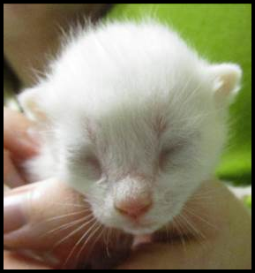
Although their eyes open between 7 and 14 days old, kittens cannot hear until they are
2 weeks old, and a kitten’s hearing doesn’t fully develop until they are about a month old.

EYE COLOR AND SIGHT DEVELOPMENT

A kitten is born with closed eyes, which will first open anywhere between 7 and 14 days old. All kittens have blue eyes when they are born. When the kitten reaches 4 to 6 weeks old, their eyes will begin to transform into their adult color.
Photo by Kristi Brooks

When a kitten first opens their eyes, they cannot see things. In fact, it is about three weeks before their eyes can follow moving objects and they can orient themselves using visual cues. Vision is still cloudy until they reach about 5 weeks of age.

FEET AND PAWS

Typically, cats have five toes on each paw (which includes the dewclaw). However, variations in toe numbers do exist. Cats with more than five toes on at least one paw, if not more, are called “polydactyl”.

The footpads are the only area of a cat’s body that contains sweat glands.

TOOTH DEVELOPMENT

When a kitten is born, they have no visible teeth. When they are approximately 10 to 14 days old, their deciduous (baby) incisors begin to push through the gums. They should be fully in place at 4 weeks of age. These six incisors, which appear at the front of the mouth in the upper and lower gums, are designed for tearing small bits of meat off bones and extracting feathers from prey.

At 3 to 4 weeks of age, the canines at the front corners of their jaw come in. Cats use their canines to sever the spinal cord of prey and administer the killing bite.

At 4 to 6 weeks of age, the molars begin to push through the gums along the cheeks, and fully are in place at 6 weeks old. All 26 teeth are in place by the time the kitten is
2 months old.
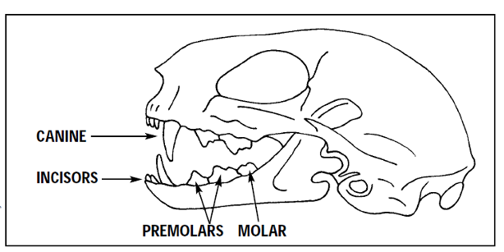



MORTALITY RATE OF KITTENS IN FOSTER CARE

You may have heard that in the wild typically only 1-2 kittens will survive out of a litter.
There are a number of reasons for this; starting with the available food and availability of quality food for the mother cat when she is pregnant. Exposure to disease and illness is another factor that will take lives. How much colostrum did they receive and how much of the Maternally Derived Antibodies did they get? Do they have a birth defect that is internal and undetectable? There are so many things that can go wrong.
Even with foster care and with the mentor system, we still can lose kittens. Yet, they have the highest chance of survival in our care. We provide high-quality food and water, temperature-controlled environments, medical care including routine services, and a clean litter box. With all of this extra help, we typically have a very high survival rate.

Determining the Sex of a Kitten

It can be difficult to tell the difference between male and female kittens. They are sometimes described as the male looking like a : (colon) and the female looking like an upside-down exclamation mark ¡.

Usually, there is bigger space between the anus and genital area in a male kitten—the space where the testicles will grow. It may be possible to feel small testicles in male kittens.
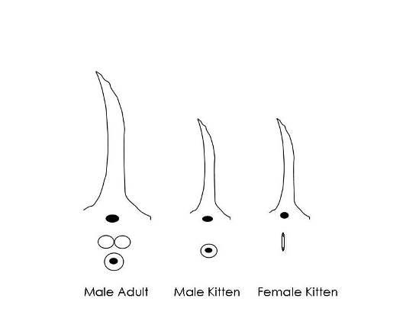

General Weight Guidelines

Ideal weight gain is 10 to 15 grams per day (113 grams (4oz) per week, 1 pound per month). Remind foster parents to note weight gain on their weight chart. This is an average! Help foster parents understand that not all of their kittens will make this mark, and some will surpass it. We want to make sure kittens are gaining weight, and not losing weight. Monitor kitten weight daily (twice daily if ill). If the kitten is less than 3 weeks old and has failed to gain weight or has lost weight in a 24 hour period, then start supplementing with a bottle. If the kitten is 3 weeks or older and has failed to gain weight or has lost weight in a 48 hour period, then start supplementing with a bottle or slurry. You should do this after the kitten nurses; you are just “topping off”.

In addition to weight, it is important to monitor body condition. Please use this Body Condition Scoring chart to assess cats and kittens during home visits and vaccination appointments. All cats and kittens should have a BCS of 3.5 or greater.

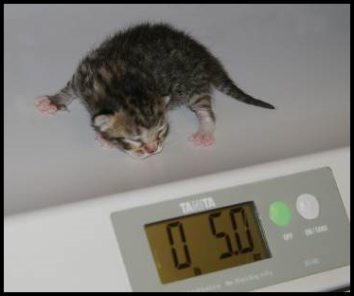

Heating Devices

Kittens cannot maintain their own body temperature until they are at least four weeks old. The average rectal temperature of a newborn kitten ranges between 92°–97° F. Between 2 to 21 days old, a kitten’s temperature will be about 96°–100° F.

To help a kitten maintain the proper body temperature, the foster parent can place them on a covered SnuggleSafe warming disk. When using a warming disk, the foster parent should set it up so that the kittens can safely move off of it if they overheat.

Syringe Feeding

When you notice that a cat or kitten (4+ weeks) is not eating well or losing weight, first try offering different types of food. The shelter has lots of different wet and dry foods you can try. You can also try plain boiled chicken. Cut the chicken into tiny pieces and give it to the cat or kitten. Save the broth that has been made by freezing it into cubes and then storing it in the freezer in a freezer bag. Each broth cube is about 1 ounce. You can take one cube and melt it over the pieces of chicken to keep it moist. If the kitten's tummy is upset, only use chicken breast. If the tummy is okay and there is no diarrhea, use dark meat since it is fattier.

You can also try making “kitten crack” or slurry. We suggest using prescription CN or AD, human baby food (Chicken or Turkey with no onion or garlic added), and Breeders Edge powder. Take ¹/₈ to ¼ can of AD, one teaspoon of baby food, and one scoop of Breeders Edge. Mix it all together and add warm water until it is a thick soupy consistency. You can use regular kitten food in place of CN/AD in a pinch.

If you can’t get a cat or kitten (4+ weeks) to eat on their own despite offering different foods, you might need to syringe feed them. Please note that syringe feeding can cause food aversion and should be avoided when possible. Please only syringe feed until they can be seen by a vet and other treatments can be explored. The hospital may decide to place an esophagostomy feeding tube (e-tube), which is much less stressful and unlikely to cause food aversion.

If you do need to syringe feed in an urgent situation, use a 3 ml or larger syringe without a needle. The shelter has larger sizes with large tips to make this easier. Get a hand towel to wrap around the kitten. This will be messy, so you may want to protect your clothing as well. Wrap the kitten in a towel or blanket (like a burrito) with only the head exposed. Take the syringe and place it behind the canine, open the mouth slightly, and gently squeeze out a little bit of the slurry mixture. The kitten should begin to eat. You do not have to maintain the burrito towel wrap unless the kitten does not hold still for you. Follow the feeding guidelines outlined below, and make sure not to over-feed. If the kitten is eating some food on their own, you will want to reduce the amount you syringe feed.

weight (lb) | Recommended syringe feeding of diluted CN (1 can CN mixed with 1/2 cup water)
1 | 14 ml, 6 times daily
1.5 | 18 ml, 5 times daily
2 | 19 ml, 5 times daily
2.5 | 26 ml, 4 times daily
3 | 28 ml, 4 times daily
4 | 41 ml, 3 times daily
5 | 46 ml, 3 times daily
6 | 50 ml, 3 times daily
7 | 55 ml, 3 times daily or 83 ml, 2 times daily
8 | 60 ml, 3 times daily or 89 ml, 2 times daily
9 | 63 ml, 3 times daily or 95 ml, 2 times daily
10 | 68 ml, 3 times daily or 102 ml, 2 times daily
11 | 73 ml, 3 times daily or 110 ml, 2 times daily
12 | 78 ml, 3 times daily or 118 ml, 2 times daily
13 | 82 ml, 3 times daily or 124 ml, 2 times daily
14 | 87 ml, 3 times daily or 131 ml, 2 times daily
15 | 91 ml, 3 times daily or 137 ml, 2 times daily

Orphaned Kittens

There are certain difficulties that arise with fostering orphans compared to fostering kittens who still have their mother around. Mother cats are able to teach their kittens lessons that enable them to become great cats when they grow up. Among the various lessons mother cats provide their kittens, some of the most important ones include how to take a bath, how to use the litter box correctly, and the limitations of play, to name a few.

As a result, when you foster orphaned kittens, you will need to be prepared to play the role of the mother cat and help your kittens learn the lessons that they will need to become highly socialized, trained, and ready for adoption. As a mentor, you will need to instruct the foster parents on how to do this.

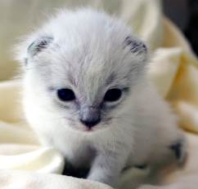
2 weeks 3 weeks
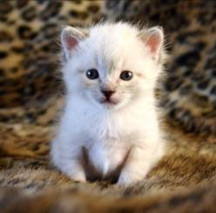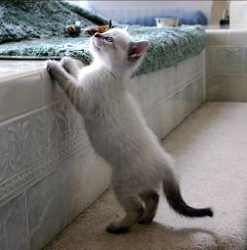
4 weeks 6 weeks
Photos by Madeleine Barker

HOUSING

Make sure the room you provide for your orphans is warm enough for the kittens, including the floor. Often bathroom floors can be cold, so make sure they have a warm place to spend time if they feel they are getting too cool. Foster parents can use a bath mat, bath rug, or put out a couple of cat beds. Don’t advise them to use towels since kittens often like to use towels to go potty on—kittens can get their claws stuck in loops of a towel’s material, which gives them the sensation of scratching in a box and will often stimulate them to go potty.

If foster parents don’t have, or don’t know how to create a good place for the kittens to sleep, offer to help create a nesting box. You can make one out of a large cardboard box or put a bed in a pet carrier with the door removed. The carrier is a great place for kittens to sleep. It is best to cover the carrier with a blanket to trap heat. They can also jump on top of the covered carrier and sleep there as well.

Snuggle Safe warming disks can also be used to keep a nesting box or other small area warm. Just make sure they have the option to get away from the disk if they get too warm.

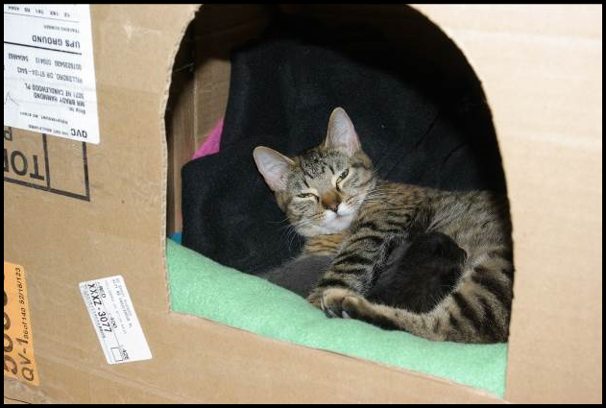Photo by Debbie Brusius

POTTY TRAINING

If the kittens are not 100% potty trained when the foster parents receive them, you will need to offer tips and tricks on how to get the orphans to use their litter box.

- Kitten Attract brand litter is a great way to get kittens into the litter box; however, this is an expensive option, so you can just sprinkle the Kitten Attract on top of the regular litter and then put the kitten in the box.

- Make sure that the litter box is getting cleaned on a regular basis—a dirty litter box can foster poor potty habits.

- Check to see if the foster parents should try a different kind of litter. Different brands, textures, and materials could provide relief from inappropriate elimination.

- Make sure there are enough litter boxes for the number of kittens in the litter. Be sure that there is plenty of space between the litter boxes—multiple litter boxes placed next to each other act as just one extremely large litter box, rather than separate potty spaces.

- See if the kittens would prefer a differently sized litter box; maybe one with shorter walls or even one with or without a hood will make the difference.

- Try placing the kitten’s waste in the litter box using a tissue. That will associate the scent with the correct location.

- Try placing the litter box in the location where the kitten is pottying, sometimes corners are preferred!

- Address any medical issues such as diarrhea, a UTI or a urinary blockage.

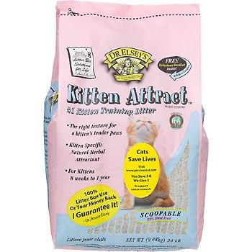

APPROPRIATE PLAY

Mother cats are very adept at handling kittens who display bad manners when playing; they will often swat a kitten, bite a kitten at the scruff, or pick them up to tell the kitten when they are playing too hard and let them know that enough is enough.

Foster parents should never use their hands for play. If a kitten does try to go for hands, have the foster parent spray their hands with Bitter Apple® before they go into the foster room. This should adequately detract the kittens from trying to play with and attack hands. Instruct the foster parent to use a wand toy, laser light, toys they can roll on the ground, etc. While hand play may seem cute and not hurt too badly when a kitten is just 6 weeks old, it will not be fun when they grow into a 12-lb adult cat who still believes that attacking like this is okay. Remind the foster parents that they are raising kittens to become great cats.

Luckily, kittens can also help each other learn appropriate play. If you have a single orphaned kitten, it will be more work. For a single orphan, offer a stuffed animal (choose one that is slightly larger than the kitten) for the kitten to wrestle and sleep with. We may be able to pair up a single kitten with another kitten or litter if they are all healthy and Felv negative.

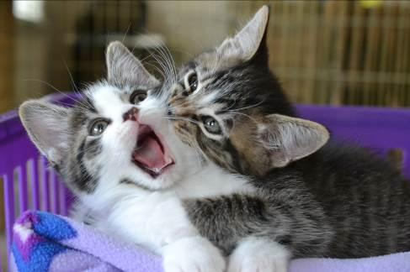

CRYING AT NIGHT

Kittens are like human babies—they eat, go potty, and sleep; they also haven’t learned to sleep through the night yet. One way to keep kittens satisfied at night is to play with them right before you go to bed. After playtime, feed them wet food and turn off the lights. By exercising them and then satiating them, it will help them sleep more soundly for greater stretches of time. Turn on a fan for white noise if needed.

FOOD

As orphans move from nursing to eating food on their own, their tummies can become upset. If the kittens are under 6 weeks of age they may need to be eating a slurry mixture. See syringe feeding for tips and tricks as well as amounts to feed. Kittens that are six weeks of age should be eating kibble and wet food on their own without help from the foster parent. Make sure the foster parent is feeding a high-quality kitten food (preferably the Purina Pro Plan that we provide) and that they are offering enough wet food each day. Dry kibble should be provided at all times, and wet food should be fed in amounts of ¹/₄ can per kitten with three feedings a day, at a minimum.

BABY FOOD

It is a good idea to have a few jars on hand. Look for baby food that has meat (chicken, turkey, or lamb) as the only ingredient besides water. Teach foster parents to read the labels because some brands are higher in calories than others. You will want the highest calorie content that you can find.

Baby food is good when kittens have upset tummies, aren’t interested in eating because they are sick, or dip your syringe in before you give them a liquid medication if they have given you trouble in the past.

WEIGHT GUIDELINES
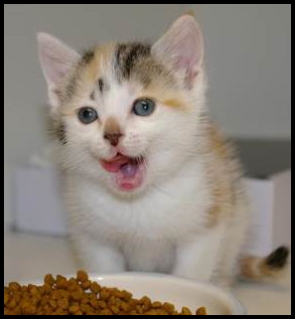
Ideal weight gain is 10 - 15 grams per day (113 grams (4 ounces) per week, 1 pound per month). Remind foster parents to note weight gain in their weight chart. This is an average! Help foster parents understand that not all of their kittens will make this mark, and some will gain more. We want to make sure kittens are gaining weight, and not losing weight. Monitor the kitten's weight daily (it’s not necessary to weigh the kitten more than once or twice per day). If the kitten is less than 3 weeks old and has failed to gain weight or has lost weight in a 24 hour period, then start supplementing with a bottle. If the kitten is 3 weeks or older and has failed to gain weight or has lost weight in a 48 hour period, then start supplementing with a bottle or slurry. You should do this after the kitten nurses; you are just “topping off”.

BOTTLE FEEDING

See Kitten Foster Manual

TUBE FEEDING

Some kittens may not be able to nurse from their mother or from a bottle due to birth defects or an illness. We see this a lot with neonates who get an upper respiratory infection - if they can’t smell or have nasal congestion, they can’t nurse. If a foster parent has attempted to bottle feed and addressed all the possible issues with no success, it may be time to consider tube feeding. Tube feeding is a safe and easy alternative but can be tricky at first.

Please contact the foster department before attempting to tube feed. The foster parent will need to make an appointment with the hospital to be trained on this method as the need arises. Approved mentors may keep tube feeding supplies on hand and assist foster parents if needed on evenings and weekends, but the foster parent must make a vet appointment to get trained if they want to do the tube feeding themselves.

Here is a video demonstrating tube feeding if you are curious!

Here is a list of trained tube-feeders you can call in a pinch.

Here is the step by step process for Tube Feeding:
- Please get someone experienced to show you the first time you tube feed
- Use a 5F red rubber feeding tube
- Prepare the appropriate amount (see table below) of formula and warm to kitten body temperature. Get out any air in the syringe.
- Have a 3 ml syringe prepared with 1 ml warm water
- Cut the end of the feeding tube so it has a single opening and it is shorter
- The wide end of the tube may need to be cut to fit the syringe - ensure the syringe will go over the end with a snug fit
- Measure the feeding tube from mouth to the end of the rib cavity (end of tube) - mark the tube at the mouth insertion site so you know how far to insert it
- Attach the warm water syringe to the tube and put some water in the tube until it drips out the end (eliminate the air in the tube)
- Wrap the kitten and ensure it stays warm. Cold kittens won’t absorb the formula properly
- Insert the feeding tube into the mouth and down the esophagus
- A properly placed tube will go all the way to the mark you made
- The kitten will still be able to vocalize
- If either of these does not happen, remove the tube and try again
- Push a small amount of water into the tube (½ ml or less)
- If the kitten coughs, remove the tube and place again
- Once the tube is properly placed and there is no coughing, you can feed the formula.
- Remove the water syringe and attach the formula syringe. Slowly push the contents through the tube.
- Be sure to keep the tube in position (the marking should be right at the mouth) and don’t let the kitten push it out when they wiggle.
- Pinch the end of the tube, face the kitten with their head down, and remove the tube swiftly

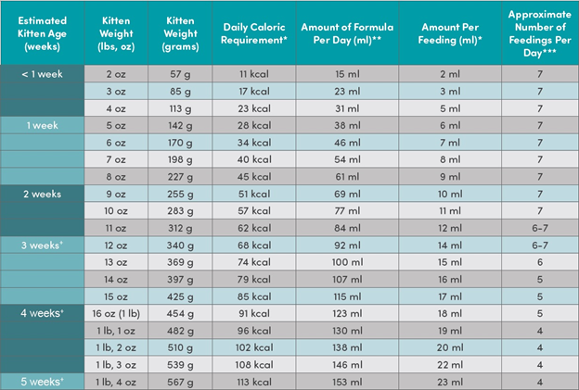

Vaccination Chart
Kitten’s Name: ID#:
Kitten DOB:
Foster Family Name:

Activity | Timing | Approx  Due Date | Enter Date of Completion
Strongid | At 4 weeks or done at the time of admissions
2nd Strongid | 2 weeks after the first dose
1st FVRCP Vaccine | At 6 weeks or done at the time of admissions
Photo/Video/Bio for Petfinder | Kittens can be  pre-adopted at 5 weeks
3rd Strongid | 2 weeks after the second dose
2nd FCVRP | Approx. 21 days after the first FVRCP
Surgery | Minimum 1.5lbs, sturdy, healthy, vaccinated
Droncit | Will be given at the time of surgery unless severe or bothersome

Kittens and Vaccinations

See Kitten Foster Manual

Vaccines, Deworming and Flea Treatment Protocol

It’s very important that all mentors understand the vaccine and worming timelines and dosages. Timing on these is very important. If a follow-up is given too late, the kitten is not protected. If a mom cat’s follow up is given too late, the series will need to be restarted.

VACCINES

FVRCP is the vaccine for Feline Viral Rhinotracheitis, CaliciVirus, and Panleukopenia (URI and Distemper). FVRCP vaccinations are started at six weeks of age (or possibly younger at admissions) and are repeated every 21 days. The last FVRCP vaccination in the series is given after the kittens reach over 18 weeks of age. Mother cats and adult cats will receive one FVRCP vaccination at admissions or prior. They will need one booster FVRCP 21 days later. FVRCP vaccines should only be postponed if the cat or kitten has a fever. Temperatures only need to be taken if the cat is showing signs of illness.

FeLV is the vaccine for Feline Leukemia. The FeLV vaccine is not a core vaccine at CAT. However, if the vaccine was administered at a previous shelter we will boost the vaccine at 21 days.

DEWORMING

Strongid is for roundworms. They will look like spaghetti. Strongid is given at 4 weeks of age or older depending on when they went through admissions. Strongid kills adult roundworms. Kittens must have treatments every 2 weeks until they come back to the shelter for spay/neuter. At that time, they will receive Selamectin and no longer need Strongid.

Selamectin is for fleas, ear mites, and roundworms. Cats and kittens 8 weeks and older will receive Selamectin before going out to foster. Selamectin will treat roundworms, so it is not necessary to give them Strongid.

Droncit is for tapeworms. They will look like rice. Droncit kills tapeworms. This is a one-time only injectable treatment. Droncit is given at the time of the spay/neuter surgery, UNLESS tapeworm segments are seen by the foster parent before surgery and they are very concerned about it. Droncit can be administered to kittens 6 weeks and older.

Cestex is an oral medication for tapeworms: Cestex is a one-time-only oral medication that can be given in foster. This can be given by the foster parent and is usually a better alternative than Droncit for the foster home. Cestex can be administered to kittens 6 weeks and older.

FLEA TREATMENT

Capstar is an oral medication for fleas: Capstar is given to kittens under 4 weeks who have live fleas.

Advantage is a topical medication for fleas: Advantage is given to kittens 4-8 weeks old who have live fleas.

Selamectin is a topical medication for fleas, ear mites, and roundworms Selamectin is given to kittens 8 weeks and older, mom cats, and adult cats, regardless of the presence of fleas. If the kittens are not old enough at admissions, they will get Selamectin during their spay/neuter surgery.

When a Foster Parent Calls

When a foster parent calls and informs you that their cat/kitten is sneezing and sick, be prepared with a list of standard questions to get more information. Be sure to listen to your foster parents’ answers and encourage them to elaborate when describing the situation. This will give you a wealth of useful information. Standard questions include:

TEMPERATURE

This is a question that very few foster parents will have an answer to when they call you. It is important for you to know that a kitten with a temperature below 98º F cannot digest food, and a cat/kitten with a temperature over 102.6º F has begun to have a fever. A low temperature on an adult cat is less of a concern unless it is associated with lethargy or other symptoms.

As a mentor, you will often have to instruct your foster parents on how to take a cat or kitten’s temperature. The thermometer should be inserted until the silver tip is no longer visible (about ½ inch) for cats and kittens and go along the line of its spine. The normal range is 99º-102º F.

EAR THERMOMETERS We do sometimes have ear thermometers available for use. These work great for kittens or cats that struggle with the rectal thermometer or are too fearful to temp rectally. We have tested the Braun ThermoScan for accuracy, so if you plan to purchase your own, please use that brand. Please follow these instructions for using the ear thermometers:

- Apply a fresh disposable thermometer cap
- Press the power button
- Wait for it to warm up - it is ready when it beeps and three lines appear
- If you only get two lines, try to adjust the cap to make sure it is on correctly
- Point the thermometer down into the kitten’s ear.
- Once you are in the ear, reposition the thermometer so it is perpendicular to the kitten’s head.
- This points the reader directly at the eardrum so we can get an accurate reading
- You can use the same thermometer cap on a litter of kittens, just be sure to wipe off any debris.
- Discard the cap and place a new for a new litter of kittens/cat

Kittens with a temperature below 98º F will need to be warmed up immediately. The best place to achieve warmth is under the foster parent’s shirt, right against the skin near your heart. You can also warm up a towel in the dryer, but this takes time. You will want to warm the kitten gradually.

Knowing the temperature of a kitten will sometimes have an impact on what instructions you give foster parents. Is the temperature affected by the environment? Does the foster parent know the room temperature? Just because they might have central air conditioning does not mean that a room with the sun beating on it and the door closed will have enough air circulation to keep it cool.

Room temperature is vitally important for the health of the kittens, as they cannot regulate their body temperatures until they are five weeks of age.

Age | Room Temperature
Birth to 7 days | 80º F
8 to 30 days | 75º-80º F
1 month | 75º F

If your foster parent cannot increase the room temperature, then having a nesting box for the kittens is necessary. A box that can create an enclosed space, such as a cardboard box, will be essential for heat retention. You can also use their carrier that they came in (remove the door). Put a towel over the top to help trap the heat.

During warm weather, the foster parents will need to make sure the kittens have access to surfaces on which to cool down. If a SnuggleSafe warming disk is used to create a source of warmth, be sure that it is covered and they have the option to get away from it. Having a surface such as marble tiles or a cooling pad designed for pets nearby where the kittens can go to cool down will be necessary. Cooling pads and marble tiles are for kittens five weeks or older.

EATING

How much is the kitten/mom eating? How often are they eating? Kittens need the right amount of food to suit their energy needs at their age. Lack of food can cause low blood sugar levels. Kittens should be gaining 113 grams (4oz) a week on average or 10 - 15g per day. With nursing kittens, it can be hard to know how much each is getting. If they still chase the mother after feeding, you may need to suggest supplemental feeding.

Don’t forget about the mother cat, either! Sometimes foster parents will be so focused on the kitten that they forget to note what the mother is doing. She will need to be eating enough food to maintain her weight and her milk supply. Lactating moms should have high-quality kitten dry food available at all times and be getting 2-4 meals of wet food per day. If the mother is not consuming enough calories, she may not be able to produce enough milk for the kittens.

Knowing how many kittens are nursing on a mother can also make a difference—you need to be sure that she is capable of producing enough milk for the whole group. Depending on the age of the kittens and the size of the litter, the foster parent may need to supplement their feeding with a bottle. The best way to do this would be to allow the kittens time to nurse and then “top them off” about 20 minutes after they have begun to nurse. If the group is larger than eight kittens, it is best to bottle feed the larger kittens first to allow the smaller kittens more time to nurse with their mother. Sometimes it will be necessary to crate the mother with really small kittens to allow them time to nurse without having to fight siblings.

Orphans will be a little more challenging, as they need to be encouraged to eat. With orphans and weaning kittens, it never hurts to attract them with other food sources. Canned kitten food with fish, second stage baby food, or unseasoned, skinless, boiled chicken breast can be used as incentives. If the foster parent does choose to boil chicken meat, have them save the juices by freezing them in ice cube trays to add to dry food later on. For more about food and bottle-feeding, see this section.

Adult cats/mom cats should be eating at least 50% of the food offered to them twice daily. After 3 meals (1.5 days) of not eating or eating less than 50%, offer them a different wet food option that is smelly (try fish flavors, beef, chicken, or turkey). After 5 meals (2.5 days) of not eating or only eating 50% or less, the foster should be making an appointment to have the cat seen by the hospital.

DRINKING/Dehydration

How much is the cat/kitten drinking? How often is it drinking? Cats need fresh water daily. Sometimes if adult cats drink a lot of water it can be a sign of other medical issues. Kittens not yet weaned will not drink much water. If the kittens are eating canned food, which is typically more than 70% fluids, they may not need to drink a lot of water separately.

Along with knowing how much fluid a cat/kitten consumes, foster parents should also monitor for dehydration. When you pinch the scruff of the neck and then set it back down, does the skin go back into place quickly? If it instead remains puckered, the cat is dehydrated. Another way to check for dehydration is by feeling the gums of the cat/kitten. They should be nice and moist, and your finger should slide with ease. If they are tacky, then you should consider administering fluids.

PLAYING

Playing is a very important gauge of a kitten’s health. If the kitten has siblings, do they play with others? Does the kitten initiate play? Sometimes it can appear that two kittens are playing when in reality one of the kittens is merely picking on the other. Have foster parents make notes at playtime. Do the kittens track their toys? Are they following the toy with their eyes, or do they look down when the toy moves above them? How are their motor skills developing? A big warning sign for health problems is if a kitten just wants to cuddle. There is no such thing as “just a cuddly kitten” or a “mama’s boy”. If a kitten likes to cuddle exclusively and never engages in play, it could mean that they are becoming ill.

Adult cats, especially shy ones or older ones, may not want to play as much as kittens. What’s important here is to monitor any changes in behavior. Did the cat love to play and then suddenly had little interest? This could be a sign of pain or discomfort.

FECAL AND URINE

Blood in the urine can be a sign of a urinary tract infection (UTI). Sometimes this is only visible at the time the cat/kitten is urinating. Since the background of most cats/kittens at CAT is unknown, it is always a good idea to closely monitor litter box activities for the first 48 hours when in a foster home.

Male cats can also experience a urinary blockage. Foster parents should watch for repeated trips to the litter box with little or no urine production, excessive licking of the genitals, and vocalizing while using the litter box. If the cat is not able to urinate, it is an emergency!

Is the cat/kitten crying or straining when attempting to eliminate feces? This could be an indicator of more serious underlying issues. If the cat/kitten continues to strain in an attempt to defecate, it could cause the rectum to prolapse; in most cases, an extended rectum results. Hydration issues could be the root of these problems, so be sure to have foster parents check the cat/kitten’s hydration levels when straining issues arise.

Diarrhea can be a life-threatening situation in small kittens, as it can cause rapid dehydration. The color, odor, and softness of the stool can all tell you something different. Be sure to ask how long the cat/kitten has had diarrhea, and make sure the foster differentiates between soft stool and watery stool. Foster parents will have a fecal scoring chart in their baby bag to help identify the severity.

EYES

Eyes should be clear and bright in color. Brown, crusty matter in the corner of eyes is not a cause for concern. Yellow and green discharge and eyelids that are swollen or sealed shut when they were previously open are all cause for concern. Ask if the third eyelid is showing with no discharge—this could be a sign of gastrointestinal trouble.

Conjunctivitis typically creates greenish/yellowish discharge at the inner corner of the eyes, near the nose. Sometimes the third eyelid will raise and look very red and inflamed. Dilation of the pupil can also occur.

It is important to keep the eyes clean and follow the directions given for medications. Most medications are prescribed for 5 days - see the Conjunctivitis section for treatment. If things appear worse after 3 days of medication or are not resolved after 5 days of medication, have the foster parent schedule an appointment with the hospital. Cloudiness or spots within the pupil should also be checked by the veterinarian. Have the foster parent schedule an appointment.

Make sure the foster parent uses a new gauze pad or a clean baby washcloth each time they clean the eyes. Use a separate gauze pad or fresh section of the washcloth to clean each eye on the same kitten. Washcloths must be washed between each use. Using the same, unwashed washcloth will perpetuate the cat/kitten’s illness.

NOSE

Noses should be moist without being runny. Clear or mucousy discharge indicates an upper respiratory infection.

Lungs should be clear and soundless. Have the foster parent listen for coughing, congestion, or raspy breathing. This can be a sign of an upper respiratory infection, pneumonia, or even asthma. A little congestion with an upper respiratory infection can be treated per the URI protocol. Persistent congestion or difficulty breathing requires an appointment with the hospital or an emergency vet visit if severe.

EARS

Ears should be clean. Scratching or bloody or brown debris can indicate ear mites or an ear infection.

MEDICATION

What medications has the kitten been on, and how long have they been taking them? You will need this information from the foster parent before calling the lead mentor.

VOMIT

Vomiting is rare in kittens and always a cause for alarm. First, determine how often and how long the kitten has been vomiting to establish a timeframe. If the kitten has vomited twice within 24 hours, place a call to the on-call lead mentor for advice. An underweight or unthrifty kitten who is vomiting is more concerning/urgent than a robust/healthy kitten.

Vomiting in adults is less alarming, but should still be monitored. If an adult cat vomits 3 or more times in a 12 hour period, they will need to seek vet care immediately. For less frequent vomiting, an appointment can be made with the hospital for fluids and anti-nausea meds.

What has the cat/kitten vomited? You will need to differentiate between food, hairballs, and stomach acids. Has the cat/kitten been anywhere near plants or other substances that could pose a poison risk? Is the cat/kitten foaming at the mouth? Did the cat/kitten throw up after it was given medication or food?

BODY

Sometimes you might get a call because there is something oozing from a body part. For example, a sibling biting at the base of another kitten’s ear can cause an infection at that site.

Lameness in a limb can be related to an injury, a vaccine, or an illness. You will need additional information to be able to determine the cause of lameness.

It is important to know the stages of kitten development and whether changes that arise during growth periods are abnormal. Typically, when a kitten is born, its umbilical cord will remain attached until it reaches 3-4 days old. However, herniated or infected umbilical cords can form. Watch for swelling in that area.

FUR

White flakes on the fur coat could be dandruff, but if they are at the end of the hair and stick to the hair there is a good chance that it might be lice. Feline lice are species-specific so they won’t be transmitted to people or other animals except for other cats. Contact the shelter for a treatment plan.

Hair loss can be a sign of a flea allergy, over-grooming (stress response in adult cats), or ringworm (fungal infection). Have the foster parent make an appointment with the hospital to evaluate it.

GUMS

Healthy gums are firm and pink (some cats have black pigment spots). They should be moist to the touch. If gums are tacky and sticky then the cat/kitten could be dehydrated.

Color of the gums can tell you a number of things going on in regards to the health of your cat/kitten. Pale (very light pink) can be a sign of anemia. Bluish gray gums indicate a lack of oxygen or shock. Bright red gums can mean heatstroke or infection. A yellowish tint may indicate that the kitten is jaundiced.

Teach your foster parents to look at the gums of healthy cats/kittens. That way they have an idea of what the gums of a healthy cat/kitten look like.

You may be asked by the on-call lead mentor to have the foster parent check the capillary refill time. When the foster parent presses gently on the gums, they should go to almost white and refill to the nice pink color in two seconds or less.

Signs of Ill Health

MOUTH | EYES |  | RESPIRATORY
- Drooling and pawing at mouth  - Bad breath  - Difficulty eating  - Loss of appetite  - Broken, loose, or missing teeth  - Inflamed gums | - Discharge from the eye  - Inflammation of the eyelid  - Change in the eye color  - Abnormal sensitivity to light  - Visible third eyelid  - Problems with vision  (like tracking toys) |  | - Labored breathing  - Persistent sneezing  - Persistent coughing  - Discharge from the  eyes and nose  - High temperature
BLOOD & HEART DISORDERS | SKIN PARASITES |  | SKIN & COAT DISORDER
- Collapse or fainting  - Bluish discoloration of the gums  - Breathing difficulties  - Unwillingness to exercise  - Coughing while exercising | - Persistent scratching  - Loss of hair  - Excessive grooming  - Biting at the skin and coat  - Signs of parasites in the  coat |  | - Persistent scratching  - Loss of hair  - Excessive grooming  - Biting at the skin and coat  - Signs of parasites in the coat
REPRODUCTIVE | NERVOUS |  | DIGESTIVE
- Bleeding from genitals  - Abnormal discharge from vulva  - Swelling of mammary glands  - Harding of mammary glands  - Swelling of the testes | - Convulsions and fits  - Muscle spasms and tremors  - Partial/complete paralysis  - Staggering gait  - Acute skin irritation |  | - Repeated vomiting  - Persistent diarrhea  - Loss of appetite  - Blood in the feces or vomit  - Persistent constipation
EARS |  | INTERNAL PARASITES
- Discharge from the ear  - Dark brown wax in the ear  - Persistent scratching or rubbing of the ear  - Head shaking or holding the head to one side  - Swelling of the ear flap  - Hearing problems |  | - Worms passed in the stool  - Persistent diarrhea  - White grains visible on the rear  - Licking and rubbing of the rear  - Potbellied appearance  - Loss of weight  - Scooting on the carpet or floor
URINARY DISORDER |  | BONE, MUSCLE & JOINT DISORDERS
- Straining to pass urine  - Abnormal urination or incontinence  - Blood or excessive cloudiness in urine  - Excessive thirst  - Persistent licking of the genitals |  | - Lameness and limping  - Swelling around the affected area  - Tenderness when the area is touched  - Reluctance to walk or jump  - Abnormal gait

When Is It an Emergency?

It’s an emergency if:

- A cat/kitten is lethargic and not responding
- A cat/kitten has trouble breathing
- A cat/kitten has a severe injury that is bleeding or causing pain
- A male cat has a urinary blockage (cannot urinate)
- A cat/kitten has a fever over 105 F for a prolonged period (Still has 105 F or more 1 hour post SubQ fluids)
- A mother cat has been in active (pushing) labor for 30 minutes without producing a kitten

If it is not an emergency, please call the on-call lead mentor and wait up to 2 hours if you don’t get an immediate response. If the situation gets worse, place a call again. If it is a true emergency and you haven’t heard back from the on-call lead mentor, you can bypass them and call the on-call manager.

In case you do need to send a foster parent to the Emergency Clinic, be ready!

In the case of an Emergency Clinic visit, our Vet Triage Doctors will make that call. If your foster parent has been instructed by the on-call lead to virtually meet with the Vet Triage Doctors, they will make the call on if a cat or kitten needs to be seen at an ER vet clinic.

See our approved list of emergency vet clinics in the Kitten Foster Manual

Emergency Call Sheet

EMERGENCY CALL

Foster Parent Name:______________________________________________

Foster Parent Phone Number:_____________________________________

Cat Name & ID#:_________________________________________________
Date/Time:_______________________________________________________
Temp:____________________________________________________________

Eating:___________________________________________________________
BM:______________________________________________________________

Urine:____________________________________________________________
Symptoms:_______________________________________________________

__________________________________________________________________

Other:____________________________________________________________

__________________________________________________________________
Noted:___________________________________________________________

__________________________________________________________________

__________________________________________________________________ Recommended:__________________________________________________

Quick Treatment Reference

DIARRHEA: FortiFlora can be found in the foster bag. See Diarrhea protocol for next steps.

DEHYDRATION: Hydracare or Kitten Lyte and Sub-Q fluids.

HYPOGLYCEMIA (low blood sugar): Karo syrup – ½ mL wait 2 minutes and ½ mL again if needed. Apply with your finger to the gums and tongue of the cat/kitten.

CONJUNCTIVITIS: Tobramycin drops - one drop per eye 3-4 times per day for 5 days.

URI: Amoxicillin: Dose is 0.2 ml/lb. BID (2 X day for 7 days) when using the concentration 25 mg/1 ml (this is the concentration in foster and mentor bags. Dose is 0.1 ml/lb. BID (2 X day for 7 days) when using the concentration 50 mg/1 ml (this concentration is provided by the hospital). Only start amoxicillin if there is colored nasal discharge. Doxycycline might be prescribed by the CAT hospital for cats or kittens 8 weeks and older that are not responding to Amoxi. Steam the room with either a running shower or a humidifier.

VOMITING: If a kitten vomits more than twice in 24 hours, try to get an same day vet appointment or call on the on-call lead mentor. If an adult cat vomits more than 3 times in a 12 hour period, try to get a same-day vet appointment or contact the on-call lead mentor.

BLOOD IN URINE: Make an appointment with the hospital.

CAT/KITTEN WON’T EAT: Try boiled chicken, baby food (plain chicken or turkey – NO onions), broth from boiled chicken (can freeze in ice cube trays) poured over food or tuna water from canned tuna for cats. Offer other brands of food - Royal Canin Mother and Baby cat is a popular variety. Give SQ fluids.

THERMOMETER: Needs to go in until the silver tip is not visible for kittens and adult cats. You can also use approved ear thermometers (found in the foster department). The normal temperature of a kitten/cat: 99°-102° F. Newborn kittens have lower body temps ranging down to 95° F. See here for ear thermometers.

TEMPERATURE FOR KITTEN BATH WATER: Same as for bathing a human baby. The water should be about body temperature for the kitten, so around 100°-101°. The temperature of bathwater for a cat should be the same as for kittens. Make sure they are completely dry and have a source of warmth afterward.

Dosing Medication

Directions on all medications must be followed as prescribed.

If a dose is late, then it is to be given as soon as possible. If it is too close to the next dose, then skip and do not double-dose. Most of the medications the foster program uses will be once or twice a day. There are others, like eye medications, which may be given more often, so read all directions.

SID = Once a day (every 24 hours)
BID = Twice a day (every 12 hours)
TID = Three times a day (every 8 hours)
QID = Four times a day (every 6 hours)

Suggested questions to ask when you pick up medications from the shelter/hospital.

- Can this medication be given with food?
- Will they dislike the medication? Is it bitter?
- Does the medication need to be shaken?
- How should it be stored? Refrigeration? Away from sunlight?
- Are there any side effects to watch for?
- When do we notify if the medication appears not to be working?

MEDICATION DOSING GUIDE

New foster parents often have a difficult time distinguishing 1 ml from 0.1 ml or other similar-sounding dosages. Kittens are so small that we are often giving them a very small amount of medication. This picture guide is located in their baby bag. Please have them refer to it when dosing out Strongid, Panacur, or any other medication.

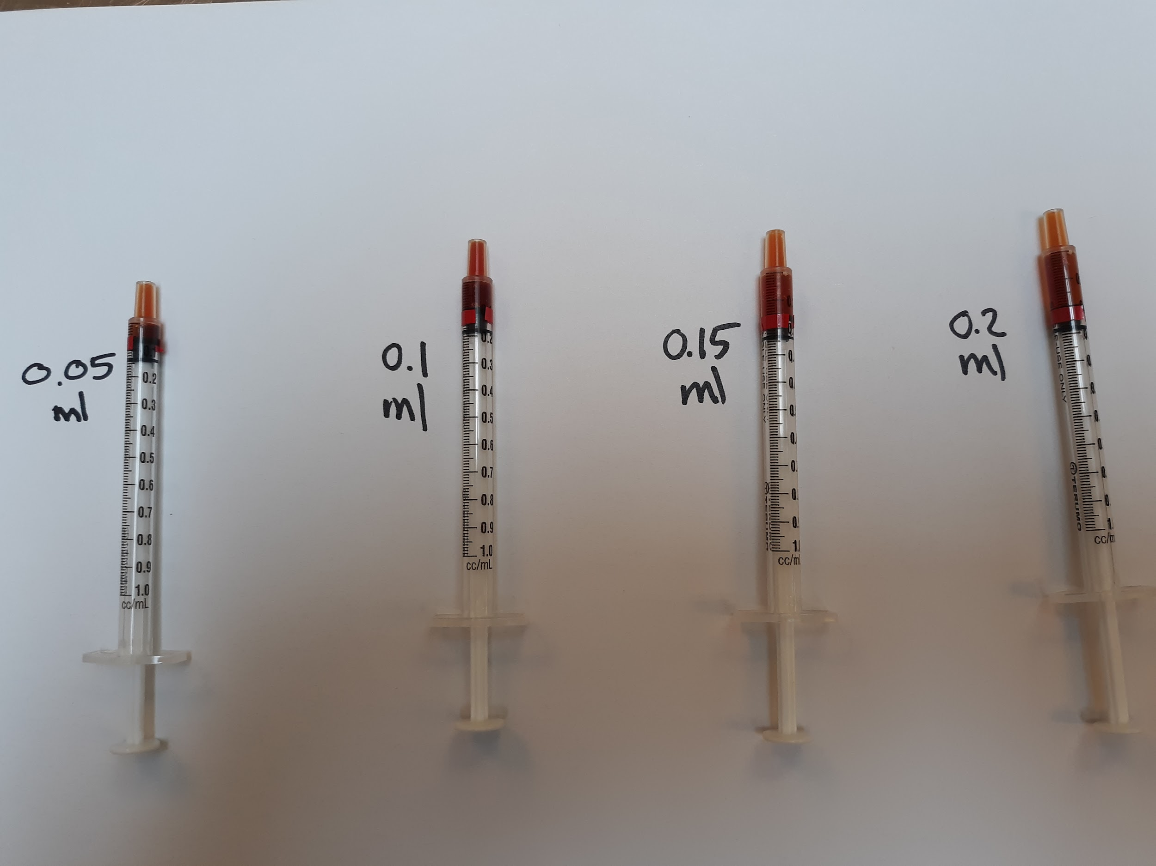
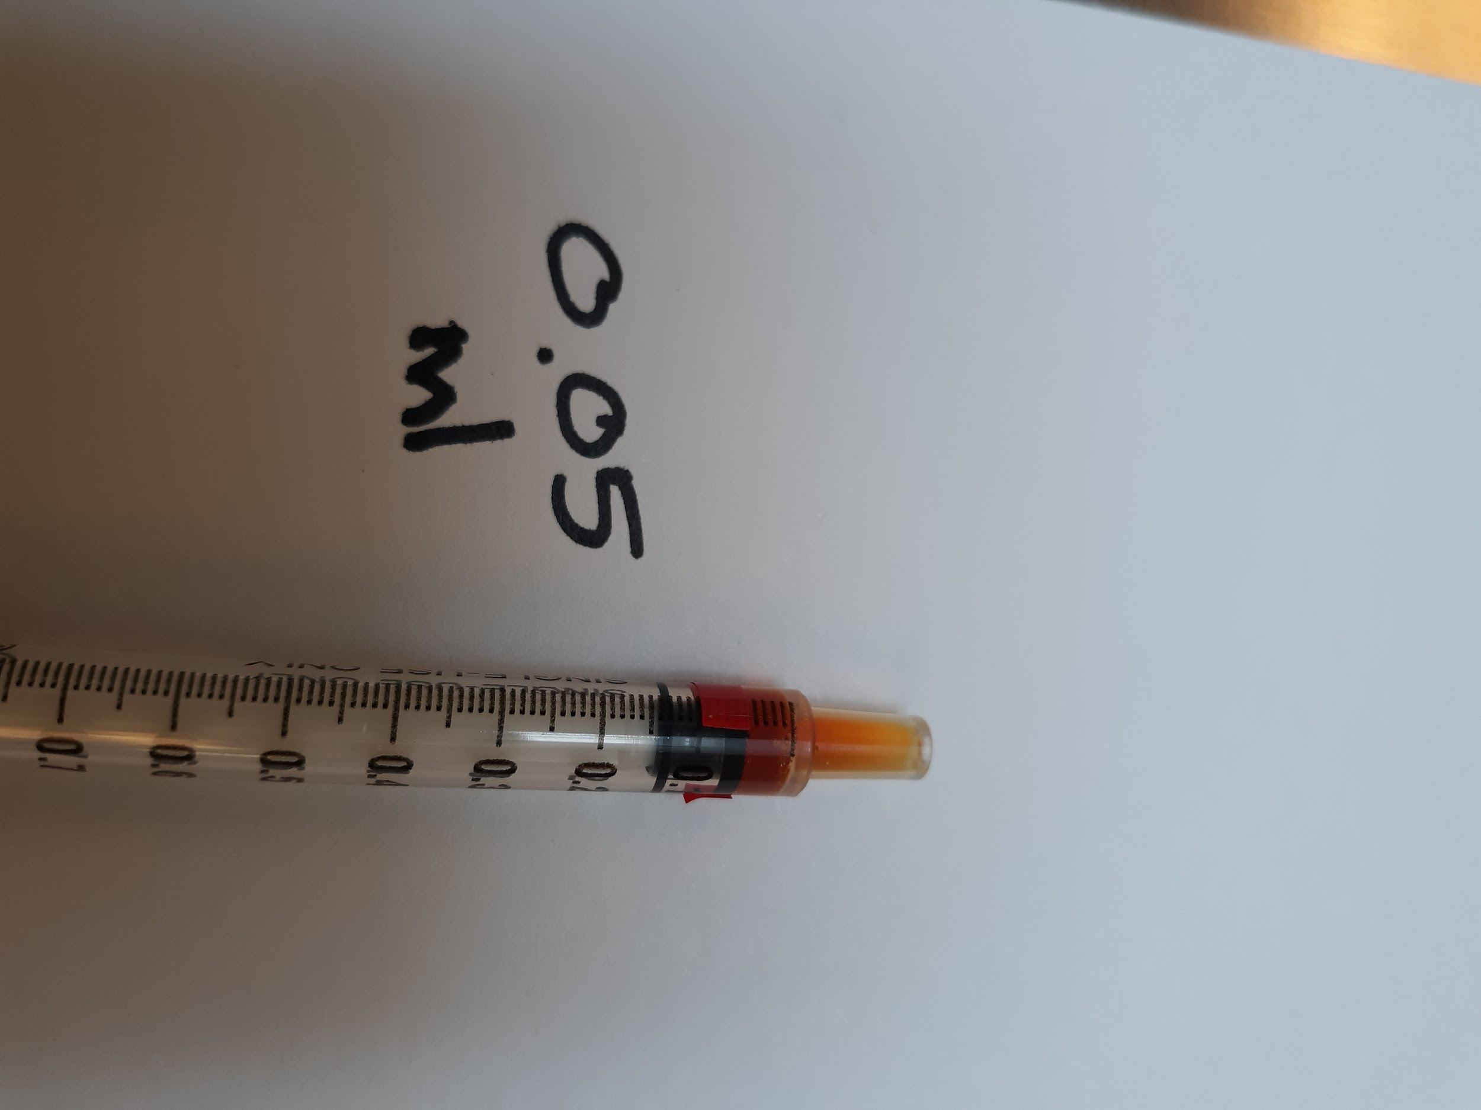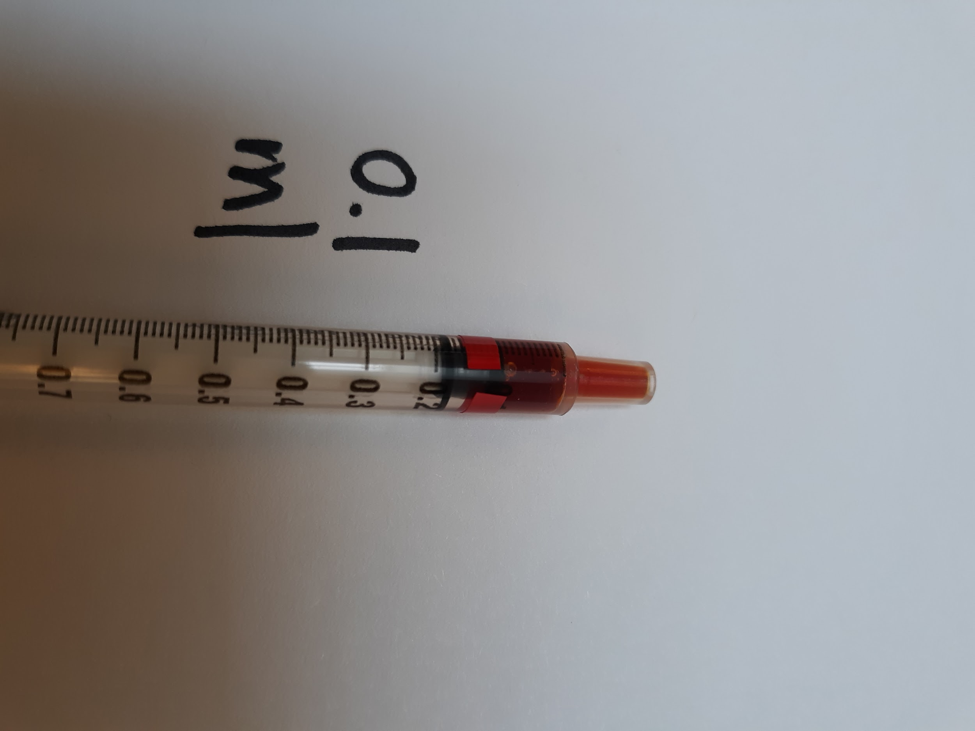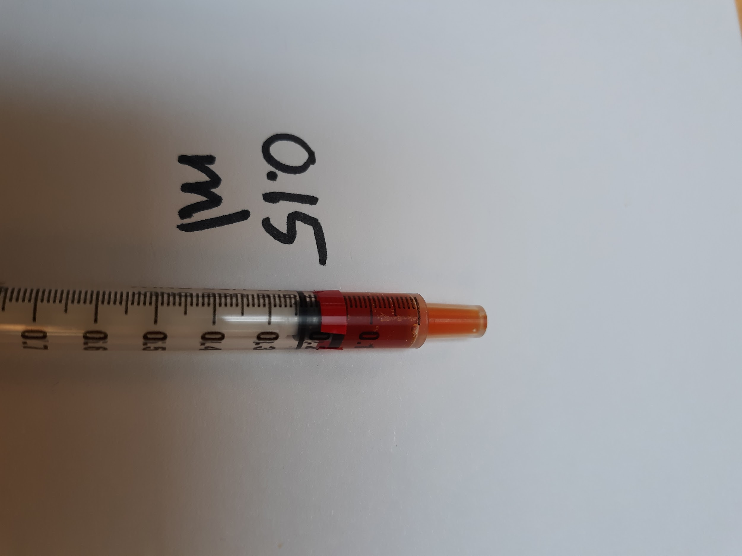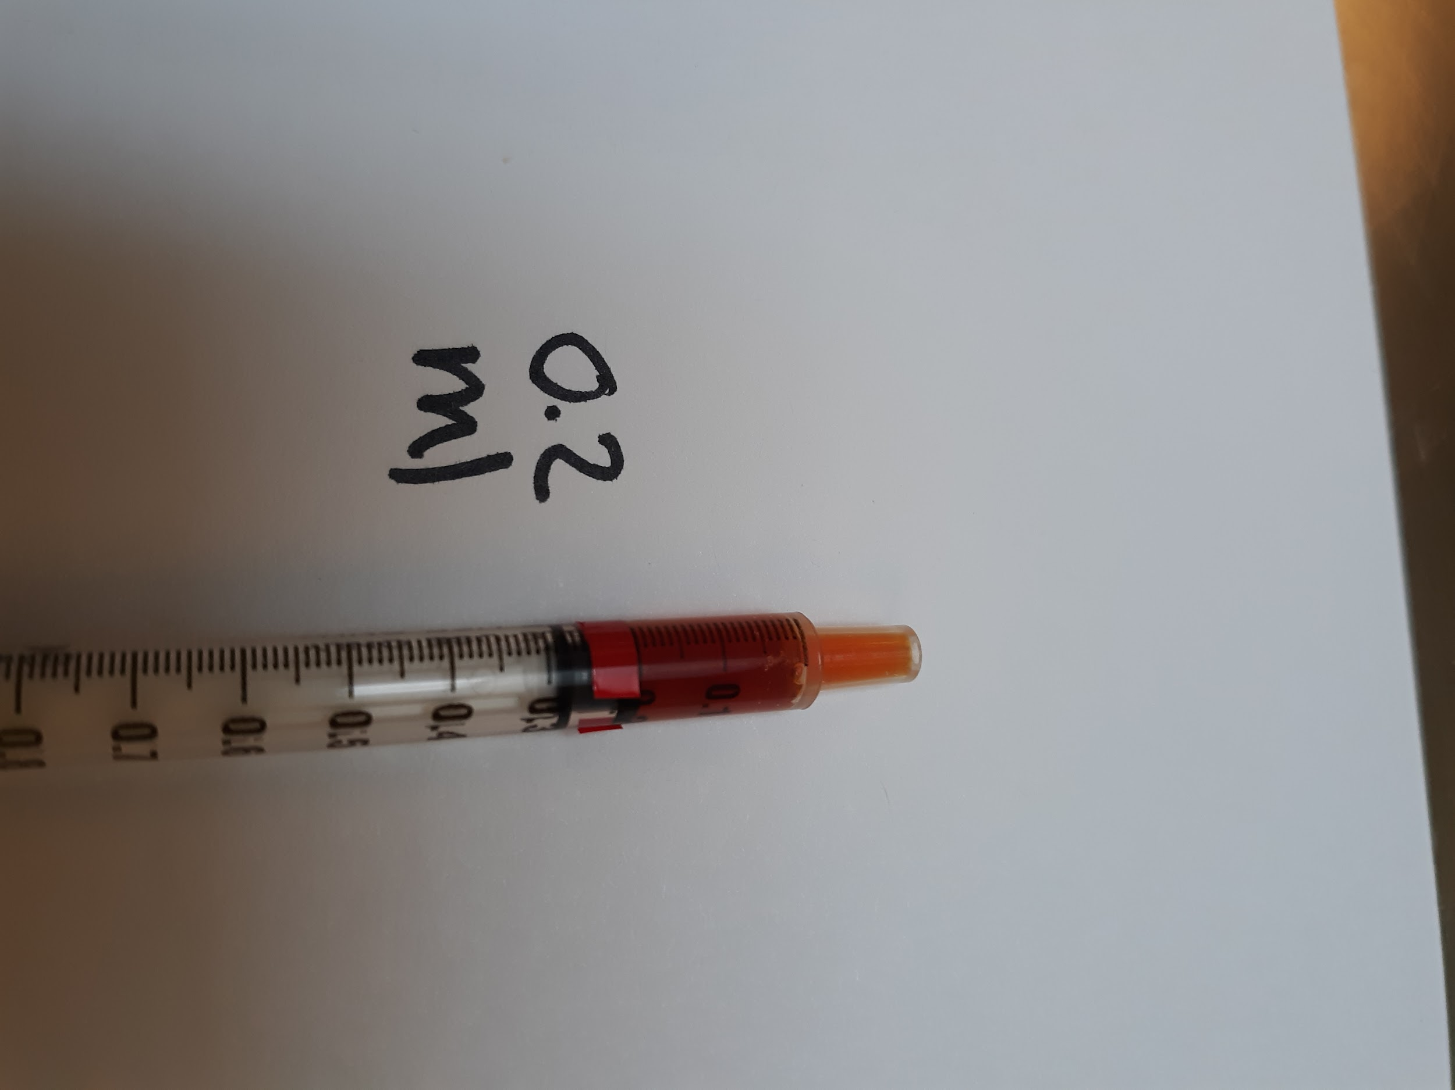

GIVING MEDICATION

See Kitten Foster Manual

Medications and Commonly Used Remedies

Please refer to the Client Drug Consultation Forms document for more information on prescription medications that CAT uses. Although you are not required to read this information to your mentee when starting a drug, you may find it helpful to do so for new foster parents. It is also a great reference if you have any questions about a drug.

A&D OINTMENT

Type: Ointment
Used for: Creating barrier on skin for kittens with diarrhea
Approval by: None needed.
Dose: Apply a thin layer to the clean affected area—usually the bottom, tail, and sometimes back of legs, two to three times a day.
Special Instructions: This is greasy and will cause the kitten to lick it off if you apply it too thick.

AMOXICILLIN

Type: Antibiotic
Used for: Upper Respiratory Infection (URI); must have yellow or green discharge from the nose. Do not start Amoxicillin for a fever without URI symptoms or for clear nasal discharge. See section on URI for more signs of illness. Also used to treat other infections as listed in this manual.
Approval by: Mentor for kittens and mom cats. Hospital for adult cats.
Dose: Dose is 0.2 ml/lb. BID (2 X day for 7 days) when using the concentration 25 mg/1 ml (this is the concentration in foster and mentor bags). Dose is 0.1 ml/lb. BID (2 X day for 7 days) when using the concentration 50 mg/1 ml (this concentration is provided by the hospital). *Please note that the strength of Amoxicillin in foster is not the same as what is provided in the hospital, therefore the doses are different.*
Special Instructions: Shake well before drawing up the dose. Can be given with food. If a kitten gains more than 4 ounces (113 grams) while on the medication, you will need to recalculate the dose to make sure they are getting the right amount.

BABY FOOD

Type: Human baby food
Used for: Enticing cats/kittens to eat
Approval by: None needed
Dose: As needed
Special Instructions: Chicken or Turkey (Gerber stage 2—no onion or garlic).
Can be used to dip the tip of the syringe in for some medications.

BUPRENORPHINE

Type: Pain Medication
Used for: Treating pain
Approval by: Foster Coordinator, On-call Manager, Veterinarian
Dose: Dose determined by weight. Given in the cheek pouch or under the tongue up to twice daily for pain.
Special Instructions: Light sensitive - keep in the prescription bottle. Possible adverse effects include sleepiness, constipation, and restlessness or agitation.

CESTEX

Type: Dewormer
Used for: Tapeworms
Approval by: Foster Coordinator or Hospital
Dose: A pill given once; dose determined by weight. Can be administered to kittens six weeks or older.
Special Instructions: Follow up pilling with 3 mL of water. Only given to altered cats/kittens or unaltered cats/kittens with a heavy load of tapeworms that cannot wait until surgery for treatment.

CLAVAMOX

Type: Antibiotic
Used for: Broad-spectrum antibiotic commonly used for wound infections.
Approval by: Veterinarian
Dose: As directed. The liquid form will need to be refrigerated. Pills do not.
Special Instructions: Clavamox should be rinsed down with 3 mL of water and then followed with wet food.

DOXYCYCLINE

Type: Antibiotic
Used for: Upper Respiratory Infection (URI). Must have yellow or green discharge from the nose.
Approval by: Veterinarian
Dose: As directed.
Special Instructions: Doxycycline should be rinsed down with 3-5 mL of water. Then offer wet food. This drug can cause throat irritation, even ulceration if not rinsed with water.

DRONCIT Injection

Type: Dewormer
Used for: Tapeworms
Approval by: Foster Coordinator/Hospital (only given during spay/neuter)
Dose: One-time injectable dose on kittens six weeks or older who are at least 1.5 lbs. The injection can cause stinging at the site.
Special Instructions: It is best to wait until spay/neuter surgery if you can. There can be an injection site reaction that will cause hair loss and an open sore. Report tapeworms to the Foster Coordinator so they can be treated at spay/neuter.

DRONTAL

Type: Broad-spectrum dewormer
Used for: Tapeworms, hookworms, and roundworms
Approval by: Foster Coordinator/Hospital
Dose: A pill given once; dose determined by weight. Can be administered to kittens six weeks and older who are at least 1.5lbs. To kill roundworm eggs you will need to follow up with Strongid in 14 days.
Special Instructions: Drontal should be rinsed down with 3-5 mL of water. Only given to altered cats/kittens or unaltered cats/kittens with a heavy load of tapeworms that cannot wait until surgery for treatment.

ERYTHROMYCIN EYE OINTMENT

Type: Ophthalmic eye ointment
Used for: Conjunctivitis. Must have red/swollen tissue around the eye or have yellow or green discharge from the eye.
Approval by: Hospital
Dose: 1 thin strip the size of the eye BID-TID for 7 days.
Special Instructions: Make sure the tip of the applicator does not touch the eye!

FORTIFLORA/CALMING CARE

Type: Probiotic powder
Used for: Nutritionally manage cats and kittens
Approval by: None for Fortiflora; Foster Dept/Hospital for Calming Care
Dose: FortiFlora - daily for the first two weeks of foster care for all cats and kittens eating solid food, an additional 7 days if diarrhea develops. Calming Care - daily for the duration of foster care (for stressed cats). Both products can be given in the case of diarrhea. See diarrhea protocol for details.
Special Instructions: Mix with wet food once a day. ¼ packet if <2lbs, ½ packet if 2-5lbs,1 packet if >5lbs.

HYDRACARE

Type: Liquid hydration supplement
Used for: Fever, low appetite, or dehydration
Approval by: Mentor
Dose: Empty the packet into a bowl and offer it to the cat or kitten
Special Instructions: Can be used in situations where SQ fluids cannot be administered right away. SQ fluids are preferred and should be given as soon possible if the issue persists.

KARO SYRUP

Type: Glucose Solution
Used for: Hypoglycemia (low blood sugar)
Approval by: Mentor
Dose: Up to 1 mL
Special Instructions: To be given when a kitten is showing signs of hypoglycemia or “crashing”. The kitten will be depressed, lethargic, and uninterested in eating. You will want to administer by applying a 1” bead of the Karo syrup on your finger, rub along the outer gums of the kitten (both upper and lower), and then rub the remainder down the center of the tongue. If you do not see an improvement within a few minutes, administer the remainder of the syrup to the kitten in the same way. You cannot overdose a crashing kitten. If the kitten is cold it will have a harder time absorbing the Karo syrup. Once the kitten is responding, you will want to take his/her temperature to see if you can now feed the kitten. If he/she is below 98° F you will need to warm the kitten before you start feeding. If the kitten is over 98° F you will want to get food (protein) into the kitten to stabilize his/her blood sugars.

KITTEN LYTE

Type: Hydration supplement
Used for: Treat dehydration due to diarrhea, vomiting, or inappetence.
Approval by: Mentor
Dose: Add 1 scoop (5 gm) of the powder to 8 oz of warm water and mix thoroughly. Use this instead of water to make kitten formula. Can also offer this in a bowl for older kittens.
Special Instructions: Refrigerate after mixing, use within 24 hours after mixing. Small bags of Kitten Lyte will be included in the bottle feeding kits that we send out with kittens under 5 weeks old if we have it in stock.

MARQUIS PASTE (PONAZURIL)

Type: Anti-Protozoan
Used for: Diarrhea that does not resolve with FortiFlora, treats coccidia
Approval by: Mentor for kittens and mom cats (Hospital for adult cats)
Dose: 0.2 mL/lb. given orally to each cat/kitten once.
Special Instructions: You will need the weight of the cat/kittens in order to prepare it. Must be shaken well (until all sediment at the bottom of the bottle is fully mixed in).

METRONIDAZOLE

Type: Antibiotic and Anti-Protozoan
Used for: Treat Giardia and anti-inflammatory
Approval by: Veterinarian
Dose: As directed.
Special Instructions: Give with food. The liquid form is very bitter and settles quickly - must shake really well before drawing dose from the bottle

NURTURE MATE COLOSTRUM SUPPLEMENT

Type: Colostrum supplement
Used for: Kittens 6 weeks and under who aren’t doing well (losing weight, diarrhea, etc). Can be given to newborns and bottle babies, especially orphans who didn’t get enough colostrum from their mother.
Approval by: Mentor
Dose: 3ml; administered 1ml at a time over a 24 hour period
Special Instructions: Turn dial up to the base of the tube. For 1ml, turn dial out to “1” marking, then depress the syringe. Can depress it into a 3ml syringe (remove plunger, then replace) and then give the syringe to the foster to administer. Refrigerate tube after opening.

PANACUR (FENBENDAZOLE)

Type: Broad-spectrum antiparasitic
Used for: Treats hookworms, roundworms, tapeworms (some types), and whipworms, diarrhea that does not resolve with Fortiflora.
Approval by: Mentor for kittens and mom cats (Hospital for adult cats)
Dose: 0.2 mL/lb given orally once a day for 5 days. The label on the bottle will give dose by weight. Round up to the nearest weight. Give the entire bottle to the foster parent with syringes if needed.

STRONGID (PYRANTEL)

Type: Liquid dewormer
Used for: Roundworms and hookworms
Approval by: None needed
Dose: 0.1 mL/lb. every 14 days while in foster care.
Special Instructions: Shake before you draw up medication. Cats and kittens 8 weeks and older will receive Revolution and will not need Strongid while in foster.

TOBRAMYCIN EYE DROPS

Type: Ophthalmic eye drop
Used for: Conjunctivitis. Must have red/swollen tissue around the eye or have yellow or green discharge from the eye.
Approval by: Mentor for kittens and mom cats (Hospital for adult cats)
Dose: 1 drop per eye TID-QID for 5 days.
Special Instructions: Shake well before using. See above for instructions.

VITAMIN SUPPLEMENT

Type: Liqui-Tinic vitamin supplement.
Used for: Diarrhea. Anorexia. Low appetite. To help replenish nutrients and boost appetite.
Approval by: Mentor for kittens and mom cats (Hospital for adult cats)
Dose: 0.1ml/lb OR 0-1lb: 0.1ml; 1.1-2lb: 0.2ml; 2.1-3lb: 0.3ml; 3.1-4lb: 0.4ml. For diarrhea, give amount indicated orally once daily for 5 days. For anorexia/weight loss, give amount indicated orally once.
Special Instructions: Can give the entire bottle to a foster parent with syringes if needed. Can also draw up a single dose for them.

ZYLKENE OR COMPOSURE PRO

Type: Calming supplement
Used for: Anxiety and stress in teens and adult cats.
Approval by: Foster Coordinator
Dose: Zylkene is 1 capsule (75mg) once a day for cats up to 10lbs; 2 capsules for cats over 10lbs (can give one capsule twice a day or two capsules once a day). Capsules can be opened and put on wet food. Composure Pro is one treat per day.
Special Instructions: It can take several weeks of use to see the calming effects

Anemia

- Symptoms: White gums, lack of energy, cuddly kitten.
- Action: Often this is caused by an overload of fleas. It will sometimes take weeks for the kittens to regain their strength and get back to normal. Keep an eye on their development and weight gain.
- Treatment: Sub-q fluids, sometimes a vitamin supplement. Report to the foster department if not previously diagnosed.
- Cleaning: No special cleaning required
- Notes: Make sure that the kitten has been treated for fleas and/or that the fleas have been removed successfully.

Anorexia/Losing Weight

- Symptoms: Loss of appetite, inability to eat solid food without assistance, weight loss.
- Action: Keep a close eye on them and weigh twice daily. If the kitten is unthrifty/low BCS, schedule a vet appointment right away and try the treatments below in the meantime.
- Treatment: May include supplemental feeding or trying to find something appealing that they will eat. First try smelly wet food, including wet adult cat food if they will eat it. Also try human baby food, chicken or turkey (with no onion or garlic). Boil skinless chicken breast and then cut into small pieces. Save the broth in ice cube trays for later. If no luck with any of those, then ask the shelter for prescription high-calorie food (CN).
    - You may need to make a slurry mixture for the kitten to eat or to syringe feed. See the section on syringe feeding for how to make the mixture and the amount to feed your kitten.
    - You can give one dose of the vitamin supplement to help stimulate their appetite. If the kitten is still not eating or has significantly reduced eating, they should be seen at the CAT hospital ASAP.
    - For adult cats, after 3 meals (1.5 days) of not eating or eating less than 50%, offer them a different wet food option that is smelly (try fish flavors, beef, chicken, or turkey). After 5 meals (2.5 days) of not eating or only eating 50% or less, please give SQ fluids (if you are trained and have supplies), and call the shelter for an appointment with the hospital.
- Cleaning: No special cleaning instructions needed.
- Notes: When in doubt contact the On-Call Lead Mentor for ideas and assistance

Blood in Urine

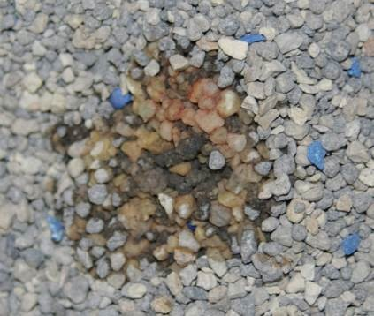
Note red color in litter

- Symptoms: Pink, orange, or red color in urine or found in the litter box. Straining or frequent trips to the litter box with little to no success.

- Action: Try to get a same-day vet appointment through the foster department or contact the on-call lead mentor if the foster team is unavailable.
- Treatment: An appointment will need to be made immediately. Urinalysis and possible X-rays may be performed.
- Cleaning: Keep the litter box clean.
- Notes: This can be very dangerous for a cat/kitten and requires immediate attention, especially if it is an adult male cat and he is straining to urinate.

Cerebellar Hypoplasia (CH)
- What is it: Cerebellar hypoplasia (CH), also known as wobbly cat syndrome, is a neurological disorder that affects a cat's brain development and causes uncoordinated movement. There are many support groups online for these types of kitties.
- Symptoms: Cats with CH may have jerky movements, tremors, and difficulty walking or standing. They may also wobble, sway, or lift their legs high when walking. You should be able to notice these symptoms around 3 weeks of age.
- Contagious: No
- What causes CH: CH is most often caused by the mother cat contracting the feline panleukopenia virus while pregnant, but other causes include malnutrition or brain trauma during development.
- Severity: CH has three levels of severity:
  - Mild; Mild cases require little to no additional care
  - Moderate; Moderate cases include more spastic head/body wobbles. Most likely will not be able to stand on all 4 limbs for very long or at all. Can move around and play/eat/use litter box. May require special feeding stations or litter box stations.
  - Severe; Severe cases include not being able to move around a room on own. Likely will have litter box issues. Will need special feeding and litter box stations.
- Action: Once CH is considered, monitor to make sure there are no changes in severity of stages or pain. A vet appointment will be needed before pre adoptions so an indemnity can be added to their shelter buddy records. If severe, a vet consultation may be needed for adoption.
- Treatment: There is no treatment for CH. Once their severity level is determined by a veterinarian, it will not get better or worse. Although it doesn’t technically get better or worse, it will appear to improve a little as the kitten grows and becomes a more coordinated adult. CH kittens can live a long and healthy life. There is no medication.
- Cleaning: No additional cleaning required

Chin Acne

- What is it: "Chin acne" in cats refers to a skin condition where the hair follicles on a cat's chin become plugged with excess keratin, leading to the formation of blackheads, red bumps, and sometimes infected pimples
- Symptoms: Dark debris or crusting under the chin area, hair loss, and sometimes swelling/discharge.
- Contagious: No!
- Action: Remove all plastic from the room and only use stainless steel or glass dishes.
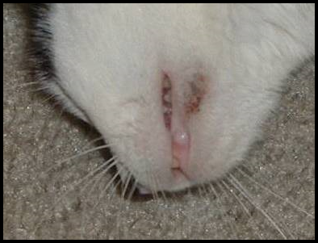
- Treatment: Use a warm water washcloth to do a compress. Don’t scrub it away. Vet appointment if it doesn't improve after 5 days of treatment with warm compresses or if it seems to be causing pain.
- Cleaning: Normal cleaning protocol
- Notes: This will happen with adult cats and should not be seen with kittens.

Coccidia

- What is it: Coccidia are microscopic, single-celled parasites that live in the intestines of cats
- Symptoms: Diarrhea, weight loss, dehydration.
- Contagious: Yes!
- How is it spread: Through feces
- Action: Follow the diarrhea protocol. Take a fresh stool sample to the hospital for testing if medications are not helping.
- Treatment: Marquis Paste
- Cleaning: Scoop the litter box as often as you can to remove any fecal matter. Wipe the foster room floor three times a day to remove any fecal matter.
- Cleaning post foster: All items that can be washed in hot water or sanitize mode should be. All toys, litter boxes, walls, floors, and equipment such as scales should be cleaned with soapy water to remove excess material and then sanitized in either a veterinary grade cleaner (Rescue) OR a clorox solution (32 parts water to 1 part clorox)
- Notes: Coccidia often has a very distinctive smell and the feces will often be yellow in color.

Conjunctivitis

- What is it: Conjunctivitis, commonly known as pink eye, is an inflammation of the conjunctiva, the thin membrane that lines the inside of the eyelids and covers the white part of the eyeball in cats
- Symptoms: It is characterized by redness, swelling, and/or yellow or green discharge around the eyes.
- Contagious: Yes!
- How is it spread: It spreads through direct contact with an infected cat's saliva
- Action: If it is crusty, have the foster parent clean with a clean moist warm cloth. A clean cloth should be used each time the eye(s) are cleaned. Have them hold the washcloth on the eye for at least 30 seconds if not longer. If the crusty discharge has softened, it can be wiped from the eyes. Make sure that the foster parent is not picking the crusty discharge off the eye area as that can cause the delicate skin to tear.
- Treatment: To clean the cat/kitten’s eyes, use a cotton ball or gauze that is clean with warm water. If the eye is sealed shut, you will need to use the warm cotton ball as a compress and hold on the eye for a few minutes. This will soften the crusted material around the eye. Once it is soft and pliable you can wipe it from the eye. Start at the area closest to the nose and wipe outward. Don’t force the material off of the eye. You may need to continue to let the cotton ball sit on the eyelid longer to soften the material. Once everything has been cleaned around the eye, you can administer eye medications. It will be helpful to the cat/kitten if you can gently wipe the eye clean multiple times a day. If you do not have a cotton ball or gauze square, you can use a soft washcloth. Make sure that you use a clean washcloth each time. Never share washcloths or gauze between cats/kittens or eyes. If the eye discharge is clear and watery, have the foster parent clean the eye 3-4 times a day with a clean washcloth and monitor for other symptoms. If there is a green or yellow-colored discharge or if the tissue around the eye is red and swollen, then have the foster parent begin administering eye medication. Medication may be available in their foster bag or can be picked up at the shelter. The medication we use is Tobramycin Eye Drops—dose is one drop per eye 3-4 times a day for 5 days. To administer eye drops, hold the cat/kitten’s eye open and let the drop fall into the inside corner of the eye near the tear duct. Open and close the eye a few times to get drops worked in well. Erythromycin Ointment: This medication may be prescribed by the hospital if the Tobramycin does not seem to be working —dose is one thin strip the size of the eye 2-3 times a day for 7 days. To administer the ointment, hold the cat/kitten’s eye open and squeeze the ointment into the eye moving across the eye without touching the tip of the tube to the eye. It is very important to make sure that only the medication—not the tube—touches the eye.
- Cleaning post foster: All items that can be washed in hot water or sanitize mode should be. All toys, litter boxes, walls, floors, and equipment such as scales should be cleaned with soapy water to remove excess material and then sanitized in either a veterinary grade cleaner (Rescue) OR a clorox solution (32 parts water to 1 part clorox)
- Notes: Conjunctivitis is often accompanied by an upper respiratory infection. Also, if not treated correctly ulcers can form on the eye, or the eye can become damaged to the point of needing extraction. Make sure the foster parent understands that if they see anything forming on the eye, or if the third eyelid becomes red and inflamed (meaty), that they need to make an appointment at the hospital right away for further evaluation.
- 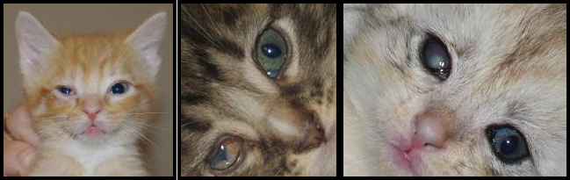
- Pic # 1: watery eye w/ 3rd eyelid showing; Pic #2: “meaty” third eyelid; Pic #3: ulceration of the right eye

Constipation

- Symptoms: This can be from infrequent elimination or difficulty eliminating hard feces. There can also be very little liquid passing by the blockage as the cat/kitten is straining to defecate.
- Contagious: No
- Action: Check for hydration. Ask the foster parent if there is any chance that the kitty could have swallowed something to cause blockage.
- Treatment: Administer sub-q fluids. Add FortiFlora to diet.
- Cleaning: Keeping the litter box clean will ensure the cat/kitten will use the litter box, also it allows the foster parent to know how much the cat/kittens are using the litter box.
- Cleaning post foster: Normal cleaning protocol
- Notes: If improvement is not noted within 24 hours after administering fluids, have the foster parent make an appointment with the hospital.

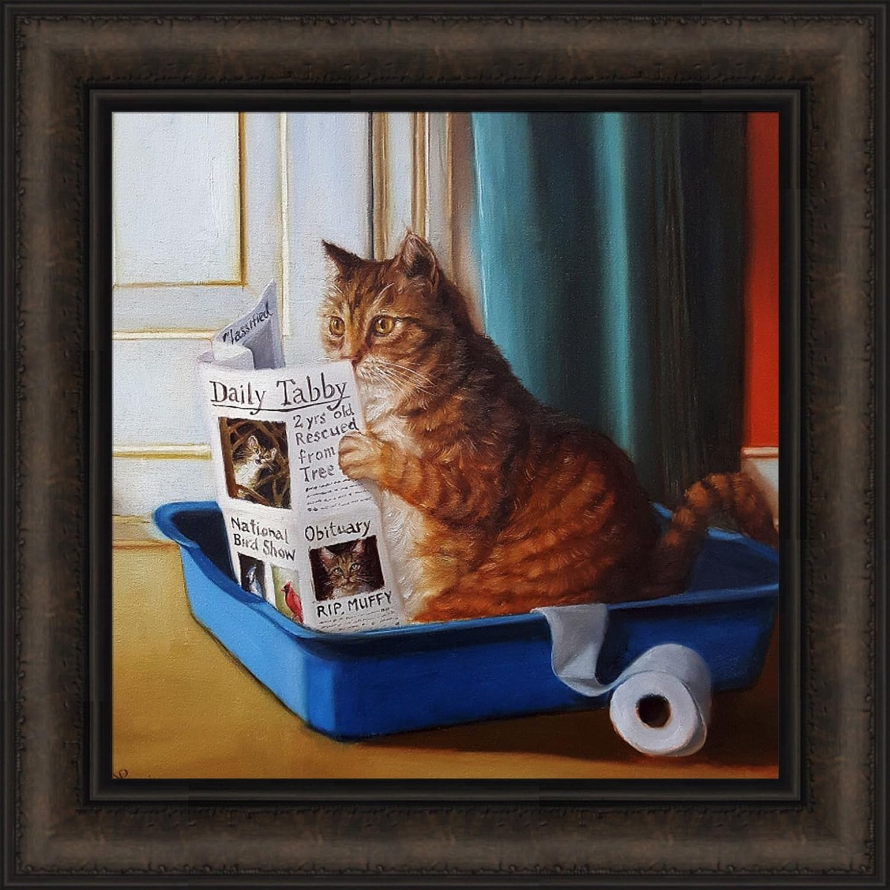

Coughing

- Symptoms: Cat/Kitten sounds like it is trying to hack up a hairball.
- Action: Take the kitten’s temperature. An adult cat may produce a hairball but kittens do not have hairballs to deal with yet and this is most likely a sign of illness. Try to determine if the kitten swallowed something that could be blocking the airway.
- Treatment: For kittens, make a vet appointment to rule out pneumonia. For adults, can make a vet appointment or send in a video of the coughing for a vet to evaluate.
- Cleaning: Nothing
- Cleaning post foster: Normal cleaning protocol
- Notes: You may also notice the cat/kitten having trouble swallowing. This could be post-nasal drip running down the back of the throat causing irritation.

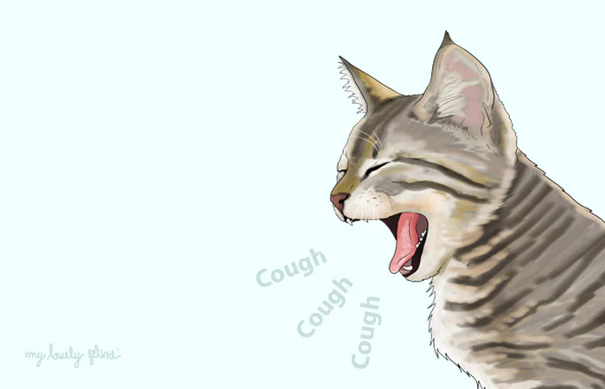

Dehydration

- Symptoms: The gums will feel a little tacky, not moist and smooth. The skin on the back of the neck when pulled up will not fall back into place immediately. Bottle babies may have concentrated urine that is dark yellow.
- Treatment: Administer sub-q fluids. See the section on sub-q fluids for how much to administer based on the weight of the cat/kitten. If a kitten cannot get fluids right away, you can instruct the foster parent to offer HydraCare. For bottle babies, use Kitten Lyte or unflavored pedialyte to make the formula and refer to the bottle feeding section of the Kitten Foster Manual for more advice.
- Cleaning: Normal cleaning protocol
- Cleaning post foster: Normal cleaning protocol
- Notes: You may need to go over each night to administer fluids for up to a week.
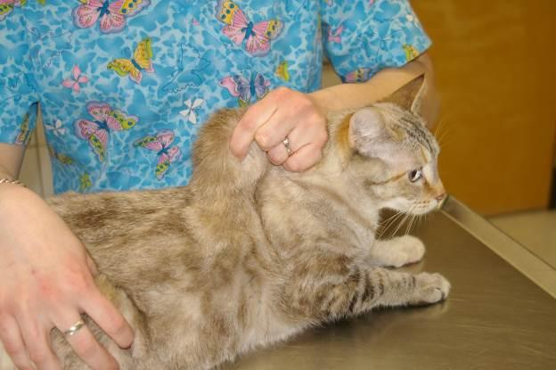
Photo by Debbie Brusius

Diabetes

- What is it: Diabetes in cats is a chronic condition that occurs when a cat's body can't properly use or produce insulin, a hormone that controls blood sugar levels
- Symptoms: Excessive thirst, urinating a lot, overweight cats are more prone to developing diabetes
- Action: Make a vet appointment.
- Treatment: Insulin, special diet, and blood glucose monitoring as directed by the shelter veterinarian.
- Cleaning: Nothing
- Cleaning post foster: Normal cleaning protocol
- Notes: How to give an insulin injection. Tracking blood glucose. Two videos on getting blood samples” AAHA and AlphaTrak

Diarrhea

- Symptoms: Liquid fecal matter found in the litter box, on the cat/kitten’s bottom, or anywhere else in the foster room.
- Contagious: Depends on the reason.
- Action: Start Diarrhea Protocol. Keep the kitten’s bottom clean at all times. You may need to run the kitten’s bottom under warm water to cleanse the area. Pat dry and then apply A&D ointment for protection. Check for dehydration.
- Treatment: FortiFlora—continue to give or restart for 7 days. Administer sub-q fluids if dehydrated.
- Cleaning: Cleaning diarrhea out of the litter box and off the cat/kitten promptly is necessary for preventing extra mess and potential spread of disease.
- Cleaning post foster: All items that can be washed in hot water or sanitize mode should be. All toys, litter boxes, walls, floors, and equipment such as scales should be cleaned with soapy water to remove excess material and then sanitized in either a veterinary grade cleaner (Rescue) OR a clorox solution (32 parts water to 1 part clorox)
- Notes: You may be given a special diet to feed the cat/kittens.
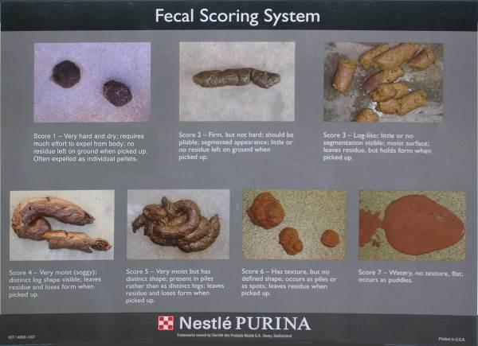

DIARRHEA PROTOCOL
See Kitten Foster Manual

Failure to Thrive

- Symptoms: Kitten is not gaining weight and/or is losing weight with supplemental syringe feeding, is lethargic, and always wants to cuddle.
- Action: Contact On-Call Lead Mentor for advice. Bring in for a vet appointment as soon as possible.
- Treatment: Keep them warm. Give Sub-q fluids and apply karo syrup. Continue with syringe feedings. The hospital may prescribe other treatments or an emergency vet visit might be necessary.
- Cleaning: Nothing needed at this time.
- Notes: Be prepared for the worst and know that not all kittens survive kittenhood. Do tell the foster parent that we will do everything we can for the kitten, but sometimes we simply can’t save them all. Don’t make it sound rosy and that there are no issues; this is a critical time in a kitten’s life.

Esophagostomy Feeding Tubes

- Symptoms: Cats that are not eating for multiple days in a row will often get esophagostomy feeding tubes (e-tubes) placed surgically in their neck. We try to send these cats to foster care so they are in a low stress environment and will start to eat on their own sooner. Here are the instructions that foster parents are provided when they take an e-tube cat. Here is a video demonstrating the process.
- Action: Possible issues with feeding tubes include (1) a blocked tube, (2) a tube that falls out on its own or (3) a tube that is vomited up. Most feeding tube issues are not an emergency and can wait for a vet appointment. If a tube is blocked (i.e. the foster is trying to push food down and the syringe won’t advance), you can try using 2-3 ml of regular Coca Cola (not diet or any other additives) to flush it, wait 5 minutes and then flush with some water. If the tube falls out of the hole into the neck, the foster may need to very carefully cut the suture that is holding it in place. The hole can be left alone or lightly cleaned with a warm compress. A vet appointment should be made to have the site checked (a vet assistant can check it on weekends - use the on-call system to set this up). If the cat vomits the tube, it can be uncomfortable and cause them to gag. We may need to address this sooner. You will want to use the on-call system to get advice.
- Cleaning: follow cleaning instructions listed in link above
- Cleaning post foster: Normal cleaning protocol
      - 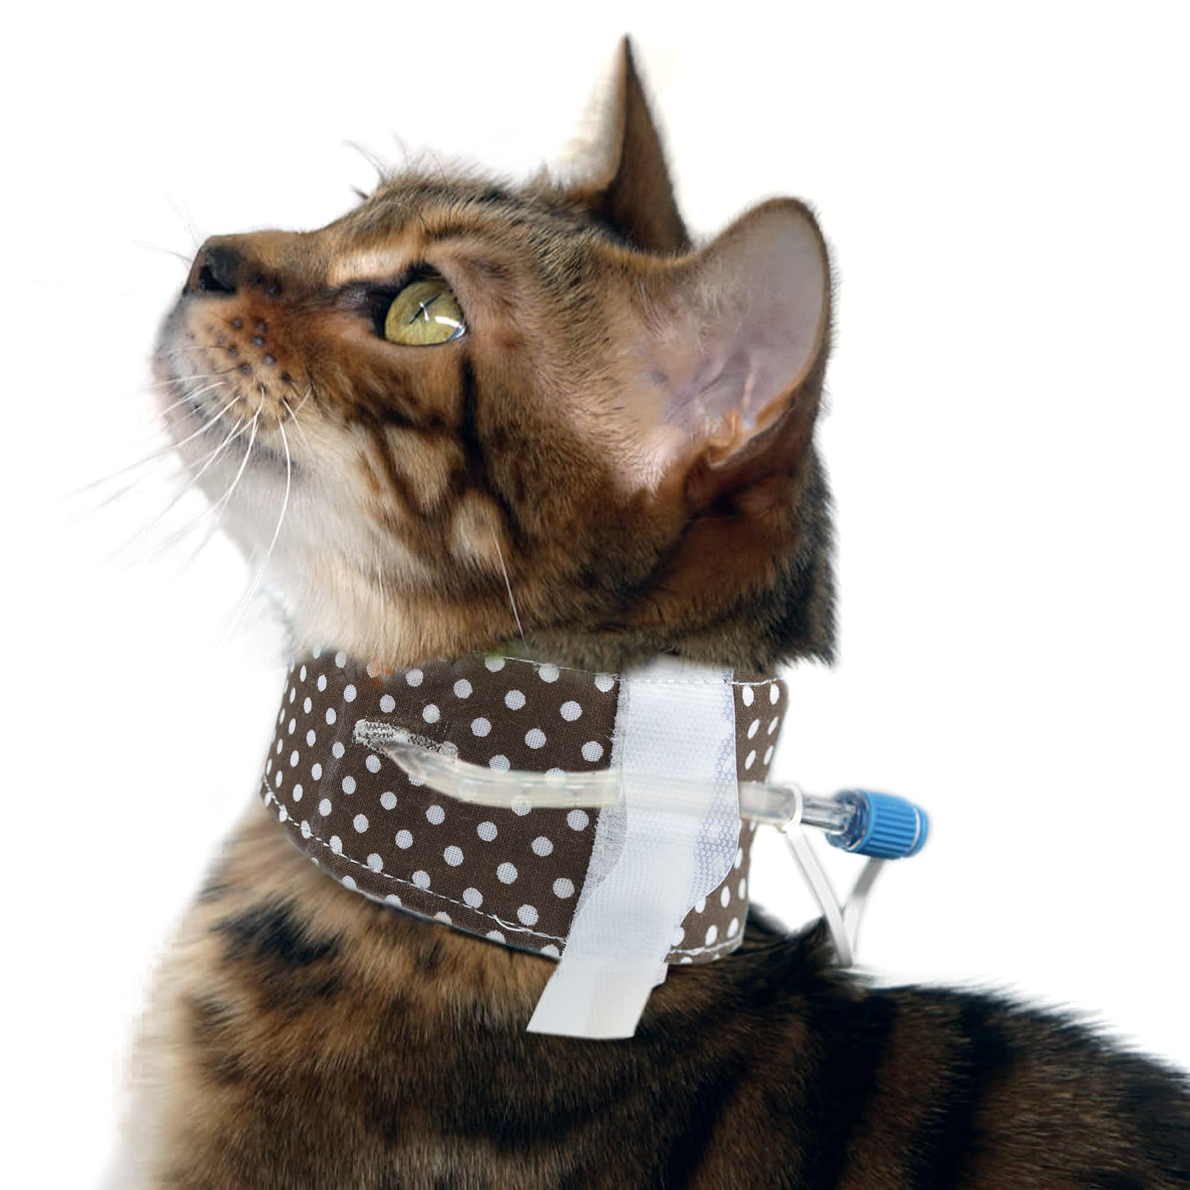

Feline Infectious Peritonitis (FIP)

- What is it: FIP is a mutation of the feline enteric coronavirus that occurs within certain cats. 1%-5% of infected cats develop FIP. At this point, the virus can now leave the intestines and infect blood cells. This stimulates a large antibody response by the body. Then, the antibodies bind to the virus to form complexes, and these complexes can cause vascular damage. At this point, it appears that the mutated virus is not contagious. FIP can be difficult to diagnose and is fatal if not treated.
- Symptoms: Wet Form: Fluid build-up in abdomen or chest, swollen abdomen, difficulty breathing. Dry Form: Neurologic disease, enlarged kidneys, Uveitis (inflammation inside the eye).
- Contagious: We don’t consider FIP too contagious in the way so many other diseases are, primarily because almost all cats are exposed to the organism early in life and carry it long-term without symptoms. The development of disease requires a specific interaction between the virus and the immune system.
- How is it spread: Most cats are exposed early in their lives to the organism that causes FIP—sometimes even from their mother. Cats almost universally carry the organism responsible for the infection—however, the development of disease requires a specific interaction between the immune system of the cat and a mutated form of the organism. Therefore, although many cats carry the organism, the vast majority never develop disease.
- Action: Schedule a vet appointment.
- Treatment: There is a program in place at CAT to treat FIP.
- Cleaning post foster: Replace the litter box. Clean all bedding, sanitize the foster room, throw out food and water bowls unless they are stainless steel.
- Notes: The coronavirus is very common in cats. It is estimated that 20%-50% of the general population of cats are infected, and 80%-100% of those cats affected are living in a multi-cat environment. The coronavirus can live for weeks in the environment, but it can also easily be killed. The virus is spread via fecal-oral transmission. Many cats are infected by the mother at 3-4 weeks of age, and a few cats are even chronic shedders of the virus. The disease is typically mild, with only transient diarrhea being its primary effect. Immunity for the virus is short-lived; because the virus can mutate very easily, cats can become reinfected.

Hernia

- Symptoms: Round marble-shaped protrusion around the belly button area.
- Action: Have the foster parent contact the Foster Department during normal business hours for advice and any instructions.
- Treatment: No treatment unless authorized by shelter or hospital.
- Cleaning: Nothing
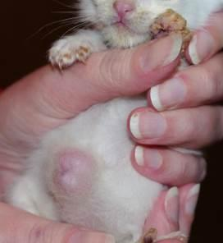
- Notes: Typically these do not bother cats/kittens and will be repaired at spay/neuter surgery.
Photo by Debbie Brusius

Hookworms
- What is it: Hookworms are internal parasites that can infect cats, causing anemia, blood loss, and potentially fatal internal bleeding. They are thread-like and less than half an inch long, making them difficult to see without magnification. This parasite is RARE in cats.
- Symptoms: Evidence of hookworm infection includes anemia (low numbers of circulating red blood cells) the presence of digested blood in the stool (a black ‘tarry’ appearance to the stool), a poor hair coat, and weight loss. Skin irritation and itching, especially of the paws, can be signs of a heavily infested environment since the larvae burrow into and along the skin.
- Contagious: Yes. This is zoonotic (able to infect humans)
- How is it spread: Hookworms can be passed to other cats through skin contact with infected stool, drinking contaminated water, or ingesting infected animals. Cats can also become infected by drinking their mother's milk as kittens.
- Action: Contact the foster department for further information. In many cases treatment has already been given in the past few days.
- Treatment: Selemectin (a second dose may be needed)
- Cleaning: Scoop litter box multiple times a day. It is important to wear gloves when scooping or handling fecal material. Clean litter boxes with bleach (clean all organic material, wash with soap and water, soak in bleach solution (1 part bleach to 32 parts water) for 10 minutes.) at time of diagnosis and weekly for 4 weeks
- Cleaning post foster: Double Cleaning protocol. All plastic litter boxes should be thrown away after treatment and not used for future fosters..

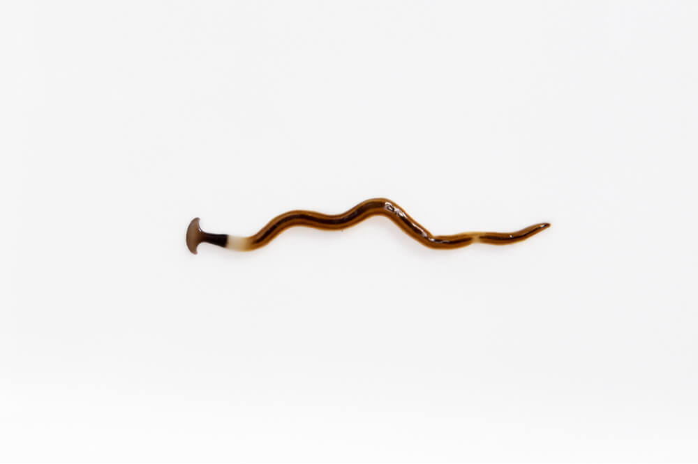

Hypothermia

- Symptoms: Kitten is cold, lethargic, not eating, and cuddly.
- Action: Take the kitten’s temperature. If lower than a normal body temperature (97°-99° F for kittens 0-3 weeks and 99°-102° F for cats/kittens 4 weeks and older) you will need to heat the kitten.
- Treatment: Put the kitten up against your chest under your shirt for warmth and so the kitten can hear your heartbeat. Place a towel in the dryer on high. Once the towel is heated, wrap up the kitten and hold them close to your chest. Increase the temperature in the foster room with the thermostat, a space heater, or SnuggleSafe warming disks. Administer Karo syrup. Place a 1” bead of syrup on your index finger and wipe that on her gums and tongue. Repeat in a few minutes if the kitten is not perking up. You can use up to 1 mL. Don’t shoot the Karo syrup in the mouth for the kitten to swallow. You may also administer warmed sub-q fluids. To warm fluids, draw them up into the large syringe, cap the syringe, and place it in a bowl of hot water for three minutes.
- Cleaning: Nothing
- Notes: After the kitten is warm, make sure that it resumes regular activities like eating, playing, going potty, etc. If the kitten does not then you may need to syringe feed to get some calories in them. Call the on-call lead mentor if the suggestions do not improve the issue.

Lethargy

- Symptoms: Seems tired, unresponsive, and also referred to as a “flat”.
- Action: Take the kitten’s temperature. If lower than a normal body temperature (97°-99° F for kittens 0-3 weeks and 99°-102° F for cats/kittens 4 weeks and older) you will need to heat the kitten.
- Treatment: Put the kitten up against your chest under your shirt for warmth and so the kitten can hear your heartbeat. Place a towel in the dryer on high. Once the towel is heated, wrap up the kitten and hold them close to your chest. Increase the temperature in the foster room with the thermostat, a space heater, or SnuggleSafe warming disks. Administer Karo syrup. Place a 1” bead of syrup on your index finger and wipe that on her gums and tongue. Repeat in a few minutes if the kitten is not perking up. You can use up to 1 mL. Don’t shoot the Karo syrup in the mouth for the kitten to swallow. You may also administer warmed sub-q fluids. To warm fluids, draw them up into the large syringe, cap the syringe, and place it in a bowl of hot water for three minutes.
    - If the cat/kitten is at a normal temperature, check the gums. They should be pink. If they are pale, the cat/kitten is not doing well. Administer Karo syrup using the instructions above. Give sub-q fluids. Then try to offer food. Try to determine if the cat/kitten has been eating or not, if they have had diarrhea, etc.
    - If the cat/kitten does not improve, contact the On-Call Lead Mentor right away.
- Cleaning: Nothing
- Notes: Lethargy can be a sign of a lot of different illnesses, birth defects, and other anomalies. Try to gather as much information for the medical team so that they can see the full picture and have the timeline of events.

Lice

- What is it: Lice are small, parasitic insects that live on a cat's skin and feed on their blood or skin cells
- Symptoms: Cat/kitten is scratching excessively, white “flakes” noticed on the fur, hair loss.
- Contagious: Yes!
- How is it spread: can spread from one cat to another through direct contact or contaminated objects
- Action: Schedule a vet appointment. The hospital team will determine if it is lice and will start a treatment plan.
- Treatment: Revolution, Selamectin, Advantage Multi, Frontline Plus, or a similar product will be used. Repeat treatment in 2 weeks. Flea comb all cats/kittens daily to remove any lice and nits.
- Cleaning: Wash all bedding/toys in hot water often. Vacuum the foster room daily, and deep clean the room with warm soapy water each week to remove any lice or nits that may have fallen off the cat or kitten.
- Cleaning post foster: Wash all bedding/toys in hot water twice or (if washer has it) Sanitize mode once. Vacuum room and mop with veterinary grade cleaner such as Rescue or Clorox mix (32 parts water to 1 part bleach). Wash all other items with warm soapy water and sanitize as previously instructed.
- Notes: Feline lice are species-specific and cannot be transmitted to humans or dogs.

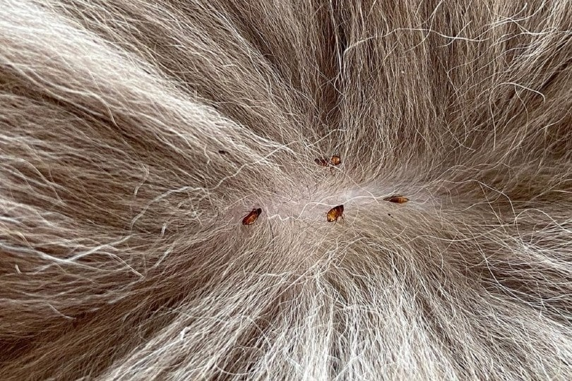

Limping/Lameness

- Symptoms: Cat/kitten is not putting full pressure or any pressure on a limb.
- Action: Try to determine if the cat/kitten jumped off something tall, was hurt while playing or stepped on something. Check the pads of the feet to make sure there are no visible signs of injury. Check for swelling of the joints and range of motion. Take a temperature.
- Treatment: Often rest is the best plan. But if the cat/kitten appears to be in pain, try to get a same day vet appointment OR call the on-call lead mentor. The hospital may decide to do an X-ray or prescribe pain medication. If a fever is present, give SQ fluids.
- Cleaning: Nothing
- Notes: A limping kitten can be a sign of Calicivirus. It is called Limping Kitten Syndrome and is often accompanied by a high fever. It could also be a vaccine reaction. Often kittens will hold up their paw for 24-48 hours after a vaccine has been administered.

Mastitis

- Symptoms: Engorged milk glands, nipples are warm/hot to the touch, red in color or streaking, painful.
- Action: Warm compress. Take a hand towel and run it under very warm water (not too hot) and place it on the mother cat’s affected breasts. Hold in place until the towel cools to room temperature. Repeat 4 times a day.
- Treatment: Schedule a vet appointment. Sometimes an antibiotic will be prescribed.
- Cleaning: Keep the area clean with a warm washcloth.
- Notes: If the mother cat has bad milk due to mastitis, she could be poisoning her kittens. Make sure the kittens are thriving, not showing signs of illness, and are gaining weight. Often mastitis will occur after the kittens are no longer nursing on the mother cat. To prevent this, it is best to remove a few kittens at a time from her so her milk production slows gradually.

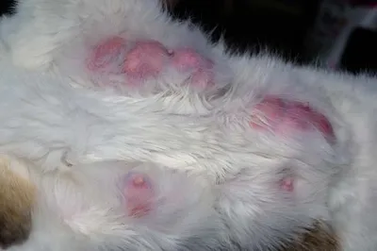

Panleukopenia

- What is it: Feline panleukopenia is also commonly referred to as feline parvovirus and feline distemper. It is not related to canine distemper. There is a decreased incidence of infection with age, and cats who manage to recover from the disease are immune from that point onwards. Panleukopenia is spread via fecal-oral transmission and has an incubation period of 2 to 14 days. It works by attacking those cells which divide rapidly – often the viral target is the cells of the intestine.
- Symptoms: Fever, vomiting, diarrhea with blood and mucus, occasional sudden death.
- Contagious: Yes!
- How is it spread: Infected cats can pass Panleuk in their feces (stool) and body fluids like urine and nasal secretions.
- Action: If panleukopenia is suspected, schedule a vet appointment right away and alert the hospital of the concern so a separate area can be prepared for the exam. Call the on-call lead mentor if a vet appointment cannot be scheduled right away and the kitten is very sick.
- Treatment: Can vary based on the severity of the case. Antibiotics are given to prevent a secondary GI infection, fluids are administered to improve hydration, and antiemetics can be prescribed to control vomiting. In some cases, blood transfusions are necessary. A hyperimmune serum can also be administered after exposure to the virus.
- Cleaning: Follow the written protocol provided to you by the CAT hospital.
- Cleaning post foster: See this document for foster room deep cleaning
- Notes: If a pregnant mama cat contracts feline panleukopenia, her unborn kittens run the risk of being born with Cerebellar Hypoplasia

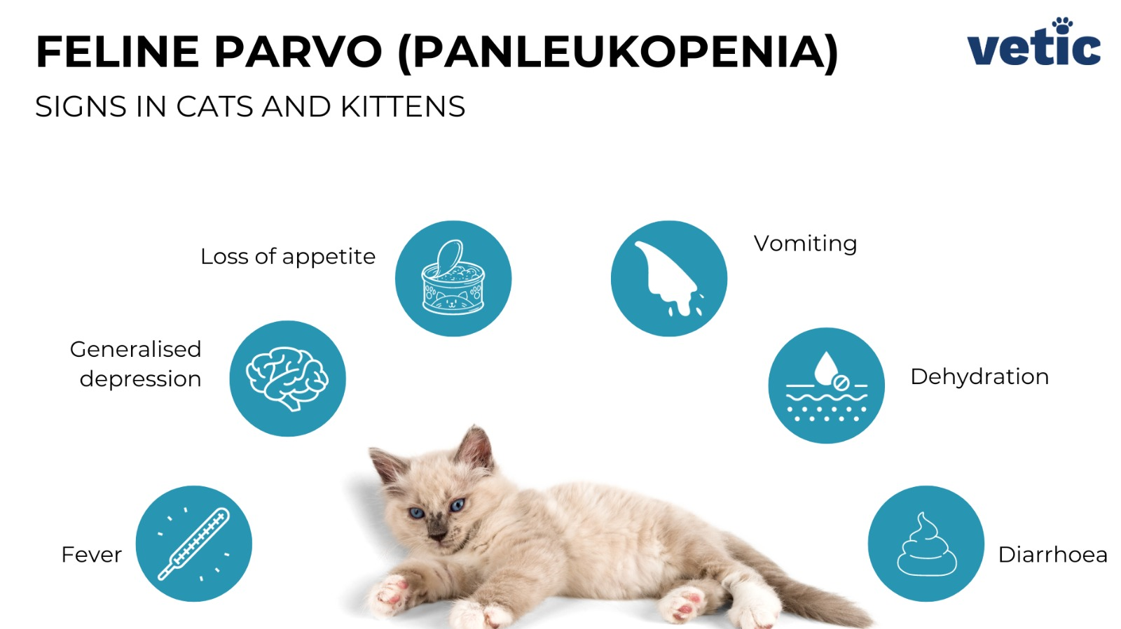

Ringworm

- What is it: Ringworm in cats is a fungal infection of the skin caused by dermatophyte fungi. It is not caused by a worm, but the name comes from the characteristic circular lesions that appear on the skin
- Symptoms: Hair loss and scaly, crusty lesions—especially on the face, ears, and paws—that may or may not be itchy.
- Contagious: Yes!
- How is it spread: Ringworm in cats is spread through direct contact with an infected animal or person, or by exposure to contaminated objects and surfaces
- Action: Schedule a vet appointment. They will need to woods lamp the area.
- Treatment: Isolate the cat to decrease contamination. Treatment options include twice-weekly lime sulfur dips and oral medications such as Terbinafine. The foster will be given the opportunity to treat the cat in foster care or leave the cat at the shelter for treatment.
- Cleaning: All contaminated areas must be cleaned with bleach or Rescue—the only effective agents against ringworm. For bleach, create a 1:10 diluted solution and leave it on surfaces for 10 minutes. Manual removal of hair can greatly decrease contamination. Rescue can be picked up from the shelter.
- Cleaning post foster: Wash all bedding/toys in hot water twice or (if washer has it) Sanitize mode once. Vacuum room and mop with veterinary grade cleaner such as Rescue or Clorox mix (10 parts water to 1 part bleach). Wash all other items with warm soapy water and sanitize as previously instructed.
- Notes: This also has a high zoonotic potential, which means it can easily be transferred from cats to people or other animals.

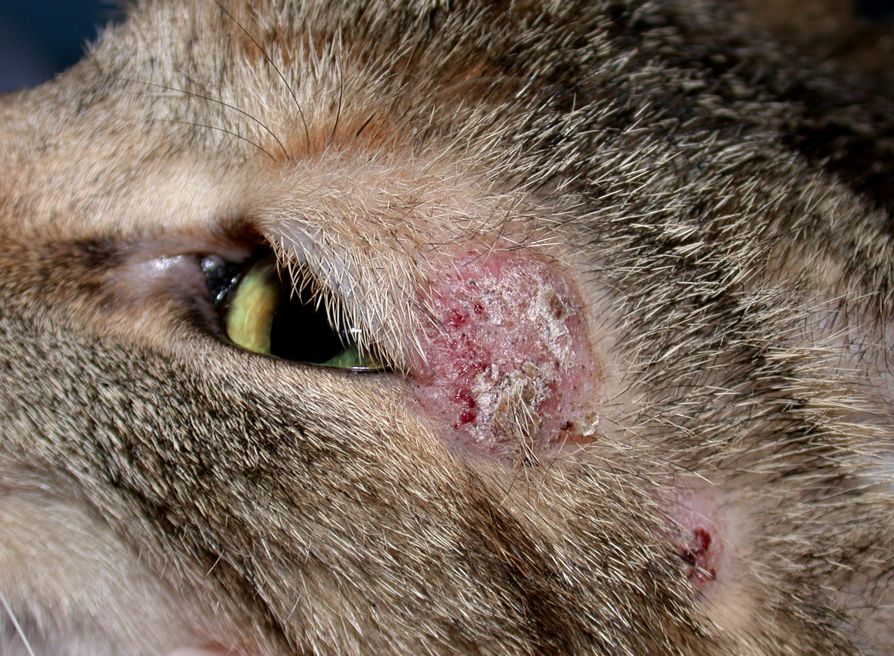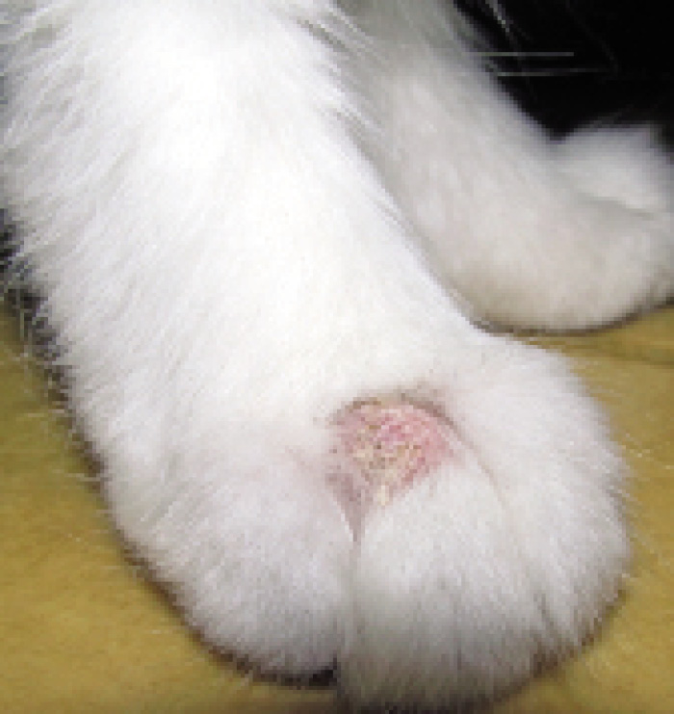

Roundworms

- What is it: Roundworms are one of the most common intestinal parasites of the cat. They can be an important cause of illness, even death, in kittens. Almost all cats will become infected with roundworms at some point in their life, most often as kittens. As their name implies, these are large-bodied round worms, averaging three to six inches (8-15 cm) in length. They do not attach to the wall of the intestine, as some intestinal parasites do. Instead, they swim freely within the intestine. Roundworms are also known as ascarids and the disease they cause is called ascariasis.
- Symptoms: Pot-bellied appearance, abdominal discomfort, depressed appetite, dull coat, vomiting, diarrhea, or poor growth. In both kittens and adult cats with small numbers of worms, there may be no clinical signs of infection. You may notice adult roundworms in your cat’s stool or vomit.
- Contagious: Yes! This is zoonotic (able to infect humans) and can cause blindness in humans.
- How is it spread: Trans-mammary (milk-borne) infection is the major route of roundworm transmission in kittens. The roundworm larvae are present in the mother's mammary glands and pass to her kittens in her milk during nursing. Both kittens and adult cats may become infected by swallowing eggs that contain infective roundworm larvae. These eggs may come from the feces of infected cats or from the tissues of an accidental host. In these hosts, the roundworm eggs do not mature into adults but are just transported. If a cat eats one of these intermediate hosts, the roundworm can complete its life cycle. Common accidental hosts for roundworms include earthworms, cockroaches, rodents, and birds. Once ingested, the eggs hatch in the cat's gastrointestinal tract, and larvae migrate through the muscles, liver, and lungs. After several weeks, the larvae return to the intestine to mature into adults. When the adult worms begin to reproduce, eggs will pass into the cat's stool, thus completing the life cycle of the parasite. During migration, some roundworm larvae may become enclosed in a cyst while in a dormant state in the host's body. In female cats, the larvae can come out of the cyst during pregnancy. These larvae can then be passed to the kittens across the placenta during pregnancy, or through the milk after birth.
- Action: Contact the foster department for further instructions. In many cases treatment has already been given within the past few days.
- Treatment: Selemectin or pyrantel; to name a couple.
- Cleaning: Scoop litter box multiple times a day. Always wear gloves when scooping or handling fecal material. Clean litter boxes with bleach (clean all organic material, wash with soap and water, soak in bleach solution (1 part bleach to 32 parts water) for 10 minutes.) at time of diagnosis and weekly for 4 weeks.
- Cleaning post foster: Double Cleaning protocol. All plastic litter boxes should be thrown away after treatment and not used for future fosters.



Seizures

- What is it: A seizure in a cat is a sudden, uncontrollable burst of muscle activity that can last from seconds to hours
- Symptom: Body tremors uncontrollably.
- Action: Remove any items that the cat may become injured by.
- Treatment: Contact On-Call Lead Mentor.
- Cleaning: Nothing
- Notes: Time the length of the seizures and the frequency in a journal.

Spay/Neuter Incision Issues

- Symptom: Redness, swelling, discharge, or pain at the spay/neuter site or an incision site that has opened up.
- Action:
    - MINOR If there is only swelling under the skin, the stitches/incision are intact, and there is no discharge, pain or fever, a vet exam is not necessary. See below for home treatment.
    - MODERATE If the swelling doesn’t reduce in size in 48-72 hours of compresses, there is colored discharge, a fever, pain, or the spay site has opened up, a vet exam should be scheduled for the same day or following day.
    - SEVERE If both walls of the spay site have opened up and there is tissue visible, call the on call lead mentor right away - this is an emergency.
- Treatment: For minor issues, apply a damp (not wet) warm compress throughout the day for 5 minutes at a time until the swelling goes down. For moderate issues that cannot be seen by a vet right away, apply a damp (not wet) warm compress throughout the day for 5 minutes at a time. If there is a fever, discharge from the spay site, redness or pain at the area, start amoxicillin (see section on Amoxicillin for dosing), and give fluids if feverish until the vet appointment. This could simply be a seroma (fluid build up under the skin) even if it is large, so do not start amoxicillin unless those symptoms are present.
- Cleaning: None
- Notes: Most spay site swellings are seromas. It can take up to two weeks for swelling to completely resolve.

Suckling on Littermates

- Symptom: Kittens who are orphaned young will sometimes suckle on their littermates in the absence of a mother.
- Action: If the suckling is occurring on areas of the body that can be covered with kitten “clothing”, you can keep the kittens together and just have the one being suckled wear a sweater (you can make one at home with an old sock!). Here is a link to make a sock sweater! If the suckling is happening in areas that can't be covered, the kittens will need to be separated when they can’t be watched. IF A KITTEN’S GENITALS ARE BEING SUCKLED, MAKE A VET APPOINTMENT RIGHT AWAY AS THIS CAN CAUSE PROBLEMS WITH URINATION. You can also try offering a mom-cat sized stuffed animal (one with a fake heart beat works best) to encourage the kitten to suckle on “mom.”
- Treatment: If the area being suckled appears infected (red, swollen or with discharge), make a vet appointment. Amoxicillin can be started if a vet appointment is not available the following day (see section on Amoxicillin for dosing information). A warm compress can also be applied to the area to help reduce swelling.

Tapeworms
- What is it: A tapeworm is a flat, segmented intestinal parasite that can infect cats
- Symptoms: Usually, an infected cat’s owner will notice the presence of proglottids (rice like segments) crawling on its feces. A cat will occasionally scoot or drag its anus across the ground or carpet due to the anal irritation caused by the proglottids; however, this behavior is much more common in dogs than cats. Occasionally, a tapeworm will release its attachment in the intestines and migrate to the stomach. When this happens, the cat may vomit an adult tapeworm several inches in length. Rarely, tapeworms may cause debilitation or weight loss if they are present in large numbers.
- Contagious: No.
- How is it spread: Tapeworms are parasitic worms that can infect cats and other animals. They are typically transmitted through the ingestion of infected fleas or rodent prey
- Action: Contact the foster department for next steps. In most cases, tapeworms will be addressed at alter.
- Treatment: Droncit. Can be given orally or via injection at alter
- Cleaning: Clean litter box multiple times a day
- Cleaning post foster: Normal cleaning protocol

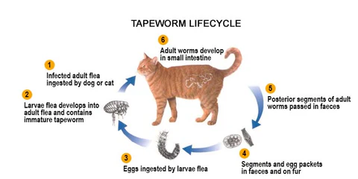

Upper Respiratory Infection (URI)

An occasional sneeze is expected from any cat. Lots of sneezing, yellow or green nasal discharge and congestion are causes for concern, as they may be an indication that a cat or kitten has an upper respiratory infection. Most URIs are caused by the Calicivirus or by the Herpes virus, and they often present as sneezing, thick mucosal discharge, and fevers. It is often difficult to diagnose the difference between the Herpes virus and Calicivirus since they often have similar symptoms. The shelter treats both of these viruses with the same medications and treatment plan.

HERPES VIRUS (FELINE RHINOTRACHEITIS VIRUS)

- Symptoms: Fever of 102.5° F or higher, sneezing, yellow or green nasal discharge, loss of appetite, lethargy.
- Contagious: Yes!
- How is it spread: Through direct contact with an infected cat's eyes, nose, or saliva, or by inhaling their sneeze droplets.
- Action: Check other kittens in the litter, as well as the mother, for signs of infection. Make sure the cat/kitten is eating or nursing well. Offer smelly food, human baby food (chicken or turkey with no onion or garlic), or boiled skinless chicken breast chopped into very small pieces. Take a temperature.
- Treatment: Amoxicillin (see dosing under Amoxicillin) every 12 hours for 7 days ONLY IF colored nasal discharge is present.. “Steam” twice a day with a hot shower running in the bathroom or by using a humidifier. Never add anything but water to the humidifier. Little Noses with Saline can be used in both nostrils up to three times per day. Saline can dry out the nose and cause bleeding. Avoid using saline if the cat/kitten is having bloody sneezes. If cat/kitten is dehydrated or has a fever, give sub-q fluids.
- Cleaning: The foster room will need to be wiped down twice a day, including the walls since the spray from a sneeze can project up to 4 ft. The virus can live in the environment including on your clothes and shoes for 12-18 hours. However, most disinfectants will kill the virus. The sick kitten should have his face cleaned with a warm washcloth or gauze pad at least three times a day. Use soap and water, not hand sanitizer to clean your hands after touching the cat/kittens. Calicivirus is not killed by hand sanitizer and we can’t be sure which virus is causing the URI.
- Cleaning post foster: Wash all bedding/toys in hot water. Vacuum room and mop with veterinary grade cleaner such as Rescue or Clorox mix (32 parts water to 1 part bleach). Wash all other items with warm soapy water and sanitize as previously instructed.
- Notes: If the cat/kitten does not improve after 7 days of treatment, contact the foster department to see if they want the medication extended to 10 days or if they would like to have the kitten seen by the vet.

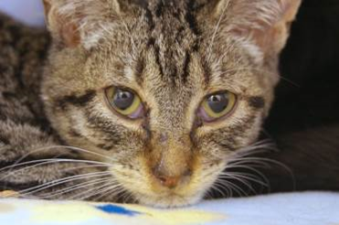A kitten that has contracted the Herpes virus
Nasal discharge

CALICIVIRUS

- Symptoms: Fever of 102.5° F or higher (typically a high spiking fever of 104.0° F or higher), yellow or green nasal discharge, red sores on the tongue, the roof of the mouth, or nose, loss of appetite, lethargy, limping (caused by inflammation) usually found on a rear leg for kittens.
- Contagious: Yes!
- How is it spread: Infected cats can shed the virus in their saliva, nose, and eyes, and airborne particles can be sprayed when they sneeze. FCV can also be spread through contact with objects like litter boxes and watering dishes used by an infected cat.
- Action: Check other kittens in the litter, as well as the mother, for signs of infection. Make sure the cat/kitten is eating or nursing well. Offer smelly food, human baby food (chicken or turkey with no onion or garlic), or boiled skinless chicken breast chopped into very small pieces. Take a temperature.
- Treatment: Amoxicillin (see dosing under Amoxicillin) every 12 hours for 7 days ONLY IF colored nasal discharge is present. “Steam” twice a day with a hot shower running in the bathroom or by using a humidifier. Never add anything but water to the humidifier. Saline can dry out the nose and cause bleeding. Avoid using saline if the cat/kitten is having bloody sneezes. If the cat/kitten is dehydrated or has a fever, give sub-q fluids.
  - For cats/kittens who are limping or not eating due to painful mouth ulcers, contact the foster department or the on-call lead mentor for pain medication.
- Cleaning: The foster room will need to be wiped down twice a day, including the walls since the spray from a sneeze can project up to 4 ft. The virus can live in the environment for up to 28 days. The virus is killed only by bleach or Rescue. The sick cat/kitten should have his face cleaned with a warm washcloth or gauze pad at least 3 times a day. Use soap and water, not hand sanitizer to clean your hands after touching the kittens. Calicivirus is not killed by hand sanitizer.
- Cleaning post foster: Wash all bedding/toys in hot water. Vacuum room and mop with veterinary grade cleaner such as Rescue or Clorox mix (32 parts water to 1 part bleach). Wash all other items with warm soapy water and sanitize as previously instructed.
- Notes: If the cat/kitten does not improve after 7 days of treatment, contact the foster department to see if they want the medication extended to 10 days or if they would like to have the kitten seen by the vet.

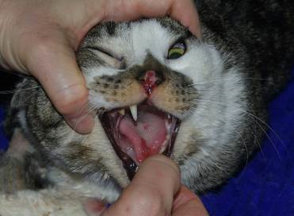A cat that has contracted the Calicivirus
Tongue Ulcer
Nasal Ulcer

Vomiting

- Symptoms: Partly digested food, hair, clear saliva-looking vomit, or a yellow or green slime.
- Action: Determine who is vomiting and how often. What has the cat/kitten thrown up? You will need to differentiate between hairballs, food, and stomach acids. Has the cat/kitten been anywhere near plants or other substances that could pose a poison risk? Is it foaming at the mouth? Did the cat/kitten throw up after it was given medication or food?
- Treatment: One episode of vomiting (or a scarf and barf) is not cause for concern. If a kitten has vomited twice within 24 hours, place a call to the On-Call Lead Mentor for advice. Give SQ fluids. A vet appointment might be necessary to get anti-nausea meds. If an adult cat vomits more than 3 times in a 12 hour period, call the hospital for a same-day appointment or contact the on-call lead mentor after hours.
- Cleaning: Spot clean the area with a disinfectant cleaner, rinse, and dry.
- Notes: Dehydration is a large concern for kittens. It is important to establish who is vomiting and what they are vomiting so it can be stopped.
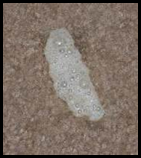 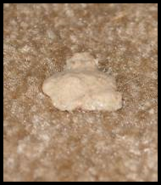 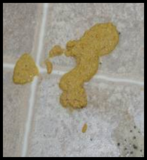Cleary foamy vomit Partly digested baby food Partly digested food

Cat and Kitten Restraint Basics

Please keep in mind that whatever technique you choose to employ, you should use restraining methods as minimally as possible.

The following are methods of restraint employing a towel:

Lateral Recumbency: In kittens, this position is most helpful when taking a temperature, administering sub-q fluids, or administering vaccines.
- In one hand, wrap the cat lightly in a towel.
- Using your opposite hand, grab the cat’s hind legs and place the animal on her side.
- Wrap the cat or kitten snuggly with the towel to control her feet and body. A sock can be used as well for smaller kittens.

Taco Method: This method traps the cat’s legs, but leaves access to the head and rear.
- Drape a towel with the middle of the towel over the cat’s back.
- Sweep sides of the towel together underneath the cat.
- Lay the cat on her side.

Burrito Method: Covers legs and entire body, access is only open to the head.
- Place towel on the table.
- Lay cat about one-third of the way down the length of the towel.
- Take the short end of the towel and wrap it around the cat’s body and legs.
- The long end of the towel should wrap the cat up in the opposite direction with the extra length of the towel covering the cat’s rear.

Snake Hold:
- Place your forefinger and middle finger on top of the cat’s head and your thumb and ring finger under the jaw.
- This hold is a great alternative to scruffing calm cats while allowing you access to scruff the cat if absolutely necessary.
- The snake hold is more advanced and requires practice prior to use on an unknown cat.
REMEMBER: Cats are very agile and are strong and capable of using all four feet and/or their teeth in defense.

Use distractions:
- Pet vigorously on the head or back.
- Tapping or blowing gently on the cat’s head or nose.

Use caution:
- The cat could try to get away
- The cat may swipe at you
- You could get scratched or bitten

FVRCP Vaccine Administration
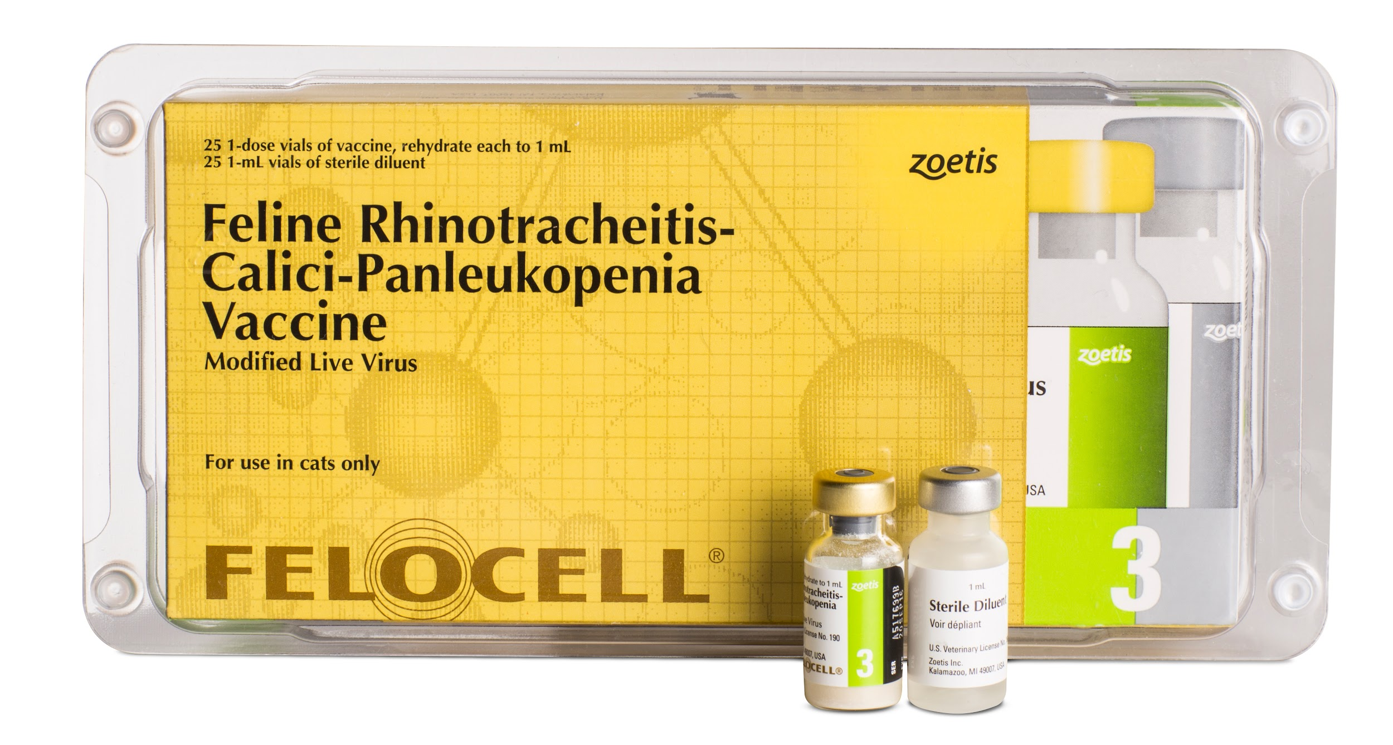

SAFETY

Our vaccines contain modified live virus, which means it can be very dangerous if cats/kittens get any on their fur or in their mouth. You should always have gauze and alcohol ready to go in case there is a spill, which does happen sometimes, to wipe up the vaccine. Do it immediately, don’t let mom or babies clean it off.

Never use the same needle on two different cats, even from the same litter. Needles should be changed between drawing up the vaccine and injection, and a whole new syringe should be used for each cat. Needles become dull very quickly. If you miss-shoot, make sure you only use the needle to poke twice. After that, a new needle will be needed because the needle will dull and start to hurt.

Vaccines must be kept in your refrigerator at 36-44 degrees Fahrenheit. Do not allow them to freeze. Vaccines must be mixed and administered within 15 minutes of removal from the refrigerator. If the vaccines have not been stored as described above, they must be discarded.

FVRCP vaccines should only be postponed if the cat or kitten has a fever (102.5 or greater). Temperatures only need to be taken if the cat is showing signs of illness.

PROCEDURE
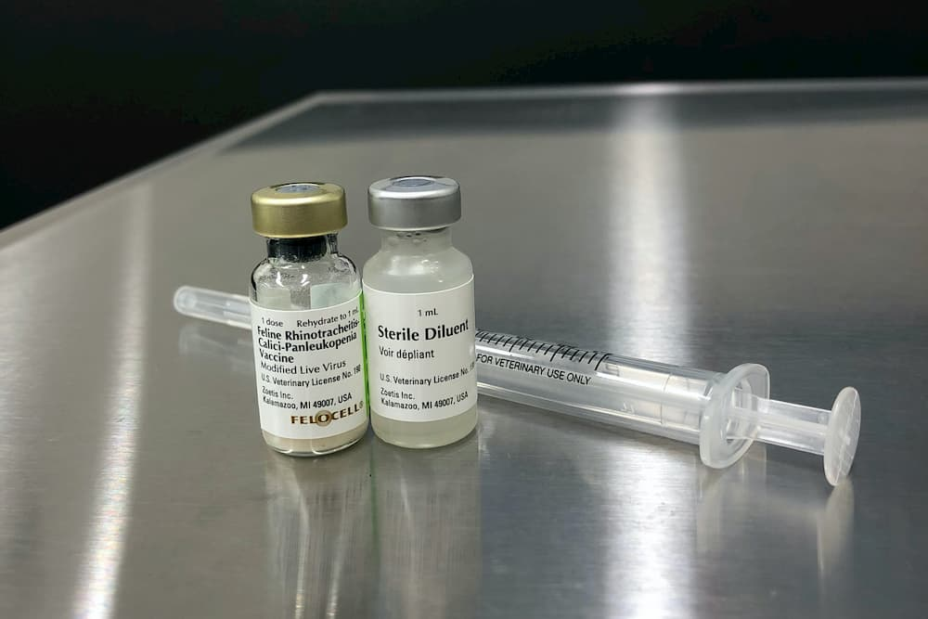
Prepare the vaccine before getting the cat. Cats can be fearful of the sounds of the plastic packaging and can lose patience quickly if they are waiting for you to draw it up.

To prepare the vaccine, remove the 3 ml syringe from the package. Insert the needle into the diluent vial and draw up all the liquid. Insert the needle into the powder vial and depress the plunger. Roll the vial until all the powder is mixed into the liquid. It should appear pink in color. Draw up the vaccine in the syringe. Replace the needle with a fresh 25g needle.

It’s helpful to have two people for administering the vaccine, even after you’ve had a lot of practice. Kittens, especially, are quite squirmy and that can make giving the vaccine difficult. Have your partner hold the cat, usually holding it so the head is pointing toward them. They should offer a yummy treat to distract the cat, like Churu or baby food. They may also “bounce” the kitten, pet the kitten’s head, or tap its nose as a distraction. For kittens that are hard to distract, wrapping them in a large towel or blanket may be helpful.

Vaccines should be injected top-down so that the needle is pointing down into the leg. They should also be administered as far down the leg as possible. If the injection site should have a reaction, which is rare but does happen, this position can save the leg, and the cat’s life, should the leg need to be amputated.

The person giving the vaccine should stand so that the injection site is on the opposite side of the cat from them. FVRCP vaccines are always given in the right front limb. Stand so that the left side of the cat is against you, so you can reach over with both hands.

Pull up a small tent of skin from the cat’s leg and insert the needle into the tent. Pull back on the needle just a bit- if you see air coming into your syringe, then you have poked through the skin. Reposition the needle until you pull back and get negative pressure (no air). Start injecting but make sure you feel and look for liquid coming out. It’s very easy to push all the way through the skin the first time. If that happens, immediately wipe it up with your alcohol and gauze and try again. At least half the shot should be injected. If you don’t think that much has made it in, they will need another shot within 24 hours.

Once you’ve injected, pull the needle right out and re-cover it so you don’t poke yourself. The needle should be taken off and stored to be brought back into the shelter in a secure container for disposal. Please see this video for proper needle handling. Please also see this document on sharps safety at CAT.

Tips for giving vaccines from your fellow mentors!

- Hold off on feeding their meal so they are hungry and the food distractions are effective.
- Play with them beforehand to get them tired out.
- Move them to an unfamiliar room just before giving the vaccine.
- Get fast at it! Practice on a banana or a stuffed animal if you are new.
- Scarf wrap with a good blanket or towel, needs to be strong enough that they can’t wiggle out!
- If they still squirm when wrapped up, try other distractions instead. Sometimes the wrapping itself is stressful.
- Have your holder pet their entire head/face while keeping control of it. You can even tap gently on their nose!
- For fearful cats, cover fully with a blanket or towel and just pull out the front limb. You can do this right from their hidey bed or box. Have the person holding keep control of their head. Try to make sure they can’t back away.
- Scruff as a last resort. This is very stressful for cats.

Subcutaneous Fluids (Sub-Q Fluids)

If the cat/kitten has a fever, use room-temperature Lactated Ringers Solution (LRS). Otherwise warm LRS by putting it in a warm water bath for five minutes. Shake the syringe or bag well and check the temperature by putting a few drops on the inside of your wrist, as you do for a baby’s bottle. It should feel warm but not hot.

Have some yummy food ready to distract them. Wet food, baby food, or Churu are good options. You can also have someone hold them, pet their face/head or bounce them up and down as a distraction. If they are really squirmy, try wrapping them in a towel with only the head and back of the neck exposed.

Prepare your supplies ahead of time. Remove the wrapping from the fluid bag and prepare your syringe or line so you are ready to go. Try to do this away from the cat to reduce noise and stress.

You should always use a fresh needle when administering fluids. Syringes can be reused on the same kitten for the duration of their illness but should be discarded afterward. Fluid bags should be discarded 10 days after opening.

SUPPLIES NEEDED

FOR KITTENS:

1) Sterile scalp vein set or “butterfly” set
2) Large sterile syringe. 20-60 mL
3) Sterile 18-gauge needle
4) Small bag (250ml) of Lactated Ringers (LRS)

FOR ADULT CATS:

1) Large bag (1000ml) of Lactated Ringers (LRS)
2) Sterile 18-gauge needle
3) Fluid line

AMOUNT TO ADMINISTER

10 ml per pound of body weight, rounded down.

0.5 - 0.99 lb (225g - 449g) = 5 ml
1.0 - 1.49 lb (450g - 679g) = 10 ml
1.5 - 1.99 lb (680g - 906g) = 15 ml
2.0 - 2.49 lb (907g - 1132g) = 20 ml
2.5 - 2.99 lb (1133g - 1359g) = 25 ml
3.0 - 3.49 lb = 30 ml
3.5 - 3.99 lb = 35 ml
4.0 - 4.49 lb = 40 ml
4.5 - 4.99 lb = 45 ml
5.0 - 5.49 lb = 50 ml
5.5 - 5.99 lb = 55 ml
6.0 - 6.49 lb = 60 ml
6.5 - 6.99 lb = 65 ml
7.0 - 7.49 lb = 70 ml
7.5 - 7.99 lb = 75 ml
8.0 - 8.49 lb = 80 ml
8.5 - 8.99 lb = 85 ml
9.0 - 9.49 lb = 90 ml
9.5 - 9.99 lb = 95 ml
10.0 + lb = 100 ml

If the cat has been identified as having a heart murmur or heart condition, only give half the amount of fluids listed once (not multiple days) and contact the foster department. The hospital will need to approve further doses in these cases.

ADMINISTRATION OF SUB-Q FLUIDS FOR A KITTEN

- Remove the plastic packaging from the LRS bag. Pop off the cap from one of the ports at the bottom of the bag.
- Place an 18-gauge needle on the syringe.
- Insert the needle into the bag via the port and draw up the desired amount of LRS into the syringe. Warm fluids now, if needed.
- Remove the needle from the syringe and put the scalp vein or butterfly set on the syringe. Depress the syringe slightly to remove air from the line.
- Make a tent on the kitten’s scruff, remove the cap from the needle and insert the needle into the scruff tent, parallel to the spine. Depress the syringe. Watch for leakage indicating the needle has gone in one side and out the other. If this occurs, pull the needle back a little bit and continue.
- When finished, pinch the injection site for a couple of minutes to help the hole close and reduce leakage. Some LRS will still leak out and that is okay.

ADMINISTRATION OF SUB-Q FLUIDS FOR AN ADULT CAT:

- Remove the plastic packaging from the LRS bag. Pop off the cap from one of the ports at the bottom of the bag.
- Remove the plastic packaging from the fluid line. Remove the cap and insert the spike into the uncapped port on the LRS bag. Allow the fluid to flow until the air is out of the line.
- Warm the LRS bag before starting if needed by placing it in a warm water bath. Hang the LRS bag at least 2-3 ft above the cat.
- Put a new sterile 18-gauge needle on the end of the fluid line.
- Make a tent in the kitty’s scruff, remove the needle cap and insert the needle into the tent, parallel to the spine.
- Open the fluid line by unrolling or unhooking the pinch points. Note how much LRS is in the bag when you start so that you’ll know when you’re done!
- Look at the “well” in the fluid line to see how fast it is flowing: if it is not dripping continuously, check that the bag is hung high enough, or try moving the needle under the skin to improve flow. Be careful not to pull the needle out.
- When the desired amount of LRS is in the cat, close the fluid line by rerolling or rehooking the pinch points.
- Remove the needle from the cat's scruff and pinch injection site to reduce leakage.
- Remove the used needle and replace it with a clean needle. Leave packaging on the clean needle to show it is clean for the next use. Dispose of used needle in sharps container or glass jar.

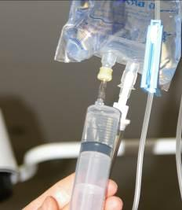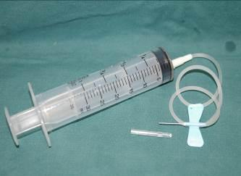
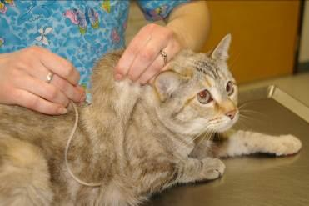

Rescue Disinfectant

Foster parents are allowed to purchase their own Rescue disinfectant. We use a 1:16 dilution (1 part rescue concentrate to 16 parts water) for all cat housing as it kills all the viruses, bacteria and fungi that we see at our shelter. The contact time is 5 minutes (meaning the surface needs to stay wet with disinfectant for a full 5 minutes to work). It is still important to fully clean all surfaces with soapy water and remove all organic material prior to disinfection. Rescue can be bought in ready made bottles or as a concentrate. If purchasing the concentrate, refer to the Rescue website for full information on how to do the 1:16 dilution properly. The shelter can also provide you with Rescue for cleaning.

Emergency Contacts

EMERGENCY PHONE CALL CONTACTS

Please call the On-Call Lead Mentor first. If you cannot reach them please call the On-Call Manager. The On-Call lead mentor for the week will be emailed out on Thursdays, and can also be found on the shared Google Calendar. The On-Call Manager schedule will be emailed out once a month.

ON-CALL LEAD MENTORS

Jac Jennen 218-731-3495
Renee Stachura 503-956-6385
Carrie Goolsby 503-712-8218
Anna Anderson 503-484-6846
Liv Brockway 503-505-0322

Please remember that these phone numbers are for true emergencies only.

ON-CALL DOCTORS/MANAGERS

Dr. Alexa Bell 503-858-2767
Brittany Perkins 530-545-2466
Dr. Dianne Brown 503-739-0564
Karen Green 503-313-3981
Kristi Brooks 503-734-6663
Nancy Puro 503-320-0729
Shelter Manager - TBD
Comm Director -TBD

If you can’t get a hold of the On-Call Lead Mentor, please try the On-Call Manager. If you cannot reach the On-Call Manager after 15 minutes, please try again. Wait 15 minutes before calling the next contact.

After the second call when you do not reach someone, leave them a message stating that you are now going to call the next person (leave the name). If you do not hear back from the second person in 15 minutes, leave them a second message that you have called the first person, the second person (them), and now you are calling the third person. Hopefully, this will never happen, but just in case it does everyone will know what is going on.

MENTORS

See Kitten Foster Manual for mentor contact list.

Hospital Line for urgent issues on weekday mornings (7:30am-11am) - 503-925-8903 x237
You can email your fellow mentors and mentor assistants for non-urgent advice, to request vacation coverage, or to request help from a mentor assistant using the google group email address: catfostermentors@googlegroups.com.

MENTOR ASSISTANTS

Mentor Assistants are trained to give FVRCP vaccines and SQ fluids. You can contact them to assist you as needed. You will need to provide them direction on what needs to be done and they should provide you with information about what they observe. They are like your hands, eyes and ears when you can’t physically be there!

Name | Phone | Email | Area of town | In home vs Travel | Safety Requests
Bruce Blaser (he/him) | 503-641-6913 | bbsmooth@gmail.com | NW Portland/ Beaverton/Hillsboro | Both | None
Dana Wade | 971-212-8078 | Dangil1@msn.com | Downtown Portland, NW Portland (Bethany) | Both | None
Emily Biskey | 503-380-9113 | biskeyem@gmail.com | Tualatin, Sherwood, Tigard, Wilsonville | Travel | Vaccines
Heather Case (she/her) | 503-866-0726 | hcase1012@gmail.com | Tigard, Tualatin, SW Portland, Beaverton, Lake Oswego | Travel | Masks, Distancing
Hita Bhagat (she/her) | 408-693-7027 | hita.bhagat@yahoo.com | NW/SW Portland, Bridgeport Village | Travel | None
Jennifer Adams (she/her) | 503-706-4041 | Jennifer.adams.atc@gmail.com | Tualatin, Sherwood, Tigard, Lake Oswego, Wilsonville | Both | None
Juanita Jimenez (she/her) | 503-840-2098 | jjimenez0202@yahoo.com | Tualatin/Tigard/Lake Oswego | Both | None
Laura Joyce (she/her) | 503-810-6011 | fwjoyce1@gmail.com | SW Portland | Both | None
Megan Alpine (she/her) | 208-830-4099 | Megan.alpine@gmail.com | N Portland, NE Portland | Both | None
Nicole Greene (she/her) | 847-840-7812 | ngreene83@gmail.com | SE Portland (flex to nearby) | Both | Masks
Susan Calllihan (she/her) | 818-648-5356 | callihanfostermom@gmail.com | Tigard, Sherwood, Tualatin | Both | None

Mentee List

Foster Parent | Phone Numbers | Email Address | Address

