You love kittens as much as we do, and they need our help right now. Together, we can save their lives.

<<Date>>
Dear <<first name>>,
Eva needed the kindness of strangers before her eyes were even open.
Only a few days old, Eva and her littermates were meowing loudly beneath a porch. Despite their cries, their mother was nowhere to be found. Without help, their chance of survival was slim to none.
Many shelters struggle to provide for such young kittens. The high costs, extra time, and intense efforts are too big a strain on already limited resources.
If YOUR ORGANIZATION had not had an available foster home with access to the necessary supplies and support, Eva and her siblings might not have survived.
That’s why I’m asking for your donation today.
When you give generously to YOUR ORGANIZATION now, you provide the resources and care that the most vulnerable young kittens need to stay alive. Your support saves kittens’ lives.
Because of people like you, YOUR ORGANIZATION’s foster program has flourished. We take in and care for close to 1,000 kittens a year. And they’re coming to us right now.
As I write this, YOUR ORGANIZATION staff and volunteers are busily caring for 130 kittens who came into our shelter from organizations or people who couldn’t keep them. More requests to take in needy kittens are coming in daily.
You have a big heart for cats and kittens. Our kitten foster program wouldn’t exist without generous cat people like you who care deeply about saving lives. With your continued support, I know we can save even more!
YOUR ORGANIZATION is poised to expand our kitten foster program to take in more of the youngest and most vulnerable kittens. But saving these lives isn’t easy, and it isn’t cheap.
Preparing hundreds of kittens for foster homes and training and supporting foster volunteers takes extra staff time and lots of supplies. Newborn kittens, like Eva, need specialized assistance such as bottle-feeding every two hours, help using the litter box, and many hours of loving devotion.
Kittens also need costly veterinary care to ensure their healthy growth and development.
Yes, caring for kittens is a lot of work. But it’s worth it.
After weeks of bottle-feedings, veterinary visits, and cuddle sessions, Eva and her siblings grew into adorable, healthy fuzz balls. Today they are in loving, permanent homes. They are alive and happy because of you.
You can save even more lives. Kittens are coming in every day, and they need your help!
Donate to YOUR ORGANIZATION today to stock our hospital shelves and ensure that kittens get the loving care they need.
Thank you from Eva, her littermates, and all of us at YOUR ORGANIZATION!
Warmly,

YOUR ORGANIZATION’s Executive Director

P.S. Your donation helps kittens right now.
Give online at: YOUR ORGANIZATION’s website URL

ENVELOPE TEXT: For the love of kittens, open immediately!
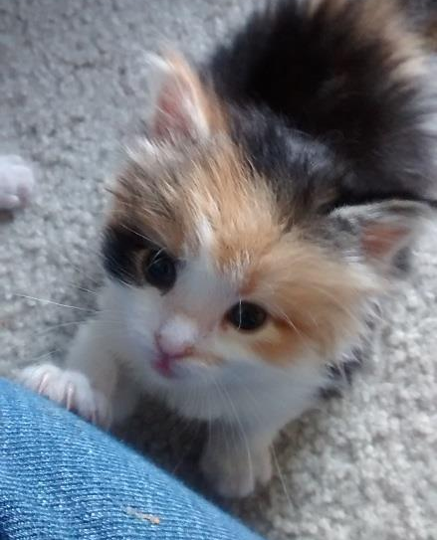
(envelope image)
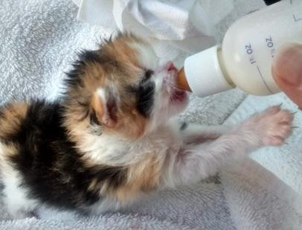
FRONT SIDEBAR IMAGES & TEXT:
Eva needed round-the-clock care. She survived because of you.
BACK SIDEBAR IMAGE & TEXT:
Helping Eva wasn’t easy,
but it was worth it.
You can save the lives
of more kittens in need.
Give today.

