Social Media Tips from 32 Leading Nonprofits
Nonprofits often have too tight a budget and too many other priorities to build a social media team or even craft a social media strategy. However, studies have shown that having a strong social media presence can substantially further your cause as a nonprofit.
In order to help nonprofits build a more effective social media strategy, we reached out to 33 organizations around the world that were characterized by having a strong social media presence and asked them to give us their top social media tip for fellow nonprofits. We organized them according to the category they fall under, in order of frequency. Here’s what your fellow nonprofits said:
1. Be consistent and post regularly
“My tip to fellow nonprofits would be that they should always keep in touch with their fans/followers. Never leave a comment hanging on its own, always respond. Further to this, I would recommend that they keep their posts to the look and feel of their nonprofit. If it is a professional nonprofit, remain professional. If it’s supposed to be funky, keep it funky and leave the professional bit out. Always make it more human, we are dealing with human and must appeal to their softer, gentler side.” – Ashley Nel, Sweet Hearts Foundation
“The best tip we can give, and what we’re trying to stick to in our social media revamp, is to maintain activity! Whether it’s liking, commenting, or sharing other pages, or curating original content, we attempt to post at least once a day to keep up engagement with our followers.” – Mahboba’s Promise
“Our top social media tip would be consistency! Often nonprofits only post when they have an event coming up or when they need to raise funds. You need to build a relationship all year long to truly create awareness. ” –ICUbaby.org
“The social media tip that we live by most is to consistently post content relevant to your mission. We recommend posting at least 2 times a day, 3 if you have time.” – TT Charities
“Regular and consistent posts that ‘speak’ to your followers.” – Small Change

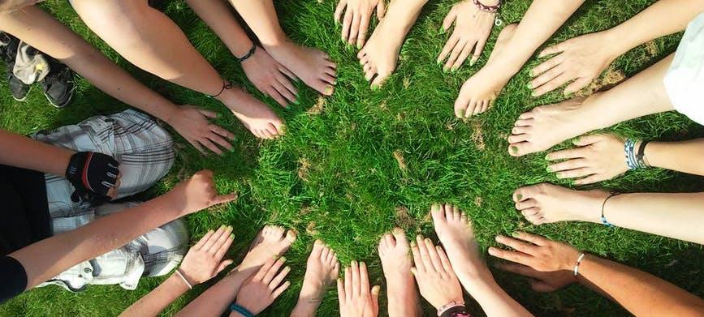
2. Engage with organizations similar to yours:
“My top tip would be to engage within your industry. Network with other accounts similar to yours.” – Communities Int’l
“My tip is to be interpersonal with accounts by commenting on relevant user’s posts.” Franklin County Animal Rescue
“Engage as much as possible. Identify your target market and go speak to them. Go onto their profile and genuinely like a few of their images and even comment. It builds your community, a loyal following and your brand awareness.” – Peal Meets Crystal
3. Pay attention to your message (start a conversation!):
“I would say my top social media tip would be to really know your arrangement of words as far the tone and if your wording is too formal, not formal enough, not edgy enough … Perhaps your point can be made with a softer choice of colloquialisms. Just really pay attention to the words even individual words can make all the difference between something being received well or indifferent. And to have a conversation, try not to talk at folks.” – THE LIFE SOCIETY
“Be meticulous about your communication to the world. Both with your personal & business accounts.” – Hope Across America
4. Posts serve a purpose:
“Our top social media tip is to make sure your social media posts serve a purpose. Don’t post photos to get likes but rather to share a message, or spread love or awareness on something close to your organization’s heart!” – Trusting the Process FL
“I would recommend that they keep their posts to the look and feel of their nonprofit. If it is a professional nonprofit, remain professional. If it’s supposed to be funky, keep it funky and leave the professional bit out. Always make it more human, we are dealing with humans and must appeal to their softer, gentler side.“ – Ashley Nel, Sweet Hearts Foundation
5. Make your supporters feel valued and appreciated:
“You’ve made your ask over and over. Now what? In the nonprofit world, communications can be very self-centered — It’s all about “me” and “I”. Make your supporters feel valued and appreciated by saying “thank you” regularly. It seems that one phrase your parents taught you as a kid really does make a difference! Try thanking your donors and volunteers as a whole, or individually, from time to time on social media...” – Jonathan Koshy, Catholic Charities
“Post regularly and give value to your followers.” – Bula Batiki Coconut Oil
6. Share stories:
“Hi, thanks for getting in touch. We are a non profit company focused mostly on Women empowerment, and hence we use social media prominently to share their stories. We try to share the process behind making any commodity which adds an emotional and human value to it.” – Swavlambi
“Always show the love and happiness you and your donors bring. This makes people want to get involved and do the same.” – HGiving
7. Seek out your target community:
“So far, I think the biggest tip I can give is to really find, and connect with your niche. There are literally millions of social media accounts and whatever your area of interest is, there is likely to be a relatively large group of people with similar interests/missions. So seek them out, connect and engage with them, and help grow the community.” – Blame It On The Sugar Tees
“We try to gather 2 niches, volunteers/adventurers and the general public enclosed in 16 – 60 years old and we develop consistent posting in our social media every day to make it grow in these communities.” – Medical Impact
8. Quality over quantity:
“Quality over quantity.” – Becky Mendoza, Changing Tides Foundation
“Our top social media tip is to concentrate on quality over quantity.” – Trevor Williams Kids Foundation
9. Provide quality visual content:
“Our tip with social media would be that it’s very important to provide quality visual content- a little photo editing, even just on the Instagram app itself (e.g. increasing the brightness and warmth) can go a long way.” – Small Art School
“Our tip for social media would be to take simple but good quality pictures and post often.Phone’s are great, they usually have good enough cameras, and the personal touch of taking pictures as you “find” them during the day is a great way for the audience to connect with the [the organization].” – Etz
10. Post positive content:
“We would say posting positive content that is empowering and uplifting to the people you are working with.” – Abide Family Center Uganda
“To get to the point: our social media tip would be to stop the pity party when it comes to photos. Show the empowering aspect of your work, instead of focusing on the sad situation that your target group might be in. Not because it doesn’t matter, but because they are human beings as well and they deserve to keep their dignity.” [Ann] Backup Uganda

Investing in a social media team can seem like it isn’t a worthwhile use of your time or budget. But as these and other nonprofits have found, the return on investment is much greater than you would anticipate. Hopefully these tips will give you a good place to start.

