WE’RE HERE TO HELP!
Mentors: You will never feel like you are doing it alone. Every foster volunteer is assigned a mentor. Each mentor has been a foster volunteer for at least one year and will be able to guide you through the fostering process. Your mentor will also be there to contact the medical team in the event of
an emergency.
Vaccine Clinics: Our cats and kittens are vaccinated for their health and well-being before they return to the shelter. We offer clinics to instruct our foster volunteers how to safely administer shots when needed. This is not mandatory to fostering. Your mentor can meet with you to administer the shots at a convenient time.
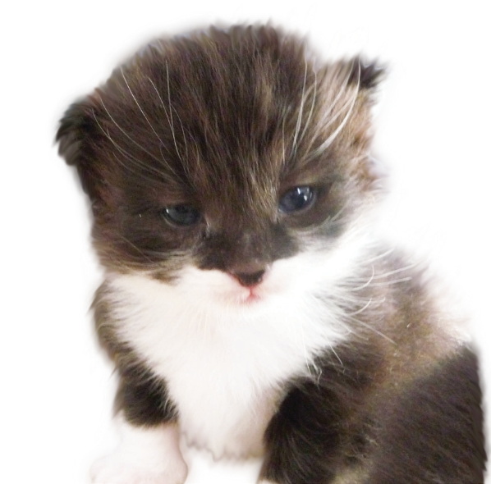
Adopt-a-thons: To help you find homes for your fosterlings, you can take them to an offsite adoption center on the weekends. We also use www.petfinder.com to display their pictures and biographies. This helps the kittens find their forever home and alleviates extra time spent at the shelter.

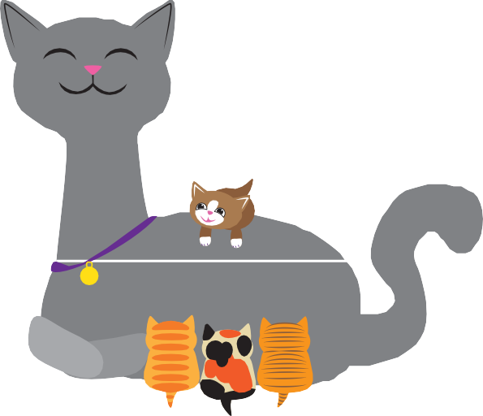

Do you want to play with kittens all day?
YOUR LOGO HERE

YOUR ORGANIZATION NAME
Foster Care Program
Phone number

Email address

Website address

GET INVOLVED

Fostering takes up a small space in your house but a huge space in your heart! It can be as easy as converting your spare bathroom or an extra bathroom into an instant kitten nursery.
It’s an ideal way to teach your children about the miracle of birth or a lesson in compassion while comforting a sick kitten.
We send every litter home with a baby bag full of the supplies you may need while giving your foster kittens a loving start to a long life.
Our volunteer foster families are so important to us, and we are always looking for more loving homes. We can’t wait to have you join us!

FOSTER WITH US
The guiding mission of the Foster Care Program is to give kittens and cats individualized care and socialization to prepare them for adoption. Information gathered during the foster process helps us place them in homes with families who can best meet their needs.

Foster at Your Home

What you need to do:
- Submit a completed volunteer application
- Have a safe, indoor place in your home for fostering pets
- Be able to travel to /from our Sherwood shelter
- Attended required trainings

Fostering requirements:
- Separate room for fosters
- Kept indoors only
- Maintain medical treatment records
- Socialize and play with fosters

VOLUNTEER WITH US
You can learn more about our volunteer opportunities at: URL.. If you’re interested in fostering, a member of the foster program team will contact you. Every foster volunteer attends the shelter orientation and foster trainings.
We provide you with the tools and information to be successful. The kittens provide the joyful fun. You provide the love and caring.

ABOUT US
Your mission statement or other
“about us” text goes here.
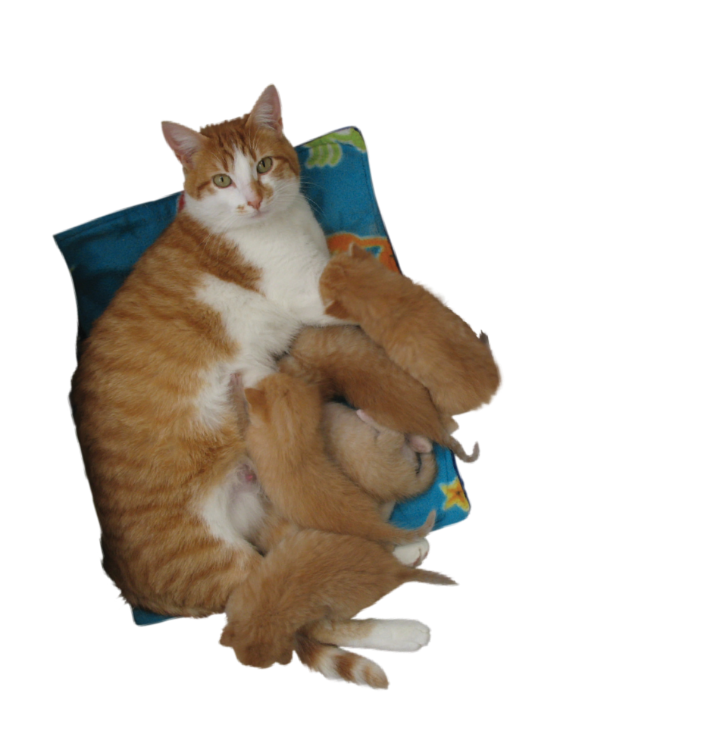

Phone number │ email address
url for foster/volunteer program

