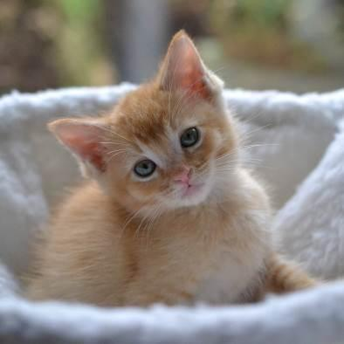

Your Organization’s
Logo & Contact Information
Your Organization’s

Foster Mentor Manual

Welcome, Mentors! 4
Position Description: Volunteer Foster Mentor 5
Position Description: Volunteer Foster On-Call Lead Mentor 6
Competencies of a Mentor 6
How Often Should You Contact Your Foster Parents? 9
Mother Cat Health Check 10
Illness in Mother Cats 11
Limited Milk 11
Reading Body Language 12
Maternity Foster Home Guidelines 13
Kitten Health Check 13
Early Handling 13
Teething Kittens 14
Drooling 14
Sense of Smell 14
Ears and Hearing 15
Eye Color and Sight Development 15
Feet and Paws 15
Tooth Development 15
Mortality Rate of Kittens in Foster Care 16
Reading Body Language 17
Determining the Sex of a Kitten 17
General Weight Guidelines 18
Heating Devices 19
Syringe Feeding 19
Orphaned Kittens 21
Housing 21
Potty Training 22
Appropriate Play 23
Crying at Night 24
Food 24
Baby Food 25
Weight Guidelines 25
Bottle Feeding 25
Tube Feeding 25
Vaccination Chart 28
Kittens and Vaccinations 29
Vaccines, Deworming, and Flea Treatment Protocol 29
When a Foster Parent Calls 30
When Is It an Emergency? 37
If you need to send a foster parent to the Emergency Clinic, be ready! 38
Quick Treatment Reference 38
Dosing 39
Medication Dosing Guide 39
Giving Medication 40
Medications and Commonly Used Remedies 40
Medical Conditions 45
Cat and Kitten Restraint Basics 60
FVRCP Vaccine Administration 61
Safety 61
Procedure 62
Subcutaneous Fluids (Sub-Q Fluids) 64
Emergency Contacts 66

Welcome, Mentors!

Welcome to Your Organization's mentor team! Your Organization's mentor program's purpose is to support our foster parents. Our volunteer mentors are talented people with a great variety of skills and knowledge - sometimes, finding a way to get a kitten to eat something can require a little creativity. Simply put, mentors provide the invaluable service of helping foster families with questions and supportive care when the shelter is closed. Thank you for joining the team, and we look forward to working with you!

The following guide for becoming a mentor was compiled from the knowledge and wisdom of experienced staff and fellow mentors within the foster program at Your Organization.

You are the extension of our hospital and the foster program and must follow all directions and guidelines given. This includes helping new foster parents understand the policies and why we have them.

As a mentor, your responsibilities will include the following:

- Calling your foster family shortly after they take their cat/kittens home to introduce yourself and let them know you are available to help with questions or concerns.
- Familiarizing yourself with the foster care program, including maternity foster home guidelines. Read and reread them! Many answers to questions are already there but can be forgotten in the excitement of new cats and kittens.
- Acquiring information about kittens born in foster care as soon as possible. The information on color, sex, and litter size needs to be reported so the database records can be created. People love to talk about their birth experiences. Often, a foster parent just wants reassurance that everything is normal. Allow them to do most of the talking and only relate experiences that would be helpful or pertinent to the situation. Always be supportive; remember how it felt with your first litter!
- Answering questions to the best of your ability regarding the cats/kittens in their care.
- Referring your foster families to other sources if you don’t know the answers to their questions.
- Checking in with your active foster families every couple of weeks if you have not heard from them to see whether they need any help or support.
- Vaccinating kittens on time and helping foster parents with deworming.

Position Description: Volunteer Foster Mentor
Title: Foster Mentor

Reports to: Foster Coordinator

Purpose of Position: Provide support to foster families and act as a liaison between foster parents and the shelter/hospital.

Duties and Responsibilities:
- Ensure foster rooms are set up properly and in accordance with program guidelines. Be able to offer suggestions for improving the foster room setup.
- Ensure that foster cats/kittens are vaccinated, dewormed, and medicated on time and that all are posted to the Google Form so the shelter can maintain up-to-date records.
- Encouraging foster families to submit pictures and bios of their kittens to the Petfinder team when they are ready for pre-adoption/adoption.
- Be a resource for questions regarding behavior issues that may arise for foster families.
- Field calls and emails from foster parents regarding the foster cats/kittens.
- Counsel foster families through difficult situations involving foster cats/kittens. Preparing fosters for the possibility of a foster cat/kitten's death and helping them cope with the loss if it occurs.

Qualifications: One to two years of experience as a foster parent for cats/kittens with Your Organization or a similar organization. Demonstrated knowledge of Your Organization's foster program protocols. Willingness to travel to foster parents’ homes to give routine vaccinations and check on sick kittens if needed.
Training Requirements: Foster training and shadowing of a current mentor and/or attend mentor training. Adoption counselor training is not required but is a bonus.
Time Commitment: About 2-5 hours per week—varies depending on the time of year and how many foster families you assist.
Benefits to Volunteer: See cats/kittens find loving homes. Work with foster families and Your Organization's staff. Opportunities to attend workshops on cat-related topics as offered by Your Organization and advanced volunteer opportunity with room for growth.

Position Description: Volunteer Foster On-Call Lead Mentor
Title: On-Call Lead Mentor

Reports to: Foster Coordinator

Purpose of Position: Be a liaison between Your Organization's hospital, foster parents/mentors, and the Foster Coordinator.

Duties and Responsibilities:
- Be on-call as a backup to Foster Mentors for medical emergencies and approve hospital visits via the veterinarian or other on-call manager.
- Counsel foster families through difficult situations involving foster cats/kittens. Prepare foster parents for the possibility of a cat/kitten's death and help them cope if they encounter a loss.

Qualifications:
- Minimum of one year of experience as a Foster Mentor or staff person in a related area.
- Demonstrated extensive knowledge of Your Organization's foster program protocols.
- Willingness and availability to be on-call 24/7 during assigned on-call periods (usually one week at a time).

Training Requirements: Foster training and shadowing of a current on-call lead mentor.
Time Commitment: About 1-3 hours per week—varies depending on the time of year.
Benefits to Volunteer: See cats/kittens find forever homes. Work with foster families and mentors and Your Organization's staff. Opportunities to attend workshops on cat-related topics as offered by Your Organization. Know that you are making a difference. An advanced volunteer opportunity.

Competencies of a Mentor
What attributes should a mentor have?

Approachability
- Easy to approach and talk to
- Spends the time and makes the extra effort to put others at ease
- Warm, pleasant, and gracious
- Sensitive and patient
- Builds rapport
- Good listener

Why is approachability important? All mentors are volunteers, and we recognize that you have many responsibilities beyond taking calls from foster parents. But, if your foster parent does not feel like they can call because they might interrupt you, things can worsen for the kitten. It is essential that you set clear boundaries with your foster parents. For example, establishing when they should call you and when they should email. Keeping open communication by email for non-emergency needs allows communication as it fits your schedule.

Compassion
- Genuinely cares about people and kittens
- Concerned about fostering and non-fostering problems and if it impacts fostering
- Available and ready to help
- Sympathetic when dealing with the death of an animal
- Demonstrates genuine empathy with the joys and pains of others

Compassion is the second part of approachability. In your experiences as a foster parent, your mentor, in all likelihood, displayed great compassion as you talked over some situations. When you had those tough litters, your mentor supported you through those tough times. Foster parents feel like their foster cats/kittens are an extension of their families and may find it hard to send them back to Your Organization. This tends to happen more with new foster parents, and they may look to you for support and guidance.

Composure
- Cool under pressure
- Does not become defensive or irritated when times are tough
- Mature
- Can be counted on to hold things together during stressful times
- Handles stress well
- Not knocked off balance by the unexpected
- Does not show frustration when issues seem to be ongoing

Composure can play a significant role in being a mentor. At times, situations can be very stressful; for example, when you get a phone call about a kitten found unconscious on the floor, is now lethargic, and appears to be on the brink of death. You are the one who helps foster parents through these challenging times. You are going to need to be able to get information from a stressed and panicked foster parent. Remaining calm as the medical staff tries different treatments for a sick cat/kitten helps maintain a less stressful atmosphere. How you respond to these situations can greatly impact your foster parents. It is okay to shed a tear and show empathy, but it’s most helpful to remain calm and not escalate anxiety at that moment.

Directing Others
- Good at establishing clear directions
- Sets fostering objectives (fostering within a household’s limits)
- Describes how to identify a sick cat/kitten
- Lays out work in a well-planned and organized manner
- Maintains two-way dialogue with foster parents
- Brings out the best in people
- Clear communicator

Mentors need to be able to communicate clearly when instructing foster parents. For example, if a foster cat/kitten is sneezing but not showing signs of a URI, the manner in which a mentor tells a foster parent what symptoms to be on the lookout for needs to be clear and give them specific symptoms and behaviors to look for. It is also essential to let foster parents know what to do if other symptoms develop. Simply saying, “wait three days and let me know how it’s going,” is very frustrating to a foster parent who wants to provide the best care possible for the kittens and may not have encountered kitten illness before. Clear direction keeps the guesswork out of the hands of the foster parent and makes foster parents feel supported.

Setting realistic fostering expectations with foster parents can be challenging, as they want to save the world! Some foster parents are best with small groups, and then after time, can work up to more challenging groups.

Listening
- Practices attentive and active listening
- Patient when hearing people out
- Accurately restate the opinion of a foster parent even when they disagree
- Listen for what is not addressed and ask questions to find answers

As a mentor, you will be contacted about a wide range of questions. Each of these competencies will play a part in your ability to help your foster parents. Besides giving clear instructions, listening is another challenge. What did the foster parent mean by “gooey eyes”? Is the kitten just cuddly? As you listen, you need to confirm with the foster parent what you are hearing. You are the eyes and ears for the Veterinarian if you need to contact them about a particular situation.

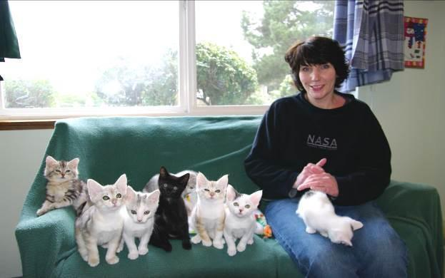
Photo by Debbie Brusius

How Often Should You Contact Your Foster Parents?

You should contact your foster parent as soon as they take a cat or kitten home. If you have not been to their home, we ask that you make an appointment to meet with them to put a face with a name and to help kitten-proof their foster room. This meeting is meant to be fun, not an opportunity to be critical of the foster family. If you have serious concerns about a foster family, please get in touch with the Foster Coordinator. You should continue to check in with your foster parents every one to two weeks.

You may consider sending new foster families our Foster Check-in Questionnaire weekly. You can copy the questions and send them in the body of an email. This will help ensure they know what to look for and when to come to you with concerns. Once you know your foster family well, you likely won’t need to send this anymore.

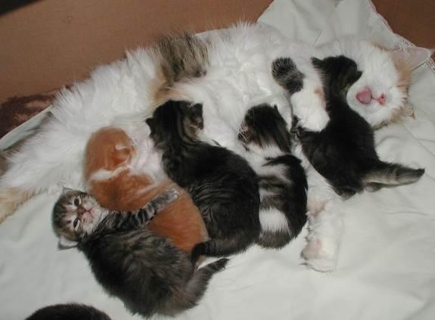

Mother Cat Health Check

Why check your mother cat as soon as you get her? This will allow foster parents to establish what is “normal” or notice something the shelter might have overlooked.

- Ears should be clean with no discharge. Dark-looking wax and constant scratching could indicate ear mites.

- Eyes should be clear, bright, and free from discharge. The third eyelid should not be showing.

- Nose should be cool and damp to the touch. There should be no nasal discharge or crusting around the nose.

- Mouth and gums should be pink and odorless. The gums should not be tacky, as if you were touching the tacky portion of a post-it note. Tackiness could indicate dehydration. An older mother cat could have tartar on her teeth or gingivitis (inflammation of the gums). If the mother has a broken tooth, please alert the Foster Coordinator.

- Fur should be clean and shiny. Make sure there are no missing patches that could be a sign of ringworm. Black dandruff is flea debris for which all kittens/cats are treated before going into foster care. White spots at the top of the fur could mean lice. Feline lice are not contagious to people or animals besides cats, but it still needs to be treated. White spots or flakes not at the top of the fur are often dandruff and are easily brushed away.

- Rear ends should be clean.

- Body should be in good shape, but often moms are thin and bony, aside from their bellies. She will need extra food to get her weight up.

- Nipples should be clean and usually erect. There should not be any blood coming from them. The breast tissue should not feel hard or as if there are large lumps within it, nor should it feel hot to the touch—these could be signs of mastitis. The nipples should not
be red.

Illness in Mother Cats

If the mother cat is ill or malnourished when she rears her litter, her illness leaves a lasting physical and psychological deficit on all of her kittens. Sick kittens are more common in the latter half of the kitten season. This is thought to be because the mother cats are in their second or third litter at this point, and their bodies are worn down.

An ill mother cat will most likely be less attentive to her kittens and less able to do her maternal duties, specifically teaching social skills. The early social skills that a mother teaches her kittens are essential to preparing them for later in life. If that learning stage is compromised, those kittens will have personalities that reflect this deficit. This can lead to kittens growing into cats with behavioral problems such as being timid, having aggression issues, and/or an antisocial attitude toward other cats.

Limited Milk

If the mother has insufficient milk for her litter, the kittens will end up smaller and weaker than properly nourished kittens. This situation may also result in kittens who lack proper social and physical skills. Kittens who spend an extended amount of time suckling in an attempt to get nourishment from their mother’s supply will have less time to learn how to interact with other cats. Food instability will also create an environment in which the kittens will not be able to relax.

Reading Body Language

Tail
- Erect, like a flagpole = friendly, content, ready to interact
- Hairs on end (piloerection) = heightened anxiety, passively aggressive
- Wrapped somewhat tightly around body = wants to be alone, possibly fearful
- Inverted U = defensive aggression (but in kittens can signal play)
- Curled very tightly around the body = threatened
- Arched over the back with piloerection = defensive aggression (may lower tail if other animal doesn’t back off)
- Arched over the back without piloerection = interested, aroused
- Thumping = conflicted, frustrated, irritated; may attack

Voice
- Chattering = excitement when seeing prey but unable to get to it
- Chirp = expecting something desirable like a treat or meal; mother cats to kittens
- Growl = offensive or defensive low-pitch sound
- Hiss = open-mouthed snakelike sound, usually defensive
- Meow = greeting just for people
- Mew = identify and locate another cat
- Moan = a long, sad sound made just before vomiting, when disoriented (in senior cats), or when wanting to be let inside or outside of a space
- Murmur = soft, closed-mouth sound used as a greeting, can accompany purring
- Purr = contentment, anxiety (a stress-relief mechanism), or self-soothing when ill or injured
- Shriek = harsh, high-pitched sound for pain or highly aggressive meetings
- Snarl = threatening expression with upper lip curled, showing teeth, and can accompany a growl
- Spit = sudden, short popping sound, heard before or after hissing
- Squeal = raspy, high-pitched sound when expecting food; also occurs during play
- Trill = chirp-like sound that is more musical, expressing happiness

NOTE: For convenience, “Reading Body Language” is repeated in the Kittens section.

Maternity Foster Home Guidelines

See the Kitten Foster Manual

Kitten Health Check
Why check your kitten(s) as soon as you get them? This will allow foster parents to establish what is “normal” or notice something the shelter might not have noticed during the initial exam.

- Ears should be clean with no discharge. Dark-looking wax and constant scratching could indicate ear mites.
- Eyes should be clear, bright, and free from discharge. The third eyelid should not be showing.
- Nose should be cool and damp to the touch. There should be no nasal discharge or crusting around the nose.
- Mouth and gums should be pink and odorless. The gums should not be tacky, as if you were touching the tacky portion of a post-it note. Tackiness could indicate dehydration.
- Fur should be clean and shiny. Make sure there are no missing patches that could be a sign of ringworm. Black dandruff is flea debris for which all kittens/cats are treated before going into foster care. White spots at the top of the fur could mean lice. Feline lice are not contagious to people or animals besides cats, but it still needs to be treated. White spots or flakes not at the top of the fur are often dandruff and are easily brushed away.
- Body should be sturdy with a nice belly. Sometimes kittens will come in malnourished; if so, you can often feel their spine, ribs, and hip bones. These kittens will need extra food and attention.
- Rear ends should be clean.

Early Handling
As a mentor, you need to know your foster parents’ strengths. Some foster parents live alone and have quiet homes, while other foster homes can be filled with children, other animals, and lots of sensory stimulants. Introducing these stimulants slowly over a long period of time allows foster parents to raise kittens who are well-socialized and unfazed by things like small children, dogs, and vacuum cleaners. The amount of handling foster kittens receive in foster care will influence their reaction to humans and other stimuli.

Sometimes, your foster parents might have kittens that are unsure about humans. Mothers and kittens who are truly scared have often been moved at least three times before being placed in a stable foster home.

To help these groups, foster parents keep a TV or radio going with people talking while they are out of the house. If music is used, classical music is best—remember, cats’ hearing is more sensitive than ours. Introducing novel items into the room daily can also let the cat/kittens know that new things are okay. Have the foster parents gently stroke the mother cat and kittens during feeding time and speak to them in a soothing voice. Before you pet them during feeding, sit near them as they feed, then sit next to them. Slowly build up their comfort with you until you can pet them as they eat. Confidence starts to show when they roll over to expose their stomachs.

When kittens are done playing, hold them until they settle down. Rubbing your nose or stroking a finger on the side of their face mimics a mother cat licking them, and they sometimes settle down and purr with this activity. Once kittens stop wiggling, let them free by putting them down—the kittens are also training you to know when they’ve had enough. But make sure this relationship has a good give-and-take dynamic. If you set them down immediately whenever they start to fidget, they will never build up a tolerance for being held and will instead learn that if they fidget, you will release them.

If a kitten seems “wild” or “crazy, " that’s perfect! There is nothing wrong with a wild, energetic kitten—this is just a normal kitten. What would be abnormal is if a kitten was just interested in being cuddled most of the time. However, “wild” should not include biting or scratching people.

Teething Kittens
Kittens can start teething at 2-3 weeks old. The incisor teeth poke through first, followed by the canines, and then the pre-molars. You might find that kittens want to chew on things at this age. This is the time to hide power cords and make toys available. They also enjoy biting cardboard boxes during this stage, which is okay.

This period may also be when they start showing an interest in foods. Softening hard food by soaking it in water might help them start eating solid foods.

Drooling
Quite a few cats drool when they have a pleasurable experience. Salivation is essential to feeding because it lubricates the food and aids in swallowing. It can also indicate nausea or pain, so ensure that nothing else is happening with the kitten.

Sense of Smell
A cat or kitten’s ability to smell is directly related to their ability to eat well. If the kitten or mother is fighting a sinus infection or has a congested nasal cavity, they may not want to eat at all. Canned food that gives off a strong odor may help—something with sardines or fish can help if the kitten or mother does not have a sensitive stomach. Another option is to boil a skinless chicken thigh in water with no seasoning. Your fellow mentors can be a wealth of information regarding feeding; be sure to ask them what they have found to work.

Ears and Hearing
Although their eyes open between 7 and 14 days old, kittens cannot hear until they are
two weeks old. A kitten’s hearing doesn’t fully develop until they are about a month old.

Eye Color and Sight Development
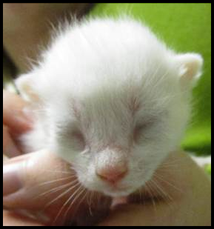
A kitten is born with closed eyes, which will open between 7 and 14 days old. All kittens have blue eyes when they are born. When the kitten reaches 4 to 6 weeks old, their eyes will begin to transform into their adult color.

When a kitten first opens their eyes, they cannot see things. It is about three weeks before their eyes can follow moving objects, and they can orient themselves using visual cues. Vision is still cloudy until they reach about five weeks of age.

Photo by Kristi Brooks

Feet and Paws
Cats typically have five toes on each paw (including the dewclaw). However, variations in toe numbers do exist. Cats with more than five toes on at least one paw, if not more, are called “polydactyl.” The footpads are the only area of a cat’s body that contains sweat glands.

Tooth Development
When a kitten is born, they have no visible teeth. When they are approximately 10 to 14 days old, their deciduous (baby) incisors begin to push through the gums. They should be fully in place at four weeks of age. These six incisors, which appear at the front of the mouth in the upper and lower gums, are designed to tear small bits of meat off bones and extract feathers from prey.

At 3 to 4 weeks of age, the canines at the front corners of their jaw come in. Cats use their canines to sever the prey's spinal cord and administer the killing bite.

At 4 to 6 weeks of age, the molars begin to push through the gums along the cheeks and are fully in place at six weeks old. All 26 teeth are in place by the time the kitten is Two months old.

Mortality Rate of Kittens in Foster Care
You may have heard that in the wild, only 1-2 kittens will survive out of a litter.

There are several reasons, starting with the available food and quality of food available for the mother cat when she is pregnant. Exposure to disease and illness is another factor that will take lives. How much colostrum did they receive, and how much of the Maternally Derived Antibodies did they get? Do they have a birth defect that is internal and undetectable? There are so many things that can go wrong.

In foster care, and with the mentor system, we still can lose kittens. Yet, they have the highest chance of survival in our care. We provide high-quality food and water, temperature-controlled environments, medical care, routine services, and a clean litter box. With all of this extra help, we typically have a very high survival rate.

Reading Body Language
Tail
- Erect, like a flagpole = friendly, content, ready to interact
- Hairs on end (piloerection) = heightened anxiety, passively aggressive
- Wrapped somewhat tightly around body = wants to be alone, possibly fearful
- Inverted U = defensive aggression (but in kittens can signal play)
- Curled very tightly around the body = threatened
- Arched over the back with piloerection = defensive aggression (may lower tail if other cat doesn’t back off)
- Arched over the back without piloerection = interested, aroused
- Thumping = conflicted, frustrated, irritated; may attack
Voice
- Chattering = excitement when seeing prey but unable to get to it
- Chirp = expecting something desirable like a treat or meal; mother cats to kittens
- Growl = offensive or defensive low-pitch sound
- Hiss = open-mouthed snakelike sound, usually defensive
- Meow = greeting just for people
- Mew = identify and locate another cat
- Moan = a long, sad sound made just before vomiting, when disoriented (in senior cats), or when wanted to be let inside or outside of a space
- Murmur = soft, closed-mouth sound used as a greeting, can accompany purring
- Purr = contentment, anxiety (a stress-relief mechanism), or self-soothing when ill or injured
- Shriek = harsh, high-pitched sound for pain or highly aggressive meetings
- Snarl = threatening expression with upper lip curled, showing teeth, and can accompany a growl
- Spit = sudden, short popping sound, heard before or after hissing
- Squeal = raspy, high-pitched sound when expecting food; also occurs during play
- Trill = chirp-like sound that is more musical, expressing happiness

Determining the Sex of a Kitten
It can be challenging to tell the difference between male and female kittens. They are sometimes described as the male looking like a : (colon) and the female looking like an upside-down exclamation mark (¡).

Usually, there is a bigger space between the anus and genital area in a male kitten—the space where the testicles will grow. It may be possible to feel small testicles in male kittens.
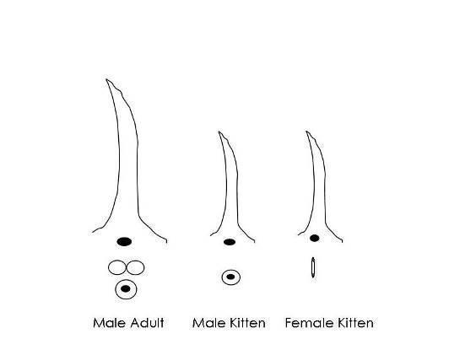

General Weight Guidelines
Ideal weight gain is 113 grams (4oz) per week, 1 pound per month. Remind foster parents to note weight gain on their weight chart. This is an average! Help foster parents understand that not all of their kittens will make this mark, and some will surpass it. We want to make sure kittens are gaining weight and not losing weight. Monitor the kitten’s weight daily (it’s not necessary to weigh the kitten more than once or twice daily). If the kitten is less than three weeks old and has failed to gain weight or has lost weight in 24 hours, then start supplementing with a bottle. If the kitten is three weeks or older and has failed to gain weight or has lost weight in 48 hours, then start supplementing with a bottle or slurry. You should do this after the kitten nurses; you are just “topping off.”

In addition to weight, it is important to monitor body condition. Please use this Body Condition Scoring chart to assess cats and kittens during home visits and vaccination appointments. All cats and kittens should have a BCS of 3.5 or greater.

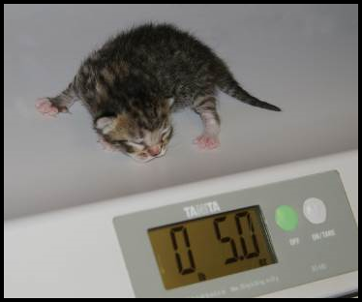
Photo by Debbie Brusius

Heating Devices
Kittens cannot maintain their body temperature until they are at least four weeks old. The average rectal temperature of a newborn kitten ranges between 92°–97° F. Between 2 to 21 days old, a kitten’s temperature will be about 96°–100° F.

To help a kitten maintain the proper body temperature, the foster parent can place them on a covered SnuggleSafe warming disk or a sock warmie. When using a disk warmer, the foster parent should set it up so that the kitten can safely move off of it if s/he overheats.

Syringe Feeding
When you notice that a cat or kitten (4+ weeks) is not eating well or losing weight, try offering different types of food. The shelter has lots of different wet and dry foods you can try. You can also try plain, boiled chicken. Cut the chicken into tiny pieces and give it to the cat or kitten. Save the broth that has been made by freezing it into cubes and then storing it in the freezer in a freezer bag. Each broth cube is about 1 ounce. You can take one cube and melt it over the chicken pieces to keep it moist. If the kitten's tummy is upset, only use chicken breast. If the tummy is okay and there is no diarrhea, use dark meat since it is fattier.

You can also try making “kitten crack” or slurry. We suggest using prescription CN or AD, human baby food (Chicken or Turkey with no onion or garlic added), and KMR powder. Take ¹/₈ to ¼ can of AD, one teaspoon of baby food, and one scoop of KMR (you can use KMR Second Step as well). Mix it all together and add warm water until it is a thick soupy consistency. You can use regular kitten food in place of CN/AD in a pinch.

If you can’t get a cat or kitten (4+ weeks) to eat on their own despite offering different foods, you might need to syringe feed them. Please note that syringe feeding can cause food aversion and should be avoided when possible. Please only syringe feed until a vet can see them and other treatments can be explored. The hospital may decide to place an esophagostomy feeding tube (e-tube), which is much less stressful and unlikely to cause food aversion.

If you need to syringe feed in an urgent situation, use a 3 ml or larger syringe without a needle. The shelter has larger sizes with large tips to make this easier. Get a hand towel to wrap around the kitten. This will be messy, so you may also want to protect your clothing. Wrap the kitten in a towel or blanket (like a burrito) with only the head exposed. Take the syringe and place it behind the canine, open the mouth slightly, and gently squeeze out a little bit of the slurry mixture. The kitten should begin to eat. You do not have to maintain the burrito towel wrap unless the kitten does not hold still for you. Follow the feeding guidelines outlined below, and make sure not to over-feed. If the kitten eats some food on their own, you will want to reduce the amount you syringe feed.

weight (lb) | Recommended syringe feeding of diluted CN (1 can CN mixed with 1/2 cup water)
1 | 14 ml, 6 times daily
1.5 | 18 ml, 5 times daily
2 | 19 ml, 5 times daily
2.5 | 26 ml, 4 times daily
3 | 28 ml, 4 times daily
4 | 41 ml, 3 times daily
5 | 46 ml, 3 times daily
6 | 50 ml, 3 times daily
7 | 55 ml, 3 times daily, or 83 ml, 2 times daily
8 | 60 ml, 3 times daily, or 89 ml, 2 times daily
9 | 63 ml, 3 times daily, or 95 ml, 2 times daily
10 | 68 ml, 3 times daily, or 102 ml, 2 times daily
11 | 73 ml, 3 times daily, or 110 ml, 2 times daily
12 | 78 ml, 3 times daily, or 118 ml, 2 times daily
13 | 82 ml, 3 times daily, or 124 ml, 2 times daily
14 | 87 ml, 3 times daily, or 131 ml, 2 times daily
15 | 91 ml, 3 times daily, or 137 ml, 2 times daily

Orphaned Kittens
Certain difficulties arise with fostering orphans compared to fostering kittens who still have their mother around. Mother cats are able to teach their kittens lessons that enable them to become great cats when they grow up. Among the various lessons mother cats provide their kittens, some of the most important ones include how to take a bath, how to use the litter box correctly, and the limitations of play, to name a few.

As a result, when you foster orphaned kittens, you will need to be prepared to play the role of the mother cat and help your kittens learn the lessons they will need to become highly socialized, trained, and ready for adoption. As a mentor, you will need to instruct the foster parents on how to do this.

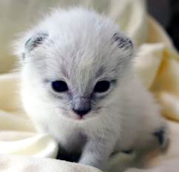
Two weeks Three weeks
Four weeks Six weeks
Photos by Madeleine Barker

Housing
Ensure the room you provide for your orphans is warm enough for the kittens, including the floor. Often bathroom floors can be cold, so ensure they have a warm place to spend time if they feel they are getting too cool. Foster parents can use a bath mat, bath rug, or put out a couple of cat beds. Don’t advise them to use towels since kittens often like to use towels to go potty on—kittens can get their claws stuck in loops of a towel’s material, which gives them the sensation of scratching in a box and will often stimulate them to go potty.

If foster parents don’t have or know how to create a good place for the kittens to sleep, offer to help create a nesting box. You can make one out of a large cardboard box or put a bed in a pet carrier with the door removed. A carrier is an excellent place for kittens to sleep. It is best to cover the carrier with a blanket to trap heat. They can also jump on top of the covered carrier and sleep there.

Snuggle Safe warming disks can also warm a nesting box or another small area. Just make sure they have the option to get away from the disk if they get too warm.

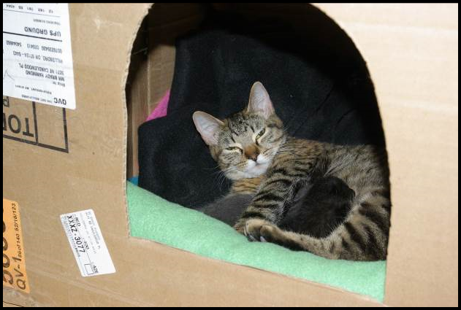
Photo by Debbie Brusius

Potty Training
If the kittens are not 100% potty trained when the foster parents receive them, you will need to offer tips and tricks on how to get the orphans to use their litter box.

- Kitten Attract brand litter is a great way to get kittens into the litter box; however, this is an expensive option, so sprinkle the Kitten Attract on top of the regular litter and then put the kitten in the box.
- Make sure the litter box is cleaned regularly—a dirty litter box can foster poor potty habits.
- Check to see if the foster parents should try a different kind of litter. Different brands, textures, and materials could provide relief from inappropriate elimination.
- Ensure there are enough litter boxes for the number of kittens in the litter. Be sure there is plenty of space between the litter boxes—multiple litter boxes placed next to each other act as just one extremely large litter box rather than separate potty spaces.
- See if the kittens would prefer a differently sized litter box; maybe one with shorter walls or even one with or without a hood will make the difference.
- Try placing the kitten’s waste in the litter box using a tissue. That will associate the scent with the correct location.
- Try placing the litter box where the kitten is pottying; sometimes, corners are preferred!
- Address any medical issues such as diarrhea, a UTI, or a urinary blockage.

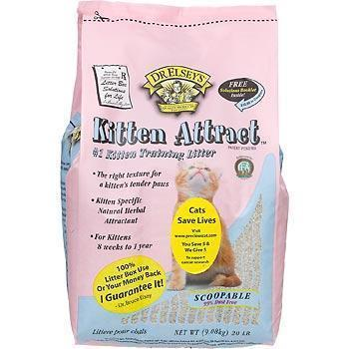

Appropriate Play
Mother cats are very adept at handling kittens who display bad manners when playing; they will often swat a kitten, bite a kitten at the scruff, or pick them up to tell the kitten when they are playing too hard and let them know that enough is enough.

Foster parents should never use their hands for play. If a kitten does try to go for hands, have the foster parent spray their hands with Bitter Apple® before they go into the foster room. This should detract the kittens from trying to play with and attack hands. Instruct the foster parent to use a wand toy, laser light, toys they can roll on the ground, etc. While hand play may seem cute and not hurt too badly when a kitten is just six weeks old, it will not be fun when they grow into a 12-lb adult cat who still believes that attacking like this is okay. Remind the foster parents that they are raising kittens to become great cats.

Luckily, kittens can also help each other learn appropriate play. If you have a single orphaned kitten, it will be more work. For a single orphan, offer a stuffed animal (choose one slightly larger than the kitten) for the kitten to wrestle and sleep with.

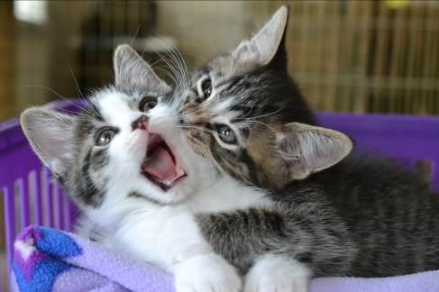

Crying at Night
Kittens are like human babies—they eat, go potty, and sleep; they also haven’t learned to sleep through the night yet. One way to keep kittens satisfied at night is to play with them right before you go to bed. After playtime, feed them wet food and turn off the lights. Exercising them and then satiating them will help them sleep more soundly for greater stretches of time. Turn on a fan for white noise if needed.

Food
As orphans move from nursing to eating food independently, their tummies can become very upset. If the kittens are under six weeks of age, they may need to be eating a slurry mixture. See supplemental feeding for tips and tricks as well as amounts to feed. Kittens six weeks of age should eat kibble and wet food independently without help from the foster parent. Ensure the foster parent is feeding high-quality kitten food (preferably the Purina ProPlan that we provide) and that they are offering enough wet food each day. Dry kibble should be provided at all times, and wet food should be fed in amounts of ¹/₈ can per kitten with three feedings a day, at a minimum.

Baby Food
It is a good idea to have a few jars on hand. Look for baby food with meat (chicken, turkey, or lamb) as the only ingredient besides water. Teach foster parents to read the labels because some brands are higher in calories than others. You will want the highest calorie content that you can find.

Baby food is good when kittens have upset tummies, aren’t interested in eating because they are sick, or dip your syringe in before you give them a liquid medication if they have given you trouble in the past.

Weight Guidelines
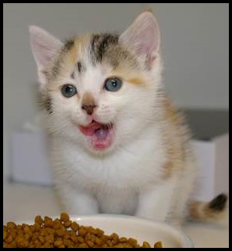
Ideal weight gain is 113 grams (4 ounces) per week, 1 pound per month. Remind foster parents to note weight gain in their weight chart. This is an average! Help foster parents understand that not all of their kittens will make this mark, and some will gain more. We want to make sure kittens are gaining weight and not losing weight. Monitor the kitten’s weight daily (it’s not necessary to weigh the kitten more than once or twice daily). If the kitten is less than three weeks old and has failed to gain weight or has lost weight in 24 hours, then start supplementing with a bottle. If the kitten is three weeks or older and has failed to gain weight or has lost weight in 48 hours, then start supplementing with a bottle or slurry. You should do this after the kitten nurses; you are just “topping off.”
Photo by Debbie Brusius

Bottle Feeding
See Kitten Foster Manual

Tube Feeding
Some kittens may be unable to nurse from their mother or a bottle due to congenital disabilities or an illness. We see this often with neonates who get an upper respiratory infection - if they can’t smell or have nasal congestion, they can’t nurse. If a foster parent has attempted to bottle feed and addressed all the possible issues with no success, it may be time to consider tube feeding. Tube feeding is a safe and easy alternative but can be tricky initially.

Please get in touch with the foster coordinator before attempting to tube feed. The foster parent will need to make an appointment with the hospital to be trained on this method as the need arises. Approved mentors may keep tube feeding supplies on hand and assist foster parents if needed on evenings and weekends, but the foster parent must make a vet appointment to get trained if they want to do the tube feeding themselves.

Here is a neat video demonstrating tube feeding if you are curious!

Here is the step-by-step process for Tube Feeding:
- Please get someone experienced to show you the first time you tube feed
- Use a 5F red rubber feeding tube
- Prepare the appropriate formula amount (see table below) and warm to the kitten's body temperature. Get out any air in the syringe.
- Have a 3 ml syringe prepared with 1-2 ml warm water
- Cut the end of the feeding tube so it has a single opening and it is shorter
- The wide end of the tube may need to be cut to fit the syringe - ensure the syringe will go over the end with a snug fit
- Measure the feeding tube from the mouth to the end of the rib cavity (end of the tube) - mark the tube at the mouth insertion site, so you know not to insert it any farther
- Attach the warm water syringe to the tube and put some water in the tube until it drips out the end (eliminate the air in the tube)
- Wrap the kitten and ensure it stays warm. Cold kittens won’t absorb the formula properly
- Insert the feeding tube into the mouth and down the esophagus
- A properly placed tube will go all the way to the mark you made
- The kitten will still be able to vocalize
- If either of these does not happen, remove the tube and try again
- Push a small amount of water into the tube (½ ml or less)
- If the kitten coughs, remove the tube and place it again
- Remove the water syringe and attach the formula syringe. Slowly push the contents through the tube
- Pinch the end of the tube, face the kitten with their head down, and remove the tube swiftly

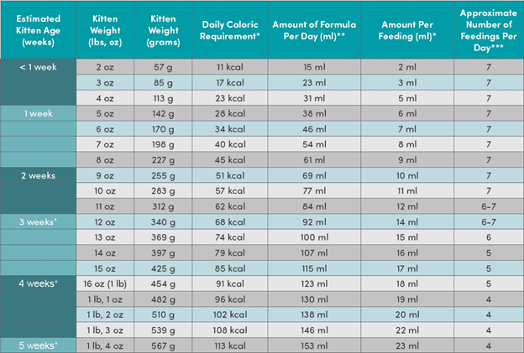

Vaccination Chart
Kitten’s Name: ID#:
Kitten DOB:
Foster Family Name:
Activity | Timing | Approx  Due Date | Enter the Date of Completion
Strongid | At 4 weeks or done at the time of intake
2nd Strongid | 2 weeks after the first dose
1st FVRCP Vaccine | At 6 weeks or done at the time of intake
Photo/Video/Bio for Petfinder | Kittens can be  pre-adopted at 5 weeks
3rd Strongid | 2 weeks after the second dose
2nd FCVRP | Approx. 21 days after the first FVRCP
Surgery | Minimum 1.5lbs, sturdy, healthy, vaccinated
Droncit | Will be given at the time of surgery unless severe or bothersome

Kittens and Vaccinations
See Kitten Foster Manual

Vaccines, Deworming, and Flea Treatment Protocol
It’s imperative that all mentors understand the vaccine and worming timelines and dosages. Timing on these is critical. If a follow-up is given too late, the kitten is not protected, and we have to start over—bad for the kitten, expensive for Your Organization, and wasteful of time and effort for all of us.

Vaccines
FVRCP is the vaccine for Feline Viral Rhinotracheitis, CaliciVirus, and Panleukopenia (URI and Distemper). FVRCP vaccinations are started at six weeks of age (or at the time of intake if they are older) and are repeated every 21 days. The last FVRCP vaccination in the series is given after the kittens reach over 18 weeks of age. Mother cats and adult cats will receive one FVRCP vaccination at intake or prior. They will need one booster FVRCP 21 days later. FVRCP vaccines should only be postponed if the cat or kitten has a fever. Temperatures only need to be taken if the cat shows signs of illness.

FeLV is the vaccine for Feline Leukemia. The FeLV vaccine is not a core vaccine at Your Organization. However, if the vaccine was administered at a previous shelter, we will boost the vaccine at 21 days.

Deworming
Strongid is for roundworms. They will look like spaghetti. Strongid is given at four weeks of age or older depending on when they went through admissions. Strongid kills adult roundworms. Kittens must have treatments every two weeks until they return to the shelter for spay/neuter. At that time, they will receive Revolution and no longer need Strongid.

Revolution is for fleas, ear mites, and roundworms. Cats and kittens eight weeks and older will receive Revolution before going out to foster. The revolution will treat roundworms, so it is not necessary to give them Strongid.

Droncit is for tapeworms. They will look like rice. Droncit kills tapeworms. It is a one-time-only treatment. Droncit is given at the time of the spay/neuter surgery UNLESS the foster parent sees tapeworm segments before surgery and they are very concerned about it. The treatment is an injection or a tablet. Both should be administered by the vet staff or the mentors if they are confident about giving injections, and NOT the foster parents. Droncit can be administered to kittens six weeks and older.

Cestex is an oral medication for tapeworms: Cestex is a one-time-only oral medication that can be given in foster. It can be given by the foster parent and is usually a better alternative than Droncit for the foster home. Cestex can be administered to kittens six weeks and older.

Flea Treatment
Capstar is an oral medication for fleas: Capstar is given to kittens under four weeks who have live fleas.

Advantage is a topical medication for fleas: Advantage is given to kittens 4-8 weeks old who have live fleas.

Revolution (generic name: Selamectin) is a topical medication for fleas, ear mites, and roundworms. Revolution is given to kittens eight weeks and older, mom cats, and adult cats, regardless of the presence of fleas. If the kittens are not old enough at intake, they will get Revolution during their spay/neuter surgery.

When a Foster Parent Calls
When a foster parent calls and informs you that their cat/kitten is sneezing and sick, be prepared with a list of standard questions to get more information. Be sure to listen to your foster parents’ answers and encourage them to elaborate when describing the situation. This will give you a wealth of helpful information. Common questions include:

Temperature
It is a question that very few foster parents will have an answer to when they call you. You need to know that a kitten with a temperature below 98º F cannot digest food, and a cat/kitten over 102.6º F has begun to have a fever. A low temperature on an adult cat is less of a concern unless it is associated with lethargy or other symptoms.

As a mentor, you will often have to instruct your foster parents on how to take a cat's or kitten’s temperature. The thermometer should be inserted until the silver tip is no longer visible (about ½ inch) for cats and kittens and go along the line of its spine. The normal range is 99º-102º F.

Kittens with a temperature below 98º F need to be warmed up immediately. The best place to achieve warmth is under the foster parent’s shirt, right against the skin near your heart. You can also warm a towel in the dryer, but this takes time. You will want to warm the kitten gradually.

Knowing the temperature of a kitten will sometimes have an impact on what instructions you give foster parents. Is the temperature affected by the environment? Does the foster parent know the room temperature? Just because they might have central air conditioning does not mean that a room with the sun beating on it and the door closed will have enough air circulation to keep it cool.

Room temperature is vitally important for the health of the kittens, as they cannot regulate their body temperatures until they are four weeks of age.

Age | Room Temperature
Birth to 7 days | 80º F
8 to 30 days | 75º-80º F
1 month | 75º F

If your foster parent cannot increase the room temperature, then having a nesting box for the kittens is necessary. A box that can create an enclosed space, such as a cardboard box, will be essential for heat retention. You can also use their carrier that they came in (remove the door). Put a towel over the top to help trap the heat.

Cats do not have sweat glands, so during warm weather, the foster parents will need to ensure the kittens have access to surfaces to cool down. If a SnuggleSafe warming disk is used to create a source of warmth, be sure that it is covered, and they have the option to get away from it. Having a surface such as marble tiles or a cooling pad designed for pets (see Foster Coordinator) nearby where the kittens can go to cool down will be necessary. Cooling pads and marble tiles are for kittens four weeks or older.

Ear Thermometers We do sometimes have ear thermometers available for use. These work great for kittens or cats that struggle with the rectal thermometer or are too fearful to temp rectally. We have tested the Braun ThermoScan for accuracy, so please use that brand if you plan to purchase your own. Please follow these instructions for using the ear thermometers:

- Apply a fresh disposable thermometer cap
- Press the power button
- Wait for it to warm up - it is ready when it beeps, and three lines appear
- If you only get two lines, try to adjust the cap to make sure it is on correctly
- Point the thermometer down into the kitten’s ear.
- Once you are in the ear, reposition the thermometer, so it is perpendicular to the kitten’s head.
- This points the reader directly at the eardrum so we can get an accurate reading
- You can use the same thermometer cap on a litter of kittens; just be sure to wipe off any debris.
- Discard the cap and place a new for a new litter of kittens/cat

Eating
How much is the kitten/mom eating? How often are they eating? Kittens need the right amount of food to suit their energy needs at their age. Lack of food can cause low blood sugar levels. On average, kittens should gain 113 grams (4oz) a week. With nursing kittens, it can be hard to know how much each is getting. If they still chase the mother after feeding, you may need to suggest supplemental feeding.

Don’t forget about the mother cat, either! Sometimes foster parents will be so focused on the kitten that they forget to note what the mother is doing. She will need to eat enough food to maintain her weight and milk supply. Lactating moms should have high-quality kitten dry food available at all times and get 2-4 meals of wet food per day. If the mother is not consuming enough calories, she may not be able to produce enough milk for the kittens.

Knowing how many kittens are nursing on a mother can also make a difference—you need to be sure that she can produce enough milk for the whole group. Depending on the kittens' age and the litter's size, the foster parent may need to supplement their feeding with a bottle. The best way to do this would be to allow the kittens time to nurse and then “top them off” about 20 minutes after they have begun to nurse. If the group is larger than eight kittens, it is best to bottle-feed the larger kittens first to allow the smaller kittens more time to nurse with their mother. Sometimes it will be necessary to crate the mother with really small kittens to allow them time to nurse without having to fight siblings.

Orphans will be a little more challenging, as they need to be encouraged to eat. With orphans and weaning kittens, attracting them with other food sources never hurts. Canned kitten food with sardines, second-stage baby food, or unseasoned, skinless, boiled chicken breast can be used as incentives. If the foster parent chooses to boil chicken meat, have them save the juices by freezing them in ice cube trays to add to dry food later. For more about food and bottle-feeding, see pages 27-31.

Adult cats should eat at least 50% of the food offered twice daily. After three meals (1.5 days) of not eating or eating less than 50%, offer them a different wet food option that is smelly (try fish flavors, beef, chicken, or turkey). After five meals (2.5 days) of not eating or only eating 50% or less, the foster should be making an appointment to have the cat seen by the hospital for SQ fluids and B vitamins.

Drinking
How much is the cat/kitten drinking? How often is it drinking? Cats need fresh water daily. Sometimes if adult cats drink a lot of water, it can be a sign of other medical issues. Kittens not yet weaned will not drink much water. If the kittens are eating canned food, typically more than 70% fluids, they may not need to drink a lot of water separately.

Knowing how much fluid a cat/kitten consumes, foster parents should also monitor for dehydration. When you pinch the scruff of the neck and then set it back down, does the skin go back into place quickly? If it instead remains puckered, the cat is dehydrated. Another way to check for dehydration is by feeling the gums of the cat/kitten. They should be nice and moist, and your finger should slide with ease. If they are tacky, then you should consider administering fluids.

Playing
Playing is an essential gauge of a kitten’s health. If the kitten has siblings, do they play with others? Does the kitten initiate play? Sometimes it can appear that two kittens are playing when in reality, one of the kittens is merely picking on the other. Have foster parents make notes at playtime. Do the kittens track their toys? Are they following the toy with their eyes, or do they look down when the toy moves above them? How are their motor skills developing? A big warning sign for health problems is if a kitten only wants to cuddle. There is no such thing as “just a cuddly kitten” or a “mama’s boy.” If a kitten likes to cuddle exclusively and never engages in play, it could mean that they are becoming ill.

Adult cats, especially shy or older ones, may not want to play as much as kittens. What’s important here is to monitor any changes in behavior. Did the cat love to play and then suddenly have little interest? It could be a sign of pain or discomfort.

Fecal and Urine
Blood in the urine can be a sign of a bladder infection. Sometimes this is only visible when the cat/kitten urates. Since the background of most cats/kittens at Your Organization is unknown, it is always a good idea to closely monitor litter box activities for the first 48 hours when in a foster home.

Male cats can also experience a urinary blockage. Foster parents should watch for repeated trips to the litter box with little or no urine production, excessive licking of the genitals, and vocalizing while using the litter box. If the cat is not able to urinate, it is an emergency!

Is the cat/kitten crying or straining when attempting to eliminate feces? It could be an indicator of more serious underlying issues. If the cat/kitten continues to strain in an attempt to defecate, it could cause the rectum to prolapse; in most cases, an extended rectum results. Hydration issues could be the root of these problems, so be sure to have foster parents check the cat/kitten’s hydration levels when straining issues arise.

Diarrhea can be life-threatening in small kittens, as it can cause rapid dehydration. The stool's color, odor, and softness can tell you something different. Be sure to ask how long the cat/kitten has had diarrhea, and make sure the foster differentiates between soft and watery stools. Foster parents will have a fecal scoring chart in their baby bag to help identify the severity.

Eyes
Eyes should be clear and bright in color. Brown, crusty matter in the corner of the eyes is not a cause for concern. Yellow and green discharge and eyelids that are sealed shut when they were previously open are all cause for concern. Ask if the third eyelid shows no discharge—this could be a sign of gastrointestinal trouble.

Conjunctivitis typically creates a greenish/yellowish discharge at the inner corner of the eyes, near the nose. Sometimes the third eyelid will raise and look very red and inflamed. Dilation of the pupil can also occur.

It is essential to keep the eyes clean and follow medication directions. Most medications are prescribed for five days - see the Conjunctivitis section for treatment. If things worsen after three days of medication, have the foster parent schedule an appointment with the hospital. The veterinarian should also check cloudiness or spots within the pupil. Have the foster parent schedule an appointment.

Ensure the foster parent uses a new gauze pad or a clean baby washcloth each time they clean the eyes. Use a separate gauze pad or a new section of the washcloth to clean each eye on the same kitten. Washcloths must be washed between each use. Using the same unwashed washcloth will perpetuate the cat/kitten’s illness.

Nose
Noses should be moist without being runny. Clear or mucousy discharge indicates an upper respiratory infection.

Lungs should be clear and soundless. Have the foster parent listen for coughing, congestion, or raspy breathing. It can be a sign of an upper respiratory infection, pneumonia, or even asthma. A little congestion with an upper respiratory infection can be treated per the URI protocol. Persistent congestion or difficulty breathing requires an appointment with the hospital or an emergency vet visit if severe.

Ears
Ears should be clean. Scratching or bloody or brown debris can indicate ear mites or an ear infection.

Medication
What medications have the kitten been on, and how long have they taken them? You will need this information from the foster parent before calling the lead mentor.

Vomit
Vomiting is rare in kittens and is always a cause for alarm. First, determine how often and how long the kitten has been vomiting to establish a timeframe. Call the on-call lead mentor for advice if the kitten has vomited twice within 24 hours.

Vomiting in adults is less alarming but should still be monitored. If an adult cat vomits three or more times in 12 hours, they will need to seek vet care immediately. For less frequent vomiting, an appointment can be made with the hospital for fluids and anti-nausea meds.

What has the cat/kitten vomited? You will need to differentiate between food, hairballs, and stomach acids. Has the cat/kitten been anywhere near plants or other substances that could pose a poison risk? Is the cat/kitten foaming at the mouth? Did the cat/kitten throw up after being given medication or food?

Body
Sometimes you might get a call because something is oozing from a body part. For example, a sibling biting at the base of another kitten’s ear can cause an infection at that site.

Lameness in a limb can be related to an injury, a vaccine, or an illness. You will need additional information to determine the cause of lameness.

It is essential to know the stages of kitten development and whether changes that arise during growth periods are abnormal. Typically, when a kitten is born, its umbilical cord will remain attached until it reaches 3-4 days old. However, herniated or infected umbilical cords can form. Watch for swelling in that area.

Fur
White flakes on the fur coat could be dandruff, but if they are at the end of the hair and stick to it, there is a good chance it might be lice. Feline lice are species-specific, so they won’t be transmitted to people or other animals except for other cats. Contact the shelter for a treatment plan.

Hair loss can be a sign of a flea allergy, over-grooming (stress response in adult cats), or ringworm (fungal infection). Have the foster parent make an appointment with the hospital to evaluate it.

Gums
Healthy gums are firm and pink (some cats have black pigment spots). They should be moist to the touch. If gums are tacky and sticky, the cat/kitten could be dehydrated.

The color of the gums can tell you several things going on regarding the health of your cat/kitten. Pale (very light pink) can be a sign of anemia. Bluish gray gums indicate a lack of oxygen or shock. Bright red gums can mean heatstroke or infection. A yellowish tint may indicate that the kitten is jaundiced.

Train your foster parents to look at the gums of healthy cats/kittens. That way, they have an idea of what the gums of a healthy cat/kitten look like.

The on-call lead mentor may ask you to have the foster parent check the capillary refill time. When the foster parent presses gently on the gums, they should go to almost white and refill to the nice pink color in two seconds or less.

Signs of Ill Health
MOUTH | EYES |  | RESPIRATORY
- Drooling and pawing at mouth  - Bad breath  - Difficulty eating  - Loss of appetite  - Broken, loose, or missing teeth  - Inflamed gums | - Discharge from the eye  - Inflammation of the eyelid  - Change in the eye color  - Abnormal sensitivity to light  - Visible third eyelid  - Problems with vision  (like tracking toys) |  | - Labored breathing  - Persistent sneezing  - Persistent coughing  - Discharge from the  eyes and nose  - High temperature
BLOOD & HEART DISORDERS | SKIN PARASITES |  | SKIN & COAT DISORDER
- Collapse or fainting  - Bluish discoloration of the gums  - Breathing difficulties  - Unwillingness to exercise  - Coughing while exercising | - Persistent scratching  - Loss of hair  - Excessive grooming  - Biting at the skin and coat  - Signs of parasites in the  coat |  | - Persistent scratching  - Loss of hair  - Excessive grooming  - Biting at the skin and coat  - Signs of parasites in the coat
REPRODUCTIVE | NERVOUS |  | DIGESTIVE
- Bleeding from genitals  - Abnormal discharge from vulva  - Swelling of mammary glands  - Harding of mammary glands  - Swelling of the testes | - Convulsions and fits  - Muscle spasms and tremors  - Partial/complete paralysis  - Staggering gait  - Acute skin irritation |  | - Repeated vomiting  - Persistent diarrhea  - Loss of appetite  - Blood in the feces or vomit  - Persistent constipation
EARS |  | INTERNAL PARASITES
- Discharge from the ear  - Dark brown wax in the ear  - Persistent scratching or rubbing of the ear  - Head shaking or holding the head to one side  - Swelling of the ear flap  - Hearing problems |  | - Worms passed in the stool  - Persistent diarrhea  - White grains visible on the rear  - Licking and rubbing of the rear  - Potbellied appearance  - Loss of weight  - Scooting on the carpet or floor
URINARY DISORDER |  | BONE, MUSCLE & JOINT DISORDERS
- Straining to pass urine  - Abnormal urination or incontinence  - Blood or excessive cloudiness in urine  - Excessive thirst  - Persistent licking of the genitals |  | - Lameness and limping  - Swelling around the affected area  - Tenderness when the area is touched  - Reluctance to walk or jump  - Abnormal gait

When Is It an Emergency?
It’s an emergency if:

- A cat/kitten is lethargic and not responding
- A cat/kitten has trouble breathing
- A cat/kitten has a severe injury that is bleeding or causing pain
- A male cat has a urinary blockage (cannot urinate)
- A cat/kitten has a fever over 105 F for a prolonged period
- A mother cat has been in active (pushing) labor for 30 minutes without producing a kitten

Email can be used for simple husbandry calls and general information.

If it is not a life-or-death emergency, please call the on-call lead mentor and wait up to 2 hours if you don’t get an immediate response. If the situation gets worse, place a call again.

If you need to send a foster parent to the Emergency Clinic, be ready!

You must have approval from the on-call manager before the kitty can be treated. The on-call manager will need the following information about the cat/kitten, so be sure to gather it from the foster parent and pass it along to the on-call lead mentor: Animal ID, name, symptoms, temperature, hydration, appetite, urine/feces, current/past treatments, and any other pertinent information. They will also need the foster parent’s name and phone number. Please fill out this document for foster emergencies.

See our approved list of emergency vet clinics in the Kitten Foster Manual

Quick Treatment Reference

Diarrhea: FortiFlora, Pumpkin - in the foster bag. See the Diarrhea protocol for the next steps.

Dehydration: Hydracare or Kitten Lyte and Sub-Q fluids.

Hypoglycemia(low blood sugar): Karo syrup – ½ mL; wait 2 minutes and ½ mL again if needed. Apply with your finger to the gums and tongue of the cat/kitten.

Conjunctivitis: Tobramycin drops - one drop per eye 3-4 times per day for five days.

URI: Amoxicillin: The dose is 0.2 ml/lb. BID (2 X day for 7 days) when using the concentration 25 mg/1 ml. The dose is 0.1 ml/lb. BID (2 X day for 7 days) when using the concentration 50 mg/1 ml. Only start amoxicillin if there is a colored nasal discharge. Doxycycline (as prescribed by the Your Organization’s hospital) for cats or kittens eight weeks and older that are not responding toAmoxi. Steam the room with either a running shower or a humidifier.

Vomiting: If a kitten vomits more than twice in 24 hours, call the hospital for a same-day appointment or call on the on-call lead mentor after hours. If an adult cat vomits more than three times in 12 hours, call the hospital for a same-day appointment or contact the on-call lead mentor after hours.

Blood in Urine: Make an appointment with the hospital.

Cat/Kitten Won’t Eat: Try boiled chicken, baby food (plain chicken or turkey – NO onions), broth from boiled chicken (can freeze in ice cube trays) poured over food, or tuna water from canned tuna for cats. Offer other brands of food - Royal Canin Mother and Baby cat is a popular variety. Give SQ fluids.

Thermometer: Needs to go in until the silver tip is not visible for kittens and adult cats. The average temperature of a kitten/cat is 99°-102° F. Newborn kittens have lower body temps ranging down to 95° F.

Temperatures for Kitten Bath Water: Same as for bathing a human baby. The water should be about the kitten's body temperature, around 100°-101°. The bathwater temperature for a cat should be the same as for kittens.

Dosing
Directions on all medications must be followed as prescribed.

If a dose is late, it must be given as soon as possible. If it is too close to the next dose, skip it and do not double-dose. Most of the foster program's medications will be taken once or twice a day. There are others, like eye medications, which may be given more often, so read all directions.

SID = Once a day (every 24 hours)
BID = Twice a day (every 12 hours)
TID = Three times a day (every 8 hours)
QID = Four times a day (every 6 hours)

Suggested questions to ask when you pick up medications from the shelter/hospital.
- Can this medication be given with food?
- Will they dislike the medication? Is it bitter?
- Does the medication need to be shaken?
- How should it be stored? Refrigeration? Away from sunlight?
- Are there any side effects to watch for?
- When do we notify if the medication appears not to be working?

Medication Dosing Guide
New foster parents often have difficulty distinguishing 1 ml from 0.1 ml or other similar-sounding dosages. Kittens are so tiny that we often give them a very small amount of medication. This picture guide is located in their baby bag. Please have them refer to it when dosing out Strongid, Panacur, or any other medication.

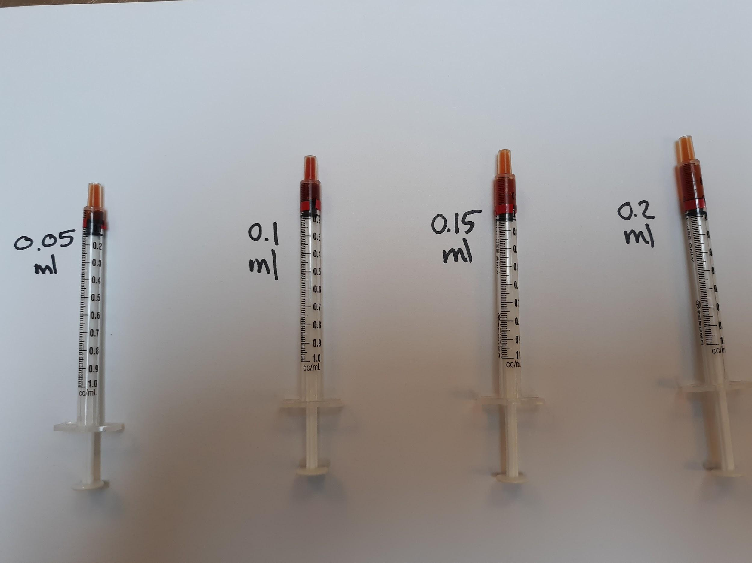

Giving Medication
See Kitten Foster Manual

Medications and Commonly Used Remedies
Please refer to the Client Drug Consultation Forms document for more information on Your organization's prescription medications. Although you are not required to read this information to your mentee when starting a drug, you may find it helpful to do so for new foster parents. It is also a great reference if you have any drug-related question

A&D Ointment
Type: Ointment
Used for: Creating barrier on skin for kittens with diarrhea
Approval by: None needed.
Dose: Apply a thin layer to the clean affected area—usually the bottom, tail, and sometimes back of legs, two to three times a day.
Special Instructions: This is greasy and will cause the kitten to lick it off if you apply it too thick.

Amoxicillin
Type: Antibiotic
Used for: Upper Respiratory Infection (URI); must have yellow or green discharge from the nose and/or fever of 102.7° F or higher. Do not start Amoxicillin for a fever without URI symptoms. Symptoms include sneezing, coughing, watery eyes, gulping (sore throat), or other discharge from the nose. See the section on URI for more signs of illness. It is also used to treat other infections, as listed in this manual.
Approval by: Mentor for kittens and mom cats (Hospital for adult cats)
Dose: 0.2 ml/lb when using the concentration 25mg/ml BID (2 X day) for 7 days. The dose is 0.1 ml/lb BID (2 X day) when using the concentration of 50 mg/ml BID for 7 days.
Special Instructions: Shake well before drawing up the dose. It can be given with food. If a kitten gains more than 4 ounces (113 grams) while on the medication, you must recalculate the dose to ensure they get the right amount.

Baby Food
Type: Human baby food
Used for: Enticing cats/kittens to eat
Approval by: None needed
Dose: As needed
Special Instructions: Chicken or Turkey (Gerber stage 2—no onion or garlic).
It can be used to dip the tip of the syringe in for some medications.

Cestex
Type: Dewormer
Used for: Tapeworms
Approval by: Foster Coordinator or Hospital
Dose: A pill given once; dose determined by weight. It can be administered to kittens seven weeks or older.
Special Instructions: Follow up pilling with 3 mL of water. They are only given to altered cats/kittens or unaltered cats/kittens with a heavy load of tapeworms that cannot wait until surgery for treatment.

Clavamox
Type: Antibiotic
Used for: Broad-spectrum antibiotic commonly used for wound infections.
Approval by: Veterinarian
Dose: As directed. The liquid form will need to be refrigerated. Pills do not.
Special Instructions: Clavamox should be rinsed down with 3 mL of water and followed with wet food.

Doxycycline
Type: Antibiotic
Used for: Upper Respiratory Infection (URI). Must have a fever of 102.7° F or higher and/or yellow or green discharge from the nose.
Approval by: Veterinarian
Dose: As directed.
Special Instructions: Doxycycline should be rinsed down with 3 mL of water. Then offer wet food. If not rinsed with water, this drug can cause throat irritation and even ulceration.

Droncit
Type: Dewormer
Used for: Tapeworms
Approval by: Foster Coordinator/Hospital (only given during spay/neuter)
Dose: One-time injectable dose on kittens six weeks or older who are at least 1.5 lbs. The injection can cause stinging at the site.
Special Instructions: It is best to wait until spay/neuter surgery. There can be an injection site reaction that will cause hair loss and an open sore. Report tapeworms to the Foster Coordinator so they can be treated at spay/neuter.

Drontal
Type: Broad-spectrum dewormer
Used for: Tapeworms, hookworms, and roundworms
Approval by: Foster Coordinator/Hospital
Dose: A pill given once; dose determined by weight. It can be administered to kittens six weeks and older who are at least 1.5 lbs. To kill roundworm eggs, you must follow up with Strongid in 14 days.
Special Instructions: Drontal should be rinsed down with 3 mL of water and only given to altered cats/kittens or unaltered cats/kittens with a heavy load of tapeworms that cannot wait until surgery for treatment.

Erythromycin Eye Ointment
Type: Ophthalmic eye ointment
Used for: Conjunctivitis. They must have yellow or green discharge from the eye.
Approval by: Hospital
Dose: 1 thin strip the size of the eye BID-TID for seven days.
Special Instructions: Make sure the tip of the applicator does not touch the eye!

Fortiflora/Calming Care
Type: Probiotic powder
Used for: Nutritionally managed cats and kittens
Approval by: None for Fortiflora; Foster Dept/Hospital for Calming Care
Dose: FortiFlora - daily for the first two weeks of foster care for all cats and kittens eating solid food, an additional seven days if diarrhea develops. Calming Care - daily for the duration of foster care (for stressed cats). Both products can be given in the case of diarrhea. See diarrhea protocol for details.
Special Instructions: Mix with wet food once a day. ¼ packet if <2lbs, ½ packet if 2-5lbs,1 packet if >5lbs.

Hydracare
Type: Liquid hydration supplement
Used for: Fever, low appetite, or dehydration
Approval by: Mentor
Dose: Empty the packet into a bowl and offer it to the cat or kitten
Special Instructions: Can be used when SQ fluids cannot be administered immediately. SQ fluids are preferred and should be given immediately if the issue persists.

Karo Syrup
Type: Glucose Solution
Used for: Hypoglycemia (low blood sugar)
Approval by: Mentor
Dose: Up to 1 mL
Special Instructions: To be given when a kitten shows signs of hypoglycemia or “crashing.” The kitten will be depressed, lethargic, and uninterested in eating. You will want to administer by applying a 1” bead of the Karo syrup on your finger, rubbing along the outer gums of the kitten (both upper and lower), and then rubbing the remainder down the center of the tongue. If you do not see an improvement within a few minutes, administer the remainder of the syrup to the kitten in the same way. You cannot overdose a crashing kitten. If the kitten is cold, it will have a harder time absorbing the Karo syrup. Once the kitten responds, you will want to take his/her temperature to see if you can feed the kitten. If they are below 98° F, you must warm the kitten before feeding. If the kitten is over 98° F, you will want to get food (protein) into the kitten to stabilize their blood sugars.

Kitten Lyte
Type: Hydration supplement
Used for: Treat dehydration due to diarrhea, vomiting, or inappetence.
Approval by: Mentor
Dose: Add one scoop (5 gm) of the powder to 8 oz of warm water and mix thoroughly. Use this instead of water to make kitten formula. You can also offer this in a bowl for older kittens.
Special Instructions: Refrigerate after mixing, and use within 24 hours after mixing. Small bags of Kitten Lyte will be included in the bottle-feeding kits that we send out with kittens under five weeks old.

Marquis Paste (Ponazuril)
Type: Anti-Protozoan
Used for: Diarrhea that does not resolve with FortiFlora
Approval by: Mentor for kittens and mom cats (Hospital for adult cats)
Dose: 0.2 mL/lb. Give orally to each cat/kitten once.
Special Instructions: You will need the weight of the cat/kittens to prepare it. Must be shaken well (until all sediment at the bottom of the bottle is thoroughly mixed in).

Metronidazole
Type: Antibiotic and Anti-Protozoan
Used for: Treat Giardia and anti-inflammatory
Approval by: Veterinarian/Technician
Dose: As directed.
Special Instructions: Give with food. The liquid form is very bitter and settles quickly - must shake well before drawing dose from the bottle

Nurture Mate Colostrum Supplement
Type: Colostrum supplement
Used for: Kittens 6 weeks and under who aren’t doing well (losing weight, diarrhea, etc.). It can be given to newborns and bottle babies, especially orphans who didn’t get enough colostrum from their mothers.
Approval by: Mentor
Dose: 1ml once
Special Instructions: Turn the dial up to the base of the tube. For 1ml, turn the dial out to the “1” marking, then depress the syringe. Depress it into a 3ml syringe (remove plunger, then replace it) and give the syringe to the foster to administer—Refrigerate the tube after opening.

Panacur (Fenbendazole)
Type: Broad-spectrum antiparasitic
Used for: Treats hookworms, roundworms, tapeworms (some types), and whipworms, diarrhea that does not resolve with Fortiflora.
Approval by: Mentor for kittens and mom cats (Hospital for adult cats)
Dose: 0.2 mL/lb given orally once daily for five days. The label on the bottle will give the dose by weight. Round up to the nearest weight. Give the entire bottle to the foster parent with syringes if needed.
Strongid (Pyrantel)
Type: Liquid dewormer
Used for: Roundworms and hookworms
Approval by: None needed
Dose: 0.1 mL/lb. Every 14 days while in foster care.
Special Instructions: Shake before you draw up medication. Cats and kittens eight weeks or older will receive Revolution and will not need Strongid while in foster care.

Tobramycin Eye Drops
Type: Ophthalmic eye drop
Used for: Conjunctivitis. Must have red/swollen tissue around the eye or have yellow or green discharge from the eye.
Approval by: Mentor for kittens and mom cats (Hospital for adult cats)
Dose: 1 drop per eye TID-QID for five days.
Special Instructions: Shake well before using. See above for instructions.

Vitamin Supplement
Type: Liqui-Tinic vitamin supplement.
Used for: Diarrhea. Anorexia. To help replenish nutrients and boost appetite.
Approval by: Mentor for kittens and mom cats (Hospital for adult cats)
Dose: 0.1ml/lb OR 0-1lb: 0.1ml; 1.1-2lb: 0.2ml; 2.1-3lb: 0.3ml; 3.1-4lb: 0.4ml. For diarrhea, give the amount indicated orally once daily for five days. For anorexia/weight loss, give the amount indicated orally once.
Special Instructions: You can give the entire bottle to a foster parent with syringes if needed. You can also draw up a single dose for them.

Zylkene
Type: Calming supplement
Used for: Anxiety and stress in teens and adult cats.
Approval by: Foster Coordinator
Dose: 1 capsule (75mg) once a day for cats up to 10lbs; 2 capsules for cats over 10lbs (can give one capsule twice a day or two capsules once a day). Capsules can be opened and put on wet food.
Special Instructions: It can take several weeks of use to see the calming effects

Medical Conditions
Anemia
- Symptoms: White gums, lack of energy,cuddly kitten
- Action: Often, this is caused by an overload of fleas. It will sometimes take weeks for the kittens to regain their strength and return to normal. Keep an eye on their development and weight gain.
- Treatment: Sub-q fluids, sometimes a vitamin supplement. Make sure that the kitten has been treated for fleas and/or that the fleas have been removed successfully.
- Cleaning: Nothing
Anorexia/Losing Weight
- Symptoms: Loss of appetite or inability to eat solid food without assistance.

- Action: If a kitten has weight loss or not eating for more than 24 hours, schedule an appointment with the hospital. Adult cats should eat at least 50% of the food offered twice daily.

- Treatment: May include supplemental feeding or trying to find something appealing that they will eat. First, try smelly wet food, including wet adult cat food, if they will eat it. Also, try human baby food, chicken or turkey (with no onion or garlic).

Boil skinless chicken breast and then cut it into small pieces. Save the broth in ice cube trays for later. If you have no luck with any of those, ask the shelter for prescription high-calorie food. You may need to make a slurry mixture for the kitten to eat or to syringe feed. See the section on supplemental feeding for how to make the mixture and the amount to feed your kitten.

You can give one dose of the vitamin supplement to help stimulate their appetite. If the kitten is still not eating or has significantly reduced eating, they should be seen at the Your Organization’s hospital ASAP.

For adult cats, after three meals (1.5 days) of not eating or eating less than 50%, offer them a smelly wet food option (try fish flavors, beef, chicken, or turkey). After five meals (2.5 days) of not eating or only eating 50% or less, please give SQ fluids (if you are trained and have supplies), and call the shelter for an appointment with the hospital.
- Cleaning: No special cleaning instructions are needed.
- Notes: Contact the On-Call Lead Mentor for ideas and assistance when in doubt.

Blood in Urine
- Symptoms: Pink, orange, or red color in urine or found in the litter box. Straining or frequent trips to the litter box with little to no success.

Note red color in litter
- Action: Contact On-Call Lead Mentor for advice
- Treatment: An appointment will need to be made immediately. Urinalysis and possible X-rays may be performed.
- Cleaning: Keep the litter box clean.

- Notes: This can be very dangerous for a cat/kitten and requires immediate attention, especially if an adult male cat is straining to urinate.
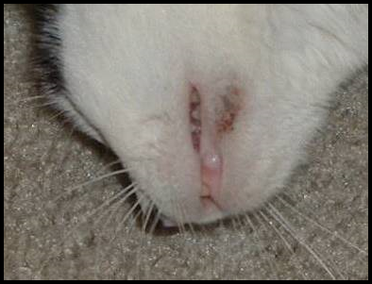
Chin Acne
- Symptoms: Dark debris or crusting under the chin area, hair loss, and sometimes swelling.
- Action: Remove all plastic from the room and only use stainless steel or glass dishes.
- Treatment: Use a warm water washcloth to do a compress. Don’t scrub it away. Vet appointment if it doesn't improve after five days of treatment with warm compresses or if it seems to be causing pain.
- Cleaning: Nothing

- Notes: This will happen with adult cats and should not be seen with kittens.
Coccidia
- Symptoms: Diarrhea, weight loss, dehydration.
- Action: Follow the diarrhea protocol. Take a fresh stool sample to the hospital for testing if the medications aren’t helping.
- Treatment: Marquis Paste
- Cleaning: Scoop the litter box as often as you can to remove any fecal matter. Wipe the foster room floor three times a day to remove any fecal matter.
- Notes: Coccidia often has a very distinctive smell, and the feces will often be yellow.

Conjunctivitis
- Symptoms: Redness, swelling, and/or yellow or green discharge around the eyes.
  - To clean the cat/kitten’s eyes, use a cotton ball or gauze that is clean with warm water. If the eye is sealed shut, you will need to use the warm cotton ball as a compress and hold on the eye for a few minutes. This will soften the crusted material around the eye. Once it is soft and pliable, you can wipe it from the eye. Start at the area closest to the nose and wipe outward. Don’t force the material off of the eye. You may need to continue to let the cotton ball sit on the eyelid longer to soften the material. Once everything has been cleaned around the eye, you can administer eye medications. It will be helpful to the cat/kitten if you gently wipe the eye clean multiple times a day. You can use a soft washcloth if you do not have a cotton ball or gauze square. Make sure that you use a clean washcloth each time. Never share washcloths or gauze between cats/kittens or eyes.
- Action: If it is crusty, have the foster parent clean it with a clean moist warm cloth. A clean cloth should be used each time the eye(s) are cleaned. Have them hold the washcloth on the eye for at least 30 seconds, if not longer. If the crusty discharge has softened, it can be wiped from the eyes. Ensure the foster parent is not picking the crusty discharge off the eye area, which can cause the delicate skin to tear.
- Treatment: If the eye discharge is clear and watery, have the foster parent clean the eye 3-4 times a day with a clean washcloth and monitor for other symptoms. If there is a green or yellow-colored discharge or if the tissue around the eye is red and swollen, then have the foster parent begin administering eye medication. Medication may be available in their foster bag or can be picked up at the shelter.
  - The medication we use is: Tobramycin Eye Drops—the dose is one drop per eye 3-4 times a day for five days. To administer eye drops, hold the cat/kitten’s eye open and let the drop fall into the inside corner of the eye near the tear duct. Open and close the eye a few times to get the drops worked in well.
  - Erythromycin Ointment: This medication may be prescribed by the hospital if the Tobramycin does not seem to be working —the dose is one thin strip the size of the eye 2-3 times a day for seven days. To administer the ointment, hold the cat/kitten’s eye open and squeeze the ointment into the eye, moving across the eye without touching the tip of the tube to the eye. It is imperative to ensure that only the medication—not the tube—touches the eye.
- Notes: Conjunctivitis is often accompanied by an upper respiratory infection. Also, if not treated correctly, ulcers can form on the eye, or the eye can become damaged to the point of needing extraction. Ensure the foster parent understands that if they see anything forming on the eye or if the third eyelid becomes red and inflamed (meaty), they need to make an appointment at the hospital immediately for further evaluation.
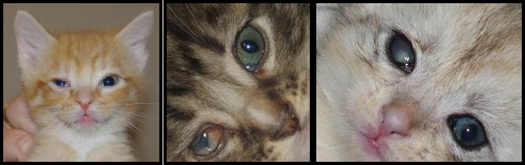
Pic # 1: watery eye w/ 3rd eyelid showing; Pic #2: “meaty” third eyelid; Pic #3: ulceration of the right eye
Constipation
- Symptoms: This can be from infrequent elimination or difficulty eliminating hard feces. There can also be very little liquid passing by the blockage as the cat/kitten is straining to defecate.
- Action: Check for hydration. Ask the foster parent if there is any chance that the kitty could have swallowed something to cause blockage.
- Treatment: Administer sub-q fluids. Add canned pumpkin puree (no spices added). Add one teaspoon of pumpkin puree to each wet food meal.
- Cleaning: Keeping the litter box clean will ensure the cat/kitten will use the litter box. Also, it allows the foster parent to know how much the cat/kittens are using the litter box.
- Notes: If improvement is not noted within 24 hours after administering fluids and adding pumpkin to the diet, have the foster parent make an appointment with the hospital.

Coughing
- Symptoms: The cat/Kitten sounds like it is trying to hack up a hairball.
- Action: Take the kitten’s temperature. An adult cat may produce a hairball, but kittens do not have hairballs to deal with yet, and this is most likely a sign of illness. Try to determine if the kitten swallowed something that could be blocking the airway.
- Treatment: For kittens, make a vet appointment to rule out pneumonia. You can make a vet appointment for adult cats or send a video of the coughing for a vet to evaluate.
- Cleaning: Nothing
- Notes: You may also notice the cat/kitten having trouble swallowing. This could be a post-nasal drip running down the back of the throat, causing irritation.

Dehydration
- Symptoms: The gums will feel a little tacky, not moist and smooth. When pulled up, the skin on the back of the neck will not fall back into place immediately.
- Treatment: Administer sub-q fluids. See the section on sub-q fluids for how much to administer based on the weight of the cat/kitten. If a kitten cannot get fluids immediately, you can instruct the foster parent to slowly syringe water into the kitten’s mouth. They can also use unflavored Pedialyte.
- Cleaning: Nothing
- Notes: You may need to go over each night to administer fluids for up to a week.
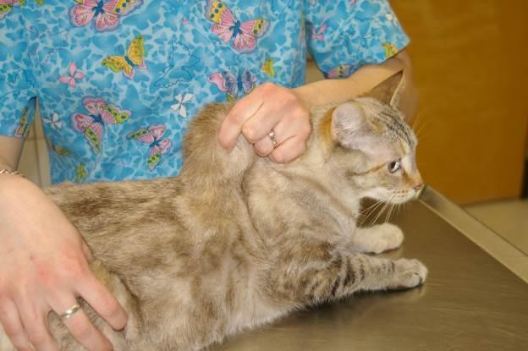
Photo by Debbie Brusius
Diabetes
- Symptoms: Excessive thirst, urinating a lot, overweight cats are more prone to developing diabetes
- Action: Make a vet appointment.
- Treatment:Insulin, special diet, and blood glucose monitoring as directed by the shelter veterinarian.
- Notes: How to give an insulin injection. Tracking blood glucose. Two videos on getting blood samples” AAHA and AlphaTrak
Diarrhea
- Symptoms: Liquid fecal matter found in the litter box, on the cat/kitten’s bottom, or anywhere else in the foster room.
- Action: Start Diarrhea Protocol. Keep the kitten’s bottom clean at all times. You may need to run the kitten’s bottom under warm water to cleanse the area. Pat dry and then apply A&D ointment for protection. Check for dehydration.
- Treatment:FortiFlora—continue to give or restart for seven days. Administer sub-q fluids if dehydrated.
- Cleaning: Cleaning diarrhea out of the litter box and off the cat/kitten promptly is necessary for preventing extra mess and the potential spread of disease.
- Notes: You may be given a special diet to feed the cat/kittens.
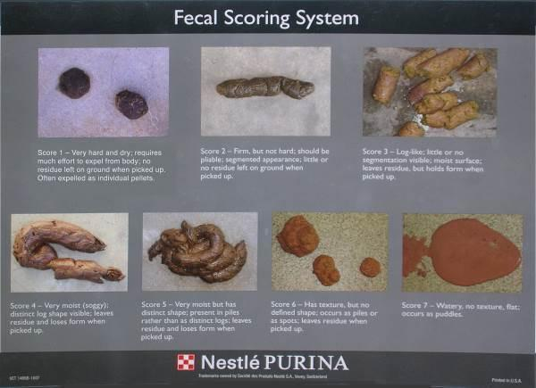
Diarrhea Protocol
See Kitten Foster Manual

Failure to Thrive
- Symptoms: Kitten is not gaining weight and/or is losing weight with supplemental syringe feeding, is lethargic, and always wants to cuddle.
- Action: Contact On-Call Lead Mentor for advice.
- Treatment: Sub-q fluids. The hospital may also prescribe Vitamin B-12, ensure the kitten is warm enough, and Karo syrup.
- Cleaning: Nothing is needed at this time.
- Notes: Be prepared for the worst, and know that not all kittens survive kittenhood. Tell the foster parent that we will do everything we can for the kitten, but sometimes we can’t save them all. Please don’t make it sound rosy and that there are no issues; this is a critical time in a kitten’s life.
Esophagostomy Feeding Tubes
- Symptoms: Cats not eating for multiple days in a row will often get esophagostomy feeding tubes (e-tubes) placed surgically in their neck. We try to send these cats to foster care so they are in a low-stress environment and will start to eat on their own sooner. Here are the instructions that foster parents are provided when they take an e-tube cat. Here is a video demonstrating the process.
- Action: Common issues with feeding tubes include (1) a blocked tube, (2) vomiting, and (3) a tube that falls out on its own or is vomited up. Most feeding tube issues are not emergencies and can wait for a vet appointment. If a tube is blocked (i.e., the foster is trying to push food down and the syringe won’t advance), you can try using 2-3 ml of regular Coca-Cola (not diet or any other additives) to flush it, wait 5 minutes and then flush with some water.

Feline Infectious Peritonitis (FIP)
FIP is a mutation of the feline enteric coronavirus that occurs within certain cats. 1%-5% of infected cats develop FIP. At this point, the virus can now leave the intestines and infect blood cells. This stimulates a large antibody response by the body. Then, the antibodies bind to the virus to form complexes, and these complexes can cause vascular damage. At this point, it appears that the mutated virus is not contagious.

- Symptoms:
  - Wet Form: Fluid build-up in abdomen or chest, swollen abdomen, difficulty breathing.
  - Dry Form: Neurologic disease, enlarged kidneys, Uveitis (inflammation inside the eye).
- Action: Contact the Hospital for an appointment when the shelter is open.
- Treatment: There are currently no FDA-approved treatments for FIP. However, off-market treatments (most commonly GS-44152) are increasingly being accessed by cat owners and, sometimes, rescues and shelters. Because of the lack of regulatory approval, a veterinarian typically does not oversee treatment. Instead, caregivers often receive guidance from online resources, especially FIP Warriors 5.0.
- Cleaning: Replace the litter box and litter, and throw out the old litter box. Clean all bedding, sanitize the foster room, and throw out food and water bowls unless they are stainless steel.
- Notes: The coronavirus is very common in cats. It is estimated that 20%-50% of the general population of cats are infected, and 80%-100% of those affected live in a multi-cat environment. The coronavirus can live for weeks in the environment but can also easily be killed. The virus is spread via fecal-oral transmission. Many kittens are infected by their mother at 3-4 weeks, and a few cats are even chronic shedders of the virus. The disease is typically mild, with only transient diarrhea being its primary effect. Immunity to the virus is short-lived; cats can become re-infected because the virus can mutate very easily.

Hernia
- Symptoms: Round marble-shaped protrusion around the belly button area.
- Action: Have the foster parent contact the Foster Coordinator during normal business hours for advice and any instructions
- Treatment: No treatment unless authorized by the shelter or hospital.
- Cleaning: Nothing

- Notes: Typically, these do not bother cats/kittens and will be repaired at spay/neuter surgery.
Hypothermia
- Symptoms: Kitten is cold, lethargic, not eating, and cuddly.
- Action: Take the kitten’s temperature. If it is below 100° F, the kitten must be warmed.
- Treatment: Put the kitten up against your chest under your shirt for warmth, and so the kitten can hear your heartbeat. Place a towel in the dryer on high. Once the towel is heated, wrap up the kitten and hold them close to your chest. Increase the temperature in the foster room with the thermostat, a space heater, or SnuggleSafe warming disks.
- Cleaning: Nothing
- Notes: After the kitten is warm, make sure that it resumes regular activities like eating, playing, going potty, etc. If the kitten does not, you will need to supplement feed to ensure the kitten is getting back on track.

Lethargy
- Symptoms: Seems tired, unresponsive, and also referred to as a “flat.”
- Action: Check temperature.
- Treatment: If not at average body temperature (97°-99° F for kittens 0-3 weeks and 99°-102° F for cats/kittens four weeks and older), you will need to heat the kitten by putting it next to your body wrapped in bedding or a fleece blanket. Put a towel in the dryer on high. When it is warm, wrap it around the kitten to warm her slowly. Increase the temperature in the foster room with the thermostat, a space heater, or SnuggleSafe warming disks. For kittens, administer Karo syrup. Place a 1” bead of syrup on your index finger and wipe that on her gums and tongue. Repeat in a few minutes if the kitten is not perking up. You can use up to 1 mL. Don’t shoot the Karo syrup in the mouth for the kitten to swallow. You may also administer warmed sub-q fluids. To warm fluids, draw them up into the large syringe, cap the syringe, and place it in a bowl of hot water for three minutes.
Check the gums if the cat/kitten is at an average temperature. They should be pink. If they are pale, the cat/kitten is not doing well. Administer Karo syrup using the instructions above. Give sub-q fluids. Then try to offer food. Try to determine if the cat/kitten has been eating, if they have had diarrhea, etc.
If the cat/kitten does not pick up, contact the On-Call Lead Mentor immediately.
- Cleaning: Nothing
- Notes:Lethargy can be a sign of many different illnesses, birth defects, and other anomalies. Try to gather as much information for the medical team so that they can see the whole picture, including admissions date, vaccine dates, and any outings to an offsite adoption center or the shelter.
Lice
- Symptoms: Cat/kitten is scratching excessively, white “flakes,” noticed on the fur, hair loss.
- Action: Make an appointment at the shelter for the cat/kittens to be examined. The hospital team will determine if it is lice and start a treatment plan.
- Treatment: Revolution, Advantage Multi, Frontline Plus, or a similar product will be used. Repeat treatment in 2 weeks. Flea comb all cats/kittens daily to remove any lice and nits.
- Cleaning: Wash all bedding/toys in hot water often. Vacuum the foster room daily, and deep clean the room each week to remove any lice or nits that may have fallen off the cat or kitten.

- Notes: Feline lice are species-specific and cannot be transmitted to humans or dogs but can be transmitted to the other cats in the household.
Limping/Lameness
- Symptoms: The cat/kitten is not putting full pressure or any pressure on a limb.
- Action: Determine if the cat/kitten jumped off something tall, was hurt while playing or stepped on something. Check the pads of the feet to ensure no visible signs of injury. Check for swelling of the joints and range of motion.
- Treatment: Often, rest is the best plan. But if the cat/kitten appears to be in pain, make an appointment with the hospital for them to be seen. They may decide to do an X-ray or prescribe pain medication.
- Cleaning: Nothing
- Notes: A limping kitten can also be a sign of the Calicivirus. It is called Limping Kitten Syndrome. Take your kitten’s temperature if there are no signs of an injury to see if your kitten is sick. It could also be a vaccine reaction. Often kittens will hold up their paw for 24-48 hours after a vaccine has been administered.

Mastitis
- Symptoms: Engorged milk glands, nipples are warm/hot to the touch, red in color or streaking, painful.
- Action: Take a hand towel, run it under very warm water (not too hot), and place it on the mother cat’s affected breasts. Hold in place until the towel cools to room temperature. Repeat 4 times a day.
- Treatment: Make an appointment with the hospital for the mother cat to be seen if the inflammation has not gone down. Often the best treatment is hot packing, but sometimes an antibiotic will be prescribed.
- Cleaning: Keep the area clean with a warm washcloth.
- Notes: If the mother cat has sour milk due to mastitis, she could be poisoning her kittens. Ensure the kittens are thriving, not showing signs of illness, and gaining weight. Often mastitis will occur after the kittens are no longer nursing on the mother cat. To prevent this, it is best to remove a few kittens at a time from her, so her milk production slows gradually.

Panleukopenia
Feline panleukopenia is also commonly referred to as feline parvovirus and feline distemper. It is not related to canine distemper. There is a decreased incidence of infection with age, and cats who recover from the disease are immune from that point onwards. Parvovirus is spread via fecal-oral transmission and has an incubation period of 2 to 14 days. Parvovirus works by attacking those cells which divide rapidly – often, the viral target is the cells of the intestine.

- Symptoms: Fever, vomiting, diarrhea with blood and mucus, occasional sudden death.
- Action: Call the shelter immediately during open hours to schedule an appointment with the hospital.
- Treatment:This can vary based on the severity of the case. Antibiotics are given to prevent a secondary GI infection, fluids are administered to improve hydration, and antiemetics can be prescribed to control vomiting. In some cases, blood transfusions are necessary. A hyperimmune serum can also be administered after exposure to the virus.
- Cleaning:Follow the written protocol provided to you by Your organization’s hospital. Replace the litter box and litter, and throw out the old litter box. Clean all bedding, sanitize the foster room and throw out food and water bowls unless they are stainless steel. Parvovirus is very resistant to treatment and containment in the environment—only bleach or Accel will be able to kill it. The parvovirus can live in the environment for months, even longer. As a result, foster parents will need to follow special cleaning instructions provided by the shelter.
- Notes:If a pregnant cat at Your Organization contracts feline panleukopenia, her unborn kittens run the risk of being born with brain damage.

Ringworm
- Symptoms:Hair loss and scaly, crusty lesions—especially on the face, ears, and paws—that may or may not be itchy.
- Action:Please schedule an appointment at the hospital at your earliest convenience for an examination and a Wood's Lamp test.
- Treatment: Isolate the cat to decrease contamination when possible. Treatment options include twice-weekly lime sulfur dips, topical antifungal creams, and oral medications such as Terbinafine.
- Cleaning:All contaminated areas must be cleaned with bleach or Rescue—the only effective agents against ringworm. For bleach, create a 1:10 diluted solution and leave it on surfaces for 10 minutes. Manual removal of hair can significantly decrease contamination. Rescue can be picked up from the shelter.
- Notes: Ringworm is not an actual worm but a fungus. It also has a high zoonotic potential, which means it can easily be transferred from cats to people or other animals.

Seizures
- Symptom: Body tremors uncontrollably.
- Action: Remove any items that the cat may become injured by.

- Treatment: Contact On-Call Lead Mentor.
- Cleaning: Nothing
- Notes: Time the length of the seizures and the frequency in a journal.
Spay/Neuter Incision Issues
- Symptom: Redness, swelling, discharge, or pain at the spay/neuter site or an incision site that has opened up.
- Action:
  - MINOR If there is only swelling under the skin, the stitches/incision are intact, and there is no discharge, pain, or fever, a vet exam is unnecessary. See below for home treatment.
  - MODERATE If the swelling doesn’t reduce in size in 48-72 hours of compresses, there is colored discharge, a fever, pain, or the spay site has opened up, a vet exam should be scheduled for the same day or the following day.
  - SEVERE If both walls of the spay site have opened up and there is tissue visible, call the on-call lead mentor immediately - this is an emergency.
- Treatment: For minor issues, apply a damp (not wet) warm compress throughout the day for 5 minutes at a time until the swelling goes down. For moderate issues that cannot be seen by a vet immediately, apply a damp (not wet) warm compress throughout the day for 5 minutes at a time. If there is a fever, discharge from the spay site, redness, or pain at the area, start amoxicillin (see the section on Amoxicillin for dosing), and give fluids if feverish until the vet appointment. This could be a seroma even if it is large, so do not start amoxicillin unless those symptoms are present.
- Cleaning: None
- Notes: Most spay site swellings are seromas (fluid build-up under the skin). It can take up to two weeks for swelling to resolve completely.
Suckling on Littermates
- Symptom: Kittens who are orphaned young will sometimes suckle on their littermates in the absence of a mother.
- Action: If the suckling occurs on areas of the body that can be covered with kitten “clothing,” you can keep the kittens together and have the one suckled wear a sweater (you can make one at home with an old sock!). If the suckling is happening in areas that can't be covered, the kittens must be separated when they can’t be watched. IF A KITTEN’S GENITALS ARE BEING SUCKLED, MAKE A VET APPOINTMENT RIGHT AWAY, AS THIS CAN CAUSE PROBLEMS WITH URINATION. You can also try offering a mom-cat-sized stuffed animal (one with a fake heartbeat works best) to encourage the kitten to suckle on “mom.”
- Treatment: If the area being suckled appears infected (red, swollen, or with discharge), make a vet appointment. Amoxicillin can be started if a vet appointment is unavailable the following day (see the section on Amoxicillin for dosing information). A warm compress can also be applied to the area to help reduce swelling.
Upper Respiratory Infection (URI)
An occasional sneeze is expected from any cat. Lots of sneezing, yellow or green nasal discharge and congestion are causes for concern, as they may indicate that a cat or kitten has an upper respiratory infection. The Calicivirus or the Herpes virus causes most URIs, and they often present as sneezing, thick mucosal discharge, and fevers. It is often difficult to diagnose the difference between the Herpes virus and Calicivirus since they often have similar symptoms. The shelter treats both viruses with the same medications and treatment plan.

Herpes Virus (Feline Rhinotracheitis Virus)
- Symptoms: Fever of 102.5° F or higher, sneezing, yellow or green nasal discharge, loss of appetite, lethargy.
- Action: Check other kittens in the litter and the mother for signs of infection. Ensure the cat/kitten is eating or nursing well. Offer smelly food, human baby food (chicken or turkey with no onion or garlic), or boiled skinless chicken breast chopped into tiny pieces.
- Treatment: Amoxicillin (see dosing under Amoxicillin) every 12 hours for seven days IF colored nasal discharge is present. “Steam” twice a day with a hot shower running in the bathroom or by using a humidifier. Never add anything but water to the humidifier. Little Noses with Saline can be used in both nostrils up to three times per day. Saline can dry out the nose and cause bleeding. Avoid using saline if the cat/kitten is having bloody sneezes. If the cat/kitten is dehydrated, give sub-q fluids at room temperature to bring down the body temperature—never cool fluids.
- Cleaning: The foster room will need to be wiped down twice a day, including the walls, since the spray from a sneeze can project up to 4 ft. The virus can live in the environment, including on your clothes and shoes, for 12-18 hours. However, most disinfectants will kill the virus. The sick kitten should have his face cleaned with a warm washcloth or gauze pad at least three times a day. Use soap and water, not hand sanitizer, to clean your hands after touching the cat/kittens. Calicivirus is not killed by hand sanitizer, and we can’t be sure which virus is causing the URI.
- Notes: If the cat/kitten does not improve after six days of treatment, contact the hospital to see if they want the medication extended to 10 days or if they would like to change to a different medication. You will need to know the kitten's weight if they want to prescribe a new drug.
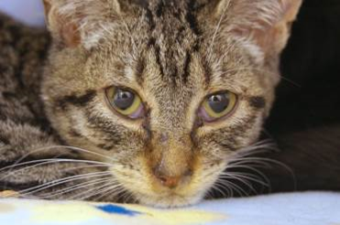

Nasal discharge
A kitten that has contracted the Herpes virus.
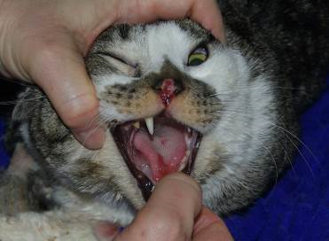
A cat that has contracted the Calicivirus

Tongue Ulcer
Nasal Ulcer
Calicivirus
- Symptoms: Fever of 102.5° F or higher (typically a high spiking fever of 104.0° F or higher), yellow or green nasal discharge, red sores on the tongue, the roof of the mouth, or nose, loss of appetite, lethargy, limping (caused by inflammation) usually found on a rear leg for kittens.
- Action: Check other kittens in the litter and the mother for signs of infection. Make sure the cat/kitten is eating or nursing well. Offer smelly food, human baby food (chicken or turkey with no onion or garlic), or boiled skinless chicken breast chopped into tiny pieces.
- Treatment: Amoxicillin (see dosing under Amoxicillin) every 12 hours for seven days IF colored nasal discharge is present. “Steam” twice a day with a hot shower running in the bathroom or by using a humidifier. Never add anything but water to the humidifier. Little Noses with Saline can be used in both nostrils up to three times per day. Saline can dry out the nose and cause bleeding. Avoid using saline if the cat/kitten is having bloody sneezes. If the cat/kitten is dehydrated, give sub-q fluids at room temperature to bring down the body temperature—never cool fluids. For cats/kittens who are limping or not eating due to painful mouth ulcers, use sub-q
fluids to help with the fever, and contact the shelter for pain medicine.
- Cleaning: The foster room will need to be wiped down twice a day, including the walls, since the spray from a sneeze can project up to 4 ft. The virus can live in the environment for up to 28 days. The virus is killed only by bleach or Accel. The sick cat/kitten should have his face cleaned with a warm washcloth or gauze pad at least three times a day. Use soap and water, not hand sanitizer, to clean your hands after touching the kittens. Calicivirus is not killed by hand sanitizer.
- Notes: If the cat/kitten does not improve after six days of treatment, contact the hospital to see if they want the medication extended to 10 days or if they would like to change to a different medication. You will need to know the kitten's weight if they want to prescribe a new drug.

Vomiting
- Symptoms: Partly digested food, hair, clear saliva-looking vomit, or a yellow or green slime.
Action: Determine who is vomiting and how often. What has the cat/kitten thrown up? You will need to differentiate between hairballs, food, and stomach acids. Has the cat/kitten been anywhere near plants or other substances that could pose a poison risk? Is it foaming at the mouth? Did the cat/kitten throw up after being given medication or food?
- Treatment: One episode of vomiting (or a scarf and barf) is not cause for concern. Call the On-Call Lead Mentor for advice if a kitten has vomited twice within 24 hours. Give SQ fluids. If the shelter is open, they may have you come in for medication to help the kitten stop vomiting. If an adult cat vomits more than three times in 12 hours, call the hospital for a same-day appointment or contact the on-call lead mentor after hours.
- Cleaning: Spot clean the area with a disinfectant cleaner, rinse, and dry.
- Notes: Dehydration is a significant concern for kittens. It is vital to establish who is vomiting and what they are vomiting to stop it.
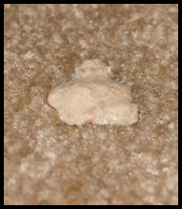
Cleary foamy vomit Partly digested baby food Partly digested food

Cat and Kitten Restraint Basics
Nose and mouth ulcers.
Photo Credit: Debbie Brusius

Please remember that you should use restraining methods as minimally as possible, whatever technique you choose.

The following are methods of restraint employing a towel:
Lateral Recumbency: In kittens, this position is the most helpful when taking a temperature, administering sub-q fluids, or administering vaccines.
- In one hand, wrap the cat lightly in a towel.
- Using your opposite hand, grab the cat’s hind legs and place the animal on her side.
- Wrap the cat or kitten snuggly with the towel to control her feet and body. A sock can be used as well for smaller kittens.

Taco Method: This method traps the cat’s legs but leaves access to the head and rear.
- Drape a towel with the middle over the cat’s back.
- Sweep the sides of the towel together underneath the cat.
- Lay the cat on her side.

Burrito Method: Covers legs and entire body; access is only open to the head.
- Place the towel on the table.
- Lay the cat about one-third of the way down the length of the towel.
- Take the short end of the towel and wrap it around the cat’s body and legs.
- The long end of the towel should wrap the cat up in the opposite direction, with the extra length of the towel covering the cat’s rear.

Snake Hold:
- Place your forefinger and middle finger on top of the cat’s head and your thumb and ring finger under the jaw.
- This hold is an excellent alternative to scruffing calm cats while allowing you access to scruff the cat if absolutely necessary.
- The snake hold is more advanced and requires practice before use on an unknown cat.
REMEMBER: Cats are very agile, strong, and capable of using all four feet and/or their teeth in defense.

Use distractions:
- Pet vigorously on the head or back.
- Tapping or blowing gently on the cat’s head or nose.
Use caution:
- The cat could try to get away
- The cat may swipe at you
- You could get scratched or bitten

FVRCP Vaccine Administration
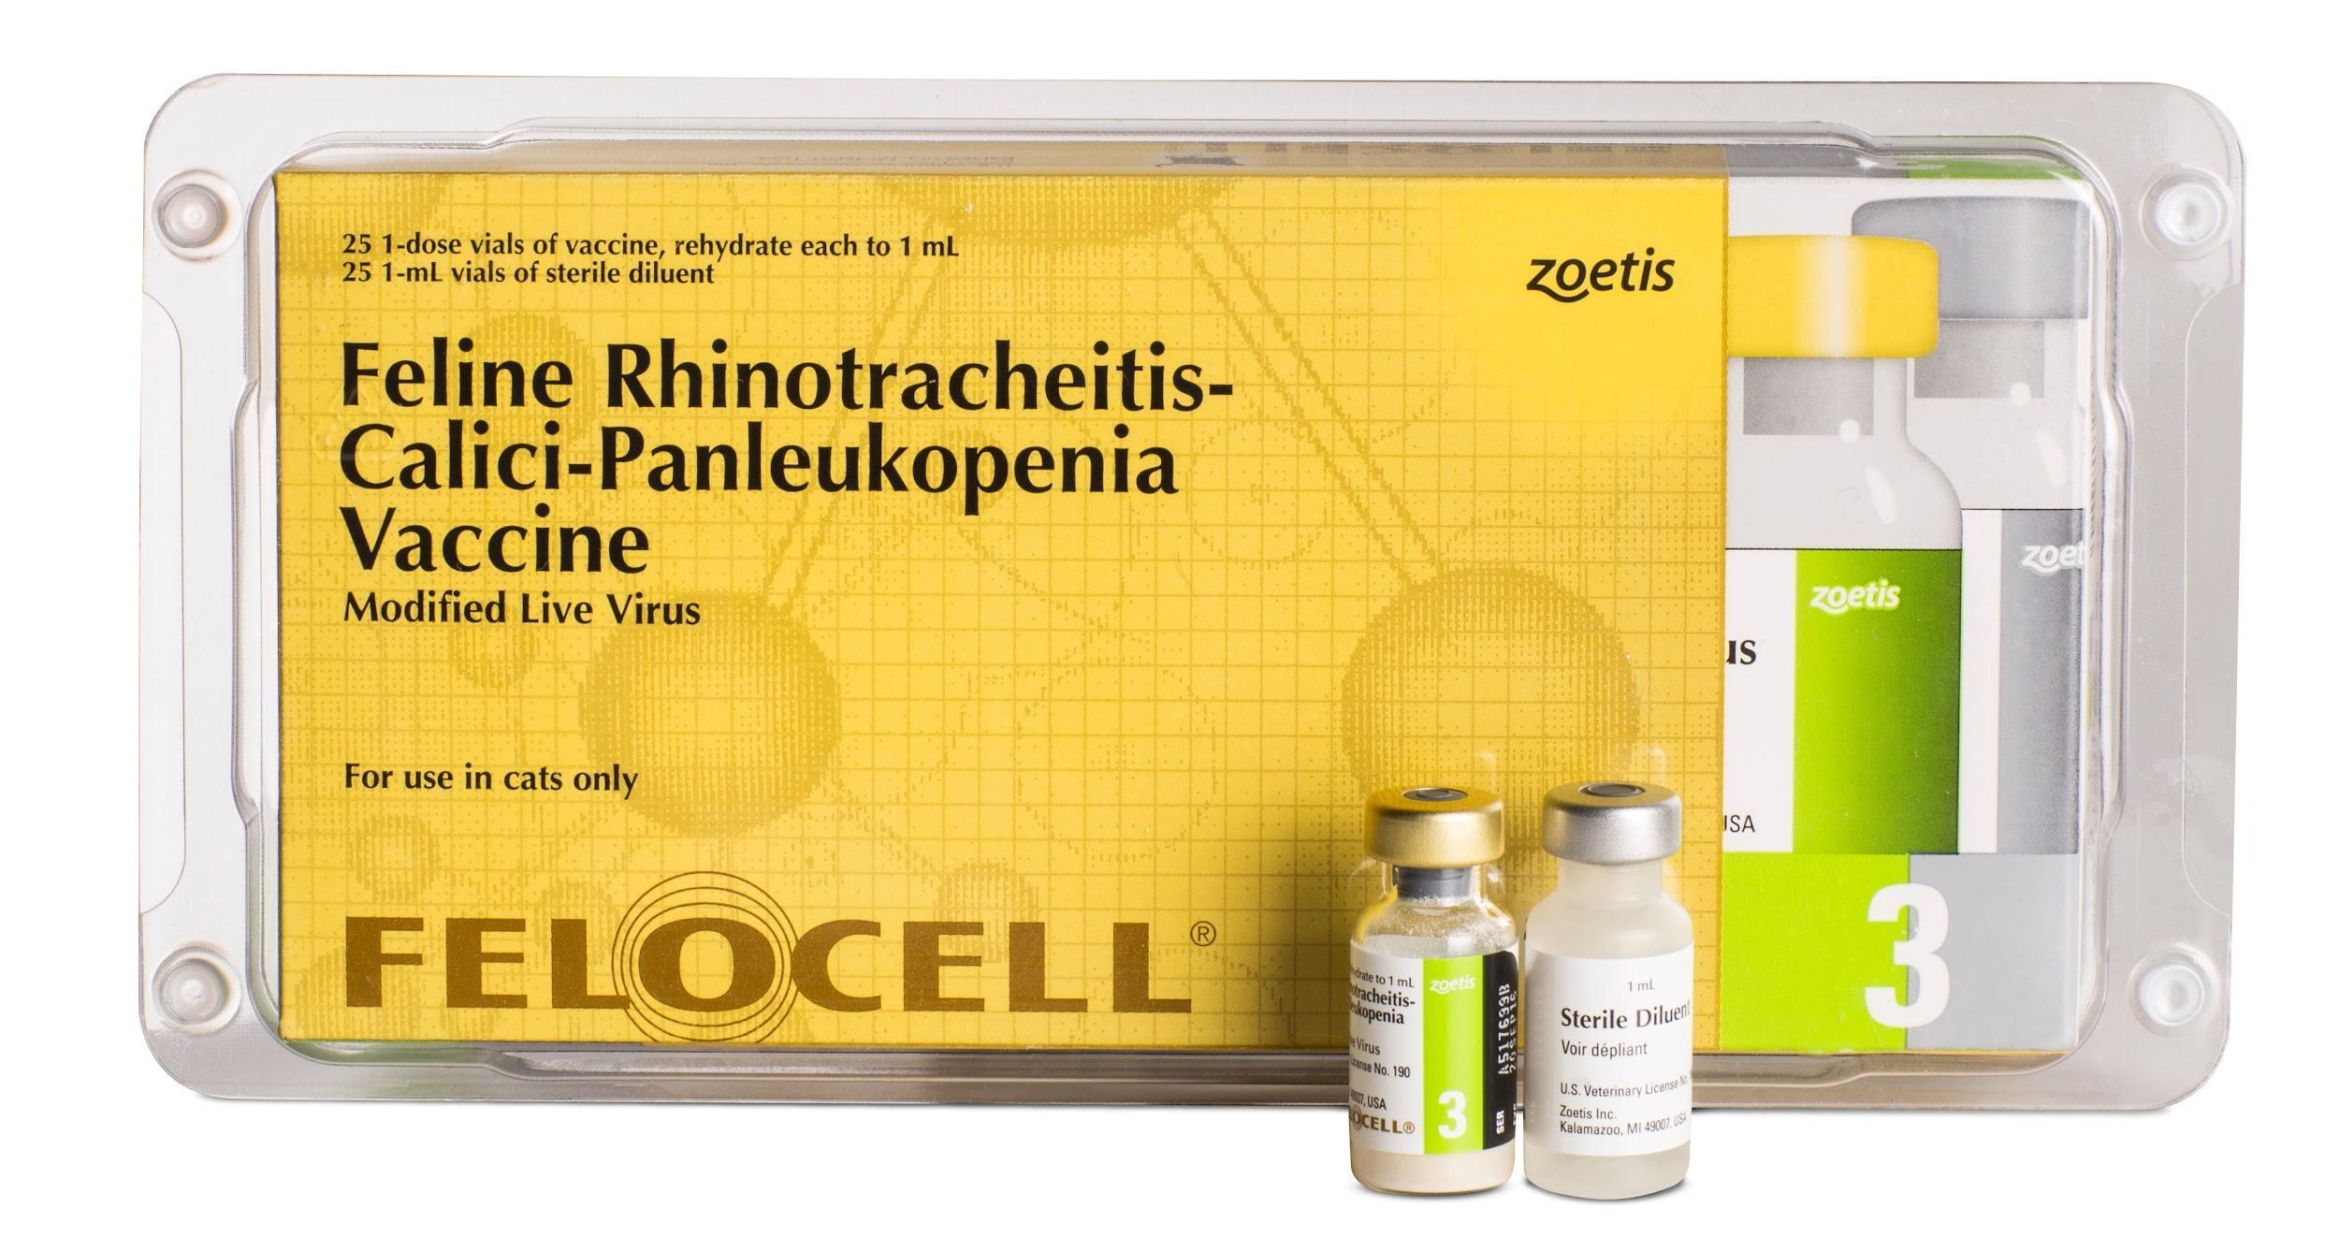

Safety
Our vaccines contain modified live viruses, which means it can be very dangerous if cats/kittens get any on their fur or in their mouth. You should always have gauze and alcohol ready to go in case of a spill to wipe up the vaccine. Do it immediately, don’t let mom or babies clean it off.
Never use the same needle on two different cats, even from the same litter. Needles should be changed between drawing up the vaccine and injection, and a new syringe should be used for each cat. Needles become dull very quickly. If you miss-shoot, ensure you only use the needle to poke twice. After that, a new needle will be needed because the needle will dull and start to hurt.
Vaccines must be kept in your refrigerator at 36-44 degrees Fahrenheit. Do not allow them to freeze. Vaccines must be mixed and administered within 15 minutes of removal from the refrigerator. If the vaccines have not been stored as described above, they must be discarded.

FVRCP vaccines should only be postponed if the cat or kitten has a fever (102.5 or greater). Temperatures only need to be taken if the cat shows signs of illness.

Procedure
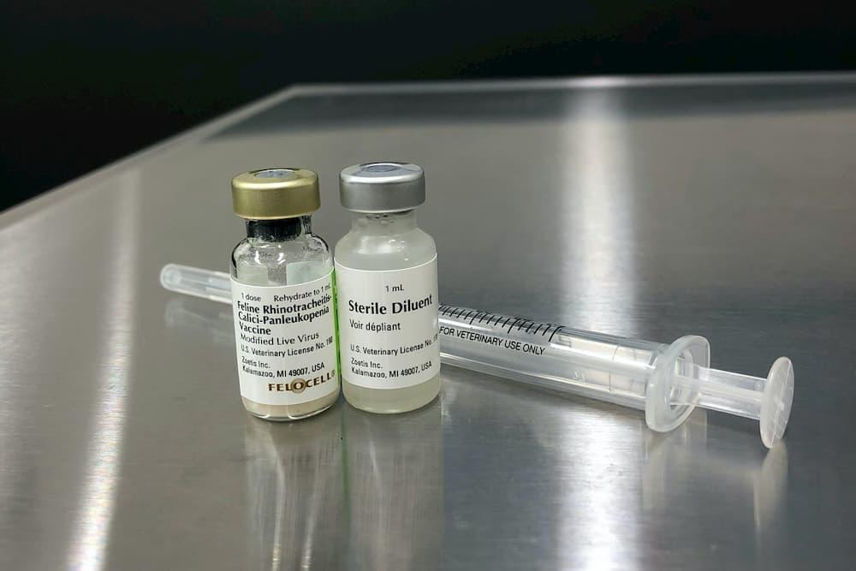
Prepare the vaccine before getting the cat. Cats can fear the sounds of plastic packaging and lose patience quickly if they wait for you to draw it up.

To prepare the vaccine, remove the 3 ml syringe from the package. Insert the needle into the diluent vial and draw up all the liquid. Insert the needle into the powder vial and depress the plunger. Roll the vial until all the powder is mixed into the liquid. It should appear pink in color. Draw up the vaccine in the syringe. Replace the needle with a fresh 22g needle.

It’s helpful to have two people to administer the vaccine, even after you’ve had a lot of practice. Kittens, especially, are quite squirmy, which can make giving the vaccine difficult. Have your partner hold the cat, usually holding it, so the head is pointing toward them. They should offer a yummy treat to distract the cat, like Churu or baby food. They may also “bounce” the kitten or pet the kitten’s head as a distraction. Wrapping them in a large towel or blanket may be helpful for kittens that are hard to distract.

Vaccines should be injected top-down, so the needle points down into the leg. They should also be administered as far down the leg as possible. If the injection site should have a reaction, which is rare but does happen, this position can save the leg, and the cat’s life, should the leg need to be amputated.

The person giving the vaccine should stand so that the injection site is on the opposite side of the cat from them. FVRCP vaccines are always given in the right front limb. Stand so that the cat's left side is against you so you can reach over with both hands.

Pull up a small tent of skin from the cat’s leg and insert the needle into the tent. Pull back on the needle just a bit- if you see air coming into your syringe, you poked through the skin. Reposition the needle until you pull back and get negative pressure (no air). Start injecting but make sure you feel and look for liquid coming out. It’s very easy to push all the way through the skin the first time. If that happens, immediately wipe it up with your alcohol and gauze and try again. At least half the shot should be injected. If you don’t think that much has made it in, they will need another shot within 24 hours.

Once you’ve injected, pull the needle right out and re-cover it, so you don’t poke yourself. The needle should be taken off and stored to be brought back into the shelter in a secure container for disposal.

Tips for giving vaccines from your fellow mentors!

- Hold off on feeding their meal, so they are hungry, and the food distractions are effective.
- Play with them beforehand to get them tired out.
- Move them to an unfamiliar room just before giving the vaccine.
- Get fast at it! Practice on a banana or a stuffed animal if you are new.
- Try using a smaller needle size (the default is 22g, but we can send 25g if requested). Keep in mind that the smaller gauge means it will take longer to administer.
- Scarf wrap with a good blanket or towel, needs to be strong enough that they can’t wiggle out!
- If they still squirm when wrapped up, try other distractions instead. Sometimes the wrapping itself is stressful.
- Have your holder pet their entire head/face while controlling it. You can even tap gently on their nose!
- For fearful cats, cover fully with a blanket or towel and pull out the front limb. You can do this right from their hidey bed or box. Have the person holding keep control of their head. Try to make sure they can’t back away.
- Scruff as a last resort. It is very stressful for cats.

Subcutaneous Fluids (Sub-Q Fluids)
If the cat/kitten has a fever, use room-temperature Lactated Ringers Solution (LRS). Otherwise, warm LRS in a warm water bath for five minutes. Shake the syringe or bag well and check the temperature by putting a few drops on the inside of your wrist, as you do for a baby’s bottle. It should feel warm but not hot.

Have some yummy food ready to distract them. Wet food, baby food, or Churu are good options. You can also have someone hold them, pet their face/head or bounce them up and down as a distraction. If they are squirmy, try wrapping them in a towel with only the head and back of the neck exposed.

Prepare your supplies ahead of time. Remove the wrapping from the fluid bag and prepare your syringe or line, so you are ready to go. Try to do this away from the cat to reduce noise and stress.

You should always use a fresh needle when administering fluids. Syringes can be reused on the same kitten for the duration of their illness but should be discarded afterward. Fluid bags should be discarded ten days after opening.
Kitten/Cat Weights and Fluids

Fluids (in mL) should be administered based on the weight of the kitten/
cat. Please see the chart below for reference.

Weight Daily Fluid Dose
5-15 oz. 5-10 mL
1-2 lb. 15-20 mL
3-4 lb. 60-80 mL
5-8 lb. 100-120 mL

Supplies Needed
For kittens:
- Sterile scalp vein set or “butterfly” set
- Large sterile syringe. 20-60 mL
- Sterile 18-gauge needle
- Small bag (250ml) of Lactated Ringers (LRS)
For Adults:
- Large bag (1000ml) of Lactated Ringers (LRS)
- Sterile 18-gauge needle
- Fluid line

Administration of Sub-Q fluids for a Kitten
- Remove the plastic packaging from the LRS bag. Pop off the cap from one of the ports at the bottom of the bag.
- Place an 18-gauge needle on the syringe.
- Insert the needle into the bag via the port and draw up the desired amount of LRS into the syringe. Warm fluids now, if needed.
- Remove the needle from the syringe and put the scalp vein or butterfly set on the syringe. Depress the syringe slightly to remove air from the line.
- Make a tent on the kitten’s scruff, remove the cap from the needle, and insert the needle into the scruff tent parallel to the spine. Depress the syringe. Watch for leakage, indicating the needle has gone in one side and out the other. If this occurs, pull the needle back a little bit and continue.
- When finished, pinch the injection site for a couple of minutes to help the hole close and reduce leakage. Some LRS will still leak out, and that is okay.

Administration of Sub-Q fluids for an Adult Cat
- Remove the plastic packaging from the LRS bag. Pop off the cap from one of the ports at the bottom of the bag.
- Remove the plastic packaging from the fluid line. Remove the cap and insert the spike into the uncapped port on the LRS bag. Allow the fluid to flow until the air is out of the line.
- Warm the LRS bag before starting if needed by placing it in a warm water bath. Hang the LRS bag at least 2-3 ft above the cat.
- Put a new sterile 18-gauge needle on the end of the fluid line.
- Make a tent in the kitty’s scruff, remove the needle cap, and insert the needle parallel to the spine into the tent.
- Open the fluid line by unrolling or unhooking the pinch points. Note how much LRS is in the bag when you start so that you’ll know when you’re done!
- Look at the “well” in the fluid line to see how fast it is flowing: if it is not dripping continuously, check that the bag is hung high enough, or try moving the needle under the skin to improve flow. Be careful not to pull the needle out.
- When the desired amount of LRS is in the cat, close the fluid line by rerolling or rehooking the pinch points.
- Remove the needle from the cat's scruff and pinch the injection site to reduce leakage.
- Replace the cap on the needle and leave the used needle on the fluid line. The next time you use it, you will put on a fresh needle.

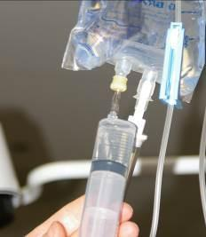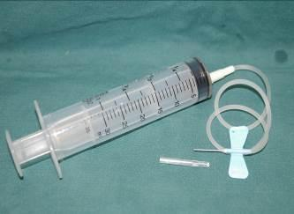
Correct set-up

Draw fluids here

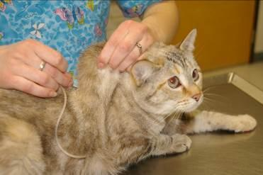

Emergency Contacts
Please call the On-Call Lead Mentor first. If you cannot reach them, please call the On-Call Manager. The On-Call lead mentor for the week will be emailed out on Sundays and can also be found on the shared Google Calendar. The On-Call Manager schedule will be emailed out once a month.

On-call Lead Mentors
Name Number
Please remember that these phone numbers are for true emergencies only.

On-call Doctors and Managers
Name Name
Title/Position Title/Position
Phone Number Phone Number

If you can’t get a hold of the On-Call Lead Mentor, please try the On-Call Manager. If you cannot reach the On-Call Manager after 15 minutes, please try again. Wait 15 minutes before calling the next contact.

After the second call, when you do not reach someone, leave them a message stating that you will call the following person (leave the name). If you do not hear back from the second person in 15 minutes, leave them a second message that you have called the first person, the second person (them), and now you are calling the third person. Hopefully, this will never happen, but everyone will know what is happening just in case it does.
Mentors
See Kitten Foster Manual for the mentor contact list.
Hospital Line for urgent issues on weekday mornings (TIMES) - PHONE NUMBER

Mentor Assistants
Mentor Assistants are trained to give FVRCP vaccines and SQ fluids. You can contact them to assist you as needed. You will need to provide them with direction on what needs to be done, and they should provide you with information about what they observe. They are like your hands, eyes, and ears when you can’t physically be there!

Name | Phone | Email | Area of town | In-home vs. Travel
Name | Number | Email | Location | Both

