So You Want to Throw a Kitten Baby Shower???
When is the best time to throw a shower?
We suggest late March, April, or early May. This will help you get supplies on time and psych everyone up for the imminent arrival of kittens. A weekend day in the late morning or early afternoon works best.
Who should be invited?
Staff, Volunteers, Foster Families, Donors, Public
Where?
If you can hold the Baby Shower at your shelter it gives you a chance to showcase your shelter to potential, volunteers, donors, and adopters. Ideally your space should be large enough to accommodate attendees as well as a refreshment table, information table, gifts/donations, and a space to play games.
Food and Beverages
It’s nice to have refreshments available for your guests. Some sort of beverage, punch is great, as well as, cookies, cupcakes, etc. Items that do not need to be cut for serving are easiest. Try calling around to local grocery stores and bakeries to see if they would be willing to donate baked goods for your event. You can advertise their business and make them an official “sweet treat sponsor.”
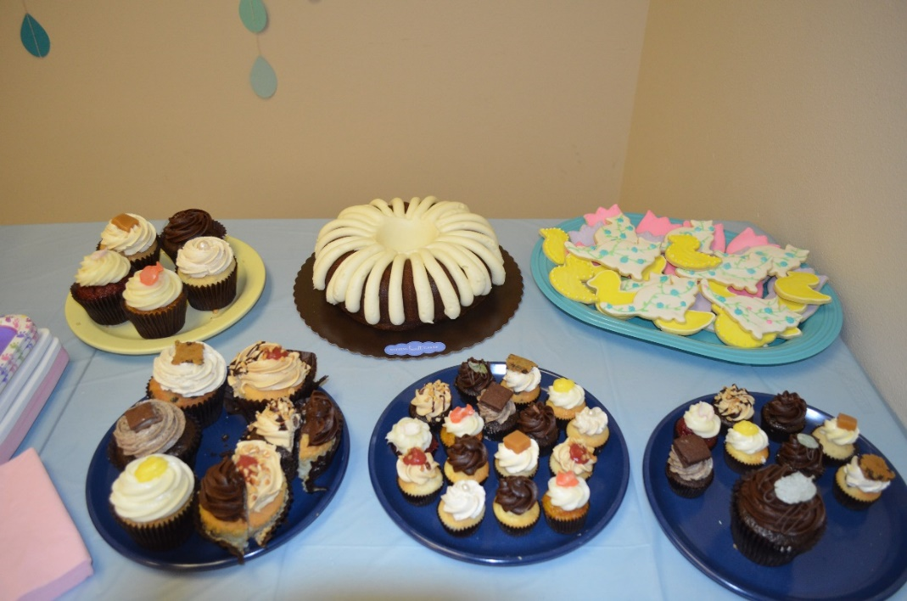

Décor
Make it a real party and hang some baby shower décor! Dollar stores and discount stores often have these items for cheap. Get your crafty staff and volunteers involved and have a decorating and set up party before the event.

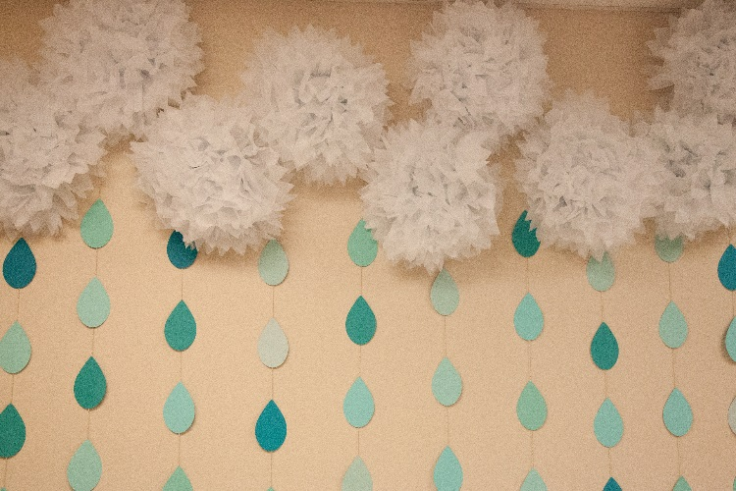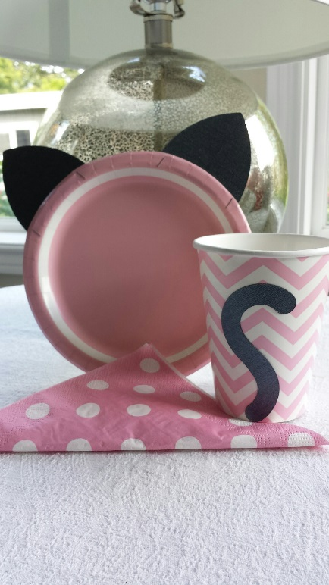

Games and Activities
Baby shower games are a great way to engage your guests. We typically do 3 games for small prizes. We have also held raffles as a way to generate revenue at the shower.
Baby Shower Game Examples:

1. Pin the Nose on the Cat
Supplies: Large poster of cat face, multiple cat noses, pens, tape, blindfold
Object: Participants attempt to pin the nose of the cat while blindfolded.
Winner: The winner is the person who most closely places their nose on the cats face – no ties!*
Prize: $10 Tom’s Pancake House Gift Certificate
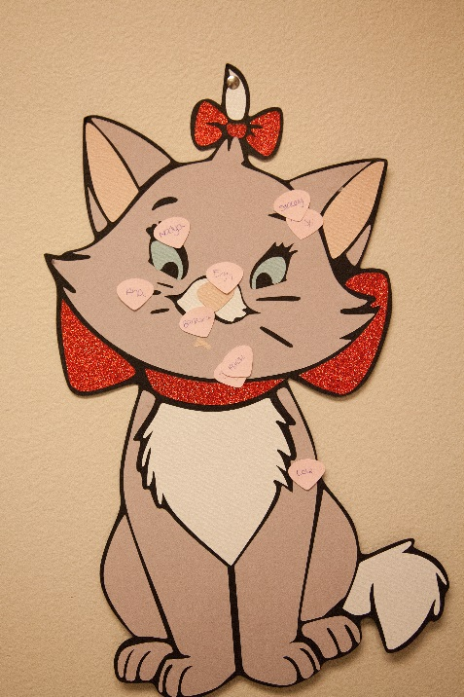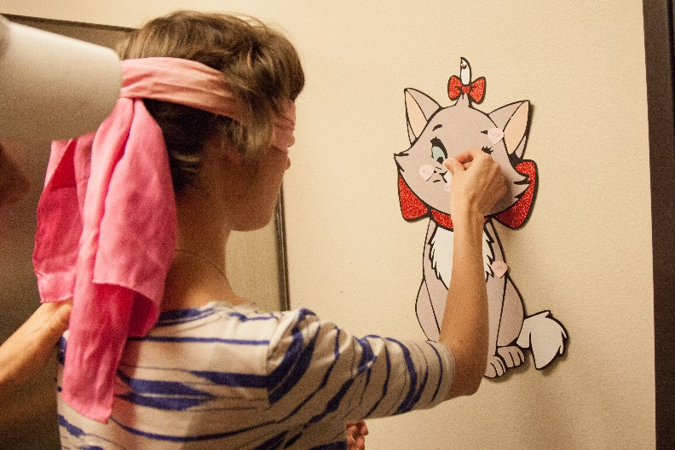

2. Kitty Name Game
Supplies: Answer sheet, pens, answer key
Object: To guess as many of the most popular cat names from 2012 correctly
Winner: Whoever guesses the most names correctly is the winner – no ties!*
Prize: Old Spaghetti Factory Gift Card

3. Draw a Kitty
Supplies: White paper plates, pens
Object: Participants will hold a paper plate on the top of their heads and attempt to draw a realistic kitty – will give folks one minute to draw.
Winner: Whoever the person running the game thinks has drawn the most realistic looking kitty.
Prize: Cookies by Design Gift Certificate

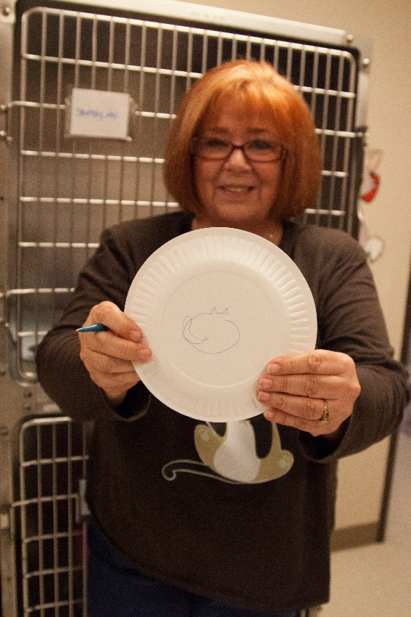

4. Guess the Number of Baby Cat Kibbles
Supplies: Baby Bottle, Royal Canin Kibbles, Small guess sheets with space for name and email address, bowl to collect guess sheets, someone who knows the number of kibbles in the bottle
Object: Participants will submit a sheet of paper with their name and contact information and a guess of how many kibbles are in the bottle.
Winner: Who ever guesses closest to the actual number of kibbles without going over – no ties!*
Prize: Hand Painted Pet Portrait
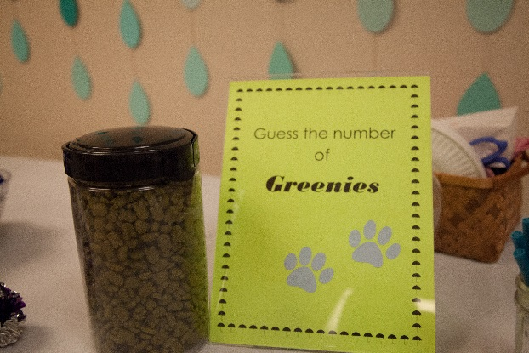

*All ties will be broken by a rousing game of rock, paper, scissors
Pinterest is also a great resource for finding ideas for baby shower games and décor.

Raffle and Fundraiser
Another great way to raise funds is to hold a raffle. Shower attendees can purchase tickets for a chance to win prizes.
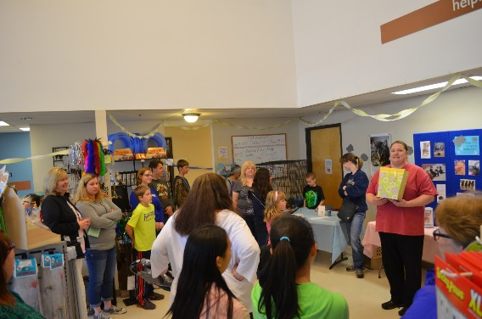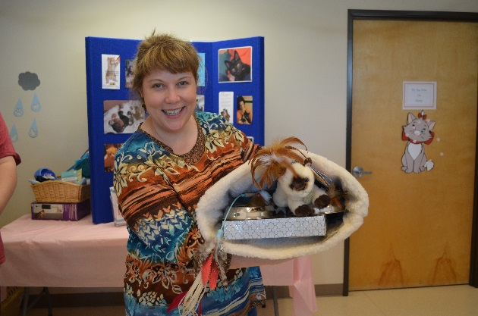

Gifts and Donations
An Amazon wish list is a great way to let folks know what supplies you most need. Amazon has a great ranking feature to help you indicate which items are of greatest priority. A link can be included in any electronic communications promoting your event. You may also want to include a wish list in plain list form for people who do not wish to purchase online. Have a donation collection jar predominately placed at the actual event to collect more funds day of.
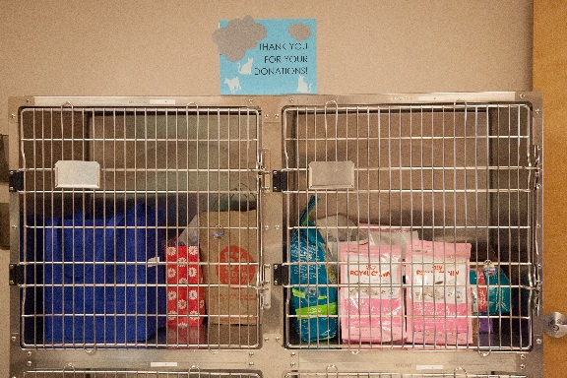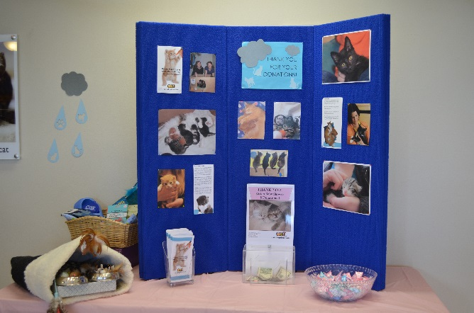

Kitten Foster Program Wish List
Royal Canin Baby Cat Dry Food Gallon Size Ziplock Freezer Bags
Avoderm Chicken Wet Food A/D Ointment- 4 oz. size in tube
PetAg KMR powder Medium Sized Diaper/Baby Bags
Pet Nursing Kit for Kittens
Frontline Plus for Cats
Advantage for Cats
Quick Read Digital Thermometers
Flea Combs
Pet Hair/Lent Rollers & Refills
Hand Sanitizer – 4oz bottles & refill packs
Latex Exam Gloves
Multi Colored Fine-Tip Sharpies
Little Noses Saline Drops
Little Noses Decongestant Drops
Baby Wash Cloths
Information and Foster Recruitment
The Baby Shower event is a fantastic opportunity to educate the public about your program and recruit volunteers and foster families. Have a sign-up sheet for folks to leave their names and contact information if they are interested in learning more about the foster program. It’s also nice to have informational signs and posters about your program.
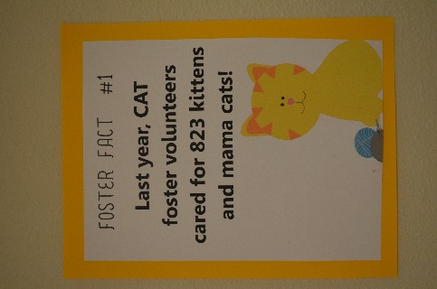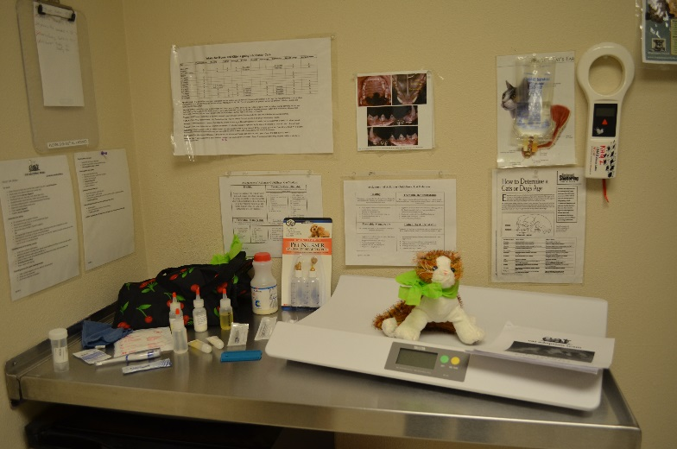
Volunteers/Staff – Who is going to run this thing?!
You will likely need a few extra hands to help your event run smoothly. The easiest way to ensure your event runs smoothly is to make sure each task has a person assigned to it. The Baby Shower Task List Included in this document will give you a list of tasks that need to be completed, who is in charge of each task and a space to set a deadline for when each task should be completed. Please see the Volunteer Jobs section of the Baby Shower Task Checklist for volunteer job descriptions.

Baby Shower Task Checklist

Task | Who | Deadline | Notes
Setup
Remove unnecessary items from event space
Cleaning - Sweep, Mop, Dust, Garbage
Hang Decorations
Set up Tables, Signs & Info, Refreshments
Games
Game #1 Guess the Number of Cat Cookies in a Jar
Game #2 Draw a Cat without Looking
Game #3 Guess the price
Create Guessing Slips
Procure Game Supplies
Hosting
Greeter at Front Door
Refreshment & Donation Area
Gift & Donation Control
PR & Marketing
Create Invitation
Create Invite List
Create Facebook Event Page
Create Organization Website Event Page
Post Invite on Organization Website
Send Event Information to Local Media
Schedule Posts to Social Media
Include Information in Organization Newsletters
Have In-Kind Donation Forms Available for Event
Signage
Create Signs for Games
Create "Wish List" Handout
Create "Reasons to Foster" Signs
Create Event Sign for Front Door/Lobby
Donations Needed for Event
Food & Drink Donation
Decorations
Cups, Plates, Napkins
Prizes for games
Volunteer Jobs
Photographer - 1
Games Master - 2
Greeter - 1
Refreshment - 1
Cash Donation Monitor - 1
Set Up - 2
Clean Up - 2
Gift Donation Manager - 1
After The Event
Post Photos to Social Media
Create Thank You Post for Social Media
Send Thank You Notes
Remove Décor
Organize Donated Items
Move Tables & Cages Back to Proper Locations
Sweep, Empty Garbage, Clean as Necessary

