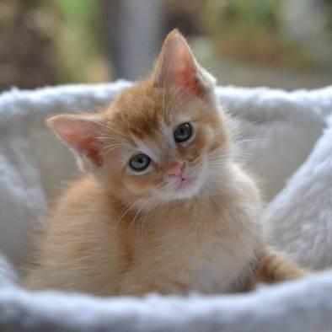
Foster Mentor
Photo by Cassidy Devore

Handbook

Your organization’s contact information and hours

Your Organization
FOSTER MENTOR HANDBOOK
Table of Contents
Welcome, Mentors! 4
Position Description: Volunteer Foster Mentor 5
Position Description: Volunteer Foster On-Call Lead Mentor 6
Competencies of a Mentor 7
How Often Should You Contact Your Foster Parents? 10
Mother Cat Health Check 11
Reading Body Language 13
Maternity Foster Home Guidelines 14
Kitten Health Check 19
Reading Body Language 24
Determining the Sex of a Kitten 25
General Weight Guidelines 26
Heating Devices 26
Supplemental Slurry Feeding 27
Orphaned Kittens 28
HOUSING 29
POTTY TRAINING 30
APPROPRIATE PLAY 31
CRYING AT NIGHT 31
FOOD 32
BOTTLE FEEDING 33
Vaccination Chart 37
Kittens and Vaccinations 38
Vaccine Reactions 39
Vaccine and Deworming Protocol 40
When a Foster Parent Calls 41
Signs of Ill Health 46
When Is It an Emergency? 47
Emergency Call Sheet 48
Quick Treatment Reference 49
Dosing 50
Medications and Commonly Used Remedies 50
Anemia 54
Anorexia/Losing Weight 54
Blood in Urine 55
Chin Acne 56
Coccidia 57
Conjunctivitis 58
Constipation 60
Coughing 60
Dehydration 61
Diarrhea 62
Failure to Thrive 64
Feline Infectious Peritonitis (FIP) 65
Hernia 66
Hypothermia 66
Lethargy 67
Lice 68
Limping/Lameness 68
Mastitis 69
Feline Panleukopenia 69
Ringworm 70
Seizures 70
Upper Respiratory Infection (URI) 71
Herpes Virus (Feline Rhinotracheitis Virus) 72
Calici Virus 73
Vomiting 74
Cat and Kitten Restraint Basics 75
FVRCP Vaccine Administration 77
Subcutaneous Fluids (Sub-Q Fluids) 78
Emergency Contacts 80
Foster Sheet 81

Welcome, Mentors!

Welcome to Your Organization’s mentor team! The purpose of Your Organization’s mentor program is to provide support to our foster parents. Our volunteer mentors are talented people with a great variety of skill and knowledge - sometimes being able to find a way to get a kitten to eat something can require a little creativity. Simply put, mentors provide the invaluable service of helping foster families with questions and supportive care when the shelter is closed. Thank you for joining the team, and we look forward to working with you!

The following guide for becoming a mentor was compiled from the knowledge and wisdom of experienced staff and fellow mentors within the foster program at Your Organization.

You are the extension of our hospital and foster program, and must follow all directions and guidelines given. This includes helping new foster parents understand what the policies are and why we have them.

As a mentor, your responsibilities will include:

- Calling your foster family shortly after they take their cat/kittens home to introduce yourself, and let them know you are available to help with questions or concerns.
- Familiarizing yourself with the foster care program, including maternity foster home guidelines. Read and reread them! Many answers to questions are already there but can be forgotten in the excitement of new cats and kittens.
- Acquiring information about kittens born in foster care as soon as possible. The information of color, sex, and litter size needs to be reported so the kitten list can be updated, and the kittens are entered into Shelter Buddy. People love to talk about their birth experiences. Often, a foster parent just wants reassurance that everything is normal. Give them the opportunity to do most of the talking and only relate experiences that would be helpful or pertinent to the situation. Always be supportive; remember how it felt with your first litter!
- Answering questions to the best of your ability in regards to the cats/kittens in their care.
- Referring your foster families to other sources if you don’t know the answers to their questions.
- Checking in with your active foster families every couple of weeks if you have not heard from them to whether they need any help or support.
- Vaccinating kittens on time and helping foster parents with deworming.

Position Description: Volunteer Foster Mentor

Title: Foster Mentor

Reports to: Foster Coordinator

Purpose of Position: Provide support to foster families and act as a liaison between foster parents and the shelter/hospital.

Duties and Responsibilities:
- Ensure foster rooms are set up properly and in accordance with program guidelines. Be able to offer suggestions for improving foster room setup.
- Ensure that foster kittens are being vaccinated, dewormed, and medicated on time, and that all are being posted to the Google Form so the shelter can maintain up-to-date records.
- Encouraging foster families to submit pictures and bios of their kittens to the Petfinder team by the time kittens reach six weeks of age.
- Be a resource for questions regarding behavior issues that may arise for foster families.
- Field calls and emails from foster parents regarding the mother cat and kittens.
- Counsel foster families through difficult situations involving foster kittens. Preparing fosters for the possibility of the death of a kitten, and helping them to cope with the loss if it occurs.

Qualifications: One to two years of experience as a foster parent for kittens with Your Organization or similar organization. Demonstrated knowledge of Your Organization’s foster program protocols. Willingness to travel to foster parents’ homes to give routine vaccinations and check on sick kittens.
Training Requirements: Foster training and shadowing of a current mentor and/or attend mentor training. Adoption counselor training not required but a bonus.
Time Commitment: About 2-12 hours per week—varies depending on the time of year and how many foster families you assist.
Benefits to Volunteer: See kittens find forever homes. Work with foster families and Your Organization’s staff. Opportunities to attend workshops on cat-related topics as offered by Your Organization. Advanced volunteer opportunity with room for growth.

Position Description: Volunteer Foster On-Call Lead Mentor

Title: On-Call Lead Mentor

Reports to: Foster Coordinator

Purpose of Position: Be a liaison between Your Organization’s hospital and foster parents/mentors and the Foster Coordinator.

Duties and Responsibilities:
- Be on-call as a backup to Foster Mentors for medical emergencies and approve hospital visits via the veterinarian or other on-call manager.
- Counsel foster families through difficult situations involving foster kittens. Prepare foster parents for the possibility of the death of a kitten and help them to cope if they encounter a loss.

Qualifications:
- Minimum of one to two years’ experience as a Foster Mentor.
- Demonstrated extensive knowledge of Your Organization’s foster program protocols.
- Willingness to travel to foster parents in some situations.
- Willingness and availability to be on-call 24/7 during assigned on-call time periods (usually one week at a time).

Training Requirements: Foster training and shadowing of a current on-call lead mentor.
Time Commitment: About 1-6 hours per week—varies depending on the time of year.
Benefits to Volunteer: See kittens find forever homes. Work with foster families and mentors, and Your Organization’s staff. Opportunities to attend workshops on cat-related topics as offered by Your Organization. Know that you are making a difference. Advanced volunteer opportunity.

Competencies of a Mentor

What attributes should a mentor have?

Approachability
- Easy to approach and talk to
- Spends the time and makes the extra effort to put others at ease
- Warm, pleasant, and gracious
- Sensitive and patient
- Builds rapport
- Good listener

Why is approachability important? All mentors are volunteers, and we recognize that you have many responsibilities beyond taking calls from foster parents. But, if your foster parent does not feel like they can call because they might be interrupting you, then things can become worse for the kitten. It is very important that you set clear boundaries with your foster parents. For example, establishing when they should call you and when they should email. Keeping open communication by email for
non-emergency needs allows for communication as it fits your schedule.

Compassion
- Genuinely cares about people and kittens
- Concerned about fostering and non-fostering problems, if it impacts fostering
- Available and ready to help
- Sympathetic when dealing with the death of an animal
- Demonstrates real empathy with the joys and pains of others

Compassion is the second part to approachability. In your experiences as a foster parent, your own mentor in all likelihood displayed great compassion as you talked over some situations. When you had those tough litters, your mentor was there to support you through those tough times. Foster parents feel like their foster kittens and mother cats are an extension of their families and they may find it hard to send them back to Your Organization. This tends to happen more with new foster parents, and they may look to you for support and guidance.

Composure
- Cool under pressure
- Does not become defensive or irritated when times are tough
- Mature
- Can be counted on to hold things together during stressful times
- Handles stress well
- Not knocked off balance by the unexpected
- Does not show frustration when issues seem to be ongoing

Composure can play a big role in being a mentor. At times, situations can be very stressful; for example, when you get a phone call about a kitten who is found unconscious on the floor, and is now lethargic and appears to be on the brink of death. You are the one who helps foster parents through these tough times. You are going to need to be able to get information from a stressed and panicked foster parent. Remaining calm as the medical staff tries different treatments for a sick kitten helps maintain a less stressful atmosphere. How you respond to these situations can make a huge difference to your foster parents. It is okay to shed a tear and show empathy, but in the moment it’s most helpful to remain calm and not escalate anxiety.

Directing Others
- Good at establishing clear directions
- Sets fostering objectives (fostering within a household’s limits)
- Describes how to identify a sick kitten
- Lays out work in a well-planned and organized manner
- Maintains two-way dialogue with foster parents
- Brings out the best in people
- Clear communicator

Mentors need to be able to communicate clearly when instructing foster parents. For example, if a foster kitten is sneezing but not showing signs of an URI, the manner in which a mentor tells a foster parent what symptoms to be on the lookout for needs to be clear, and give them specific symptoms and behaviors to look for. It is also important to let foster parents know what to do if further symptoms develop. Simply saying, “wait three days and let me know how it’s going” is very frustrating to a foster parent who wants to provide the best care possible for the kittens and may not have encountered kitten illness before. Clear direction keeps the guesswork out of the hands of the foster parent, and makes foster parents feel supported.

Setting realistic fostering expectations with foster parents can be a challenge, as they want to save the world! Some foster parents are best with small groups, and then after time can work up to more challenging groups. Do not forget the second half of the season, where kittens and moms seem to be ill more often.

Listening
- Practices attentive and active listening
- Patient when hearing people out
- Accurately restate the opinion of a foster parent even when he/she disagrees
- Listen for what is not addressed and ask questions to find answers

As a mentor, you will be contacted about a wide range of questions. Each of these competencies will play a part in your ability to help your foster parents. Besides giving clear instructions, listening is another challenge. What did the foster parent mean by “gooey eyes”? Is the kitten just cuddly? As you listen, you need to confirm with the foster parent what you are hearing. You are the eyes and ears for the Veterinarian if you need to contact him/her about a particular situation.

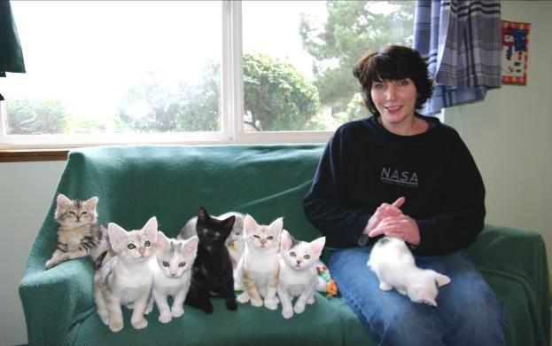
Photo by Debbie Brusius

How Often Should You Contact Your Foster Parents?

You should contact your foster parent as soon as they take a new litter home. If you have not been to their home, we ask that you make an appointment to meet with them to put a face with a name and to help kitten-proof their foster room. This meeting is meant to be fun, not an opportunity to be critical of the foster family. If you have serious concerns about a foster family, please contact the Foster Coordinator. You should continue to check-in with your foster parents every one to two weeks.

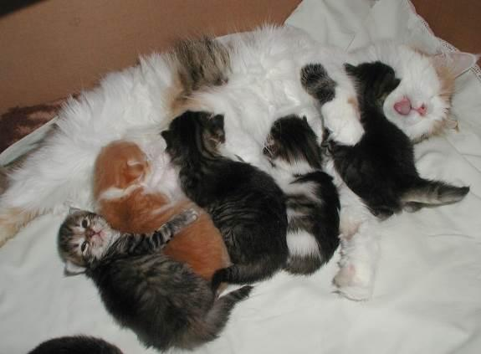

Mother Cat Health Check

Why check your mother cat as soon as you get her? This will give foster parents a chance to establish what is “normal” or notice something that the shelter might have overlooked.

- Ears should be clean with no discharge. Dark-looking wax and constant scratching could indicate ear mites.

- Eyes should be clear, bright, and free from discharge. The third eyelid should not be showing.

- Nose should be cool and damp to the touch. There should be no nasal discharge or crusting around the nose.

- Mouth and gums should be pink and odorless. The gums should not be tacky, as if you were touching the tacky portion of a post-it note. Tackiness could indicate dehydration. An older mother cat could have tartar on her teeth or gingivitis (inflammation of the gums). If the mother has a broken tooth, please alert the Foster Coordinator.

- Fur should be clean and shiny. Make sure there are no missing patches that could be a sign of ringworm. Black dandruff is flea debris, which all kittens/cats are treated for before going into foster care. White spots at the top of the fur could mean lice. Feline lice is not contagious to people or other animals besides cats, but it still needs to be treated. White spots or flakes not at the top of the fur is often dandruff and is easily brushed away.

- Rear ends should be clean.

- Body should be in good shape, but often moms are thin and bony, aside from their bellies. She will need extra food to get her weight up.

- Nipples should be clean and usually erect. There should not be any blood coming from them. The breast tissue should not feel hard or as if there are large lumps within it, nor should it feel hot to the touch—these could be signs of mastitis. The nipples should not be red.

AN ILL MOTHER

If the mother cat is ill or malnourished when she rears her litter, her illness leaves a lasting deficit—both physically and psychologically—on all of her kittens. Sick kittens are more common in the latter half of the kitten season. This is thought to be because the mother cats are into their second or third litter at this point in time and their bodies are worn down as a result.

An ill mother cat will most likely be less attentive to her kittens and less able to do her maternal duties, specifically teaching social skills. The early social skills that a mother teaches her kittens are essential to preparing them for later in life. If that learning stage is compromised, those kittens will have personalities that reflect this deficit. This can lead to kittens growing into cats with behavioral problems such as being timid, aggression issues, and/or an antisocial attitude toward other cats.

LIMITED MILK

If the mother has insufficient milk for her litter, the kittens will end up smaller and weaker than properly nourished kittens. This situation may also result in kittens who lack proper social and physical skills. Kittens who spend an extended amount of time suckling in an attempt to get nourishment from their mother’s supply will have less time to learn how to interact with other cats. Food instability will also create an environment in which the kittens will not be able to relax.

Reading Body Language

TAIL

- Erect, like a flagpole = friendly, content, ready to interact
- Hairs on end (piloerection) = heightened anxiety, passively aggressive
- Wrapped somewhat tightly around body = wants to be alone, possibly fearful
- Inverted U = defensive aggression (but in kittens can signal play)
- Curled very tightly around body = threatened
- Arched over back with piloerection = defensive aggression (may lower tail if other animal doesn’t back off)
- Arched over back without piloerection = interested, aroused
- Thumping = conflicted, frustrated, irritated; may attack

VOICE

- Chattering = excitement when seeing prey but unable to get to it
- Chirp = expecting something desirable like a treat or meal; mother cats to kittens
- Growl = offensive or defensive low-pitch sound
- Hiss = open-mouthed snakelike sound, usually defensive
- Meow = greeting just for people
- Mew = identify and locate another cat
- Moan = a long, sad sound made just before vomiting, when disoriented (in senior cats), or when wanting to be let inside or outside of a space
- Murmur = soft, closed-mouth sound used as a greeting, can accompany purring
- Purr = contentment, anxiety (stress-relief mechanism), or self-soothing when ill or injured
- Shriek = harsh, high-pitched sound for pain or highly aggressive meetings
- Snarl = threatening expression with upper lip curled, showing teeth, and can accompany a growl
- Spit = sudden, short popping sound, heard before or after hissing
- Squeal = raspy, high-pitched sound when expecting food; also occurs during play
- Trill = chirp-like sound that is more musical, expressing happiness

NOTE: For your convenience, “Reading Body Language” is repeated in the Kittens section.

Maternity Foster Home Guidelines

We hope that this experience will be as rewarding for you as it is beneficial to the health and well-being of mom and her kittens. The majority of births and newborn litters are trouble-free and require only your quiet supervision. The information here will help you prepare for any complications that can, although rarely do, arise. If you have any questions or concerns not addressed in these guidelines, please call your mentor. Keep in mind that these are only guidelines and are not meant to replace expert advice.

Preparing For the Birth

It is imperative that you have a quiet, out-of-the-way place in your home that will be warm, safe and available for the entire time you are fostering. This means that this space will only be used for mom and her kittens for the time you have them in your care. Inaccessibility from other family pets like dogs, or your resident cats, must be strictly enforced. This is absolutely necessary for the health and safety of not only the litter, but for your resident animals as well.

New mother cats have been known to abandon or even resort to cannibalism if they feel that other animals or people threaten the well-being of their babies. This is especially true with mothers who are not well socialized.
What to expect when she’s expecting

A cat can be in heat from 6-20 days. Pregnancy can be diagnosed by a veterinarian between 20-30 days after mating. The typical gestation period for a cat is 63 days. A cat may gain 2-3 pounds during pregnancy, depending on how many kittens she is carrying. She will require more and more food as her pregnancy progresses, and we recommend that you feed a high-quality kitten food and provide her with constant access to food before, during, and after the birth of her kittens.
New kittens are very susceptible to disease and can pick up illnesses from your seemingly healthy pets. Also, the stress of pregnancy and birth can cause the mom cat to become ill from something that has been dormant in her system, so do not put your resident pets at risk by exposing them.

A kittening or nesting box must be provided for the expectant mother. This can usually be a cardboard box without a lid and a hole cut out of the side for the mom cat to enter and exit. Fill it with clean towels or old cloth diapers and let her make her own nest. Change this bedding immediately after the birth and then on a frequent basis because it will become soiled – so don’t use the “good” towels.

After the birthing is over, remove the towels and replace them with fleece blankets, fleece beds, or cloth diapers. Some kittens cannot retract their claws and get caught in the loops of towels, making it difficult for them to crawl around. You can also put several layers of bedding in the nest prior to the birth; after the birth, you can roll the dirty upper layer off and gently move the kittens onto the clean layer underneath.

Provide a litter box, food, and water. During pregnancy, and during the nursing weeks, dry and wet canned kitten food should be fed to the mom cat. Kitten food is recommended for lactating females, as it has extra calories and nutrients and will help support mom cat during this very exhausting time in her life. Let mom eat as much as she wants—after all, she is feeding a brood herself!

The shelter strives to feed a premium diet to provide the best support for the mother cat, the best start for the babies, and an easier transition to the diet they will be fed when they return to the shelter.

The Birth

A week or less before the event, mom cat may start to move about furtively, root about in the nest, and may possibly attempt to escape the room you have designated for her in hopes of finding a linen closet or soft bedspread for her delivery. Be sure to keep your eye on her to ensure she stays in her room!

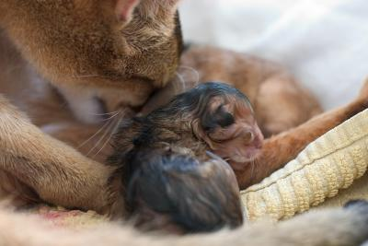
About 24 hours before delivery, you may notice her belly drop to form a “pear” shape and her nipples start to swell with milk. A small amount of discharge from the vagina is also normal. This is usually the first sign of labor and can last up to six hours. Mom will start to breath heavily, pant, or purr during this time. Some moms-to-be will give you clues that it is time—others will not. Some will not eat until the deliveries are finished and some will snack in between. Some will be vocal while delivering and some will be silent. Some will want you in the room, others will not. Let mom tell you what she needs. After all, having kittens is a natural and normal experience and cats have been doing it for thousands of years!

Most feline births are routine and trouble free, so try not to disturb her during the process. Make sure she has access to food and water, and replace her regular litter with shredded paper in the litter box before delivery begins. She will start the second stage of labor, straining a few hours before the first kitten is born. If, however, she has been heavily straining, for an hour without producing a kitten, or three or more hours pass between kittens, call your mentor.

Occasionally, first time moms will not quite “get it.” If this is the case and she delivers a kitten, and just walks away, she might not realize that it is alive and needs her care. The membrane covering the kitten’s face must be removed immediately so the kitten can breathe. If mom doesn’t do this, gently tear open the sac covering the head so the kitten can breathe. After the first kitten, mom usually figures it out and carries on as she should. Most moms will eat the afterbirth as it contains nutrients and hormones she will need to recover from the birth. She will also bite through the umbilical cord and clean the babies. After she has cleaned the kitten, she will take a rest. This rest could last 30-60 minutes before she starts labor again to give birth to the next kitten.

Signs of a Difficult Delivery

Most births proceed without incident, and your role as a foster parent is to quietly monitor the birthing process. However, call your mentor immediately if any of the following happens during delivery:

- The mother cat seems to be straining or having strong contractions for a period of 1 hour without delivering a kitten.
- There is unusual discharge from the vulva under the tail. Normal discharge is green; abnormal can be black, cloudy, or foul-smelling.
- The mother is not cleaning the kittens after delivery. If this occurs, use a piece of sterile gauze and remove any fluid from the nose and mouth. Then dry the kitten using a clean towel and a gentle rubbing action.
- A kitten is not breathing. If this occurs, rub him vigorously with a towel for several minutes all over his body to stimulate breathing.
- Occasionally the umbilical cord will not separate from the mother and kitten. If this occurs, take a thread and tie a knot ½ inch from the kitten’s belly and another knot 1 inch towards Mom, and then cut the cord with the scissors between the two knots. This will prevent bleeding if the cord tears. Don’t be surprised if the cord retracts back inside mom during a contraction. The cord and placenta will be delivered in time. Never pull on the cord to try and get it out.
- You observe any excessive bleeding (more than approximately two teaspoons).

Post-Delivery

After the delivery of the litter is finished, try to observe the family to make sure that the kittens are nursing, and that mom is not bleeding excessively from the vagina. If things are not as they should be, call your mentor. Once the event is concluded, and mom and kittens are resting comfortably, replace the soiled towels with clean fleece or cloth and let the new family rest in peace and quiet. Empty the paper out of the litter box and replace with regular kitty litter.

The temperature in the foster room should be kept a little warmer, especially for the first two weeks after birth. This is even more important if the kittens are orphans - ideally the temperature should be around 80F for the first two weeks. If you aren’t able to heat your whole room to that temperature, you can use Snuggle Safe warming disks and make sure the nesting box is well insulated. Be sure that the mom and kittens have the option to get away from the warming disks if desired.

Handle newborns gently, but make sure to check on them at least twice a day. Are they nursing? Hanging out with mom? Crying a lot (this could be an indication that they are cold or not getting enough milk). Make sure to count each time you check on them. Sometimes a mother cat will take a kitten out of the nest and leave it somewhere else in the room. If this happens, put the kitten back in the nest and call your mentor right away. Make sure to weigh your kittens in grams each morning at the same time of day. You want to see them gain 10-15 grams per day.

Be careful! Mother cats can be very protective of their young and become overly aggressive toward resident pets. This means watchful attention when entering or leaving the area you have set aside for mom and her babies.

Umbilical Cord Care

Each newborn kitten should have its umbilical cord swabbed with iodine tincture, an antiseptic antibacterial agent that aids in preventing infection (sepsis) of the umbilical cord site. Please discuss with your mentor or the Foster Coordinator if you don’t have this product in your baby bag.

As soon as the mother has chewed through the umbilical cord, or you have cut it, use a cotton swab with the iodine tincture applied to it to dab onto the entire umbilical cord and the surrounding skin. Repeat the umbilical cord swabbing again on day 2 and day 3. The umbilical cord should dry up and fall off around day 3 or 4.

IMPORTANT: If you see any signs of swelling, discharge, pain, or redness at the umbilical cord site, please contact your mentor at once.

Post-Natal Signs of Trouble

If all kittens and mom seem well, your only obligation to the mom and new kittens for the first week or so is watchful supervision. Mom will need kitten food and water at all times. Contact your mentor immediately if you observe any of the following in the mother cat:

- Acts lethargic, or as if she is in pain or continues to strain.
- Ignores her kittens.
- Continues bleeding from the vulva for more than two days.
- Has painful, hard, or swollen mammary glands

Kittens should be nursing up to 3 times an hour. The mother cat should be grooming each kitten after feeding, and licking their bottoms to stimulate elimination. Contact your mentor if you observe any of the following in the kittens:

- Constant crying and failure to stay at the nipple.
- Refusal to nurse.
- Feels cold to the touch.
- Withdrawing from the other kittens.
- Rejected or ignored by the mother.

Be careful! Children love to play with kittens, but they may not understand how to properly handle them. Please keep in mind that children should not handle kittens under three weeks of age and you must not allow unsupervised handling of any kitten by children under the age of 10.

Kitten Health Check

CHECKING YOUR KITTENS

Why check your kitten(s) as soon as you get them? This will give foster parents a chance to establish what is “normal” or notice something that the shelter might have not have noticed during the initial exam.

- Ears should be clean with no discharge. Dark-looking wax and constant scratching could indicate ear mites.

- Eyes should be clear, bright, and free from discharge. The third eyelid should not be showing.

- Nose should be cool and damp to the touch. There should be no nasal discharge or crusting around the nose.

- Mouth and gums should be pink and odorless. The gums should not be tacky, as if you were touching the tacky portion of a post-it note. Tackiness could indicate dehydration.

- Fur should be clean and shiny. Make sure there are no missing patches that could be a sign of ringworm. Black dandruff is flea debris, which all kittens/cats are treated for before going into foster care. White spots at the top of the fur could mean lice. Feline lice is not contagious to people or other animals besides cats, but it still needs to be treated. White spots or flakes not at the top of the fur is often dandruff and is easily brushed away.

- Body should be sturdy with a nice belly. Sometimes kittens will come in malnourished and, if so, you can often feel their spine, ribs, and hip bones. These kittens will need extra food and attention.

- Rear ends should be clean.

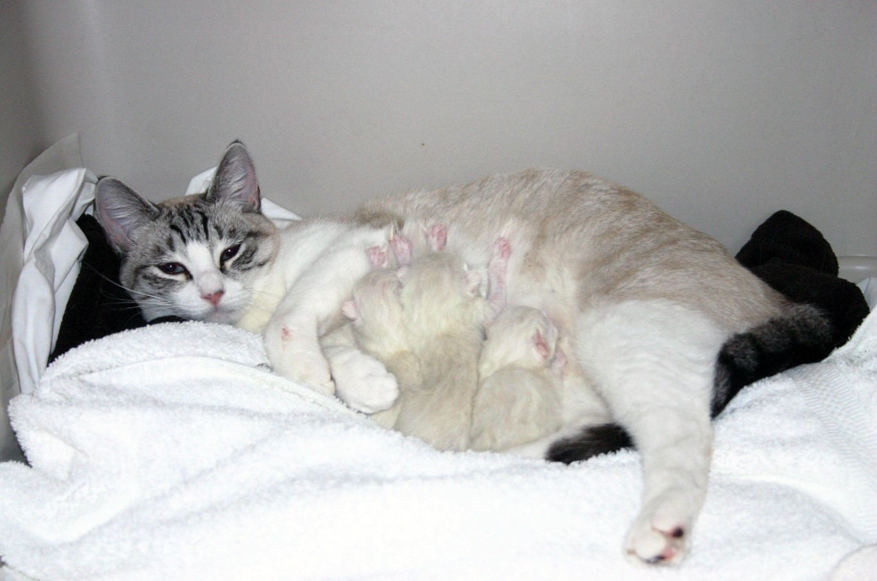
Mimzy and her Newborn Kittens
Photo by Madeleine Barker

EARLY HANDLING

As a mentor, you need to know your foster parents’ strengths. Some foster parents live alone and have quiet homes, while other foster homes can be filled with children, other animals, and lots of sensory stimulants. By introducing these stimulants slowly over a long period of time, foster parents have the opportunity to raise kittens who are well socialized and unfazed by things like small children, dogs, and vacuum cleaners. The amount of handling foster kittens receive in foster care will influence their reaction to humans and other stimuli.

Sometimes, your foster parents might have kittens that are unsure about humans. Mothers and kittens who are truly scared have often been moved at least three different times before they are placed in a stable foster home.

To help these groups, have foster parents keep a TV or radio going with people talking while they are out of the house. If music is used, classical music is best—remember, cats’ hearing is more sensitive than ours. Introducing novel items into the room each day can also let the cat/kittens know that new things are okay. Have the foster parents gently stroke the mother cat and kittens during feeding time and speak to them in a soothing voice. Before you pet them during feeding, first start by sitting near them as they feed, then sitting next to them. Slowly build up their comfort with you until you can pet them as they eat. Confidence starts to show when they roll over to expose their stomachs.

When kittens are done playing, hold them until they settle down. Rubbing your nose or stroking a finger on the side of their face mimics a mother cat licking them, and they sometimes settle down and purr with this activity. Once kittens stop wiggling, let them free by putting them down—the kittens are also training you to know when they’ve had enough. But, make sure this relationship has a good give-and-take dynamic. If you set them down immediately whenever they start to fidget, they will never build up a tolerance for being held and will instead learn that if they fidget you will release them.

If a kitten seems “wild” or “crazy”, then that’s perfect! There is nothing wrong with a wild, energetic kitten—this is just a normal kitten. What would be abnormal is if a kitten was just interested in being cuddled most of the time. However, “wild” should not include biting or scratching people.

TEETHING KITTENS

Kittens can start teething at 2-3 weeks old. The incisor teeth poke through first, followed by the canines, and then the pre-molars. You might find that kittens want to chew on things at this age. This is the time to hide power cords and make toys available. They enjoy biting cardboard boxes during this stage as well, and that is okay.

This period may also be when they start showing an interest in foods. Softening hard food by soaking it in water might help them start eating solid foods.

DROOLING

Quite a few cats drool when they have a pleasurable experience. Salivation is essential to feeding because it lubricates the food and aids in swallowing. It can also indicate nausea or pain, so make sure that nothing else is going on with the kitten.

SENSE OF SMELL

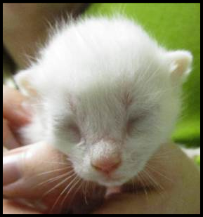
A cat or kitten’s ability to smell has a direct relationship to their ability to eat well. If the kitten or mother is fighting a sinus infection or has a congested nasal cavity, they may not want to eat at all. Canned food that gives off a strong odor may help—something with sardines or fish can help as long as the kitten or mother does not have a sensitive stomach. Another option is to boil a skinless chicken thigh in water with no seasoning. Your fellow mentors can be a wealth of information regarding feeding; be sure to ask them what they have found to work.
Photo by Kristi Brooks

EARS AND HEARING

Although their eyes open between 7 and 14 days old, kittens cannot hear until they are
2 weeks old, and a kitten’s hearing doesn’t fully develop until they are about a month old.

EYE COLOR AND SIGHT DEVELOPMENT

A kitten is born with closed eyes, which will first open anywhere between 7 and 14 days old. All kittens have blue eyes when they are born. When the kitten reaches 4 to 6 weeks old, their eyes will begin to transform into their adult color.

When a kitten first opens their eyes, they cannot see things. In fact, it is about three weeks before their eyes can follow moving objects and they can orient themselves using visual cues. Vision is still cloudy until they reach about 5 weeks of age.

FEET AND PAWS

Typically, cats have five toes on each paw (which includes the dewclaw). However, variations in toe number do exist. Cats with more than five toes on at least one paw, if not more, are called “polydactyl”.

The foot pads are the only area of a cat’s body that contains sweat glands.

TOOTH DEVELOPMENT

When a kitten is born, they have no visible teeth. When they are approximately 10 to 14 days old, their deciduous (baby) incisors begin to push through the gums. They should be fully in place at 4 weeks of age. These six incisors, which appear at the front of the mouth in the upper and lower gums, are designed for tearing small bits of meat off bones and extracting feathers from prey.

At 3 to 4 weeks of age, the canines at the front corners of their jaw come in. Cats use their canines to sever the spinal cord of prey and administer the killing bite.

A 4 to 6 weeks of age, the molars begin to push through the gums along the cheeks, and fully are in place at 6 weeks old. All 26 teeth are in place by the time the kitten is
2 months old.
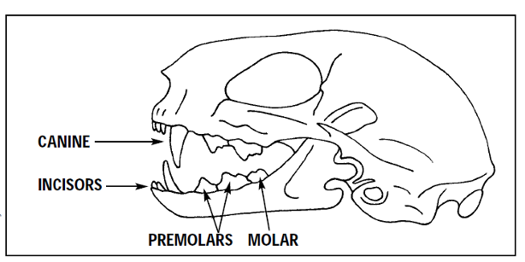

MORTALITY RATE OF KITTENS IN FOSTER CARE

You may have heard that in the wild typically only 1-2 kittens will survive out of a litter.

There are a number of reasons, starting with the available food and quality of food available for the mother cat when she is pregnant. Exposure to disease and illness is another factor that will take lives. How much colostrum did they receive and how much of the Maternally Derived Antibodies did they get? Do they have a birth defect that is internal and undetectable? There are so many things that can go wrong.

In foster care and with the mentor system, we still can lose kittens. Yet, they have the highest chance of survival in our care. We provide high quality food and water, temperature controlled environments, medical care including routine services, and a clean litter box. With all of this extra help we typically have a very high survival rate.

Reading Body Language

TAIL

- Erect, like a flagpole = friendly, content, ready to interact
- Hairs on end (piloerection) = heightened anxiety, passively aggressive
- Wrapped somewhat tightly around body = wants to be alone, possibly fearful
- Inverted U = defensive aggression (but in kittens can signal play)
- Curled very tightly around body = threatened
- Arched over back with piloerection = defensive aggression (may lower tail if other cat doesn’t back off)
- Arched over back without piloerection = interested, aroused
- Thumping = conflicted, frustrated, irritated; may attack

VOICE

- Chattering = excitement when seeing prey but unable to get to it
- Chirp = expecting something desirable like a treat or meal; mother cats to kittens
- Growl = offensive or defensive low-pitch sound
- Hiss = open-mouthed snakelike sound, usually defensive
- Meow = greeting just for people
- Mew = identify and locate another cat
- Moan = a long, sad sound made just before vomiting, when disoriented (in senior cats), or when wanted to be let inside or outside of a space
- Murmur = soft, closed-mouth sound used as a greeting, can accompany purring
- Purr = contentment, anxiety (stress-relief mechanism), or self-soothing when ill or injured
- Shriek = harsh, high-pitched sound for pain or highly aggressive meetings
- Snarl = threatening expression with upper lip curled, showing teeth, and can accompany a growl
- Spit = sudden, short popping sound, heard before or after hissing
- Squeal = raspy, high-pitched sound when expecting food; also occurs during play
- Trill = chirp-like sound that is more musical, expressing happiness

NOTE: For your convenience, “Reading Body Language” is repeated in the Mothers section.

Determining the Sex of a Kitten

It can be difficult to tell the difference between male and female kittens. They are sometimes described as the male looking like a : (colon) and the female looking like an upside down exclamation mark ¡.

Usually there is a bigger space between the anus and genital area in a male kitten—the space where the testicles will grow. It may be possible to feel small testicles in male kittens.
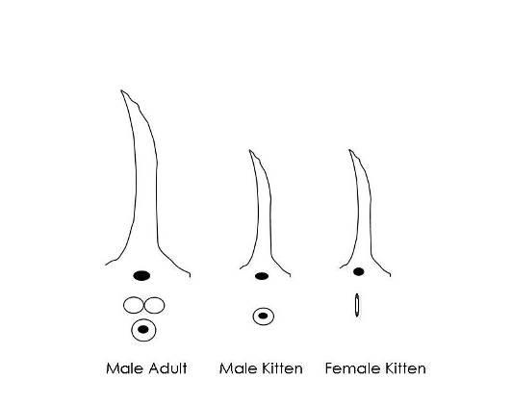

General Weight Guidelines

Ideal weight gain is 4 ounces (113 grams) per week, 1 pound per month. Remind foster parents to note weight gain on their weight chart. This is an average! Help foster parents understand that not all of their kittens will make this mark, and some will surpass it. We want to make sure kittens are gaining weight, and not losing weight. Monitor kitten’s weight daily (it’s not necessary to weigh the kitten more than once or twice per day). If the kitten has failed to gain weight or has lost weight consecutively for 3 days, then consider supplemental bottle feeding or slurry feeding. You should do this after the kitten nurses; you are just “topping off”.

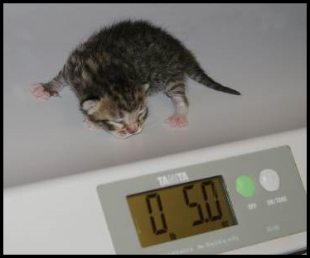
Photo by Debbie Brusius

Heating Devices

Kittens cannot maintain their own body temperature until they are at least four weeks old. The average rectal temperature of a newborn kitten ranges between 92°–97° F. Between 2 to 21 days old, a kitten’s temperature will be about 96°–100° F.

To help a kitten maintain the proper body temperature, the foster parent can place them on a covered Snuggle Safe warming disk or on a sock warmie. When using a disk warmer, the foster parent should set it up so that the kitten can safely move off of it if s/he overheats.

Supplemental Slurry Feeding
Sometimes kittens come to us without a mother cat to nurse and take care of them. If you have kittens who need help eating, you will need to make slurry for them to eat. We suggest using prescription CN or AD, human baby food (Chicken or Turkey with no onion or garlic added), and KMR powder. Take ¹/₈ to ¼ can of AD, one heaping teaspoon of baby food, and one scoop of KMR (you can use KMR Second Step as well). Mix it all together and add warm water until it is a soupy consistency.
First, offer it to the kitten to see if s/he will eat it on their own. If they do not, put some of the slurry on your finger and place the slurry mixture on their tongue—that may be enough to get them interested. If not, then you will need to syringe feed.
Use a 3 ml or larger syringe without a needle. Get a hand towel to wrap around the kitten. This will be messy, so you may want to protect your clothing as well. Wrap the kitten in a towel or blanket (like a burrito) with only the head exposed. Take the syringe and place it behind the canine, open the mouth slightly, and gently squeeze out a little bit of the slurry mixture. The kitten should begin to eat. You do not have to maintain the burrito towel wrap unless the kitten does not hold still for you. Follow the feeding guidelines outlined below, and make sure not to over-feed.
When you notice that a kitten(s) is not eating really well, try boiling a piece of chicken with no seasoning. Cut the chicken into tiny pieces and give to the kitten. Save the broth that has been made by freezing into cubes and then storing in the freezer in a freezer bag. Each broth cube is about 1 ounce. You can take one cube and melt it over the pieces of chicken to keep it moist. If the kitten's tummy is upset, only use chicken breast. If the tummy is okay and there is no diarrhea, use dark meat since it is fattier.
You can also syringe feed the baby food if you don't have AD and can't get it until the following day.

TABLE OF SYRINGE FEEDING AMOUNTS

Age Weight Amount per Day Amount per Feeding
4 weeks 1 lb. 40 mL 5 mL x 8 feedings
5 weeks 1.25 lbs. 45 mL 6-7 mL x 7 feedings
6 weeks 1.5 lbs. 50 mL 8-9 mL x 6 feedings
7 weeks 1.75 lbs. 60 mL 12 mL x 5 feedings
8 weeks 2 lbs. 75 mL 15 mL x 5 feedings
10 weeks 2.5 lbs. 80-90 mL 16-18 mL x 5 feedings

Orphaned Kittens

There are certain difficulties that arise with fostering orphans compared to fostering kittens who still have their mother around. Mother cats are able to teach their kittens lessons that enable them to become great cats when they grow up. Among the various lessons mother cats provide their kittens, some of the most important ones include how to take a bath, how to use the litter box correctly, and the limitations of play, to name a few.

As a result, when you foster orphaned kittens, you will need to be prepared to play the role of mother cat and help your kittens learn the lessons that they will need to become highly socialized, trained, and adoptable. As a mentor, you will need to instruct the foster parents on how to do this.

2 weeks 3 weeks
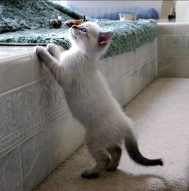
4 weeks 6 weeks

Photos by Madeleine Barker

HOUSING

Make sure the room you provide for your orphans is warm enough for the kittens, including the floor. Often bathroom floors can be cold, so make sure they have a warm place to spend time if they feel they are getting too cool. Foster parents can use a bath mat, bath rug, or put out a couple of cat beds. Don’t advise them to use towels since kittens often like to use towels to go potty on—kittens can get their claws stuck in loops of a towel’s material, which gives them the sensation of scratching in a box and will often stimulate them to go potty.

If foster parents don’t have, or know how to, create a good place for the kittens to sleep, offer to help create a nesting box. You can make one out of a large cardboard box or put a bed in a pet carrier with the door removed. The carrier is a great place for kittens to sleep. It is best to cover the carrier with a blanket to trap heat. They can also jump on top of the covered carrier and sleep there as well.

Snuggle Safe warming disks can also be used to keep a nesting box or other small area warm. Just make sure they have the option to get away from the disk if they get too warm.

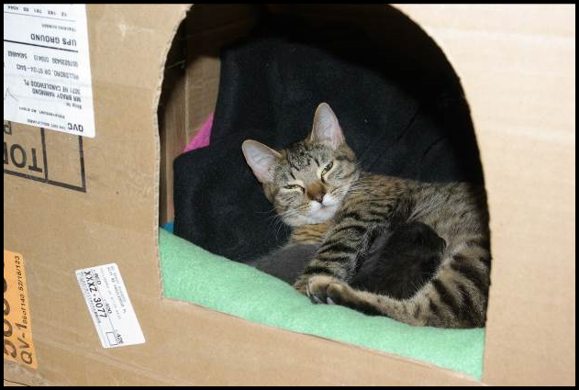
Photo by Debbie Brusius

POTTY TRAINING

If the kittens are not 100% potty trained when the foster parents receive them, you will need to offer tips and tricks on how to get the orphans to use their litter box.

- Kitten Attract brand litter is a great way to get kittens into the litter box; however, this is an expensive option, so you can just sprinkle the Kitten Attract on top of the regular litter and then put the kitten in the box.

- Make sure that the litter box is getting cleaned on a regular basis—a dirty litter box can foster poor potty habits.

- Check to see if the foster parents should try a different kind of litter. Different brands, textures, and materials could provide relief from inappropriate elimination.

- Make sure there are enough litter boxes for the number of kittens in the litter. Be sure that there is plenty of space between the litter boxes—multiple litter boxes placed next to each other act as just one extremely large litter box, rather than separate potty spaces.

- See if the kittens would prefer a differently sized litter box; maybe one with shorter walls or even one with or without a hood will make the difference.

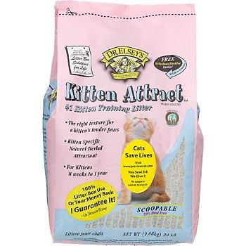

APPROPRIATE PLAY

Mother cats are very adept at handling kittens who display bad manners when playing; they will often swat a kitten, bite a kitten at the scruff, or pick them up to tell the kitten when they are playing too hard and let them know that enough is enough.

Foster parents should never use their hands for play. If a kitten does try to go for hands, have the foster parent spray their hands with Bitter Apple® before they go into the foster room. This should adequately detract the kittens from trying to play with and attack hands. Instruct the foster parent to use a wand toy, laser light, toys they can roll on the ground, etc. While hand play may seem cute and not hurt too badly when a kitten is just 6 weeks old, it not be fun will when they grow into a 12-lb. adult cat who still believes that attacking like this is okay. Remind the foster parents that they are raising kittens to become great cats.

Luckily, kittens can also help each other learn appropriate play. If you have a single orphaned kitten, it will be more work. For a single orphan, offer a stuffed animal (choose one that is slightly larger than the kitten) for the kitten to wrestle and sleep with.

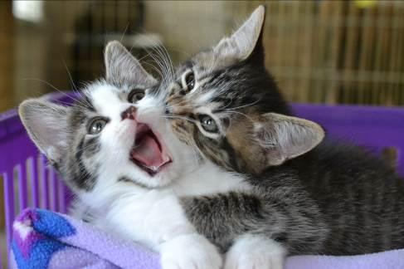

CRYING AT NIGHT

Kittens are like human babies—they eat, go potty, and sleep; they also haven’t learned to sleep through the night yet. One way to keep kittens satisfied at night is to play with them right before you go to bed. After playtime, feed them wet food and turn off the lights. By exercising them and then satiating them, it will help them sleep more soundly for greater stretches of time. Turn on a fan for white noise if needed.

FOOD

As orphans move from nursing to eating food on their own, their tummies can become very upset. If the kittens are under 6 weeks of age they may need to be eating a slurry mixture. See supplemental feeding for tips and tricks as well as amounts to feed. Kittens that are six weeks of age should be eating kibble and wet food on their own without help from the foster parent. Make sure the foster parent is feeding a high quality kitten food (preferably the Purina ProPlan that we provide) and that they are offering enough wet food each day. Dry kibble should be provided at all times, and wet food should be fed in amounts of ¹/₈ can per kitten with three feedings a day, at a minimum.

Baby Food

It is a good idea to have a few jars on hand. Look for baby food that has meat (chicken, turkey, or lamb) as the only ingredient besides water. Teach foster parents to read the labels because some brands are higher in calories than others. You will want the highest calorie content that you can find.

Baby food is good when kittens have upset tummies, aren’t interested in eating because they are sick, or to dip your syringe in before you give them a liquid medication if they have given you trouble in the past.

General Weight Guidelines
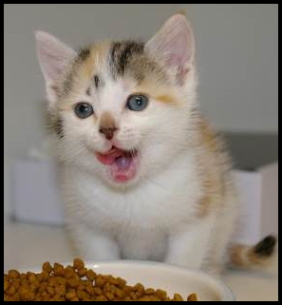
Photo by Debbie Brusius

Ideal weight gain is 4 ounces (113 grams) per week, 1 pound per month. Remind foster parents to note weight gain in their weight chart. This is an average! Help foster parents understand that not all of their kittens will make this mark, and some will gain more. We want to make sure kittens are gaining weight, and not losing weight. Monitor kitten’s weight daily (it’s not necessary to weigh the kitten more than once or twice per day). If the kitten has failed to gain weight or has lost weight consecutively for 3 days, then consider supplemental bottle feeding, or slurry feeding. You should do this after the kitten nurses; you are just “topping off”.

BOTTLE FEEDING

When to Bottle Feed a Kitten

If we take in a kitten that is too young to eat on his own, has been abandoned, refuses to eat, or if the mother cat is no longer nursing her kittens or her milk has dried up, we will then need to bottle feed. A mother cat’s milk can dry up when they are sick, on medications, or too stressed. (Please make sure that mother cat is getting proper care.) Supplemental bottle-feeding can also be helpful when a kitten loses weight or fails to gain weight over a 7-day period, even if she is still nursing on her mother. In this case, you will only be “topping off” the kitten after it nurses.

Foster parents will need the following supplies for bottle-feeding:

- Hot water bottle or heating pad designed for pets
- Cat carrier or cardboard box for kitten nest
- Towels, flannel blankets, cloth diapers, etc. for bedding
- Milk replacer formula
- Nursing bottle with nipples
- Cotton balls or swabs
- Thermometer (in baby bag)
- Scale (in baby bag)

How to Bottle Feed a Kitten

Warmth first! Heat kittens slowly so that you do not put them into shock. You can do this with a towel that has been heated in the dryer, place the kitten on a towel that is resting on a heating pad with the heat setting on low, or tuck a kitten under your shirt and use your own body heat. While heating the kitten, gently massage the body and extremities to get blood flowing throughout the body.

Never let a kitten lie on a Snuggle Safe disc without a cover. Make sure that they have space to crawl off the disc if they get too warm.

Kittens cannot maintain their own body temperature. The average rectal temperature of a newborn kitten ranges between 92°–97° F. Between 2 to 21 days old, a kitten’s temperature will be about 96°–100° F. You will need to build the kitten a nest to keep it warm. The temperature in the room where the kitten is kept should be 80° F. The temperature can be lowered five degrees per week thereafter until a mild 75° F is reached.

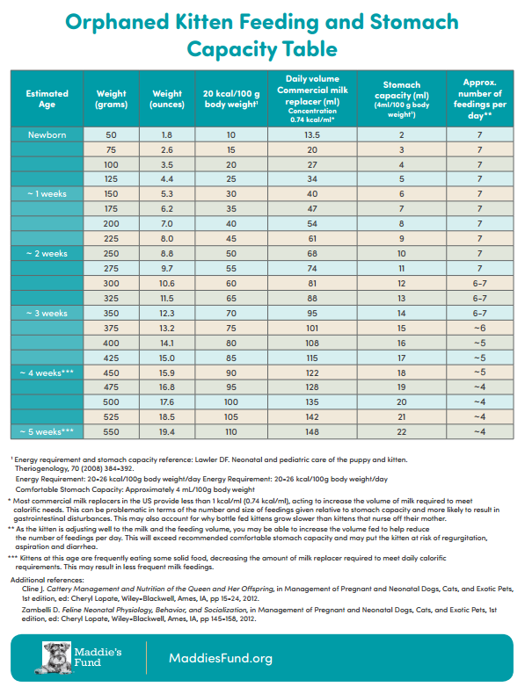It is important not to overfeed or underfeed your kitten. Overfeeding can cause serious health problems that begin with diarrhea and end with dehydration. One way to tell whether you are consistently feeding too much is the appearance of a grayish stool. On the other hand, a kitten who is not fed enough will cry continuously, appear restless, and then listless.

Check your bottle’s nipple to see if formula drips from its tip. If it does not, you will need to widen the hole. You can do this by using a hot needle to poke a larger hole, or use a razor blade to make a small “x” in the top of the nipple. Do not make it too wide though—you want the formula to drip slowly, not pour, out of the nipple.

Be sure you sterilize the bottle and nipple before each feeding, and warm the formula to no more than 100° F. Test the formula on your wrist—It should feel warm, not hot.

Start Feeding

Place your kitten on its stomach on a towel so they can grip the towel with their nails. Lift their head to a 45-degree angle. Squeeze a small drop of formula on to the tip of the nipple. Insert the nipple into their mouth (you may have to open their mouth for them). The angle will help keep air from entering their stomach and will keep milk at the front of the nipple. NEVER HOLD THE KITTEN ON THEIR BACK OR IN THE AIR WHEN YOU FEED THEM.

When your kitten is full, their tummy will be slightly rounded and bubbles will form around their mouth. If the kitten has not finished the bottle, do not force the kitten to swallow the rest of the milk.

If the kitten is not drinking well, you can use a toothbrush to brush down their sides. This mimics a mother’s tongue and will often soothe them. They should nurse from the bottle better using this technique.

Burping Your Kitten

Just like human babies, kittens need to be burped. Hold the kitten up against your shoulder, pat and rub them gently on their back. Not all kittens will burp every time. If the kitten did not finish the bottle, you can offer it to them again.

Stimulating Your Kitten to Eliminate

Kittens younger than 3 weeks of age cannot eliminate by themselves; they need your help. After feeding and burping the kitten, take a washcloth or gauze moistened with warm water and gently rub over the kitten’s stomach and bottom. The action mimics a mother cat’s licking and stimulates the kitten to relieve themselves. Kittens need to be stimulated to eliminate after every meal. Rub until you see evidence of urine and/or stool. A kitten should urinate with every feeding, but it may only defecate 2-3 times daily.

Washing Your Kitten after the Meal

Make sure you wash your kitten(s) after every meal. Kittens are messy and need the simulation of the mother’s tongue. To mimic this, you will need to get a damp warm washcloth and clean their faces with short “licks” like a mother cat would. Make sure you gently towel dry the kitten when you are done. Never submerge a kitten in water.

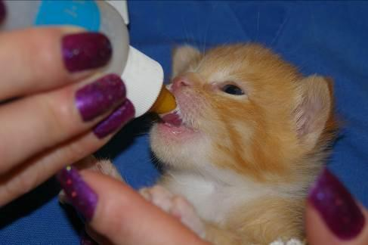
Photo by Debbie Brusius

*This information on bottle feeding was supplied by The Guide to Handraising Kittens by Susan Easterly and approved by the ASPCA.

Vaccination Chart
Kitten’s Name: ID#:
Kitten DOB: ______
Foster Family Name:

Activity | Timing | Approx  Due Date | Enter Date of Completion
Strongid | At 4 weeks or done at time of intake
2nd Strongid | 2 weeks after first dose
1st FVRCP Vaccine | At 6 weeks or done at time of intake
Photo/Video/Bio for Petfinder | Kittens can be  pre-adopted at 6 weeks
3rd Strongid | 2 weeks after second dose
2nd FCVRP | Approx. 21 days after first FVRCP
Surgery | Must weigh at least  2 lbs. and had one vaccinations for 5 days
Droncit | Will be given at time of surgery unless severe or bothersome

Kittens and Vaccinations

When a kitten is born and first nurses on the mother, the kitten gets a dose of colostrum from the mother; this colostrum is filled with good immune cells, also known as Maternally Derived Antibodies (MDA), to protect the kitten from common feline illnesses. MDA interferes with the kitten’s ability to make their own protective immune cells. This dose of colostrum starts to disappear from the body of the kitten between
4-8 weeks of age, but can last in the kitten up to 18 weeks, and we cannot predict the exact timing in the loss of the protection they receive from the MDA.

The idea of using a Modified Live vaccine is to stimulate the kitten’s own immune system into making more protective immune cells as the MDA disappears. By giving the dose of vaccine every 2-4 weeks, we are able to minimize that “window of susceptibility,” which is the time between when the MDA disappears and when the kitten is able to make their own immune cells to fight infectious disease. When we vaccinate kittens at
6 weeks of age who did not get any colostrum, the vaccine may be effective immediately. Kittens who received a large dose of colostrum, or MDA, may not be able to have a response to the vaccine until they are 18 weeks old; the best strategy then is to give the dose of vaccine every 2-4 weeks until the kitten is 18 weeks old.

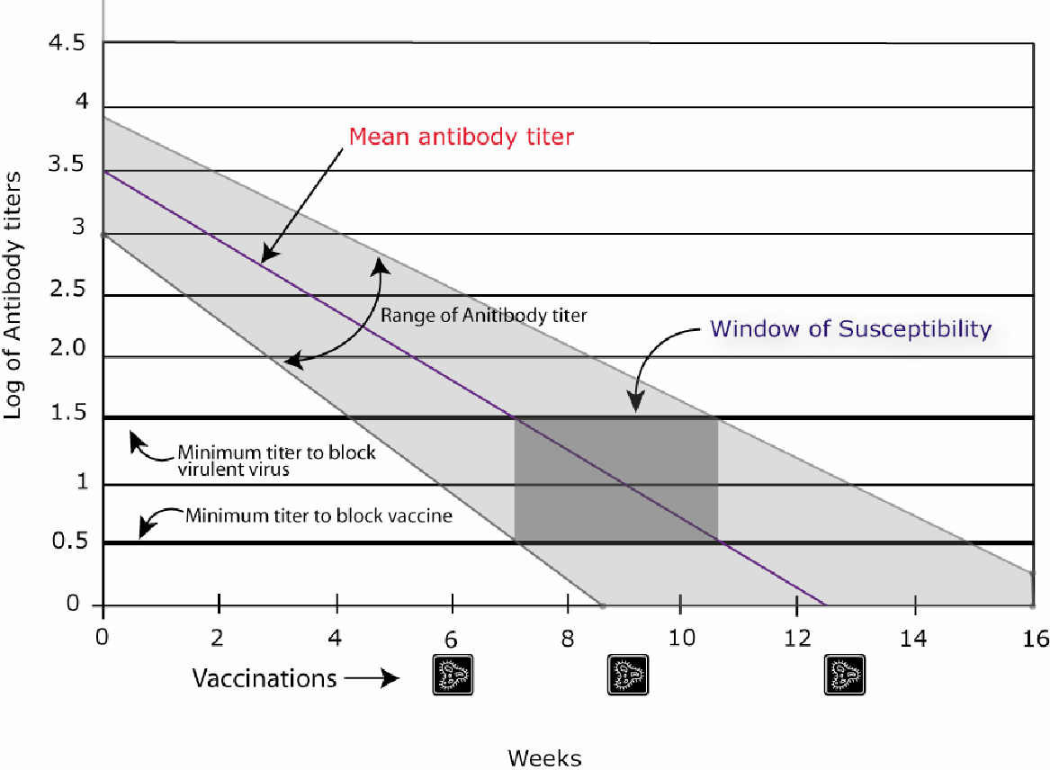

Vaccine Reactions

Vaccine reactions can include, but are not limited to:

- Limping
- Not eating or drinking the normal amounts for 1-2 days
- Lethargy
- Pain at the sight of injection
- Unwillingness to play
- Low-grade fever

If any of these symptoms do not improve by 48 hours after the injection, please contact your mentor.

A more serious reaction happens almost instantaneously and includes severe vomiting, diarrhea, facial swelling and difficulty breathing. The kitten will need to be seen by a vet IMMEDIATELY!

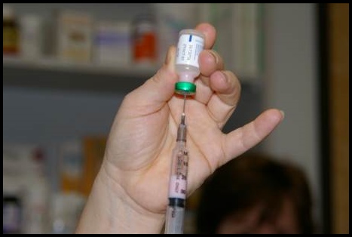
Photo by Debbie Brusius

Vaccine and Deworming Protocol

It’s very important that all mentors understand the vaccine and worming time lines and dosages. Timing on these is very important. If a follow up is given too late, the kitten is not protected and we have to start over—bad for the kitten, expensive for Your Organization, and wasteful of time and effort for all of us.

Vaccines

FVRCP is the vaccine for Feline Viral Rhinotracheitis, Calici Virus, and Panleukopenia (URI and Distemper). FVRCP vaccinations are started at six weeks of age (or at the time of intake if they are older) and are repeated every 21 days. The last FVRCP vaccination in the series is given after the kittens reach over 18 weeks of age.

Mother cats will receive one FVRCP vaccination before going out to foster. They will need one booster FVRCP 21 days later.

FeLV is the vaccine for Feline Leukemia. The FeLV vaccine is not a core vaccine at Your Organization. However, if the vaccine was administered at a previous shelter we will boost the vaccine at 21 days.

Deworming

Strongid is for roundworms. They will look like spaghetti. Strongid is given at 4 weeks of age or older depending on when they went through intake. Strongid kills adult roundworms. Kittens must have treatments every 2 weeks until they reach 3 months of age. The last treatment will kill any worms that hatched after the first treatment, before they lay new eggs. Timing is important! Two or three days early and up to six days late is okay, but if treatment is more than six days late you will need to start the dosing over again.

Revolution is for fleas, ear mites, and roundworms. Mother cats will receive Revolution before going out to foster. Revolution will treat roundworms, so it is not necessary to give them strongid.

Droncit is for tapeworms. They will look like rice. Droncit kills tapeworms. This is a one-time only treatment. Droncit is given at the time of the spay/neuter surgery, UNLESS tapeworm segments are seen by the foster parent before surgery and they are very concerned about it. The treatment is an injection or a tablet. Both should be administered by either the vet staff or the mentors if they are confident about giving injections, and NOT the foster parents. Droncit can be administered to kittens 6 weeks and older.

Cestex is an oral medication for tapeworms: Cestex is a one-time only oral medication that can be given in foster. This can be given by the foster parent and is usually a better alternative than Droncit for the foster home. Cestex can be administered to kittens 6 weeks and older.

When a Foster Parent Calls

When a foster parent calls and informs you that their kitten is sneezing and sick, be prepared with a list of standard questions to get more information. Be sure to listen to your foster parents answers and encourage them to elaborate when describing the situation. This will give you a wealth of useful information. Standard questions include:

Temperature

This is often a question that very few foster parents will have an answer to when they call you. It is important for you to know that a kitten with a temperature below 98º F cannot digest food, and a kitten with a temperature over 102.6º F has begun to have a fever.

As a mentor, you will often have to instruct your foster parents on how to take a cat or kitten’s temperature. The thermometer should be inserted until the silver tip is no longer visible (about ½ inch) for cats and kittens and go along the line of its spine. The normal range is 99º-102º F.

Kittens with a temperature below 98º F will need to be warmed up immediately. The best place to achieve warmth is under the foster parent’s shirt, right against the skin near your heart. You can also warm up a towel in the dryer, but this takes time. You will want to warm the kitten gradually.

Knowing the temperature of a kitten will sometimes have an impact as to what instructions you give foster parents. Is the temperature affected by the environment? Does the foster parent know the room temperature? Just because they might have central air conditioning does not mean that a room with sun beating on it and the door closed will have enough air circulation to keep it cool.

Room temperature is vitally important for the health of the kittens, as they cannot regulate their body temperatures until they are four weeks of age.

Age | Room Temperature
Birth to 7 days | 80º F
8 to 30 days | 75º-80º F
1 month | 75º F

If your foster parent cannot increase the room temperature, then having a nesting box for the kittens is necessary. A box that can create an enclosed space, such as a cardboard box, will be essential for heat retention. You can also use their carrier that they came in (remove the door). Put a towel over the top to help trap the heat.

Cats do not have sweat glands, so during warm weather the foster parents will need to make sure the kittens have access to surfaces on which to cool down. If a Snuggle Safe warming disk is used to create a source of warmth, be sure that it is covered and they have the option to get away from it. Having a surface such as marble tiles or a cooling pad designed for pets (see Foster Coordinator) nearby where the kittens can go to cool down will be necessary. Cooling pads and marble tiles are for kittens four weeks or older.

Eating

How much is the kitten/mom eating? How often are they eating? Kittens need the right amount of food to suit their energy needs at their age. Lack of food can cause low blood sugar levels. Kittens should be gaining 4 ounces (113 grams) a week on average. With nursing kittens, it can be hard to know how much each is getting. If they still chase the mother after feeding, you may need to suggest supplemental feeding.

Don’t forget about the mother cat, either! Sometimes foster parents will be so focused on the kitten that they forget to note what the mother is doing. She will need to be eating enough food to maintain her weight and her milk supply. Lactating moms should have high quality kitten dry food available at all times and be getting 2-4 meals of wet food per day. If the mother is not consuming enough calories, she may not be able to produce enough milk for the kittens.

Knowing how many kittens are nursing on a mother can also make a difference—you need to be sure that she is capable of producing enough milk for the whole group. Depending on the age of the kittens and the size of the litter, the foster parent may need to supplement their feeding with a bottle. The best way to do this would be to allow the kittens time to nurse, and then “top them off” about 20 minutes after they have begun to nurse. If the group is larger than eight kittens, it is best to bottle feed the larger kittens first to allow the smaller kittens more time to nurse with their mother. Sometimes it will be necessary to crate the mother with really small kittens to allow them time to nurse without having to fight siblings.

Orphans will be a little more challenging, as they need to be encouraged to eat. With orphans and weaning kittens, it never hurts to attract them with other food sources. Canned kitten food with sardines, second stage baby food, or unseasoned, skinless, boiled chicken breast can be used as incentives. If the foster parent does choose to boil chicken meat, have them save the juices by freezing them in ice cube trays to add to dry food later on. For more about food and bottle-feeding, see pages 27-31.

Drinking

How much is the cat/kitten drinking? How often is it drinking? Mother cats need fresh water daily; water should be changed at least twice each day. Sometimes if adult cats drink a lot of water it can be a sign of other medical issues. Kittens not yet weaned will not drink much water. If the kittens are eating canned food, which is typically more than 70% fluids, they may not need to drink a lot of water separately.

Along with knowing how much fluid a kitten consumes, foster parents should also monitor for dehydration. When you pick a kitten up by the scruff of the neck and then set it back down, does the skin go back into place quickly? If it instead remains puckered, the kitten is dehydrated. Another way to check for dehydration is by feeling the gums of the kitten. They should be nice and moist, and your finger should slide with ease. If they are tacky, then you should consider administering fluids.

Playing

Playing is a very important gauge of kitten’s health. If the kitten has siblings, do they play with others? Does the kitten initiate play? Sometimes it can appear that two kittens are playing, when in reality one of the kittens is merely picking on the other. Have foster parents make notes at playtime. Do the kittens track their toys? Are they following the toy with their eyes, or do they look down when the toy moves above them? How are their motor skills developing? A big warning sign for health problems is if a kitten just wants to cuddle. There is no such thing as “just a cuddly kitten” or a “mama’s boy”. If a kitten likes to cuddle exclusively and never engages in play, it could mean that they are becoming ill.

Fecal and Urine

Blood in the urine can be a sign of a bladder infection. Sometimes this is only visible at the time the kitten is urinating. Since the background of most kittens at Your Organization is unknown, it is always a good idea to closely monitor a kitten’s activities for the first 48 hours when in a foster home.

Is the kitten crying or straining when attempting to eliminate feces? This could be an indicator of more serious underlying issues. If the kitten continues to strain in an attempt to defecate, it could cause the rectum to prolapse; in most cases, an extended rectum results. Hydration issues could be the root of these problems, so be sure to have foster parents check the kitten’s hydration levels when straining issues arise.

Diarrhea can be a life-threatening situation, as it can cause rapid dehydration. Color, odor, and softness of the stool can all tell you something different. Be sure to ask how long the kitten has had diarrhea, and make sure the foster differentiates between soft stool and watery stool. Foster parents will have a fecal scoring chart in their baby bag to help identify the severity.

Eyes

Eyes should be clear and bright in color. Brown, crusty matter in the corner of eyes is not a cause for concern. Yellow and green discharge and eyelids that are sealed shut when they were previously open are all cause for concern. Ask if the third eyelid is showing with no discharge—this could be a sign of gastro-intestinal trouble.

Conjunctivitis typically creates greenish/yellowish discharge at the inner corner of the eyes, near the nose. Sometimes the third eyelid will raise and look very red and inflamed. Dilation of the pupil can also occur.

It is important to keep the eyes clean and follow the directions given for medications. Most medications are prescribed for 5 days. If things appear worse after 3 days of medication, have the foster parent schedule an appointment with our veterinarian. Cloudiness or spots within the pupil should be also be checked by the veterinarian. Have the foster parent schedule an appointment.

Make sure the foster parent uses a new gauze pad or a clean baby washcloth each time they clean the eyes. Use a separate gauze pad or fresh section of the washcloth to clean each eye on the same kitten. Washcloths must be washed between each use. Using the same, unwashed washcloth will perpetuate the kitten’s illness.

Nose

Noses should be moist without being runny. Blowing bubbles or oozing discharge are signs of an upper respiratory infection.

Ears

Ears should be clean. Scratching or bloody or brown debris are most likely ear mites and will require treatment.

Medication

What medications has the kitten been on, and how long have they been taking them? You will need this information from the foster parent before calling the lead mentor.

Vomit

Vomiting is rare in kittens and always a cause for alarm. First, determine how often and how long the kitten has been vomiting to establish a timeframe. If the kitten has vomited twice within 24 hours, place a call to the on-call lead mentor for advice.

What has the kitten thrown up? You will need to differentiate between food and stomach acids. Has the kitten been anywhere near plants or other substances that could pose a poison risk? Is the kitten foaming at the mouth? Did the kitten throw up after it was given medication or food?

Body

Sometimes you might get a call because there is something oozing from a body part. For example, a sibling biting at the base of another kitten’s ear can cause an infection at that site.

Lameness in a limb can be related to a shot or an illness. You will need additional information to be able to determine the cause of lameness.

It is important to know the stages of kitten development and whether changes that arise during growth periods are abnormal. Typically, when a kitten is born, its umbilical cord will remain attached until it reaches 3-4 days old. However, herniated umbilical cords can form. Most will be the size of a pea and difficult to see.

White flakes on the fur coat could be dandruff, but if they are at the end of the hair and stick to the hair there is a good chance that it might be lice. Feline lice are species-specific so it won’t be transmitted to people or other animals except other cats. Contact the shelter for a treatment plan.

Gums

Healthy gums are firm and pink (some cats have black pigment spots). They should be moist to the touch. If gums are tacky and sticky then the kitten could be dehydrated.

Color of the gums can tell you a number of things going on in regards to the health of your kitten. Pale (very light pink) can be a sign of anemia. Bluish gray gums indicate lack of oxygen or shock. Bright red gums can mean heatstroke or infection. Yellowish tint may indicate that the kitten is jaundiced.

Teach your foster parents to look at the gums of healthy kittens. That way they have an idea of what the gums of a healthy kitten look like.

You may be asked by the on-call lead mentor to have the foster parent check the capillary refill time. When the foster parent presses gently on the gums, they should go to almost white and refill to the nice pink color in two seconds or less.

Signs of Ill Health

MOUTH | EYES |  | RESPIRATORY
- Drooling and pawing at mouth  - Bad breath  - Difficulty eating  - Loss of appetite  - Broken, loose, or missing teeth  - Inflamed gums | - Discharge from the eye  - Inflammation of the eyelid  - Change in the eye color  - Abnormal sensitivity to light  - Visible third eyelid  - Problems with vision  (like tracking toys) |  | - Labored breathing  - Persistent sneezing  - Persistent coughing  - Discharge from the  eyes and nose  - High temperature
BLOOD & HEART DISORDERS | SKIN PARASITES |  | SKIN & COAT DISORDER
- Collapse or fainting  - Bluish discoloration of the gums  - Breathing difficulties  - Unwillingness to exercise  - Coughing while exercising | - Persistent scratching  - Loss of hair  - Excessive grooming  - Biting at the skin and coat  - Signs of parasites in the  coat |  | - Persistent scratching  - Loss of hair  - Excessive grooming  - Biting at the skin and coat  - Signs of parasites in the coat
REPRODUCTIVE | NERVOUS |  | DIGESTIVE
- Bleeding from genitals  - Abnormal discharge from vulva  - Swelling of mammary glands  - Harding of mammary glands  - Swelling of the testes | - Convulsions and fits  - Muscle spasms and tremors  - Partial/complete paralysis  - Staggering gait  - Acute skin irritation |  | - Repeated vomiting  - Persistent diarrhea  - Loss of appetite  - Blood in the feces or vomit  - Persistent constipation
EARS |  | INTERNAL PARASITES
- Discharge from the ear  - Dark brown wax in the ear  - Persistent scratching or rubbing of the ear  - Head shaking or holding the head to one side  - Swelling of the ear flap  - Hearing problems |  | - Worms passed in the stool  - Persistent diarrhea  - White grains visible on the rear  - Licking and rubbing of the rear  - Potbellied appearance  - Loss of weight  - Scooting on the carpet or floor
URINARY DISORDER |  | BONE, MUSCLE & JOINT DISORDERS
- Straining to pass urine  - Abnormal urination or incontinence  - Blood or excessive cloudiness in urine  - Excessive thirst  - Persistent licking of the genitals |  | - Lameness and limping  - Swelling around the affected area  - Tenderness when area is touched  - Reluctance to walk or jump  - Abnormal gait

When Is It an Emergency?

It’s an emergency if:

- A kitten is lethargic and not responding
- A kitten has trouble breathing
- A mother cat has been in active (pushing) labor for 30 minutes without producing a kitten—at this point call the on-call mentor to plan needed emergency care.

Email can be used for simple husbandry calls and for general information.

If it is not a life-or-death emergency, please call the on-call lead mentor and wait up to 2 hours if you don’t get an immediate response. If the situation gets worse, place a call again.

In case you do need to send a foster parent to the Emergency Clinic, be ready!

You must have approval from the on-call manager before the kitty can be treated. The on-call manager will need the following information about the kitten, so be sure to gather it from the foster parent and pass it along to the on-call lead mentor: Animal ID, name, symptoms, temperature, hydration, appetite, urine/feces, current/past treatments, and any other pertinent information. They will also need the foster parent’s name and phone number.

List Your Organization’s Approved Emergency Clinics Here:

Emergency Call Sheet

EMERGENCY CALL

Cat/Kitten Name:___________________________________________________________________
Date/Time:__________________________________________________________________________
Temp:_______________________________________________________________________________

Eating:______________________________________________________________________________
BM:_________________________________________________________________________________

Urine:_______________________________________________________________________________
Symptoms:__________________________________________________________________________

_____________________________________________________________________________________

Other:_______________________________________________________________________________

_____________________________________________________________________________________
Noted:______________________________________________________________________________

_____________________________________________________________________________________

_____________________________________________________________________________________ Recommended:_____________________________________________________________________

_____________________________________________________________________________________

_____________________________________________________________________________________

Quick Treatment Reference

DIARRHEA: Forti Flora – in baby bag with dosage instructions.

DEHYDRATION: Pedialyte – Unflavored and Sub-Q fluids.

HYPOGLYCEMIA: Karo syrup – ½ mL wait 2 minutes and ½ mL again if needed. Apply with your finger to the gums and tongue of kitten.

CONJUNCTIVITIS: Tobramycin drops - one drop per eye 3-4 times per day for 5 days.

URI: Amoxicillin: Dose is 0.27 ml/lb. BID (2 X day) when using the concentration 25 mg/1 ml. Dose is 0.14 ml/lb. BID (2 X day) when using the concentration 50 mg/1 ml. - must be okayed by a mentor, or Doxycycline for mom cats or kittens 8 weeks and older that are not responding after 4 days of treatment on Amoxi. Steam the room with either a running shower or a humidifier.

VOMITING: If more than twice in 24 hours, call hospital for same-day appointment to see the veterinarian or CVT.

BLOOD IN URINE: Call the on-call lead mentor.

KITTEN WON’T EAT: If your foster kitten won’t eat, try boiled chicken, baby food (plain chicken or turkey – NO onions), broth from boiled chicken (can freeze in ice cube trays) poured over food, or tuna water from canned tuna for cats.

THERMOMETER: Needs to go in until silver tip is not visible for kittens and adult cats. Normal temperature of a kitten/cat: 99°-102° F.

TEMPERATURE FOR KITTEN BATH WATER: Same as for bathing a human baby. The water should be about body temperature for the kitten, so around 100°-101°. Temperature of bath water for a cat should be the same as for kittens.

Dosing

Directions on all medications must be followed as prescribed.

If a dose is late, then it is to be given as soon as possible. If it is too close to the next dose, then skip and do not double dose. Most of the medications the foster program uses will on be once or twice a day. There are others, like eye medications, which may be given more often, so read all directions.

SID = Once a day (every 24 hours)
BID = Twice a day (every 12 hours)
TID = Three times a day (every 8 hours)
QID = Four times a day (every 6 hours)

Suggested questions to ask when you pick up medications from the shelter/hospital.
- Can this medication be given with food?
- Will the kitten dislike the medication? Is it bitter?
- Does the medication need to be shaken?
- How should it be stored? Refrigeration? Away from sunlight?
- Are there any side effects to watch for?
- When do we notify if the medication appears not to be working?

Medications and Commonly Used Remedies

A&D OINTMENT

Type: Ointment
Used for: Creating barrier on skin
Approval by: None needed.
Dose: Apply a thin layer to the clean affected area—usually the bottom, tail, and sometimes back of legs, two to three times a day.
Special Instructions: This is greasy and will cause the kitten to lick it off if you apply it too thick.

AMOXICILLIN

Type: Antibiotic
Used for: Upper Respiratory Infection (URI). Must have yellow or green discharge from the nose and/or fever of 102.7° F or higher. Do not start Amoxicillin for a fever without URI symptoms. Symptoms include sneezing, coughing, watery eyes, gulping (sore throat), or other discharge from the nose. See section on URI for more signs of illness.
Approval by: Mentor
Dose: 0.27 ml/lb. when using the concentration 125 ml/5 ml. BID (2 X day). Dose is 0.14 ml/lb. BID (2 X day) when using the concentration 50 mg/1 ml. BID for 7 days.
Special Instructions: Shake well before drawing up dose. Can be given with food. If the kitten gains more than 4 ounces (113 grams) while on the medication the dosing may need to be adjusted.

BABY FOOD

Type: Human baby food
Used for: Enticing kittens to eat
Approval by: None needed
Dose: As needed
Special Instructions: Chicken or Turkey (Gerber stage 2—no onion or garlic).
Can be used to dip the tip of syringe in for some medications.

CESTEX

Type: Dewormer
Used for: Tapeworms
Approval by: Mentor
Dose: One-time dose determined by weight. Pill given orally to kittens six weeks or older.
Special Instructions: Follow up pilling with 3 mL of water. Okay to wait until surgery to get treated.

CLAVAMOX

Type: Antibiotic
Used for: Broad spectrum antibiotic commonly used for wound infections.
Approval by: Veterinarian
Dose: As directed. Liquid form will need to be refrigerated. Pills do not.
Special Instructions: Clavamox should be rinsed down with 3 mL of water and then followed with wet food.

DOXYCYCLINE

Type: Antibiotic
Used for: Upper Respiratory Infection (URI). Must have fever of 102.7° F or higher and/or yellow or green discharge from the nose.
Approval by: Veterinarian
Dose: As directed.
Special Instructions: Doxycycline should be rinsed down with 3 mL of water. Then offer wet food. This drug can cause throat irritation, even ulceration if not rinsed with water.

DRONCIT

Type: Dewormer
Used for: Tapeworms
Approval by: Mentor
Dose: One time dosing per pound on kittens six weeks or older. Injection can cause stinging at site.
Special Instructions: It is best to wait until spay/neuter surgery if you can. There can be an injection site reaction that will cause hair loss and an open sore.

DRONTAL

Type: Broad spectrum dewormer
Used for: Tapeworms, hookworms, and roundworms
Approval by: Mentor
Dose: Kills tapeworms with one dose. Can be administered to kittens six weeks and older. To kill roundworm eggs you will need to follow up with Strongid in 14 days.
Special Instructions: Drontal should be rinsed down with 3 mL of water.

ERYTHROMYCIN EYE OINTMENT

Type: Ophthalmic eye ointment
Used for: Conjunctivitis. Must have yellow or green discharge from the eye.
Approval by: Hospital
Dose: 1 thin strip the size of the eye BID-TID for 7 days.
Special Instructions: Make sure the tip of the applicator does not touch the eye!

FORTIFLORA

Type: Probiotic powder
Used for: Nutritionally manage cats and kittens
Approval by: None needed
Dose: Daily for the duration of foster (¼ packet if <2lbs, ½ packet if 2-5lbs,, 1 packet if >5lbs)
Special Instructions: Mix with wet food once a day.

KARO SYRUP

Type: Glucose Solution
Used for: Hypoglycemia (low blood sugar)
Approval by: Mentor
Dose: Up to one mL
Special Instructions: To be given when a kitten is showing signs of hypoglycemia or “crashing”. The kitten will be depressed, lethargic, and uninterested in eating. You will want to administer by applying a 1” bead of the Karo syrup on your finger, rub along the outer gums of the kitten (both upper and lower), and then rub the remainder down the center of the tongue. If you do not see an improvement within a few minutes administer the remainder of the syrup to the kitten in the same way. You cannot overdose a crashing kitten. If the kitten is cold it will have a harder time absorbing the karo syrup. Once the kitten is responding, you will want to take his/her temperature to see if you can now feed the kitten. If he/she is below 98° F you will need to warm the kitten before you start feeding. If the kitten is over 98° F you will want to get food (protein) into the kitten to stabilize his/her blood sugars.

MARQUIS PASTE

Type: Anti-Protozoan
Used for: Diarrhea that does not resolve with FortiFlora
Approval by: Veterinarian/Foster Coordinator/Technician
Dose: As directed. Second dose in 1-14 days depending on treatment plan.
Special Instructions: You will need the weight of the kittens when requesting Marquis paste.

METRONIDAZOLE

Type: Antibiotic and Anti-Protozoan
Used for: Treat Giardia and anti-inflammatory
Approval by: Veterinarian/Technician
Dose: As directed.
Special Instructions: Give with food. Liquid form is very bitter and settles quickly - must shake really well before drawing dose from bottle

PANACUR (FENBENDAZOLE)

Type: Broad-spectrum antiparasitic
Used for: Treats hookworms, roundworms, tapeworms (some types), and whipworms, diarrhea that does not resolve with Fortiflora.
Approval by: Veterinarian/Foster Coordinator/Technician
Dose: As directed.
Special Instructions: You will need the weight of the kittens when requesting Panacur

STRONGID

Type: Liquid dewormer
Used for: Roundworms and hookworms
Approval by: None needed
Dose: 0.1 mL/lb. every 14 days while in foster care.
Special Instructions: Shake before you draw up medication. Cats and kittens 8 weeks and older will receive Revolution and will not need Strongid while in foster.

TOBRAMYCIN EYE DROPS

Type: Ophthalmic eye drop
Used for: Conjunctivitis. Must have yellow or green discharge from the eye.
Approval by: Mentor
Dose: 1 drop per eye TID-QID for 5 days.
Special Instructions: Shake well before using. See above for instructions.

Anemia

Symptoms: White gums, lack of energy, cuddly kitten.
Action: Often this is caused by an overload of fleas. It will take sometimes weeks for the kittens to regain their strength and get back to normal. Keep an eye on their development and weight gain.
Treatment: Sub-q fluids, sometimes a vitamin supplement
Cleaning: Nothing
Notes: Make sure that the kitten has been treated for fleas and/or that the fleas have been removed successfully.

Anorexia/Losing Weight

Symptoms: Loss of appetite or inability to eat solid food without assistance.

Action: If there has been a weight loss of more than 4 ounces (113 grams) or not eating for more than 24 hours, schedule an appointment with the hospital.
Treatment: May include supplemental feeding or trying to find something appealing that they will eat. First try smelly wet food, including wet adult cat food if they will eat it. Also try human baby food, chicken or turkey (with no onion or garlic). Boil skinless chicken breast and then cut into small pieces. Save the broth in ice cube trays for later. If no luck with any of those, then ask the shelter for prescription A/D food.
You may need to make a slurry mixture for the kitten to eat or to syringe feed. See the section on supplemental feeding for how to make the mixture and the amount to feed your kitten.
Cleaning: No special cleaning instructions needed.
Notes: When in doubt contact the On-Call Lead Mentor for ideas and assistance.

Blood in Urine

Symptoms: Pink, orange, or red color in urine or found in litter box. Straining or frequent trips to the litter box with little to no success.

Action: Contact On-Call Lead Mentor for advice

Treatment: Appointment will need to be made immediately. Urinalysis and possible
X-rays may be performed.
Cleaning: Keep litter box clean.
Notes: This can be very dangerous for a kitten and immediate attention should take place.

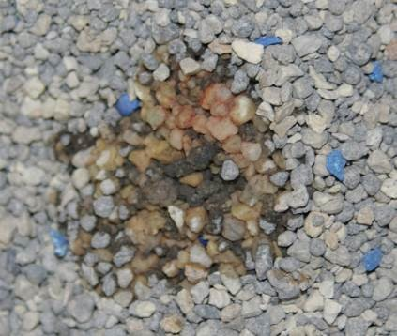
Note red color in litter

Chin Acne

Symptoms: Dark debris or crusting under the chin area, hair loss, and sometimes swelling.
Action: Remove all plastic from the room and only use stainless steel or glass dishes.
Treatment: Use a warm water washcloth to do a compress. Don’t scrub it away.
Cleaning: Nothing
Notes: This will happen with adult cats and should not be seen with kittens.

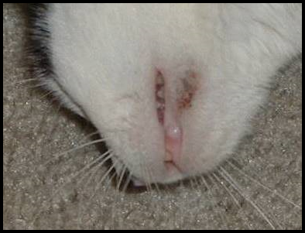
Photo by Debbie Brusius

Coccidia

Symptoms: Diarrhea, weight loss, dehydration.
Action: Take fresh stool sample to hospital for testing.
Treatment: Marquis Paste
Cleaning: Scoop the litter box as often as you can to remove any fecal matter. Wipe the foster room floor three times a day to remove any fecal matter.
Notes: Coccidia often have a very distinctive smell and the feces will often be yellow in color.

Conjunctivitis

Symptoms: It is characterized by swelling and/or yellow or green discharge around the eyes. Eyes can be red and watery, crusty, or have green discharge.
To clean the kitten’s eyes, use a cotton ball or gauze that is clean with warm water. If the eye is sealed shut, you will need to use the warm cotton ball as a compress and hold on eye for a few minutes. This will soften the crusted material around the eye. Once it is soft and pliable you can wipe it from the eye. Start at the area closest to the nose and wipe outward. Don’t force the material off of the eye. You may need to continue to let the cotton ball set on the eyelid longer to soften the material. Once everything has been cleaned around the eye, you can administer eye medications. It will be helpful to the kitten if you can gently wipe the eye clean multiple times a day. If you do not have a cotton ball or gauze square, you can use a soft washcloth. Make sure that you use a clean washcloth each time. Never share washcloths or gauze between kittens or eyes.
Action: If it is crusty, have the foster parent clean with a clean moist warm cloth. A clean cloth should be used each time the eye(s) are cleaned. Have them hold the washcloth on the eye for at least 30 seconds if not longer. If the crusty discharge has softened, it can be wiped from the eyes. Make sure that the foster parent is not picking the crusty discharge off the eye area as that can cause the delicate skin to tear.
Treatment: If the eye discharge is clear and watery, have the foster parent clean the eye 3-4 times a day with a clean washcloth and monitor for other symptoms. If there is green- or yellow-colored discharge, then have the foster parent begin administering eye medication. Medication can be picked up at the shelter.
The medication we use is: Tobramycin Eye Drops—dose is one drop per eye 3-4 times a day for 5 days. To administer eye drops hold the kitten’s eye open and let then let the drop fall into the inside corner of the eye near the tear duct. Open and close the eye a few times to get drops worked in well.
Erythromycin Ointment: This medication may be prescribed by the hospital if the Tobramycin does not seem to be working —dose is one thin strip the size of the eye 2-3 times a day for 7 days. To administer the ointment, hold the kitten’s eye open and squeeze the ointment into the eye moving across the eye without touching the tip of the tube to the eye. It is very important to make sure that only the medication—not the tube—touches the eye.
(Continued on next page…)
Notes: Conjunctivitis is often accompanied by an upper respiratory infection. Also, if not treated correctly ulcers can form on the eye, or the eye can become damaged to the point of needing extraction. Make sure the foster parent understands that if they see anything forming on the eye, or if the third eyelid becomes red and inflamed (meaty), that they need to make an appointment at the hospital right away for further evaluation.
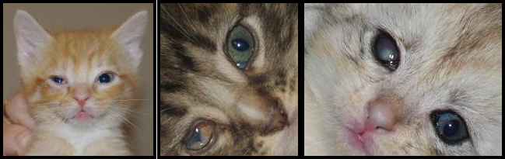
Pic # 1: watery eyelid w/ 3rd eyelid showing; Pic #2: “meaty” third eyelid; Pic #3: ulceration of the right eye

Constipation

Symptoms: This can be from infrequent elimination or difficulty eliminating hard feces. There can also be very little liquid passing by the blockage as the kitten is straining to defecate.
Action: Check for hydration. Ask the foster parent if there is any chance that the kitty could have swallowed something to cause blockage.
Treatment: Administer sub-q fluids. Add canned pumpkin puree (no spices added). Add 1 teaspoon of pumpkin puree to each wet food meal.
Cleaning: Keeping the litter box clean will ensure the kitten/mom will use the litter box, also it allows the foster parent to know how much the kittens are using the litter box.
Notes: If improvement is not noted within 24 hours after administering fluids, and adding pumpkin to the diet, have the foster parent make an appointment with the hospital.

Coughing

Symptoms: Kitten sounds like it is trying to hack up a hairball.

Action: Take the kitten’s temperature. Kittens do not have hairballs to deal with yet and this is most likely a sign of illness. Try to determine if the kitten swallowed something that could be blocking the airway.
Treatment: Monitor, unless the kitten has a fever, then administer Amoxicillin at every 12 hours for 7-10 days. See Amoxicillin information for dosing. If it appears that the kitten is not responding to the antibiotic make an appointment with the hospital for the kitten to be seen.
Cleaning: Nothing
Notes: You may also notice the kitten having trouble swallowing. This could be post-nasal drip running down the back of the kitten’s throat causing irritation. The antibiotic will take care of this as well.

Dehydration

Symptoms: The gums will feel a little tacky, not moist and smooth. The skin on the back of the neck when pulled up will not fall back into place immediately.

Treatment: Administer sub-q fluids. See the section on sub-q fluids for how much to administer based on the weight of the kitten. If you cannot get to the kittens to administer fluids right away, you can instruct the foster parent to syringe water slowly into the kitten’s mouth. They can also use unflavored Pedialyte.
Cleaning: Nothing
Notes: You may need to go over each night to administer fluids for up to a week.
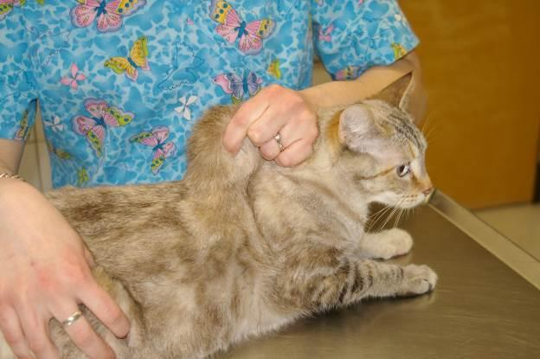
Photo by Debbie Brusius

Diarrhea

Symptoms: Liquid fecal matter found in the litter box, on the kitten’s bottom, or anywhere else in the foster room.

Action: Start Diarrhea Protocol (see next page). Keep the kitten’s bottom clean at all times. You may need to run the kitten’s bottom under warm water to cleanse the area. Pat dry and then apply A&D ointment for protection. Check for dehydration.
Treatment: FortiFlora—continue to give as normal. Administer sub-q fluids if dehydrated.
Cleaning: Cleaning the diarrhea out of the litter box and off the kitten promptly is necessary for preventing extra mess and potential spread of disease.
Notes: You may be given a special diet to feed the kittens.

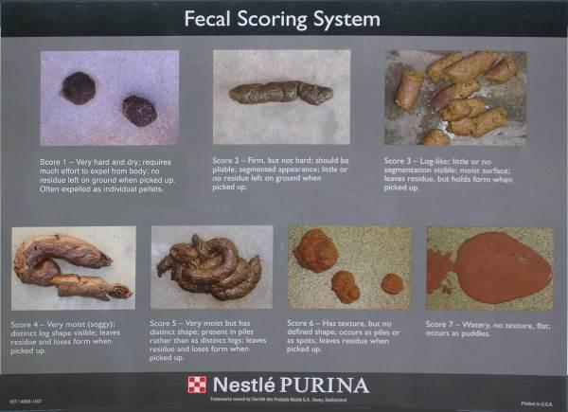

Diarrhea Protocol

All foster kittens will be sent home from Your Organization with a supply of FortiFlora. This is an oral supplement that helps with digestive health. Kittens should be given FortiFlora (sprinkled on wet food) for the duration of foster. You should be feeding only one type of canned and dry kitten food (preferably the Purina ProPlan we send home with you).
If diarrhea persists for 3 days, inform your mentor, who will have you do the following:
- Contact the Foster Coordinator with the weights of all of your kittens so that medication for the appropriate dose can be made up. You will need to pick up the following from the shelter:
  - Prescription for Panacur (fenbendazole) daily for 5 days. This is an oral prescription medication available from the Your Organization’s shelter hospital.
  - Marquis dose #2. This is an oral prescription medication available from the Your Organization’s shelter hospital.
- Optional: In addition to medication, give each kitten one teaspoon of canned pumpkin each day. Be sure to use plain canned pumpkin only, not pumpkin pie mix or spiced pumpkin mix.
If no improvement in diarrhea is seen after 3 more days (6 days total), then do the following:
- Obtain a fecal sample in the provided container.
- The ideal sample is at least the size of a Milk Dud or a half inch round sample.
- If the cat has diarrhea then scoop up a teaspoon worth into the tube provided
- Make sure the sample has very little or no litter.
- Collect the sample within 1 hour of bowel movement and bring it in immediately.
  - It can be refrigerated for up to 12 hours if necessary
- Bring the sample to the shelter.
- Fecal samples can be received at the hospital during the following days and times
  - Mon 9-4
  - Tues-Fri 8-5
  - Sat-Sun 9-4
- Complete the “Fecal Sample Drop Off Form” located at the front desk
  - Please include your email address so you can be contacted with the results.
- You do not need to call ahead, but be advised that results may not be available until later that day, or until the following day.
- If the kitten is very sick, arrange for an exam with the shelter vet by calling ahead to schedule an appointment.

- Results
- The hospital staff will contact you if any parasites are found in the fecal test, and to prescribe any additional medications.
- If your foster kittens need medication, you will need to return to the shelter to pick up medication.
- If it will be impossible for you to return for necessary medications in the next few days, please contact your mentor for assistance.
- If you have not received results within 24 hours or have questions about your results, please contact the Foster Coordinator.

If there are no parasites found on the fecal test and still no improvement in diarrhea, then:
- Call the front desk and schedule an appointment with the shelter veterinarian.
- If the kittens are eating well, gaining weight, active, and not dehydrated, the diarrhea may not need treatment and may be something the kittens just need to outgrow as their immune system matures.

Please note that any time during this protocol, if your kittens are vomiting or dehydrated, have liquid (not forming) diarrhea, diarrhea dripping from their bottoms, refusing to eat for more than 8 hours, or acting lethargic, you should immediately alert your mentor.

Failure to Thrive

Symptoms: Kitten is not gaining weight and/or is losing weight with supplemental syringe feeding, is lethargic, and always wants to cuddle.

Action: Contact On-Call Lead Mentor for advice.
Treatment: Sub-q fluids. The hospital may also prescribe Vitamin B-12, make sure kitten is warm enough, Karo syrup.
Cleaning: Nothing needed at this time.
Notes: Be prepared for the worst and know that not all kittens survive kittenhood. Do tell the foster parent that we will do everything we can for the kitten, but sometimes we simply can’t save them all. Don’t make it sound rosy and that there are no issues; this is a critical time in a kitten’s life.

Feline Infectious Peritonitis (FIP)

FIP is a mutation of the feline enteric coronavirus that occurs within certain cats. 1%-5% of infected cats develop FIP. At this point, the virus can now leave the intestines and infect blood cells. This stimulates a large antibody response by the body. Then, the antibodies bind to the virus to form complexes, and these complexes can cause vascular damage. At this point, it appears that the mutated virus is not contagious. FIP has no cure and is eventually fatal, although it may be difficult to diagnose.

Symptoms: Wet Form: Fluid build-up in abdomen or chest, swollen abdomen, difficulty breathing.
Dry Form: Neurologic disease, enlarged kidneys, Uveitis (inflammation inside the eye).

Action: Contact Hospital for appointment when shelter is open.
Treatment: There is no treatment for FIP. You can treat symptoms though to keep kitten comfortable.
Cleaning: Replace the litter box and litter, and throw out old litter box. Clean all bedding, sanitize foster room, throw out food and water bowls unless they are stainless steel.
Notes: The coronavirus is very common in cats. It is estimated that 20%-50% of the general population of cats are infected, and 80%-100% of those cats affected are living in a multi-cat environment. The coronavirus can live for weeks in the environment, but it can also easily be killed. The virus is spread via fecal-oral transmission. Many cats are infected by the mother at 3-4 weeks of age, and a few cats are even chronic shedders of the virus. The disease is typically mild, with only transient diarrhea being its primary effect. Immunity for the virus is short lived; because the virus can mutate very easily, cats can become re-infected.

Hernia
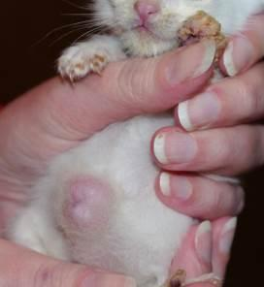
Symptoms: Round marble shaped protrusion around the belly button area.

Action: Have foster parent contact
the Foster Coordinator during normal business hours for advice and any instructions.
Treatment: No treatment unless authorized by shelter or hospital.
Cleaning: Nothing
Notes: Typically these do not bother kittens and will be repaired at spay/neuter surgery.
Photo by Debbie Brusius

Hypothermia

Symptoms: Kitten is cold, lethargic, not eating, and cuddly.

Action: Take the kitten’s temperature. If it is lower than 100° F the kitten will need to be warmed.
Treatment: Put kitten up against your chest under your shirt for warmth and so the kitten can hear your heartbeat. Place a towel in the dryer on high. Once the towel is heated, wrap up the kitten and hold them close to your chest. Increase the temperature in the foster room with the thermostat, a space heater, or Snuggle Safe warming disks.
Cleaning: Nothing
Notes: After the kitten is warm, make sure that it resumes regular activities like eating, playing, going potty, etc. If the kitten does not then you will need to supplement feed to make sure the kitten is getting back on track.

Lethargy

Symptoms: Seems tired, unresponsive, and also referred to as a flat kitten.

Action: Check temperature of kitten.
Treatment: If kitten is not at normal body temperature (97°-99° F for kittens 0-3 weeks and 100°-102° F for kittens 4 weeks and older) you will need to heat the kitten by putting it next to your body wrapped in bedding or a fleece blanket. Put a towel in the dryer on high. When it is warm, wrap it around the kitten to slowly warm her. Increase the temperature in the foster room with the thermostat, a space heater, or Snuggle Safe warming disks. Administer karo syrup. Place a 1” bead of syrup on your index finger and wipe that on her gums and tongue. Repeat in a few minutes if the kitten is not perking up. You can use up to 1 mL. Don’t shoot the karo syrup in the mouth for the kitten to swallow. You may also administer warmed sub-q fluids. To warm fluids, draw them up into the large syringe, cap the syringe, and place in a bowl of hot water for three minutes.
If the kitten is at a normal temperature, check the kitten’s gums. They should be pink. If they are pale, the kitten is not doing well. Administer karo syrup using instructions above. Try to give the kitten room temperature sub-q fluids. Then try to offer food. Try to determine if the kitten has been eating or not, if the kitten has had diarrhea, etc.
If the kitten does not pick up, contact the On-Call Lead Mentor right away.
Cleaning: Nothing
Notes: Lethargy can be a sign of a lot of different illness, birth defects, and other anomalies. Try to gather as much information for the medical team so that they can see the full picture, including intake date, vaccine dates, and any outings to an offsite adoption center or to the shelter.

Lice

Symptoms: Kitten is scratching excessively, white “flakes” noticed on the fur, hair loss.

Action: Make an appointment at the shelter for the kitten(s) to be examined. The hospital team will determine if it is lice and will start a treatment plan.
Treatment: Advantage Multi, Frontline Plus, or a similar product will be used. Repeat treatment in 2 weeks. Flea comb all cats/kittens daily to remove any lice and nits.
Cleaning: Wash all bedding/toys in hot water often. Vacuum the foster room daily, and deep clean the room each week to remove any lice or nits that may have fallen off the cat or kitten.
Notes: Feline lice are species-specific and cannot be transmitted to humans or dogs, but it can be transmitted to the other cats in the household.

Limping/Lameness

Symptoms: Kitten is not putting full pressure or any pressure on a limb.

Action: Try to determine if the kitten jumped off something tall, was hurt while playing, or stepped on something. Check the pads of the feet to make sure there are no visible signs of injury. Check for swelling of the joints and range of motion.
Treatment: Often rest is the best plan. But if the kitten appears to be in pain, make an appointment with the hospital for the kitten to be seen. They may decide to do an X-ray or prescribe pain medication.
Cleaning: Nothing
Notes: A limping kitten can also be a sign of Calici Virus. It is called Limping Kitten Syndrome. Take your kitten’s temperature if there are no signs of an injury to see if your kitten is sick. It could also be a vaccine reaction. Often kittens will hold up their paw for 24-48 hours after a vaccine has been administered.

Mastitis

Symptoms: Engorged milk glands, nipples are warm/hot to the touch, red in color or streaking, painful.

Action: Take a hand towel and run it under very warm water (not too hot) and place on the mother cat’s affected breasts. Hold in place until the towel cools to room temperature. Repeat 4 times a day.

Treatment: Make an appointment with the hospital for the mother cat to be seen if inflammation has not gone down. Often the best treatment is hot packing, but sometimes an antibiotic will be prescribed.
Cleaning: Keep area clean with a warm washcloth.
Notes: If the mother cat has bad milk due to mastitis, she could be poisoning her kittens. Make sure the kittens are thriving, not showing signs of illness, and are gaining weight. Often mastitis will occur after the kittens are no longer nursing on the mother cat. To prevent this, it is best to remove a few kittens at a time from her so her milk production slows gradually.

Feline Panleukopenia

Feline panleukopenia is also commonly referred to as feline parvovirus and feline distemper. It is not related to canine distemper. There is a decreased incidence of infection with age, and cats who manage to recover from the disease are immune from that point onwards. Parvovirus is spread via fecal-oral transmission and has an incubation period of 2 to 14 days. Parvovirus works by attacking those cells which divide rapidly – often the viral target is the cells of the intestine.

Symptoms: Fever, vomiting, diarrhea with blood and mucus, occasional sudden death.

Action: Call shelter immediately during open hours to schedule an appointment with the hospital.

Treatment: Can vary based on the severity of the case. Antibiotics are given to prevent a secondary GI infection, fluids are administered to improve hydration, and antiemetics can be prescribed to control vomiting. In some cases, blood transfusions are necessary. A hyperimmune serum can also be administered after exposure to the virus.

Cleaning: Follow written protocol provided to you by the Your Organization hospital. Replace the litter box and litter, and throw out old litter box. Clean all bedding, sanitize foster room, throw out food and water bowls unless they are stainless steel. Parvovirus is very resistant to treatment and containment in the environment—only bleach or Accel will be able to kill it. The parvovirus can live in the environment for months, even longer. As a result, foster parents will need to follow special cleaning instructions provided by the shelter.

Notes: If a pregnant mama cat contracts feline panleukopenia, her unborn kittens run the risk of being born with brain damage.

Ringworm

Symptoms: Hair loss and scaly, crusty lesions—especially on the face, ears, and paws—that may or may not be itchy.

Action: Please schedule an appointment at the hospital at your earliest convenience for examination and a Woods Lamp test.

Treatment: Isolate the subject to decrease contamination, when possible. Treatment options include twice weekly lime sulfur dips, topical antifungal creams, and oral medications such as Terbinafine.

Cleaning: All contaminated areas must be cleaned with bleach or Accel—the only effective agents against ringworm. For bleach, create a 1:10 diluted solution and leave on surfaces for 10 minutes. Manual removal of hair can greatly decrease contamination. Accel can be picked up from the shelter.

Notes: Ringworm is not an actual worm, but a fungus. This also has a high zoonotic potential, which means it can easily be transferred from cats to people or other animals.

Seizures

Symptom: Body tremors uncontrollably.

Action: Remove any items that the cat may become injured by.
Treatment: Contact On-Call Lead Mentor.
Cleaning: Nothing
Notes: Time the length of the seizures and the frequency in a journal.

Upper Respiratory Infection (URI)

An occasional sneeze is expected from any cat. Lots of sneezing, yellow or green nasal discharge, and congestion are causes for concern, as they may be an indication that a cat or kitten has an upper respiratory infection. Most URIs are caused by the Calici virus or by the Herpes virus, and they often present as sneezing, thick mucosal discharge, and fevers. It is often difficult to diagnose the difference between Herpes virus and Calici virus since they often have similar symptoms. The shelter treats both of these viruses with the same medications and treatment plan. See details on the following page.

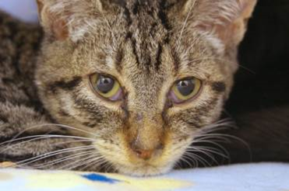
Nasal discharge
A kitten that has contracted the Herpes virus.

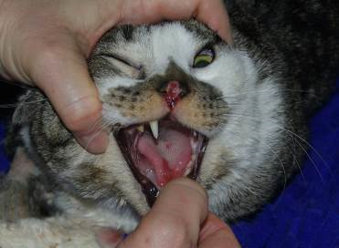
Tongue Ulcer
Nasal Ulcer
A cat that has contracted the Calici virus

Herpes Virus (Feline Rhinotracheitis Virus)

Symptoms: Fever of 102.7° F or higher, yellow or green nasal discharge, loss of appetite, lethargy.

Action: Check other kittens in the litter, as well as the mother, for signs of infection. Make sure the kitten is eating or nursing well. Offer smelly kitten food, human baby food (chicken or turkey with no onion or garlic), or boiled skinless chicken breast chopped into very small pieces.

Treatment: Amoxicillin (see dosing under Amoxicillin) every 12 hours for 7 days. “Steam” kittens twice a day with a hot shower running in the bathroom or by using a humidifier. Never add anything but water to the humidifier. Little Noses with Saline can be used in both nostrils up to three times per day. If kitten is dehydrated, offer sub-q fluids at room temperature to bring down the kitten’s body temperature. Never cool fluids.

Cleaning: The foster room will need to be wiped down twice a day, including the walls, since the spray from a sneeze can project up to 4 ft. The virus can live in the environment including on your clothes and shoes for 12-18 hours. However, most disinfectants will kill the virus. The sick kitten should have his face cleaned with a warm washcloth or gauze pad at least three times a day. Use soap and water, not hand sanitizer to clean your hands after touching the kittens. The Calici virus is not killed by hand sanitizer and we can’t be sure which virus is causing the URI.

Notes: If the kitten does not improve after 6 days of treatment, contact the hospital to see if they want the medication extended to 10 days or if they would like to change to a different medication. You will need to know the weight of the kitten in case they would like to prescribe a new drug.

Calici Virus

Symptoms: Fever of 102.7° F or higher (typically a high spiking fever of 104.0° F or higher), yellow or green nasal discharge, red sores on the tongue, roof
of mouth, or nose, loss of appetite, lethargy, limping (caused by inflammation) usually found on a rear leg for kittens.

Action: Check other kittens in the litter, as well as the mother, for signs of infection. Make sure the kitten is eating or nursing well. Offer smelly kitten food, human baby food (chicken or turkey with no onion or garlic), or boiled skinless chicken breast chopped into very small pieces.

Treatment: Amoxicillin (see dosing under Amoxicillin) every 12 hours for 7-10 days. “Steam” kittens twice a day with a hot shower running in the bathroom or by using a humidifier. Never add anything but water to the humidifier. Little Noses with Saline can be used in both nostrils up to three times per day. Avoid using saline drops if the nose is ulcerated. If kitten is dehydrated, offer sub-q fluids at room temperature to bring down the kitten’s body temperature. Never cool fluids.

For kittens who are limping or not eating due to painful mouth ulcers, use sub-q fluids to help with the fever, and contact the shelter for pain medicine.

Cleaning: The foster room will need to be wiped down twice a day, including the walls, since the spray from a sneeze can project up to 4 ft. The virus can live in the environment for up to 28 days. The virus is killed only by bleach or Accel. The sick kitten should have his face cleaned with a warm washcloth or gauze pad at least 3 times a day. Use soap and water, not hand sanitizer to clean your hands after touching the kittens. The Calici virus is not killed by hand sanitizer.

Notes: If the kitten does not improve after 6 days of treatment, contact the hospital to see if they want the medication extended to 10 days or if they would like to change to a different medication. You will need to know the weight of the kitten in case they would like to prescribe a new drug.

Vomiting

Symptoms: Partly digested food, clear saliva-looking vomit, or a yellow or green slime.
Action: Determine who is vomiting and how often. What has the kitten thrown up? You will need to differentiate between food and stomach acids. Has the kitten been anywhere near plants or other substances that could pose a poison risk? Is it foaming at the mouth? Did the kitten throw up after it was given medication or food?
Treatment: If the kitten has vomited twice within 24 hours, place a call to the On-Call Lead Mentor for advice. If the shelter is open, they may have you come in for medication to help the kitten stop vomiting. You can also administer sub-q fluids to keep the kitten hydrated.
Cleaning: Spot clean the area with a disinfectant cleaner, rinse, and dry.
Notes: Dehydration is a large concern for kittens. It is important to establish who is vomiting and what they are vomiting so it can be stopped.
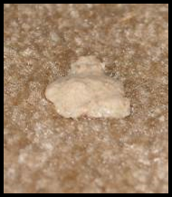 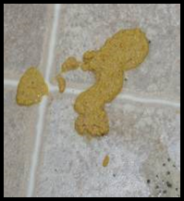Clear foamy vomit Partly digested baby food Partly digested food

Nose and mouth ulcers.
Photo Credit: Debbie Brusius

Cat and Kitten Restraint Basics

Please keep in mind that whatever technique you choose to employ, you should use restraining methods as minimally as possible.

Scruffing: The best location to scruff a cat starts at the base of the head and goes down the neckline.
- In one hand, gather as much of the skin as possible.
- Use opposite hand to control the legs and the body.
- Position the cat as needed to complete your objective.
- You have achieved a correct scruff when the ears move back and the lips part.

The following are methods of restraint employing a towel:

Lateral Recumbency: In kittens, this position is most helpful when taking a temperature, administering sub-q fluids, or administering vaccines.
- In one hand, wrap the cat lightly in a towel.
- Using your opposite hand, grab the cat’s hind legs and place the animal on her side.
- Wrap the cat or kitten snuggly with the towel to control her feet and body. A sock can be used as well for smaller kittens.

Taco Method: This method traps the cat’s legs, but leaves access to the head and rear.
- Drape a towel with the middle of the towel over the cat’s back.
- Sweep sides of the towel together underneath the cat.
- Lay the cat on her side.

Burrito Method: Covers legs and entire body, access is only open to the head.
- Place towel on the table.
- Lay cat about one-third of the way down the length of the towel.
- Take the short end of the towel and wrap it around the cat’s body and legs.
- The long end of the towel should wrap the cat up in the opposite direction with the extra length of the towel covering the cat’s rear.

Snake Hold:
- Place your forefinger and middle finger on top of the cat’s head and your thumb and ring finger under the jaw.
- This hold is a great alternative to scruffing calm cats, while allowing you access to scruff the cat if absolutely necessary.
- The snake hold is more advanced and requires practice prior to use on an unknown cat.

REMEMBER: Cats are very agile and are strong and capable of using all four feet and/or their teeth in defense.

Use distractions:
- Pet vigorously on the head or back.
- Tapping or blowing gently on the cats head or nose.

Use caution:
- The cat could try to get away
- The cat may swipe at you
- You could get scratched or bitten

FVRCP Vaccine Administration

Safety

Our vaccines contain modified live virus, which means it can be very dangerous if mom or babies gets any on their fur or in their mouth. You should always have gauze and alcohol ready to go in case there is a spill, which does happen sometimes, to wipe up the vaccine. Do it immediately, don’t let mom or babies clean it off.

Never use the same needle on two different cats, even from the same litter. Needles should be changed between drawing up the vaccine and injection, and a whole new syringe should be used for each cat. Needles become dull very quickly.

If you miss-shoot, make sure you only use the needle to poke twice. After that, a new needle will be needed because the needle will dull and start to hurt.

Procedure

It’s helpful to have two people, even after you’ve had a lot of practice. Kittens, especially, are quite squirmy and that can make giving the vaccine difficult.

Have your partner hold the cat, usually holding it so the head is pointing toward them. Vaccines should ideally be injected top-down so that the needle is pointing down into the leg. This position is ideal. If the injection site should have a reaction, which is rare but does happen, this position can also save the leg, and the cat’s life, should the leg need to be amputated.

The person giving the vaccine should stand so that the injection site is on the opposite side of the cat from them. FVRCP vaccines are always given in the right front limb, stand so that the left side of the cat is against you. This way, you can reach over with both hands.

Pull up a small tent of skin from the cat’s leg and insert the needle into the tent. Pull back on the needle just a bit- if you see air coming into your syringe, then you have poked through the skin. Reposition the needle until you pull back and get negative pressure (no air). Start injecting but make sure you feel and look for liquid coming out. It’s very easy to push all the way through the skin the first time. If that happens, immediately wipe it up with your alcohol and gauze and try again. At least half the shot should be injected. If you don’t think that much has made it in, they will need another shot within 24 hours.

Once you’ve injected pull the needle right out and re-cover it so you don’t poke yourself. The needle should be taken off and stored to be brought back into the shelter in a secure container for disposal.

Subcutaneous Fluids (Sub-Q Fluids)

If kitty has a fever, use room-temperature Lactated Ringers Solution (LRS).

If kitty is cold, warm LRS by putting it in a warm water bath for five minutes. Shake syringe or bag well and check temp by putting a few drops on the inside of your wrist, like you do for a baby’s bottle.

HINT: For both kittens and adult cats, try having a little yummy food treat ready to distract them. Wet food is good, and formula is even better since it’s both nutrition and more fluid.

Supplies Needed
Kitten/Cat Weights and Fluids

Fluids (in mL) should be administered based on the weight of the kitten/
cat. Please see the chart below for reference.

Weight Fluid Dose
5-15 oz. 5-10 mL
1-2 lb. 15-20 mL
3-4 lb. 60-80 mL
5-8 lb. 100-120 mL

For Kittens:

1) Sterile scalp vein set (can be re-used for the same animal up to 2 times)
2) Large sterile syringe. 20-60 mL
3) Sterile 18-gauge needle
4) Bag of Lactated Ringers (LRS)

For Adult Cats:

1) Bag of Lactated Ringers (LRS)
2) Sterile 18-gauge needle
3) IV Tubing

Administration of Sub-Q Fluids for a Kitten

1) Place 18-gauge needle on syringe.
2) Draw up desired amount of LRS into syringe. Warm fluids now if needed.
3) Remove needle from syringe.
4) Put scalp vein set on syringe. Depress syringe slightly to remove air from line.
5) Make a tent on the kitten’s scruff.
6) Insert needle into scruff tent, parallel to spine. Depress syringe. Watch for leakage indicating needle has gone in one side and out the other. If this occurs, pull needle back a little bit and continue.
7) When finished, pinch injection site for a couple of minutes to help hole close and reduce leakage. Some LRS will still leak out, that’s normal.

HINT: Continue holding kitten by scruff during procedure and “bounce” kitten up and down gently to distract it. Expect kitten to wiggle and maybe cry; keep going.

Administration of Sub-Q Fluids For An Adult Cat

- Warm LRS bag before starting if needed by placing it in a warm water bath. Hang LRS bag at least 2-3 ft. above the cat.
- Put new sterile 18-gauge needle on end of IV line.
- Make a tent in kitty’s scruff, insert needle parallel to spine.
- Open IV line. Note how much LRS is in bag when you start, so that you’ll know when you’re done!
- Look at “well” in IV line to see how fast LRS is flowing: if not flowing very well try moving needle under the skin to improve flow. Be careful not to pull needle out.
- When desired amount of LRS is in (100-150 mLs), close IV line.
- Remove needle from cat’s scruff; pinch injection site to reduce leakage.
- Replace cap on needle; leave used needle on IV line. (The next time you use it you will put on a fresh needle.)

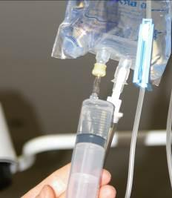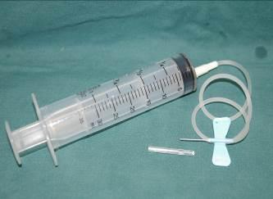
Correct set-up

Draw fluids here

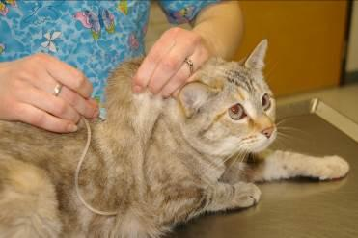
Scruff and Insert

Emergency Contacts

Please call the On-Call Lead Mentor first. If you cannot reach them please call the On-Call Doctor or Manager. The On-Call lead mentor for the week will be emailed out on Sundays, and can also be found on the shared Google Calendar. The On-Call Manager schedule will be emailed out once a month.

ON-CALL LEAD MENTORS

First Name Last Name 555-555-5555 email@gmail.com

Please remember that these phone numbers are for true emergencies only.

ON-CALL DOCTORS/MANAGERS

First Name Last Name 555-555-5555 email@gmail.com

If you can’t get a hold of the On-Call Lead Mentor, please try the On-Call Lead Doctor/Manager. If you cannot reach the On-Call Doctor/Manager after 15 minutes, please try again. Wait 15 minutes before calling the next contact.

After the second call when you do not reach someone, leave them a message stating that you are now going to call the next person (leave the name). If you do not hear back from the second person in 15 minutes, leave them a second message that you have called the first person, the second person (them), and now you are calling the third person. Hopefully this will never happen, but just in case it does everyone will know what is going on.

OTHER CONTACTS

List other mentors here.

* Preferred phone number
H – Home number, W- Work number, C – Cell phone number

Foster Sheet
Foster Parent | Phone Numbers | Email Address | Address

