Your Logo Here

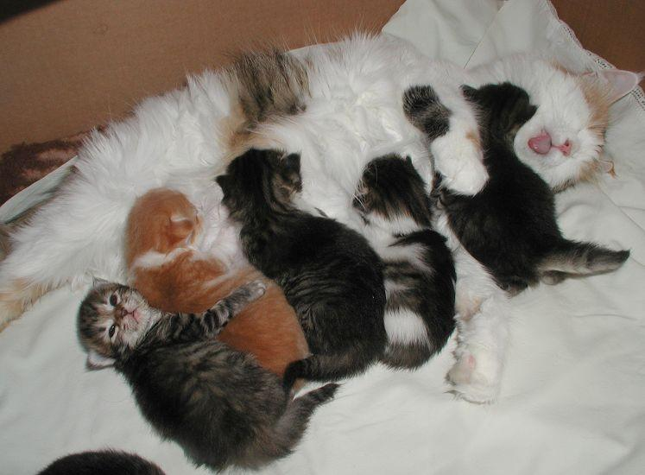
Foster Program

Your Organization
Kitten Foster Care Program

Your Organization Thanks YOU 4
Greetings, Foster Parents! 5
Overview of Key Responsibilities and Policies 6
Mentors 7
Kitty-Proofing Your Foster Room and Home 8
Housing 9
Litter Box 10
Expenses and Donations 11
Google Group and Shared Drive 12
How to Pick Up Your Foster Kittens 13
Naming Your Kittens 13
Socializing Your Foster Cats and Kittens 14
Feeding and Growth 15
Bottle Feeding 15
Dietary Habits with Growth 19
Supplies 20
Medical Records 23
Kittens and Vaccinations 24
Vaccine Reactions 25
Kitten Development and Vaccine Schedule: 26
Vaccines and Deworming Treatments 27
Health Concerns 28
Common Ailments 29
Diarrhea Protocol 32
General and Emergency Veterinary Care 34
Adoption Procedures for Cats/Kittens in Foster Care 35
Kitten List 38
Showing Kittens at Your Organization Offsite Adoption Sites 38
Petfinder 39
Returning Your Foster Cat/Kittens 41
Cleaning Between Your Foster Groups 44
Foster Program FAQ’s 46

Your Organization Thanks YOU
Thank you for opening your home and your heart to a kitten or cat in need. Whether you foster a kitten who needs some time to grow, or an adult cat who needs a little extra TLC, you make it possible for us to provide the very best care possible for all of our residents at Your Organization. Fostering is messy, rewarding, stinky, adorable, and sometimes a heartbreaking job. We certainly could not provide the level of care we do without valuable foster homes like yours.

From all our cats and kittens:
Thank You!

Greetings, Foster Parents!
Thank you for participating in the Your Organization Foster Care Program. We appreciate your willingness to open your heart and home to homeless mother cats and kittens. Your dedication allows our organization to rescue cats we would otherwise have to turn away due to limited space in our shelter.

The guiding mission of the Kitten Foster Care Program is to give mother cats and kittens the individualized care, and socialization they need to prepare them for adoption. Information gathered during the foster process helps us place cats and kittens in homes and with families who can best meet their needs. Specific goals of the program include:

- Providing a safe, healthy, nurturing environment for mother cats to raise their kittens.
- Socializing shy or timid cats, and kittens.
- Giving our long-term residents time away from the shelter in a home setting.
- Allowing mother cats to recover in a relaxing, uplifting environment.

This manual outlines the responsibilities and expectations of Your Organization foster volunteers. This should serve as a resource throughout your foster care experience.

Before taking your assigned foster cats/kittens home, please:

- Review the overview of key responsibilities and policies
- Complete a foster family information sheet
- Read and sign the foster care agreement
- Give the completed Foster Family Information Sheet and the signed Foster Care Agreement to the Foster Coordinator. If the Foster Coordinator is not available, give the forms to a Your Organization staff person.

Overview of Key Responsibilities and Policies
To ensure a successful foster program, we ask that you follow our general policy guidelines to ensure that each foster home is responsibly providing a wonderful home for these kittens to grow up and explore the world in. To this effect, you will want to keep in mind the following:

- Keep cats/kittens inside at all times.

- Cats/kittens should be in a carrier at all times when leaving the house.

- Keep doors/windows closed at all times, unless covered with a screen that is securely in place. The window should only be open no more than 1 inch with a support in place so the window cannot be opened any further. A frightened cat/kitten can escape through the tiniest holes!

- If a cat/kitten does manage to get outside, you must attempt to get the cat/kitten back inside immediately. If you delay, the cat/kitten may get frightened and run away, decreasing your chances of getting the kitty back inside. Do not chase the cat/kitten as this may make him/her run further away from your home. The easiest way to get your mother cat back to your home is to put her kittens in a secure carrier by the door or window that she went out. The kittens should cry for her, and her maternal instincts will kick in bringing her back to them. Often mother cats will come back in to the house or foster room to be with the kittens. If this is not working, you can also place her litter box outside your door so she will smell where she needs to come back in. Most mother cats were strays and are familiar with being outside, but that does not mean that they all have 'street smarts'. Some will hide and be scared as soon as they get out. Look under bushes, decks, foundations, etc. If the mother cat is injured, she may be silently hiding as to not attract predators. If you cannot get the kitty yourself within 1-2 hours, call your mentor to determine a strategy to recapture the kitty. Your Organization has humane traps available for this purpose.

- When fostering a cat who tested positive for FIV (Feline Infectious Virus) the cat must remain segregated from the other animals in your home for the duration of the stay.

- When fostering a mother cat who has not tested positive for FeLV or FIV, it is important to keep her and kittens separated from your other animals for at least two weeks to ensure they are healthy. A seemingly fine cat can become ill due to stress from a move. Foster kittens must not be introduced to your resident cats unless your resident cats are indoor only cats. Kittens must be vaccinated for more than 5 days before they can meet any of your household pets and these visits should be limited and supervised. Food dishes, water bowls, and litter boxes must be picked up so they do not use each other’s boxes or bowls, or they should meet in an area where litter boxes and food/water dishes are not present

Mentors
Each foster parent will be assigned a mentor. This is a person with at least two years of experience fostering kittens. The mentor can answer questions for you regarding kitten-proofing your foster space, behavioral and dietary concerns, and basic health and medical questions.

You should contact your mentor with ANY questions or concerns you may have about your kitten’s health or well-being. If you are worried that one of your kittens may be sick, try to get some information together before you call:

- How long have the symptoms been going on?
- Is kitty eating, drinking, pooping, peeing, playing?
- Any vomiting?
- Diarrhea?
- What is the kitty’s temperature? Normal temperature is 100.0-102.6 F. If you are worried but you aren’t sure about the symptoms mentioned above, call your mentor anyway – that is what they are here for.

If you don’t have a mentor assigned to you at the time you collect your kittens, please call the Foster Coordinator or email her and let her know. She will also be your interim mentor if you have any questions and your backup mentor if yours is not available.

Mentor Contact Information

If you have any questions, problems or issues while fostering, please contact your assigned mentor. Mentor contact information below:

First and Last Name, Mentor City
C)555-555-5555*
H) 555-555-5555 email@gmail.com
W)555-555-5555

* Preferred phone number
H – Home number, W- Work number, C – Cell phone number

On Call Lead Mentor

Each week (Mon-Sun), there is an assigned on-call lead mentor. This person’s contact information will be emailed out to the group on Sunday. It will also be available on the shared Google calendar. The on-call lead is to be used in emergencies only. If you have a foster kitten related emergency, and you have left a voicemail for your mentor, and not heard back in 15 minutes, you can call the on call lead mentor for help.

Kitty-Proofing Your Foster Room and Home
Cat-proofing and especially kitten-proofing your home is much the same as child-proofing it! That means hiding or removing cords, removing small items that kittens can choke on, etc.

To begin, your foster room should be COMPLETELY cleared out and only consist of basic cat necessities (i.e bed, food, water, litterbox, and toys). This means removing all toiletries and decorative items from the bathtub, counters, or any other surface the kittens can access. Kittens love to play with anything they can get their paws on and could be injured by heavy or sharp items.

Make sure to put your baby bag in a separate room. Please do not leave it out for your foster kittens to get into as the items inside can be very dangerous to them.

Once your kittens are vaccinated and clear of any illness (details on Page 6), you may decide to have them visit other areas of your home or interact with your resident pets. These visits should be short and well supervised. DO NOT give the kittens free reign of your home unsupervised. They can get injured, lost, have accidents outside the litter box, etc.

Before introducing your kittens to other areas of your home, please do a thorough walkthrough, and keep the following concerns in mind:

- Kittens might chew on electrical cords resulting in burns or even death. Protect your electrical cords with plastic tubing or by spraying them with “Bitter Apple”, a bitter tasting deterrent that you can find at pet stores.

- Kittens can choke on small items. Keep rubber bands, paper clips, needles, – anything kitty can swallow – out of reach.

- Keep plastic bags, which can cause suffocation, out of reach.

- Secure any heavy items that could fall and potentially injure them.

- Refrain from using any hot appliances while the kittens are out. Kittens are naturally curious and could get burned.

- Review the toxic houseplant list at www.aspca.org/pet-care/poison-control/plants and remove all poisonous plants from your household. Or, to deter kitties from munching on poisonous and non-poisonous plants, you should spray the plants with a product sold at pet stores for this very purpose.

Housing
You must provide a clean, safe environment for your foster cats/kittens. Your Organization recommends that you use a spare bedroom or bathroom as your foster room. A bathroom works best for easy cleaning between litters.

If you are fostering a pregnant cat or young kittens, keep the following tips in mind:

- Consider protecting your furniture and carpet with sheets or plastic table covers. Kittens can be messy, especially when they’re learning to use the litter box! Make sure sheets/ covers are securely tacked down so kittens can’t get under them.

- Until the age of 3-4 weeks, the mother cat will clean the genitals of her young to stimulate the bowels and bladder. As the kittens start showing interest in the litter box, provide them with an easily accessible box – such as a shoebox lid, cookie sheet, or cake pan. Once the kittens are more mobile, you should give them a larger litter box. Dollar stores have lots of inexpensive options.
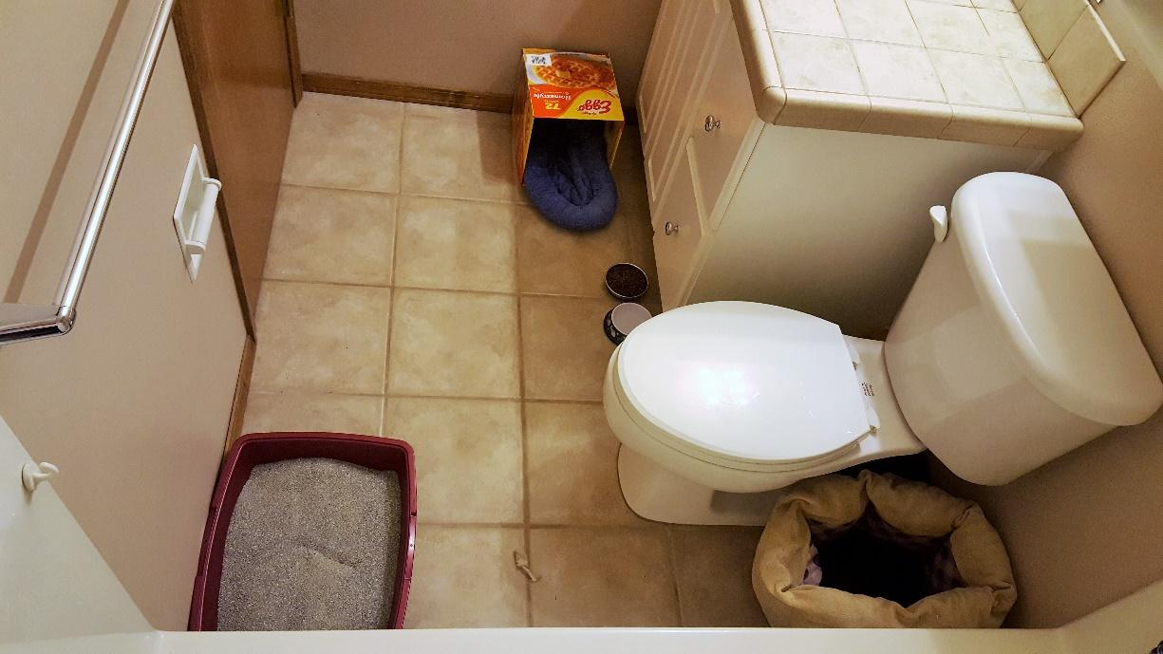

Litter Box
Kittens should be introduced to the litter box when they start eating solid foods. They need a box with shallow sides: a cookie sheet or cake pan is perfect. After they have eaten, place them in the box. They will learn how to use the litter box very quickly. Sometimes they learn how to use the litter box without any help from us, as they have been watching Mom use her box.

Observe how the kittens watch all of Mom’s actions: they find her quite fascinating and are learning how to act like cats by observing her.

Orphans may need a little more assistance from you. Simply pick them up and place them on the litter after each meal. When you bring home your foster kittens, show them where you placed their litter box. Keeping the box clean is very important…daily cleaning is a must. Your Organization recommends cleaning the litter box at least two or three times a day. No cat or kitten wants to use or smell a dirty litter box. Make sure the litter box is as far away from the food and water as possible. Place the bed near the food, not the litter box.

When first learning to use a litter box, kittens do best with store-bought recycled paper litter or clay litter. Once the kittens are older (around 8 weeks old) you can give them clumping litter. Please do not use clumping litter with kittens under 8 weeks.

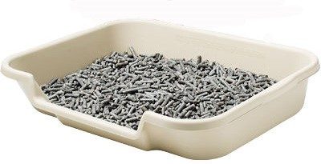
Clumping litter for older kittens Recycled paper litter for younger kittens

Expenses and Donations
Your Organization covers all medical care expenses for foster cats if performed at Your Organization on-site veterinary clinic, or at other veterinary clinics approved in advance. Your Organization will not reimburse any personal expenses incurred by foster parents for unauthorized veterinary care; seeking veterinary care for your foster cat or kittens at a clinic other than Your Organization on-site hospital is not permitted without explicit Your Organization staff approval.

Expenses that you incur during your term as foster parent, whether for supplies or medical care, cannot be applied to an adoption fee. These expenses, however, may be considered a tax-deductible donation. Keep all receipts and ask for an in-kind donation form once your litter is adopted.
Items to keep track of:

- Food
- Food/water bowls
- Litter
- Litter box
- Toys
- Scratchers/scratch trees
- Mileage to and from the shelter or adoption events

Your Organization will provide you with food and litter. It is best to keep the foster kittens on the same food that we feed at the shelter so as not to cause digestive upset when they return. This food and litter is provided for us at no cost thanks to Nestle Purina, and we are happy to pass it along to our foster families.

Always consult a tax professional to determine whether your foster expenses are tax-deductible.

Google Group and Shared Drive
There is a Google Group specifically for foster parents. All foster families are invited but may not understand how to sign on. If you missed your invitation or need assistance getting signed up, please contact the Foster Coordinator and they will help you.

This Google group is a “post only” board, not a chat group. You will see messages from the Foster Coordinator asking for foster homes and providing important updates. All postings will be emailed to the email address you signed up with. Reply to the email in order to respond to the message. Some foster parents prefer to set up a separate email account just for fostering, to avoid clogging their regular email with foster related items.

Other shared drive items include: a Google folder entitled “Foster Parents” which includes a copy of this manual and other important reference material, a Google calendar which has the current on call lead mentor and other events, and Google photos where you can upload your kitten pictures (please do this so we can use them for reports!). You will receive an email invite to these items at the same time as your Google Group invite. If you have trouble accessing any of them, please contact the Foster Coordinator.

Foster groups are assigned on a first-come, first-serve basis. Assignments are typically made before the cat(s) arrives at the shelter, but sometimes there are surprises. In all cases, a message will go out to the Google group with a description of the mom and/or kitten(s) and a general timeline of how soon a foster home is needed. Although assignments are first-come, first-serve, we also try very hard to ensure a good fit between the foster family and the foster group. For example, first-time fosters will typically not be assigned pregnant moms or bottle babies as their first foster group.

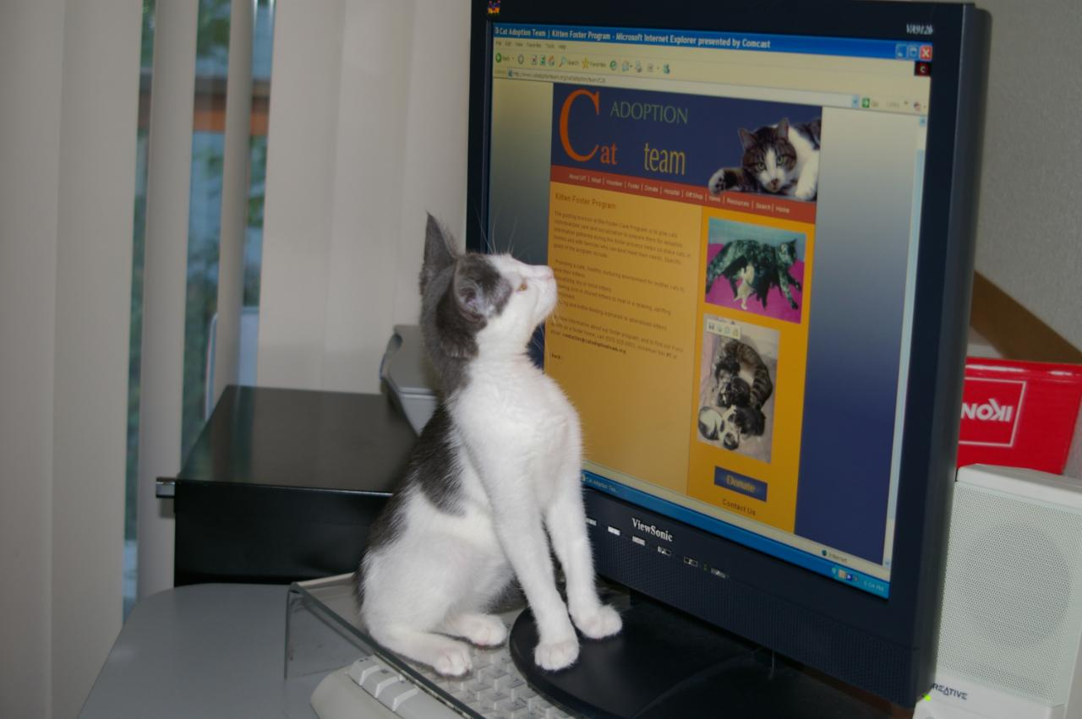

How to Pick Up Your Foster Kittens
Once you are assigned a group, and called to make sure they are ready for you to pick up, please go to the front desk at the shelter. From there, the front desk staff will get the Foster Coordinator to take you to Kitten Headquarters. If you are picking up outside of our open hours, please come to the clinic entrance on the left side of the building and ring the bell if the door is locked.

Make sure that each of these steps is completed while you are at Kitten Headquarters picking up your kittens:

- You will receive a baby bag full of supplies, a carrier, and your kittens
- You will also receive a bag of dry kitten food, a case of wet kitten food and litter if needed
- You will need to sign the Foster Agreement
- Please make sure you take a copy of the medical records home with you

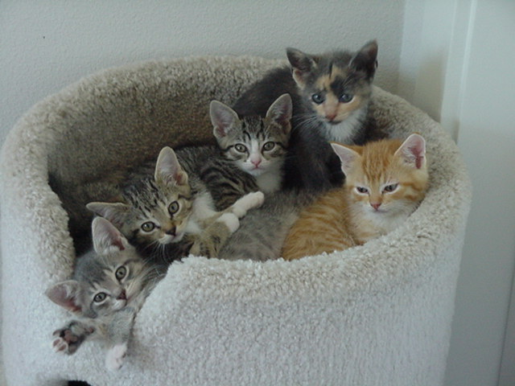
Naming Your Kittens
If you are taking home a mom with kittens, then your kittens will have the mom’s name plus K1, K2, etc. Before your kittens are 6 weeks old we would like you to name them. Please email the Foster Coordinator at foster@youroganization.com you have chosen names. Please use names that are friendly, non-offensive, and not too difficult to pronounce or spell. Try to make them unique so that we don’t have 10 Fluffies. Once you choose names, the kittens will be identified as (Mom’s name) K (number) aka (name you choose). For example, SerenaK3 aka Piper.
The “Cheese” group. Photo by Laura Murphy.

If you are taking home kittens without a mom, your kittens will be named for you. Please do not change their names.
The “Cheese” Group. Photo by Laura Murphy

Never change a Mom cat’s name!

Quick tips on naming your kittens: Theme your kittens’ names for easier marketing. The “Cheese-Group,” above, were named Cheddar, Provolone, Gouda, Parmesan, and Mozzarella.

Socializing Your Foster Cats and Kittens
First and foremost, we ask that you treat your foster cats/kittens with the same love and care that you give to your own companion animals. Daily attention (at least one full hour a day) from you and other family members or friends makes them more people-oriented, and more adoptable. This includes petting, playing, cuddling, trimming nails, and grooming.

By spending time with your foster cats on a regular basis, you will not only increase their chances of being adopted quickly, but you will also be able to determine their likes and dislikes – this helps us place them in homes with families that best meet their needs.

You should also monitor your foster cats for behavior problems, such as inappropriate urination or scratching furniture. If problems arise, contact your mentor to discuss behavior modification strategies. Your Organization is not responsible for damages that might occur to yourself, others in your household, or your personal property as a result of feline behavior problems while in foster care.

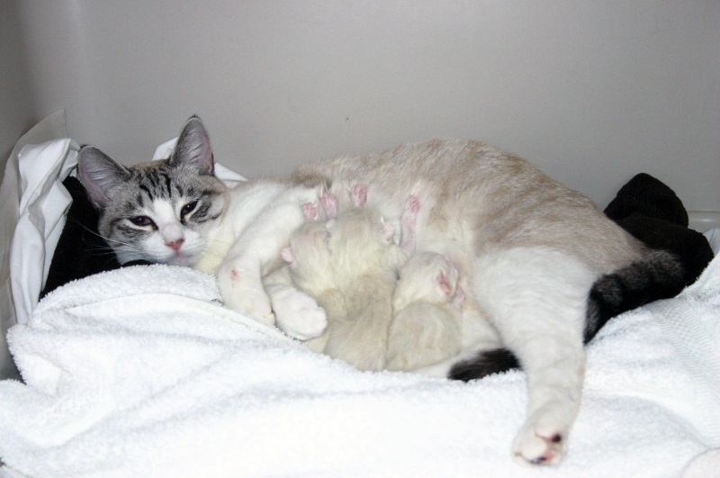
If you have “cat-friendly” dogs in your household, please consult with your mentor about proper introductions with your foster cats/kittens. Felines who have been raised with dogs, and adult cats who enjoy (or at least tolerate) the company of canines, often have an advantage on adoption days!
Special Care

Semi-feral kittens are a special challenge. These kittens can be socialized, but only with daily handling. Sometimes they will hiss and spit when you attempt to pick them up. Gently pick them up and hold them close to your body, giving them a sense of security. Speak softly as you pet them. These kittens need plenty of reassurance and attention. DO NOT give them a room in which they can hide from you. They need a box or crate in which to feel secure but you must have access to them at all times. They will not become socialized unless they are handled many times each day. They need to become accustomed to the sights and sound of people and a working home. This should be done gradually but consistently.

Mimzy and her Newborn Kittens
Photo by Madeleine Barker

Feeding and Growth

Kittens with Mom:

The recommended diet for pregnant or nursing cats and their kittens is a premium diet of canned and dry kitten food. Kittens generally start showing interest in “real” food around 4 or 5 weeks of age. Canned food should be fed 3-4 times a day in small amounts (one quarter of a 3 oz. wet food can). Dry food should be left out all day for them.

Kittens without Mom:

Newborn to four weeks: Rarely, unweaned kittens are brought to Your Organization without their mother. As a foster parent you will have the double responsibility of bottle-feeding and socialization.

Bottle Feeding

When to bottle feed a kitten:
If we receive a kitten that is too young to eat on their own, has been abandoned, refuses to eat, or if the mother cat is no longer nursing her kittens, or her milk has dried up, we then need to bottle feed the kitten. A mother cat’s milk can dry up when mother cats are sick, on medications, or too stressed. (Please make sure that mom cat is getting proper care). Supplemental bottle feeding can also be helpful when a kitten loses weight or fails to gain weight for a 7 day period, even if it is still nursing on mom. In this case, you will only be “topping off” the kitten after it nurses.
Note: If you think your kittens need to be bottle fed or supplementally fed and you have not attended CAT’s bottle baby training class, please speak to your mentor or the foster coordinator before beginning bottle feeding. This can be a tricky process!

Foster parents will need the following supplies for bottle feeding:

-Snuggle Safe disc or other device designed for animals
-Cat carrier or cardboard box for kitten nest
-Fleece blankets, cloth diapers, etc. for bedding
-Milk replacer formula (in baby bag)
-Nursing bottle with nipples (in baby bag)
-Cotton balls or gauze pads
-Thermometer (in baby bag)
-Scale (in baby bag)

How to bottle feed a kitten:
Warmth first! Heat kittens slowly so that you do not put them into shock. You can do this with a towel that has been heated in the dryer, place them on a towel that is resting on a Snuggle Safe disc, or tuck a kitten under your shirt and use your own body heat. While heating the kitten, gently massage the body and extremities to get blood flowing throughout the body.

Never let a kitten lie on a heat source without cover. Make sure that they have space to crawl off the heat source if they get too warm. Constantly check the warmth of the heat source to make sure it cannot burn the kitten, and that it is staying warm enough.
Kittens cannot maintain their own body temperature. The average rectal temperature of a newborn kitten ranges between 92-97 degrees. Between 2-21 days old, a kitten’s temperature will be about 96 – 100 degrees. You will need to build the kitten a nest to keep it warm. The temperature in the nest where the kitten is kept should be 86 degrees. The temperature can be lowered 5 degrees a week thereafter until a mild 75 degrees is reached. To create a good nest, place them in a carrier and put a towel or blanket over the carrier to trap in the heat. You can also do this with a cardboard box.
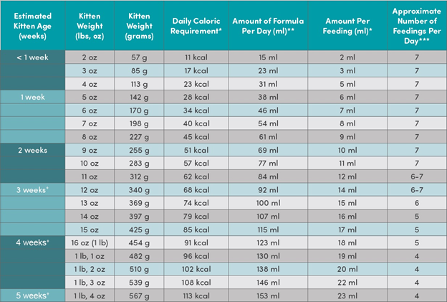
Table by Maddie’s Fund

It is important not to overfeed or underfeed your kitten. Overfeeding can cause serious health problems that begin with diarrhea, and end with dehydration. One way to tell whether you’re consistently feeding too much is the appearance of grayish stool. On the other hand, a kitten who is not fed enough will cry continuously, appear restless, and then listless. Refer to the above table for how much and how often to feed your kitten.

Check your bottle’s nipple to see if formula drips from its tip. If it does not, you will need to widen the hole. You can do this by using a hot needle to poke a larger hole, or use a razor blade to make a small “x” in the top. Do not make it too wide though. You only want the formula to drip slowly, not pour, out of the nipple.

Be sure you sterilize the bottle and nipple before each feeding, and warm the formula to no more than 100 degrees. Test the formula on your wrist – it should feel warm, not hot.

Start feeding:
Place your kitten on its stomach on a towel so they can grip the towel with their nails. Lift their head to a 45 degree angle. Squeeze a small drop of formula on to the tip of the nipple. Insert the nipple into their mouth (you may have to open their mouth for them). The angle will help keep air from entering their stomach and will keep milk at the front of the nipple. NEVER HOLD THE KITTEN ON THEIR BACK OR IN THE AIR WHEN YOU FEED THEM.
When your kitten is full, their tummy will be slightly rounded and bubbles will form around their mouth. If the kitten has not finished the bottle, do not force the kitten to swallow the rest of the milk.

If the kitten is not drinking well, you can use a toothbrush to brush down their sides. This mimics a mother’s tongue and will often soothe them. They should nurse from the bottle better using this technique.

Burping your kitten:
Just like human babies, kittens need to be burped. Hold the kitten up against your shoulder, pat and rub them gently on their back. Not all kittens will burp every time. If the kitten did not finish her bottle, you can offer it to them again.

Stimulating your kitten:
Kittens younger than 3 weeks of age cannot eliminate by themselves – they need your help. After feeding and burping the kitten, take a washcloth or gauze moistened with warm water and rub over the kitten’s stomach and bottom. The action mimics a mother cat’s licking and stimulates the kitten to relieve themselves. Kittens need to be stimulated to eliminate after every meal. Rub until you see evidence of urine and/or stool. A kitten should urinate with every feeding, but it may only defecate 2-3 times daily.

Washing your kitten after the meal:
Make sure you wash your kitten(s) after every meal. Kittens are messy and will need the simulation of the mother’s tongue. To mimic this, you will need to get a damp warm washcloth and stroke the kitten from head to tail with short “licks” like mom would. Make sure you gently towel dry the kitten when you are done. Never submerge your kitten in water.

Dietary Habits with Growth
- At four weeks, you can start introducing canned food (they usually start showing interest in what mom is eating). Mixing a little warm water with the canned food and placing it in a container with low sides (plate, small dish, etc.) will usually do the trick. Expect them to walk through it too. No one ever said kittens were neat. After a few attempts, they will get the idea. Feed them their last meal just before bedtime. They usually eat and then go straight to sleep. You can warm the food in the microwave for about 6 seconds. Make sure to stir the food and test it with your finger. Do not give hot food to kittens.

- 5-6 weeks old: three small (approximately one quarter of a three ounce can) meals of canned food per day per kitten. If that is too much food in the beginning you can adjust accordingly. Always leave plenty of dry food out for them to eat during the day.

- 6-8 weeks of age: three meals a day (about one quarter of a can) per kitten, and free feed dry food. Always keep dry kibble out at all times for the kittens to eat.

Overfeeding can cause digestive problems. Frequent small meals are preferred to large meals.
All cats and kittens need fresh water at all times.

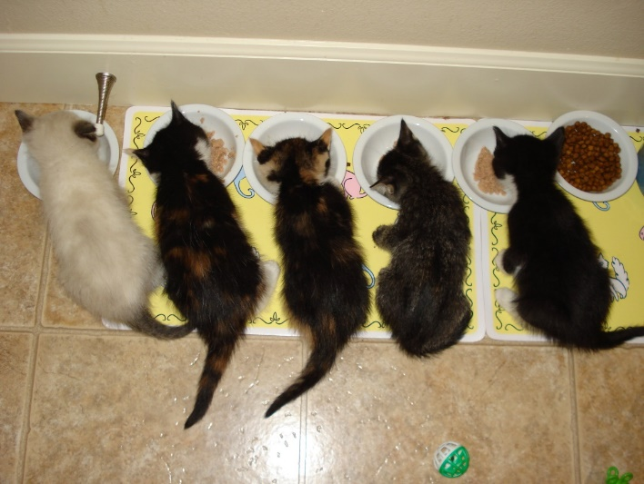
Photo by Barbara Pirk

Supplies
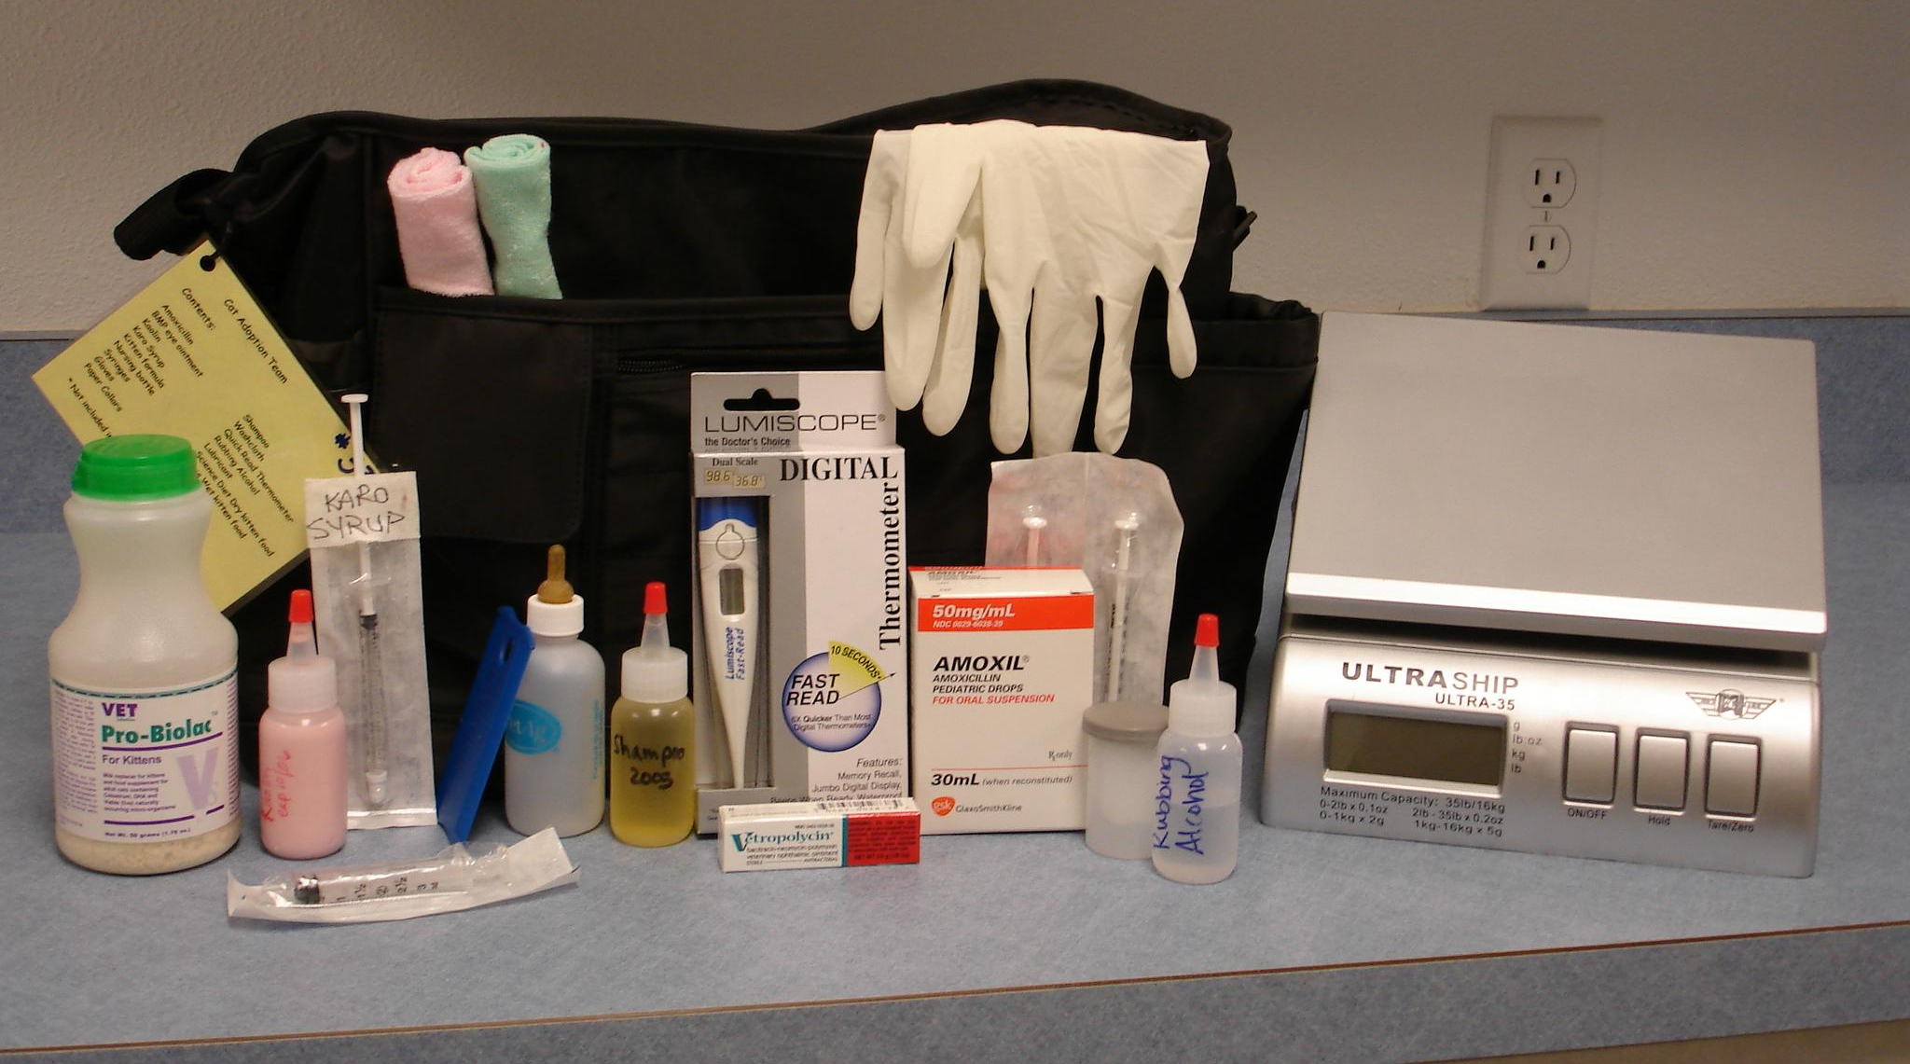
Your Organization wants you to know how much we appreciate you, and we want you to feel supported. To that end, we loan you some supplies with each foster group to use during your fostering experience, and we want to be sure you have the following information to answer frequently asked questions.

The Baby Bag
This holds all your supplies, and is a good place to keep your medical records so everything is together. A laminated card on the outside tells you what number baby bag you have, what should be in it, and gives Your Organization phone number, which will usually get you a live person during normal shelter hours. Please be sure to return the baby bag when you return your fosters, so that it can be cleaned, stocked, and passed on to the next foster parent!

You should find these supplies inside:

- Gloves
- Baby shampoo
- Washcloths
- Thermometer
- Alcohol
- Lubricant
- Baby bottles (if applicable)
- Formula (if applicable)
- Flea comb
- Syringes
- Paper collars
- FortiFlora Probiotic Powder
- Karo syrup
- Amoxicillin
- Strongid
- A&D ointment
- Nail trimmers

The following sections will provide more information on each of these supplies, including their intended use and when to use each item.

Gloves
Some folks have trouble with the “EEEWWW” factor; these will help. Let us know if you want more.

FortiFlora
You should start giving FortiFlora to your kittens as soon as they get home if they are 4 weeks or older. This will help with any diarrhea that may occur due to food changes, medications, etc. If your kittens have had FortiFlora for 3 days and are still experiencing diarrhea, see the diarrhea protocol for more information.

Baby Shampoo and Washcloths
If you have to bathe your kitten, be aware that water temperature is really important! A cat’s normal body temperature is between 100-102.6º F, so the water needs to be pretty warm, like your bath water. Try not to do full immersion baths unless you have to. If you can get away with just a bottom or a face, or a leg, do that. Imitating as best you can the firm licking motion of a mom cat’s tongue will help the kitten feel more comfortable about the whole thing. And, remember a little shampoo goes a long way! A general rule of thumb is once you have rinsed them off really well, rinse once more. Make sure they have a place to dry off that is toasty warm and not drafty, and keep them there until they are completely dry. Call your mentor with any questions.

Thermometer, Alcohol, and Lubricant
Quick tips on temperature taking:

Thoroughly clean the end of the thermometer with alcohol. Then, put a little lubricant on the end. Have a friend hold the kitten for you or wrap him in a towel like a burrito to keep him still. Support the hind end while the thermometer is inserted in the rectum. Insert the thermometer ½ inch into the kitten’s rectum, enough to cover the metal tip. Keep the thermometer in until it starts beeping, then remove and clean with alcohol. Normal kitten temperatures are as follows: newborns 97-98F, 2-4 weeks 98-100F, 4+ weeks 99-102.6. Call your mentor with problems or questions.

Use distractions – kittens will almost always struggle while their temperature is taken.

- Use a sock to cover their head and front legs.
- Bob their heads.
- Blow on their head or face.
- Tap on a glass or metal object.

Baby Bottles and Formula
Bottle feeding supplies will only be in your baby bag if you take home kittens under 4 weeks. See pages 19-22 for instructions. Be sure to contact your mentor before bottle-feeding kittens—the process can be quite tricky.

Flea Comb
We try not to put Advantage (flea treatment) on teeny kittens if it can be avoided. If they have a mom, she will ingest it while washing the kittens, which will cause her to foam at the mouth, and salivate profusely. We will usually treat the mom with Revolution, knowing that it will rub onto the kittens because they are always near/on her. And, we will ask you to flea comb the babies daily until the fleas are gone, usually between 12-36 hours.

Syringes
There should be two 1 ml syringes and one 3 ml syringe in your baby bag. These are for mixing and administering medications if needed, and for syringe feeding if required. Your mentor will be helping you if you have to do these things.

Paper Collars

The collars need to be put on the kittens the day that they come in for surgery with their full name on the dull side of the collar (MimzyK1 aka Morrigan). Collars should be put on tight enough so the kittens don’t get the collar stuck in their mouth, which can happen, but loose enough so the kittens can still breathe easily. If you can still fit two fingers between the collar and the kitten then it’s the right fit. Also, please remember to cut off any of the excess collars as kittens will chew on them.

A&D Ointment
A&D Ointment can be applied to the kitten’s bottom and down their legs if they are having diarrhea and are experiencing redness or loss of fur. Apply a very thin amount as a barrier. This can be applied after cleaning and as often as needed until resolved.

Medical Supplies
YOU MUST CONTACT YOUR MENTOR BEFORE USING ANY OF THESE ITEMS!

- Karo syrup (for extreme hypoglycemia)
- Amoxicillin (antibiotic)

Medical Records
When you pick up your kittens, you should receive copies of their medical records. These records give you an approximate date of birth, weight at time of intake, what medical services have been done, and what things your mom cat and kittens still need to have done, such as vaccines, deworming, etc., and when these things are due. We need your help to make sure these things get done on time and that the records get updated.

Your Organization does its best to track this, but there are usually 150 moms and kittens in foster care at any given time during kitten season. Stuff happens, things get missed. It is YOUR responsibility as a foster parent to help us make sure that your foster cat and kittens are vaccinated and de-wormed when they are due. Your mentor will come over to your house to give the vaccines; please call your mentor before your kitties are due and set up a time. You will give the dewormer (Strongid). If you need help administering it, please contact your mentor.

Anytime you or your mentor gives a vaccine, Strongid, or a medication like amoxicillin or tobramycin eye drops, you will need to record it on the medical records sheet and fill out this Google form. This is how your kitten’s chart gets updated in our database.

Vaccination Records

Just as important as actually doing the vaccines and deworming is recording it. If nobody knows it was done, it doesn’t count! When your foster cats and kittens come into the shelter for their spay/neuter surgeries, we MUST have a paper copy of your updated records with what the kitties have had done and when. If no records or incomplete records come in, the hospital staff must assume that nothing has been done and start over on the vaccines and deworming—which means your cat or kittens gets over-vaccinated and over-medicated, and the hospital has to waste valuable supplies. Please help us prevent this by keeping your records updated, and bringing them with your foster cats and kittens when it’s time for their surgeries.

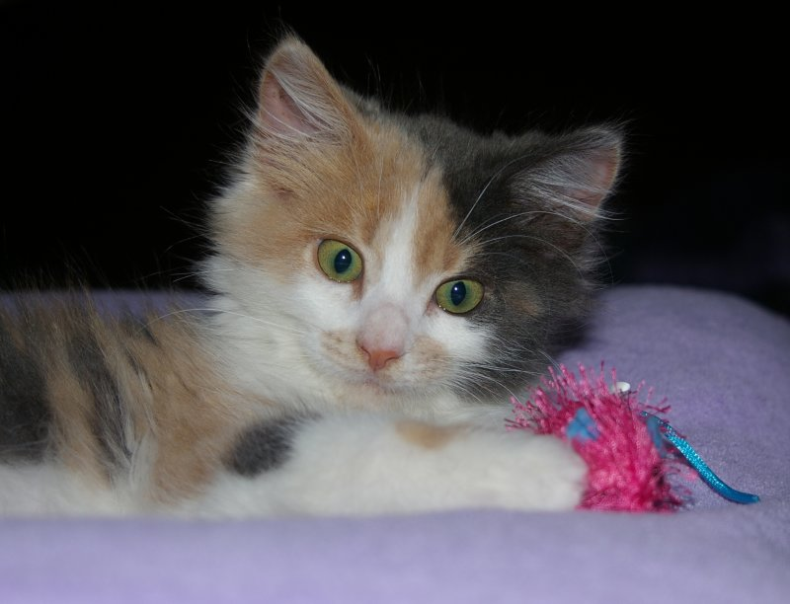
Photo by Debbie Brusius

Kittens and Vaccinations
When a kitten is born and first nurses on the mother, the kitten gets a dose of colostrum from the mother; this colostrum is filled with good immune cells, also known as Maternally Derived Antibodies (MDA), to protect the kitten from common feline illnesses. MDA will interfere with the kitten’s ability to make their own protective immune cells. This dose of colostrum starts to disappear from the body of the kitten between 4-8 weeks of age, but can last in the kitten up to 16 weeks, and we cannot predict the exact timing in the loss of the protection they receive from the MDA.

The idea of using a Modified Live Vaccine (MLV) is to stimulate the kitten’s own immune system into making more protective immune cells, as the MDA disappears. By giving the dose of vaccine every 2-4 weeks, we are able to minimize that “window of susceptibility”, which is the time when the MDA disappears and when the kitten is able to make their own immune cells to fight infectious disease. When we vaccinate kittens at 6 weeks of age that did not get any colostrum, the vaccine may be effective immediately. Kittens that received a large dose of colostrum, or MDA, may not be able to have a response to the vaccine until they are 18 weeks old; the best strategy then is to give the dose of vaccine every 2-3 weeks until the kitten is 18 weeks old.

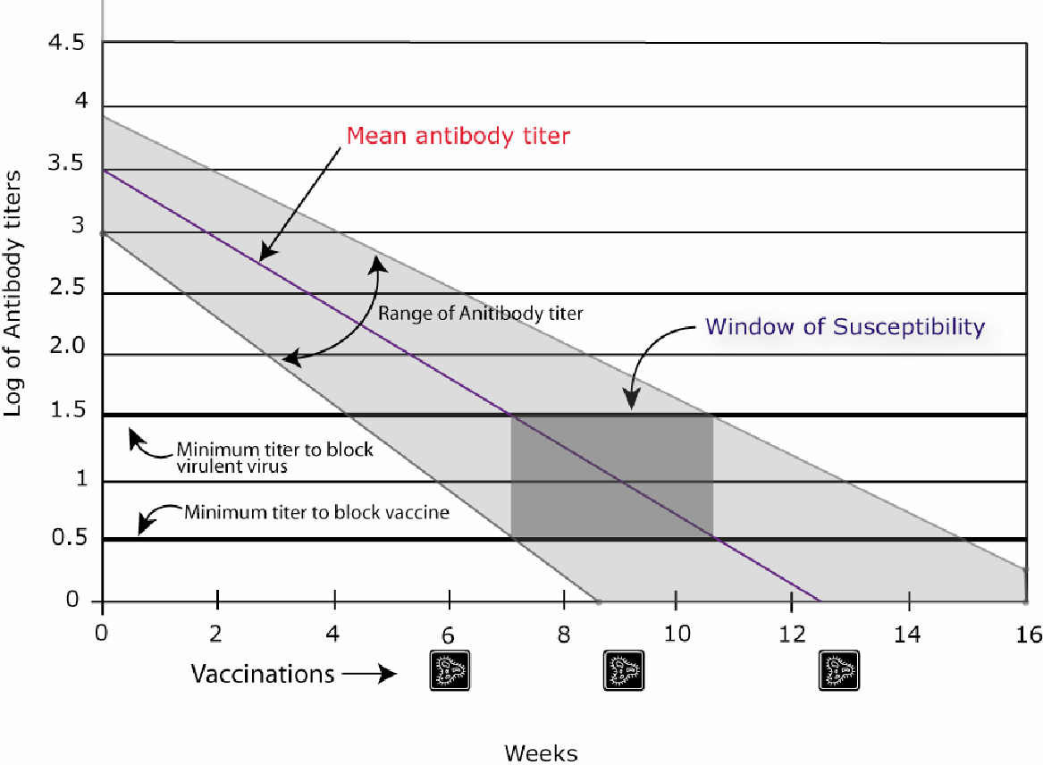

Vaccine Reactions
Vaccine reactions can include, but are not limited to:

- Limping
- Not eating or drinking the normal amounts for 1-2 days
- Lethargy
- Pain at the sight of injection
- Unwillingness to play
- Low-grade fever

If any of these symptoms do not improve by 48 hours after the injection, please contact your mentor.

A more serious reaction happens fairly instantaneously and includes; severe vomiting, diarrhea, facial swelling, and difficulty breathing. The kitten will need to be seen by a vet IMMEDIATELY.

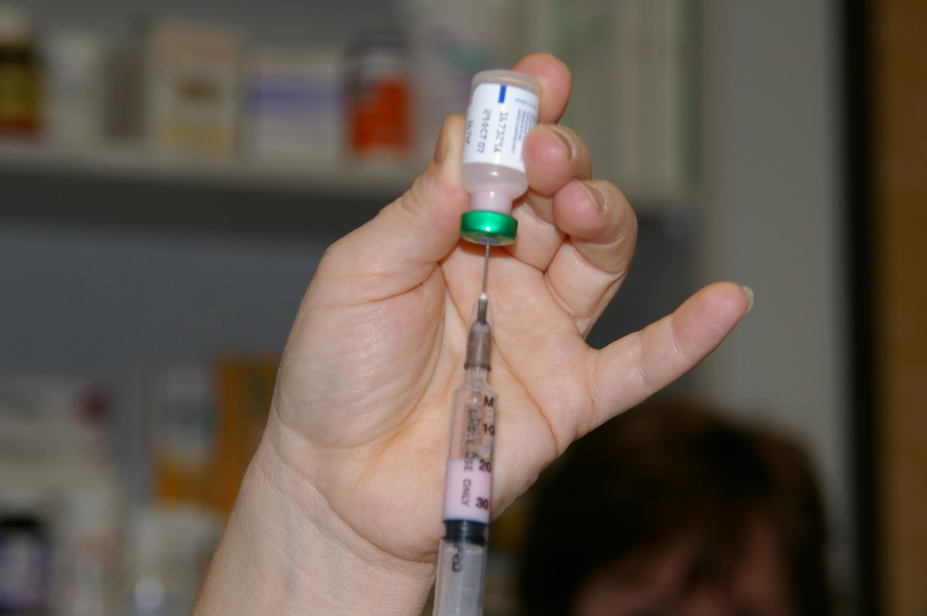

Kitten Development and Vaccine Schedule:
The following is some general information about what to expect at each stage of development. Remember that these are averages. Please weigh your kittens regularly to keep an eye on development. Daily is best for the first 3 weeks or at any time if the kittens get sick, otherwise every 2-3 days is fine. Kittens should gain about four ounces per week, on average.

Newborn | Completely dependent on mother. Eyelids closed, ears folded forward – cannot see, or hear. Sense of smell is the first to develop completely and is the most developed sense of birth.
2-3 Days | Umbilical cord falls off.
One Week | Eyes begin to open – all kittens have blue eyes. Kittens huddle together for security and warmth.
10 Days | Ears unfold, hearing will develop. Can move along with belly on the ground, “paddling” limbs for movement.
Two Weeks | Being to play with littermates, learning how to socialize. Can stand and balance, but cannot walk easily. Teething begins. Eyes are fully open.
16-18 Days | Incisors (tiny front teeth) break through.
20-24 Days | Canine teeth break through.
Three Weeks | Mobile and eager to explore, making mock-aggressive rushes and stalking littermates. Cannot retract claws. Weigh the kittens regularly to keep an eye on development. Should be played with and handled at least 1 hour every day for good socialization.
24-28 Days | Molars begin to break through.
Four Weeks | Introduce solid food in 3-4 small meals per day. Begin litter box training. Will begin wrestling with littermates. Will receive first deworming (Strongid). Ask your mentor for help with dosing and administration.
Five Weeks | Learning to hunt by pouncing on toys and each other.
Six Weeks | Adult eye color begins to appear. First vaccination for kittens. Kittens are vaccinated against common viruses that cause upper respiratory infection and feline distemper (FVRCP). Receive second deworming.
Eight Weeks and Older | Mom and kittens need to be brought to the shelter for their scheduled surgery appointment. The exam will include: FeLV and FIV testing if not previously done, deworming if needed, spay or neuter (if weight is at least 2 pounds and kitten is healthy), microchip, treatment for fleas and ear mites as directed by the veterinarian, and possibly another vaccine. Second vaccination occurs 21 days after the first.

Once your cat/kittens have been vaccinated or given a de-wormer please use the google form to communicate what was given (FVRCP or Strongid).

Please let the foster coordinator know if you would like to learn to administer the vaccines yourself; we would love to show you! The foster coordinator’s email is foster@yourorganization.org.

Vaccines and Deworming Treatments

Vaccines:
FVRCP is the vaccine for Feline Viral Rhinotracheitis, Calicivirus, and Panleukopenia (URI and Distemper)

FVRCP is given at 6 weeks of age or older depending on when they went through intake.

2nd FVRCP is given 21 days after the first FVRCP. No later than 30 days after or you will need to restart the series.

3rd FVRCP is given 21 days after the second FVRCP. No later than 30 days after or you will need to restart the series.

4th FVRCP is given 21 days after the third FVRCP. No later than 30 days after or you will need to restart the series. This vaccine may not be given if the kitten was vaccinated after its 18 week date with the 3rd FVRCP.

Worming:
Strongid is for Roundworms. You might see these pass in the stool after treatment - they will look like spaghetti.

Strongid is given at 4 weeks of age or older depending on when they went through intake.

2nd Strongid is given 14 days after the first dose. This series is repeated every 2 weeks until the kittens have returned for adoption. If you are more than 21 days late you will need to restart the dosing series.

Droncit is for Tapeworms. You will see rice-looking segments in their stools.

Droncit is given at surgery time if needed (noted by the foster parent). Tapeworms usually do not cause significant problems and may be treated at time of altering.

Health Concerns
The following is a list of common medical issues you may encounter as a foster parent with you mother cat and/or kittens. This information is not meant to be extensive, just to give you an idea of what common ailments may look like and how they might be resolved. This is not a substitute for the expert advice of a trained medical professional.

If your foster kitten displays any of these symptoms, call your Mentor immediately:

- Sneezing and/or congestion with green or yellow discharge from the nose and/or eyes.
- Coughing, wheezing, or heavy breathing.
- Diarrhea or vomiting – this can be life threatening to kittens!
- Straining to urinate or defecate – this can be life threatening, especially for male cats!
- Bleeding from any part of the body.
- Lethargy – kitten seems sleepy all the time.
- Fever.
- Paralysis.
- Extreme change in attitude or behavior.
- Not eating or drinking regularly.
- Temperature too low (below 98ºF) or too high (above 104ºF).

Please have specifics ready to give when contacting your mentor. You will also need to take your kitten’s temperature before you call.

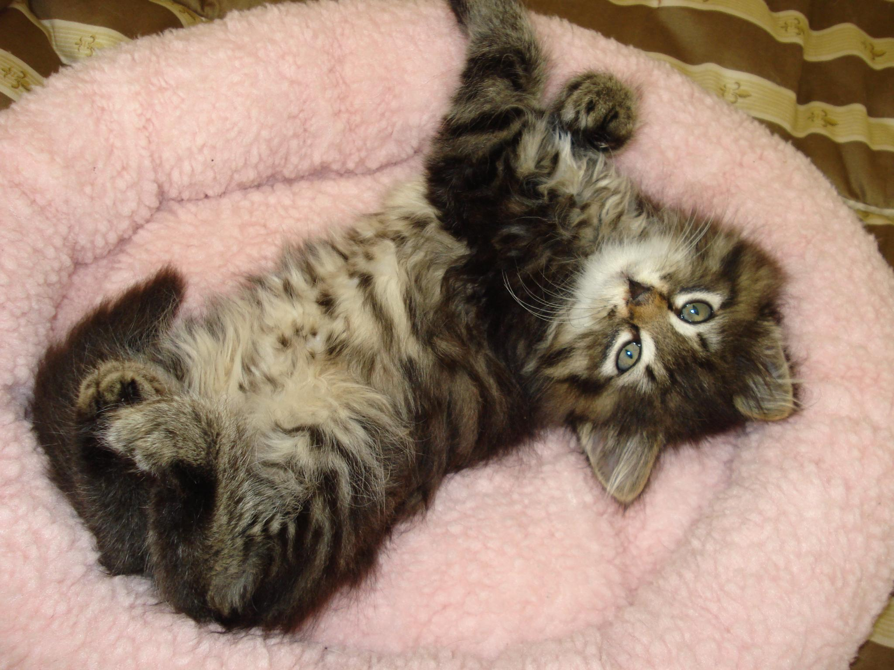
Photo by Barbara Pirk

Common Ailments

Upper Respiratory Infection
Upper respiratory tract infections (URI) or “kitty colds” are common occurrences in shelters. The majority are caused by one of two viruses, although they can have some bacterial components. Signs of URI include congestion, excessive sneezing, fever, discolored (green or yellow) nose or eye discharge, and/or a fever.

Please contact your mentor if you suspect your kitten(s) of having an Upper Respiratory Infection. They may be able to advise you to start the kittens on amoxicillin. DO NOT ADMINISTER AMOXICILLIN WITHOUT BEING ADVISED TO DO SO. If symptoms do not resolve after 7 days of Amoxicillin, please contact your mentor.

If your foster cat/kitten is showing signs of URI, please do the following:

- Make sure the cat/kitten is eating. Cats that are congested often won’t eat because they can’t smell the food. If they are not eating well, warm up a strong-smelling canned food, and offer it to them. You can also provide them several different options to ensure there is one they like.
  - Cats and kittens should be eating at least 50% of the food offered to them
  - After 24 hours of not eating or eating less than 50%, please give SQ fluids (you or your mentor). Continue this daily until the appetite resumes to more than 50%.
  - If a kitten does not eat for the next meal after the initial SQ fluids, you or your mentor should begin supplemental force feeding and schedule an appointment with the shelter hospital. Only force feed if you have been trained.
  - If an adult cat does not eat for an additional 24 hours after the initial SQ fluids, contact your mentor, and schedule an appointment with the shelter hospital.
- If the cat/kitten has eye or nose discharge, clean their nose/eyes at least twice daily with a wet, warm washcloth. Gently wipe the eye from the nose side out to the side of the face.
- If the cat/kitten is congested, place them in a room with a humidifier, or in a carrier in a bathroom with the hot shower running (steam) to aid congestion. You can also hold the kitten on your lap. Nothing should ever be added to the water like Vic’s Vapor Rub or similar products. Also, never leave a kitten alone in a bathroom with the hot shower running unless it is in the carrier.
  - Place nasal saline drops in the cat/kitten’s nose to aid congestion (1 drop per nostril, 2-3 times daily).
  - A product called “Little Noses” can also be used on URI kittens. Please use Little Noses without decongestant (saline-only solution). This product can be used as long as needed, and can be used in both nostrils up to three times daily.
- Provide supplemental warmth, especially for young kittens (rice sock, snuggle safe warming disk, etc.).

Conjunctivitis
Conjunctivitis is characterized by swelling and/or yellow or green discharge around the eyes. An eye ointment or drops are typically prescribed to treat the infection. DO NOT ADMINISTER WITHOUT BEING ADVISED TO DO SO. To administer the ointment hold the kitten’s eye open and squeeze the ointment into the eye moving across the eye without touching the tip of the tube to the eye. To administer eye drops hold the kitten’s eye open and let then let the drop fall into the inside corner of the eye near the tear duct. Open and close the eye a few times to get ointment or drops worked in well.

To clean the kitten’s eyes, use a cotton ball or gauze that is clean with warm water. If the eye is sealed shut you will need to use the warm cotton ball as a compress and let it sit there for a few minutes. This will soften the crusted material around the eye. Once it is soft and pliable you can wipe it from the eye. Start at the area closest to the nose and wipe outward. Don’t force the material off of the eye. You may need to continue to let the cotton ball set on the eyelid to soften the material for longer. Once everything has been cleaned around the eye you can administer eye medications. It will be helpful to the kitten if you can gently wipe the eye clean multiple times a day. If you do not have a cotton ball or gauze square you can use a soft washcloth. Make sure that you use a clean washcloth each time. Never share between kittens either.

Vomiting
Vomiting can be very dangerous for kittens because they dehydrate so quickly. Vomiting is not as common as diarrhea, so it’s especially troubling, especially if the kitten is vomiting repeatedly. Call your mentor right away.

Dehydration
Dehydration can kill a small kitten quickly. Mentors should train you on how to do a skin tenting test. With smaller kittens another way to test hydration is to feel the gums. If they are sticky instead of slippery, the kitten is dehydrated. Also look at the color of the gums. If it is white with no color, please report this when you call your mentor.

Diarrhea
A few things too keep in mind when examining your kitten’s poop:

- A little bit of bright red blood on poop is ok. So is a little bit of bright red blood on a kitten’s bottom. It’s usually a reaction to something that they ate, new food, stress, new location, etc.

- A lot of blood is not ok.

Diarrhea is probably the most common problem with kittens. Runny poop seems to be a kitten’s preferred response to almost all stress or illness. It can be dangerous for kittens because the water lost in the stool tends to dehydrate them rapidly.

Diarrhea Protocol
All foster kittens will be sent home from Your Organization with a supply of FortiFlora. This is an oral supplement that helps with digestive health. Kittens should be given FortiFlora (sprinkled on wet food) for the duration of foster. You should be feeding only one type of canned and dry kitten food (preferably the Purina ProPlan we send home with you).

If diarrhea persists for 3 days, inform your mentor, who will have you do the following:

- Contact the Foster Coordinator with the weights of all of your kittens so that medication for the appropriate dose can be made up. You will need to pick up the following from the shelter:
  - Prescription for Panacur (fenbendazole) daily for 5 days. This is an oral prescription medication available from the Your Organization shelter hospital.
  - Marquis dose #2. This is an oral prescription medication available from the Your Organization shelter hospital.
- Optional: In addition to medication, give each kitten one teaspoon of canned pumpkin each day. Be sure to use plain canned pumpkin only, not pumpkin pie mix or spiced pumpkin mix.
If no improvement in diarrhea is seen after 3 more days (6 days total), then do the following:

- Obtain a fecal sample in the provided container.
- The ideal sample is at least the size of a Milk Dud or a half inch round sample.
- If the cat has diarrhea then scoop up a teaspoon worth into the tube provided
- Make sure the sample has very little or no litter.
- Collect the sample within 1 hour of bowel movement and bring it in immediately.
  - It can be refrigerated for up to 12 hours if necessary
- Bring the sample to the shelter.
- Fecal samples can be received at the hospital during the following days and times
      - Mon 9-4
      - Tues-Fri 8-5
      - Sat-Sun 9-4
- Complete the “Fecal Sample Drop Off Form” located at the front desk
      - Please include your email address so you can be contacted with the results.
- You do not need to call ahead, but be advised that results may not be available until later that day, or until the following day.
- If the kitten is very sick, arrange for an exam with the shelter vet by calling ahead to schedule an appointment.
- Results
- The hospital staff will contact you if any parasites are found in the fecal test and to prescribe any additional medications.
- If your foster kittens need medication, you will need to return to the shelter to pick up medication.
- If it will be impossible for you to return for necessary medications in the next few days, please contact your mentor for assistance.
- If you have not received results within 24 hours or have questions about your results, please contact the foster coordinator.

If there are no parasites found on the fecal test and still no improvement in diarrhea, then:

- Call the front desk and schedule an appointment with the shelter veterinarian.
- If the kittens are eating well, gaining weight, active, and not dehydrated, the diarrhea may not need treatment and may be something the kittens just need to outgrow as their immune system matures.

Please note that any time during this protocol, if your kittens are vomiting or dehydrated, have liquid (not forming) diarrhea, diarrhea dripping from their bottoms, refusing to eat for more than 8 hours, or acting lethargic, you should immediately alert your mentor.

General and Emergency Veterinary Care

- Your Organization covers all approved medical expenses for the cats and kittens in the shelter’s foster program. General medical care for Your Organization foster cats is provided at the direction of the veterinarian and veterinary technician at Your Organization on-site hospital. You should call your mentor before calling the hospital for an appointment.

- Once a foster cat or kitten is in your care, you are responsible for transporting him or her to the shelter veterinarian for necessary medical care. Always use a secure carrier, designed specifically for companion animals, when transporting cats.

- Should foster cats require care from veterinary specialists, Your Organization will arrange appointments with approved veterinarians in the Portland-metro area.

- Foster parents must not medicate or shave any cats in their care without prior approval from their mentor.

- If the onsite veterinarian is not available, then you may be able to seek emergency medical care. Emergency care must be approved PRIOR to the vet visit. Call your mentor for guidance and approval. Otherwise, Your Organization will not reimburse the veterinary expenses. On approval, you will be directed to one of the following emergency clinics. Upon arrival at an emergency vet clinic, you MUST tell the veterinary staff that you cannot approve any treatment or charges. All treatments will be authorized by the on call manager over the phone.

Name of Emergency Clinic Phone Number
Street address, Town, State, Zip 555-555-5555

Be sure to get copies of the medical records of the emergency visit for the file.

Adoption Procedures for Cats/Kittens in Foster Care
- Kittens are available for adoption after 8 weeks of age as long as they are 2 pounds, healthy, and spayed/neutered.
- The counselor who approved the adoption performs adoption follow-ups. Foster parents may inquire with the counselor as to how their former foster cat(s)/kitten(s) are doing in their new homes; they are not, however, allowed to contact adopters directly.
- Foster parents who wish to adopt their foster cats are required to pay the adoption fee and go through the adoption process.
- Pre-adopting kittens: Kittens must be AT LEAST 6 WEEKS old before they can be viewed by potential adopters, and be placed on Petfinder (please see page 34 for more information). Potential adopters must meet kittens prior to adoption – NO EXCEPTIONS. If you are not an adoption counselor, adopters must visit the shelter to complete paperwork, and meet with an adoption counselor. A kitten is not considered pre-adopted until the adopter completes paperwork and pays the adoption fee. This is on a first-come, first-serve basis. If two potential adopters view a kitten the same day, the first to get to the shelter and complete paperwork will receive the kitten.
“Test Driving” a Kitten

While some people may want to take a kitten home and first see how it works in their household, “trial adoptions” are not allowed. The entire adoption process must be completed before a cat/kitten is taken to an adoptive home. Your Organization’s open return policy assures adopters that they may bring the cat/kitten back to the shelter within 60 days should the adoption not work out.

- If you live close to one of our Petsmart outreach locations, adopters can pre-adopt a kitten from there during their normal adoption hours. You must pre-approve this with the site coordinator by emailing them to make sure an adoption counselor will be available the day you are showing your kittens. Petsmart donates money to Your Organization based on the number of adoptions completed at their stores, so please encourage adopters to use this service if it is convenient!
- THERE ARE NO HOLDS IN FOSTER CARE.
- Your Organization typically adopts to indoor only homes. Because we believe cats live longer, safer lives indoors – and because we believe cats can live happy, active lives indoors – we adopt to indoor only homes unless a cat has been determined to be indoor-outdoor by the shelter.
- Your Organization will not adopt to a family that is planning on declawing a cat. Declawing a cat involves the removal of the claw up to the first knuckle joint. If someone is interested in a declawed cat the staff or adoption counselor will direct them to the cats in our care that have been previously declawed.
- All cats and kittens must be spayed or neutered before they go home. No exceptions.

Your Organization Adoption Fees

One adult cat (12 mos.+) $85-$200
Two adult cats $150-$380
One Teenager (7-12mos.) $100-$200
Two Teenagers $180-$380
One kitten (under 7 mos.) $150-$200
Two kittens $280-$380
Three kittens $410-$540
One cat, one kitten $215-$380
One senior cat (over 8) $60
One FIV+ cat $60

*Individuals 62 and over receive 20% off of the adoption fee when the cat is 12 months or older.

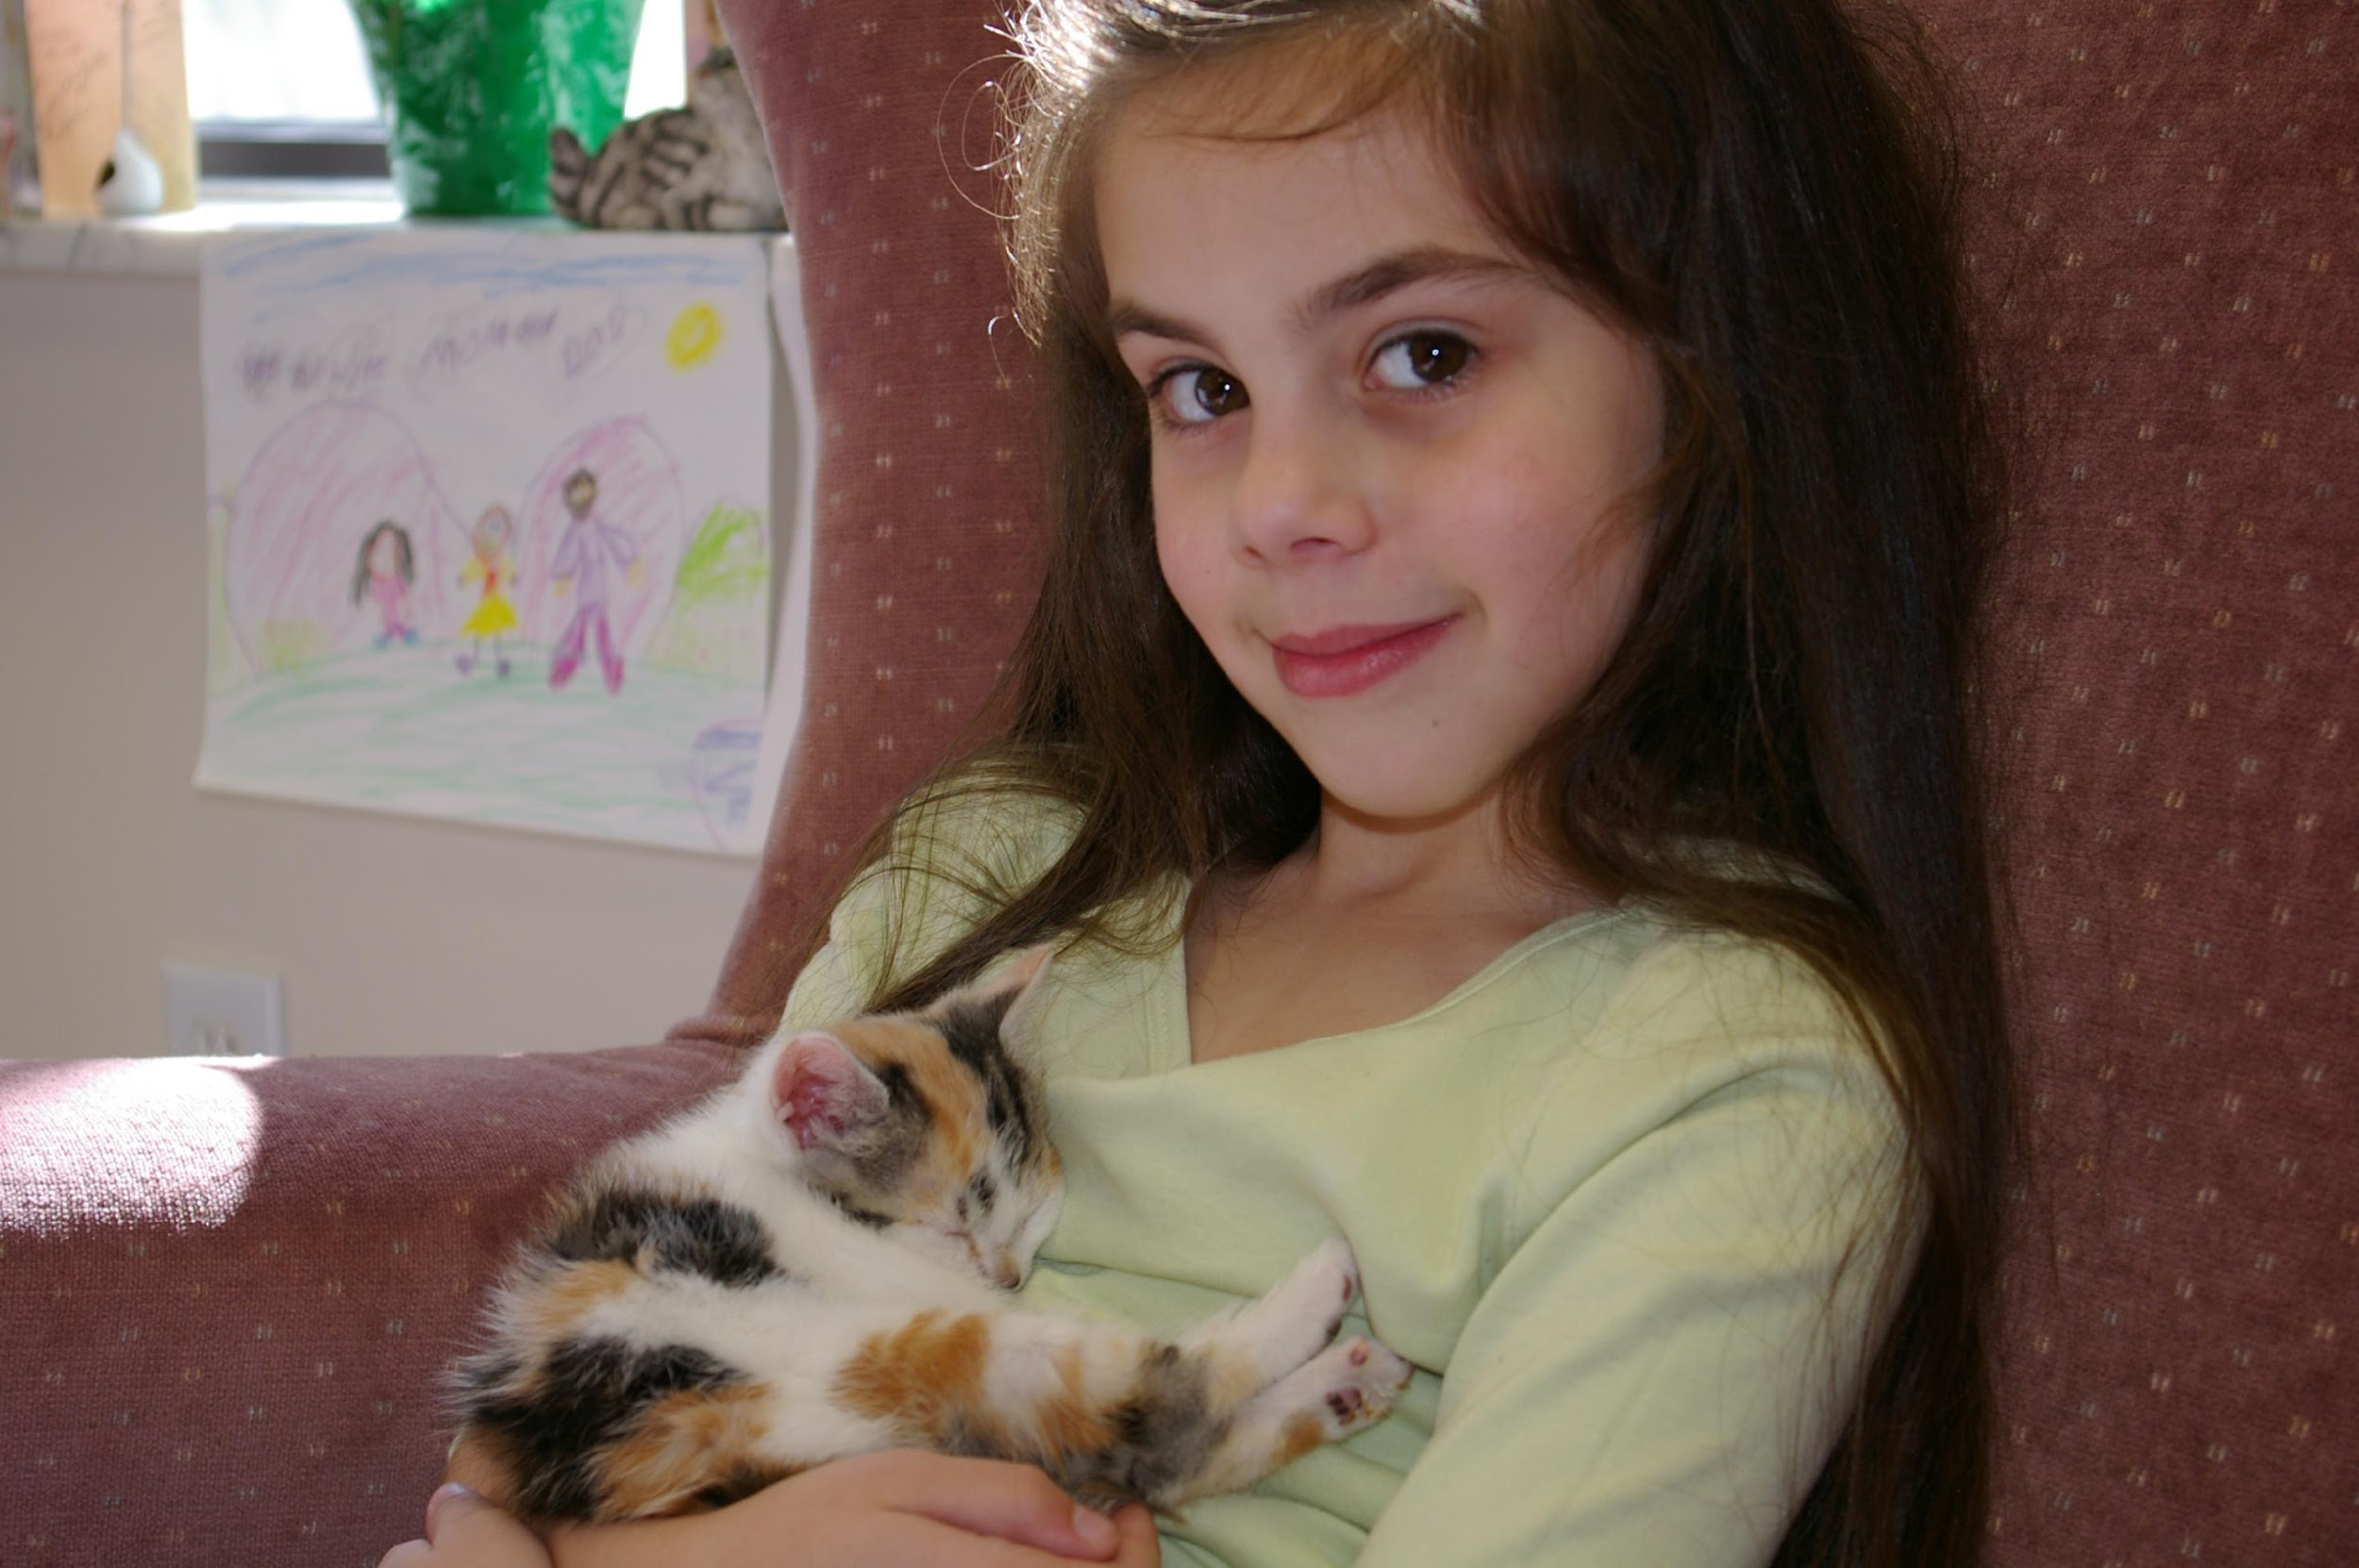
A “Free” Kitty is Never Free!
Photo by Debbie Brusius

A “Free” Kitten: | A Kitten from Your Organization:
–Average Costs –  - New Patient Vet Exam - $45-55  - Spay/Neuter - $200/$130  - FeLV and FIV Testing - $41  - Microchip (and Registration) - $50  - FVRCP Vaccinations - $18-25  - Treatment for Parasites (Fleas,  worms, etc.) - $50 | – Included in the Adoption Fee –  - Health Exam  - All Medical Care Prior to Adoption  - Spay/Neuter Surgery  - Testing for FeLV and FIV  - Microchip, including registration  - FVRCP Vaccinations  - Rabies Vaccination*  - Treatment for Parasites (Fleas, Worms, Ear Mites, etc.)  - You and Your New Kitten Handbook  - Sample of Food  - Free Vet Exam Certificate  - Advice Line  - 60-day Return Policy  *For cats over 16 weeks of age
TOTAL:  $334-$421 or more  (updated February 2017) | TOTAL:  Adult Cat: $15-$200  Teenager: $100-$200  Kitten: $150-$200  Discounts for multiple cat/kitten adoptions.

Kitten List
A list of all kittens in foster care is made available to the public for pre-adoption. We do this to encourage pre-adoption with the knowledge that the kitten will go straight home after surgery. Foster family contact information is listed for kittens once they reach 6 weeks of age. If you do not want your contact information listed, you must notify the Foster Coordinator, prior to the kittens’ 6 week date.

Showing Kittens at Your Organization Offsite Adoption Sites
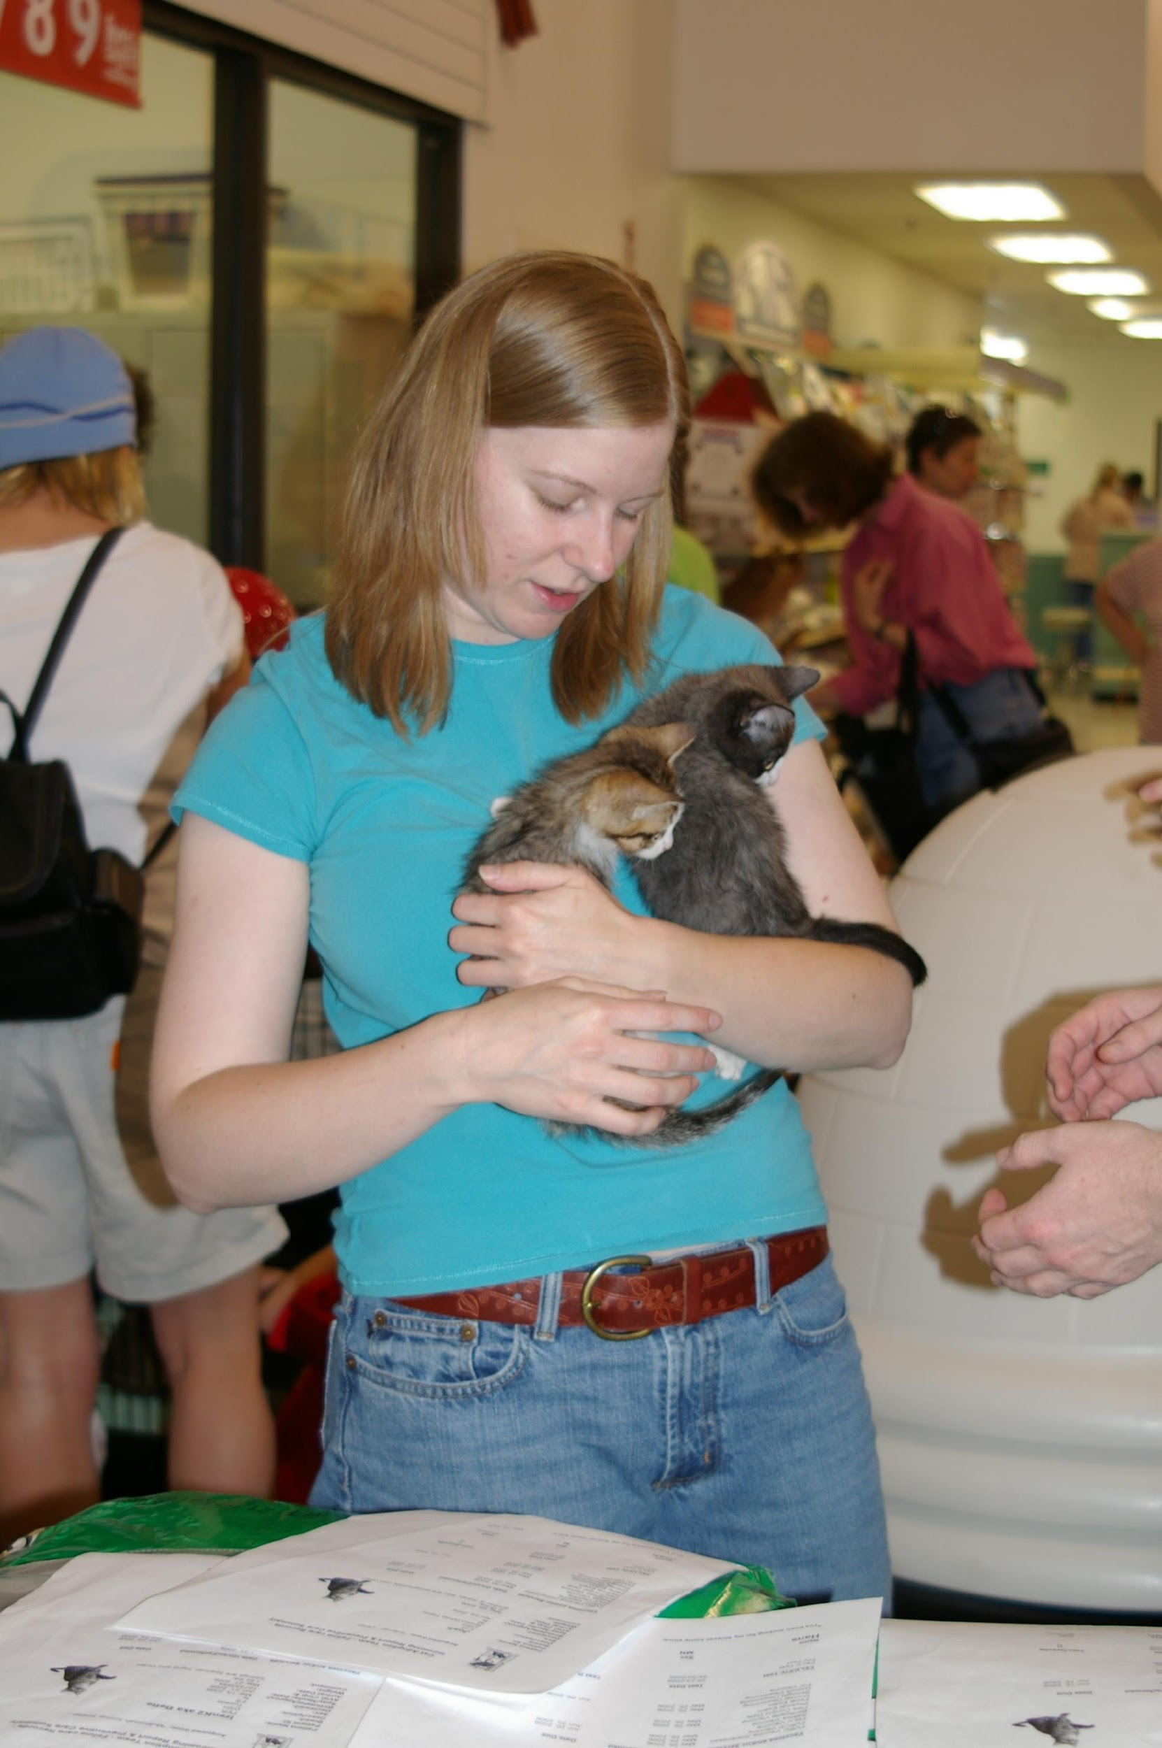
Foster families may want to show their kittens at the various offsite locations to facilitate pre-adoption. We recommend kittens be around 2lbs. and have been vaccinated for at least five days before going out in public. They cannot be on any medications, and will need to be off of medications for at least three days before going out. Foster families can contact the volunteer manager to arrange for kittens to go to an offsite location. The foster coordinator will post on the Google group when offsite opportunities arise. Please note that these opportunities are currently very limited and we highly encourage pre-adoption from your home instead.

When you bring your foster cats to Your Organization for adoption purposes, it is important to have a brief write-up about each cat’s personality, and the kind of household that would be most suitable. You can fill this information out on the personality profile page we provided you with when you picked up your kittens from the shelter. If you have photos of your foster cats, please consider providing those as well. Many adopters love to receive “baby” photos of their newest family member!

Petfinder
Petfinder is an online gallery of pets that are available for adoption. Users can search by location, age of pet, breed, etc. It’s a handy tool for adopters, and it is estimated that 1 out of 3 visitors have already browsed Petfinder before visiting the shelter or offsite locations. Your Organization shelter software (Shelter Buddy) sends pictures and bios about each cat to our website’s adoption page which also feeds to Petfinder and other adoption websites.

Kittens posted on Petfinder have the highest rate of pre-adoptions simply because adopters are able to view them prior to their arrival at the shelter. Why is this important? If a kitten can be adopted directly from your home or on the day of their spay/neuter surgery, the time spent in close contact with other kittens is greatly diminished. Less contact equals less exposure to germs equals fewer kitty colds (upper respiratory infections).

How do you get your foster kittens posted on Petfinder?
Group pictures, singles, or kitten with mom are all acceptable. Pictures are not posted until kittens are 6 weeks old. Please indicate if you would like to receive email inquiries about the kittens, whether you will show them from your home, if they will be available at an offsite location, and if you would like your phone number listed. Email your pictures, descriptions, etc. to petfinder@yourorganization.com. Please note that profiles may take one day to be posted.

What type of information?
Here’s the information needed for each kitten in the litter. Please email each kitten’s bio and pictures separately.

Full Name: (i.e. Missyk1 aka Sweety)

Bio: Tell us about your kitten. What does he like or not like? Is he dog friendly? Kid friendly? Other cats friendly? Highlight the best and most unique aspects of your kitten’s personality.

Intake date and patient ID: The patient ID number is needed to access the kitten’s Petfinder profile. It can be found on the kitten’s kennel card. The ID number is 5 digits long and located at the top of the card underneath the kitten’s name where it is labeled patient ID.

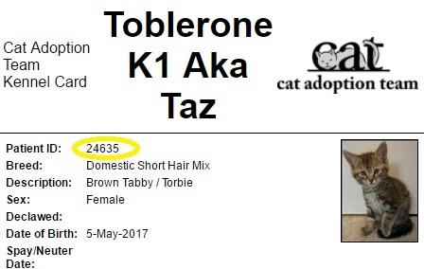

Contact Information: Please provide the email address you want to use for corresponding with potential adopters. This way potential adopters know exactly who they need to contact in order to adopt the kitten they are interested in.

We cannot post kittens without all of the information above.

What kind of pictures?
Digital only, jpg formats. Pictures should be less than 250kb, which is pretty small. Try to crop just around the cat itself. Please make sure the background is free of clutter. You don’t need posed shots, but they do help. It’s also great to show kittens with a resident dog, or maybe being held by a child. This helps adopters immediately identify which animals are most compatible with their own families. We can post up to three pictures per cat/kitten. Please send the pictures as attachments in the email.

Photographers
If you do not have a digital camera, but would like your kittens listed on Petfinder, we might be able to help. Usually volunteers are available to take pictures at your home. Please email the google group for help.

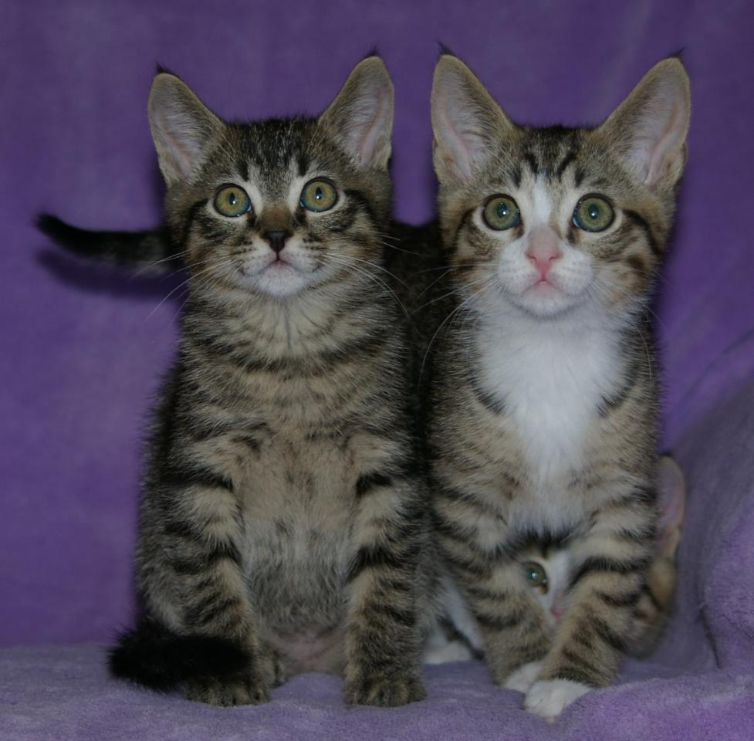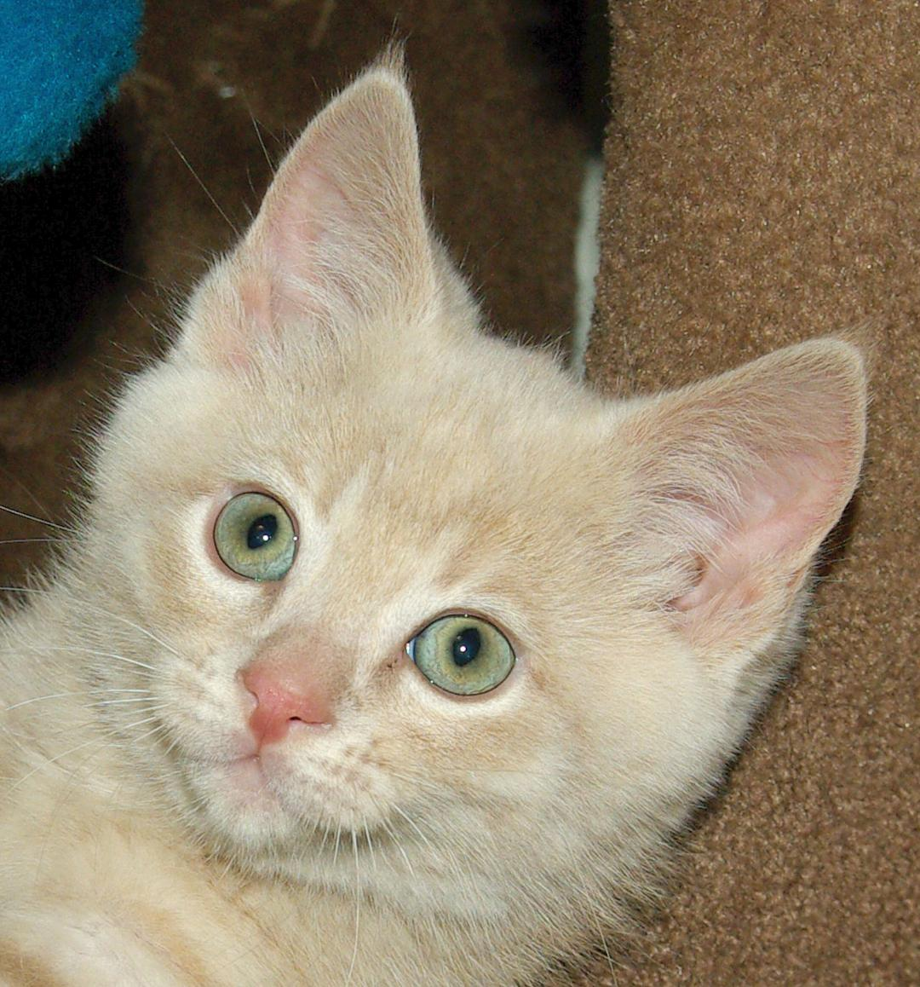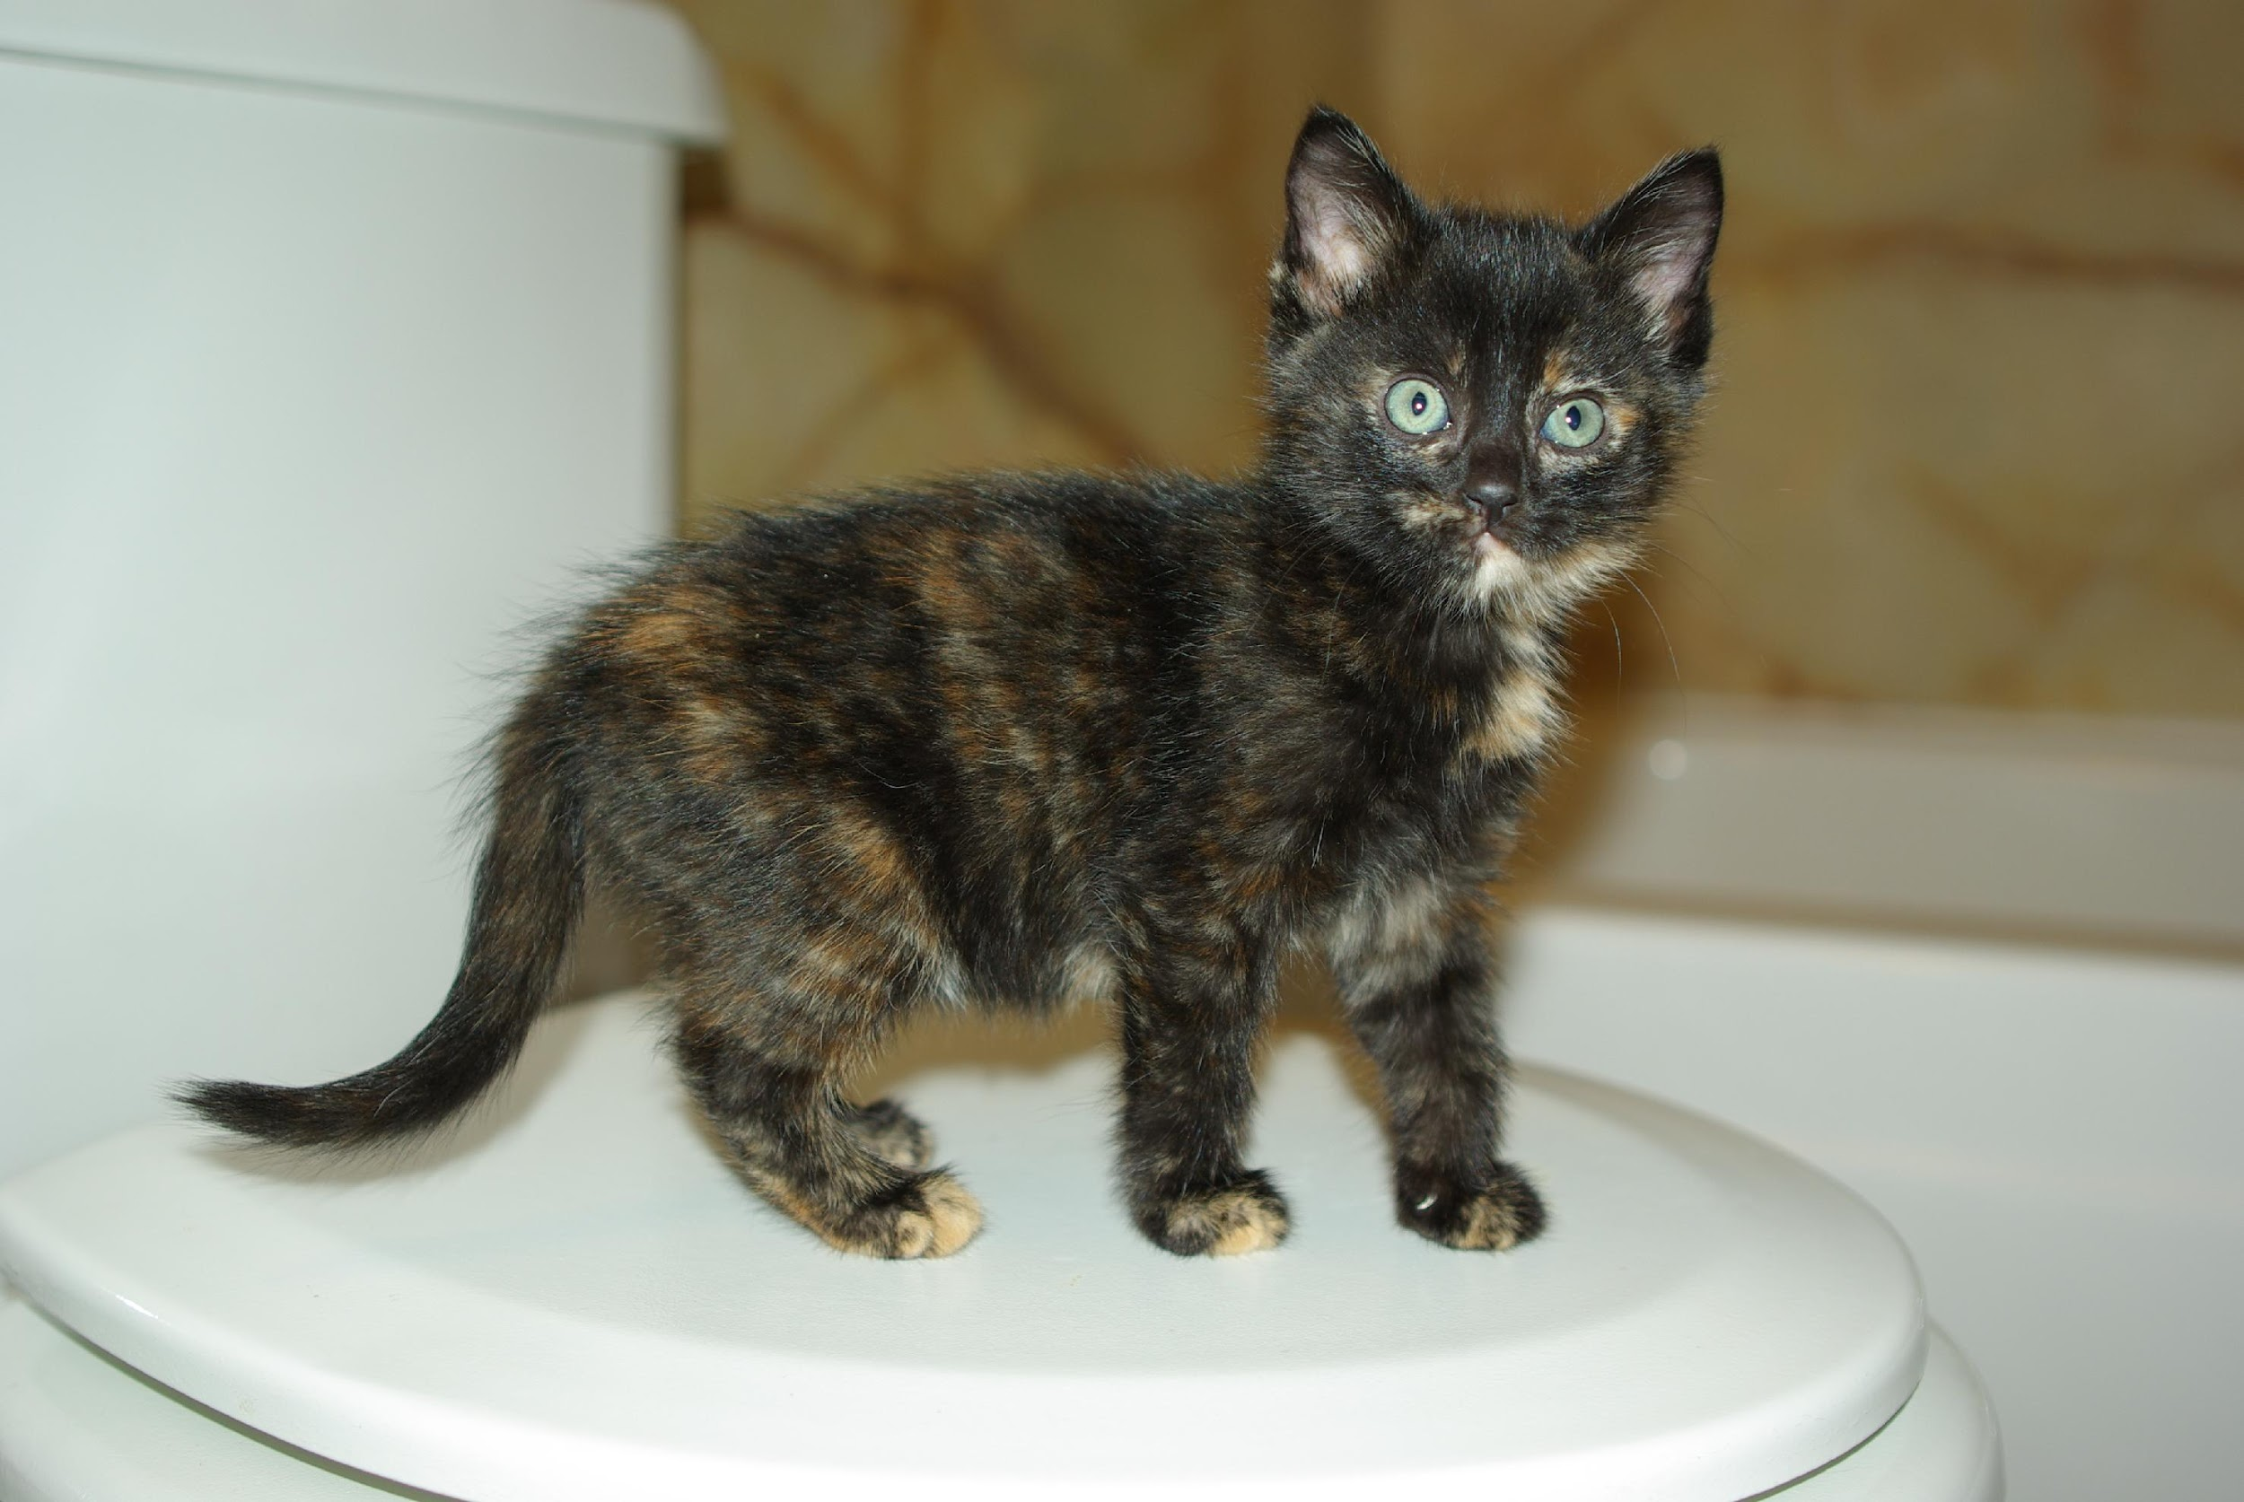

Sibling shot Face shot Body sho

Returning Your Foster Cat/Kittens
When your foster cats and kittens are ready for adoption, you can either schedule them for surgery so that you may take them home with you to market them, or you can bring them back to the shelter to stay until they are adopted. The following describes what steps to take for either scenario.

Bringing Them in for Surgery
- Spay/neuter appointments are made 2-3 weeks in advance during the busy season. The foster coordinator will contact you with some suggested surgery dates when your kittens turn 6-7 weeks old. If your kittens are all over 1.75lbs and you do not have a surgery date set yet, please email the foster coordinator to request one. If you need to cancel an appointment, please email the foster coordinator with as much notice as possible.

- Please contact pre-adopters and let them know the day their kitten is being altered. Kittens can be picked up between 4:30-6:30pm.

- Put collars on your mom and kittens at home. Make sure to write on the DULL side of the collar. For kittens, put their full name, “Valerie k1 aka Polly.” This will help us if we have 2 Polly kittens in our care (which we did at one time). If you do not have collars with you, then you will need to put them on once you reach the shelter. Collars should be snug enough so they cannot pull them over their head, but loose enough that you can fit two fingers in between the neck and collar. Cut off any excess collar carefully with scissors.

- Pick up food plate first thing in the morning preferable by 6 am. Do not feed breakfast. Water is fine. The anesthesia can make them sick and we don’t want the kittens to vomit. They can choke on their own vomit and this can be life-threatening.

- Bring kittens to the shelter for surgeries. If you cannot make the appointed time, please make arrangements through the shelter ahead of time to drop off the night before.

- Bring in your completed Medical Records sheet (attached to the kennel card) with your kittens the day of surgery.

- Please complete the Feline Personality Profile sheet for each of the kittens. Your information and recommendations are a big help in finding them the perfect forever homes.

- Fill out the Foster Return Form completely. There is a place on the form to mark whether a kitten is pre-adopted, if you are picking them up after surgery, etc. This will only take a couple of minutes.

- Hand in your baby bag, scale, and Snuggle Safe warming disc (if applicable) to a staff member or volunteer who is checking you in.

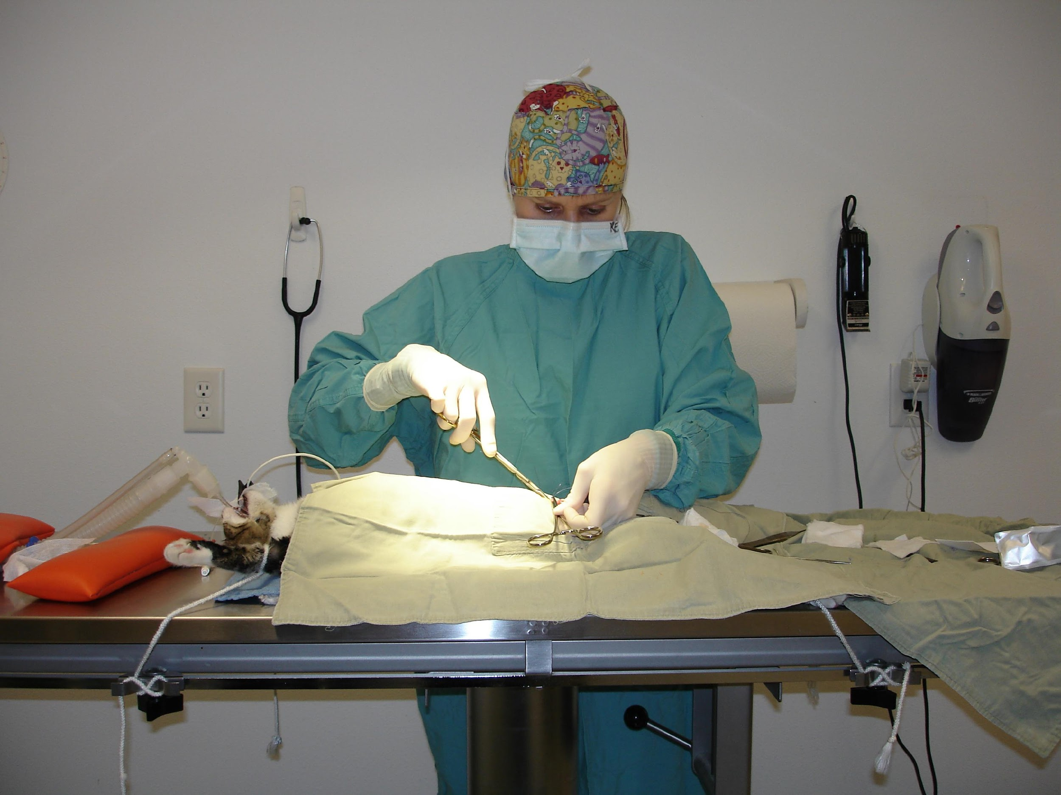
Photo by Debbie Brusius

Bringing Them Back to the Shelter
- Please email the Foster Coordinator to make an appointment for your kittens to return to the shelter. This way we will make sure they have a kennel when they arrive. Also, if your kitties are coming back to stay at the shelter to be adopted and have not yet been altered, please be sure to mark it on the Foster Return Form so we can make sure they get put on the hospital ‘needs surgery’ list.

- Bring in your completed Medical Records Sheets (attached to the kennel card) with your kittens the day of surgery.

- Please complete and turn in the Feline Personality Profile sheet for each of your kittens.

- Fill out the Foster Drop-Off Information Sheet completely. There is a place on the form to mark whether a kitten is pre-adopted. This will only take a couple of minutes.

- Hand in your baby bag, scale, and Snuggle Safe warming disc (if applicable) to a Shelter Associate.

Cleaning Between Your Foster Groups
The joy of letting go of one foster group is knowing that they will be going to loving homes while you are able to take in another that may not otherwise be able to find shelter to grow in such a loving environment. Please consider the following guidelines when transitioning between groups.

Once you have taken the kittens back to the shelter for surgery it is time to clean and prepare your kitten room for your next foster group. You will need to remove all bedding, and wash it in hot water with bleach added. Follow your machine's guidelines for adding bleach to the wash load.

You will also need to clean the litter box. Empty all of the contents, and wash with hot soapy water. Rinse well and then fill with hot water, add one cup of bleach and let it sit for at least 10 minutes. Rinse and dry well.

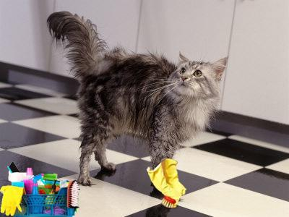
For food and water dishes you can run them through the dishwasher and they will be cleaned for your next group. Or, you can clean them as you did the litter box if you don’t have a dishwasher.

If you have carpeted floors you will need to vacuum well and spot clean any areas that need it. If you have a carpet cleaner you should use it between groups. If you do not have carpet, sweep and mop the floor. Once the floor is dry, mop again with a bleach water solution (1 cup of bleach to 1 gallon of water) and let it sit for ten minutes. Afterwards you will want to rinse with clear water and then let it dry.

You will need to wipe down all surfaces with a bleach water solution or Clorox Cleanup. You should also wipe the walls down. You do not have to do all of the wall but at least the bottom 3 feet.

If you have a bed in the room, change the covering on it. If you have a chair or couch in the room you will need to vacuum it and spot clean if needed. Ideally, your foster room will be void of anything covered in material like a chair or couch unless it is covered with a plastic sheet designed to protect them.

Foster Program FAQ’s
How do I become a foster parent?
You will need to fill out Your Organization online volunteer application. Our volunteer coordinator will set you up for general volunteer orientation as well as a specific training for the foster program. More information at: www.yourorganization.org/volunteer
What is required of me as a foster parent?
Providing a safe, ‘kitten-proofed’ room in your home that contains the kittens’ necessities; food, water, bedding, litter box, toys, etc. You are responsible for ensuring that your kitten receives any scheduled medical treatments on time, is healthy, and well socialized. Please see pages 5-10 and 23-27.

I found a litter of kittens. Can I foster them through your program?
Yes, with approval and appointment. We will try to work with you on setting an appointment if you are the foster parent. If you cannot foster this litter it may take us some time to find a foster home. We will do our best to work with you.

What are the requirements for a foster room?
The foster room needs to be a designated place for your foster kittens to live the entire time. Your Organization recommends a bathroom for ease of cleaning. A spare bedroom, or other room could work as well. This room will need to be ‘kitten-proofed’ and have plenty of space for a litter box, food and water dishes, as well as sleep and play areas. Please see pages 8-9.

What supplies do I need to provide myself?
Your Organization will provide you with a baby bag full of basic medical supplies as well as provide all vaccines and medication necessary for your kittens. We will also provide you with a high quality dry and wet kitten food diet. Pellet litter is also available if needed. Foster parents generally supply litter box, food dishes, toys and scratching implement, bedding, and other small incidentals. However, if you need help with some of these supplies, we will do our best to help you. Please see page 11.

How do I get a group of foster kittens?
After you have completed foster training you will receive an email invitation to Your Organization Google group. As foster kittens become available the foster coordinator will post a plea for a foster home to the Google group. Whoever responds first, and is the best match for the foster kittens, will get the group. The foster coordinator will then send further information with specifics on arrival and pick up information. Please see pages 12-13.

How much do I need to supervise my foster group?
You need to do welfare checks on your foster group three times a day. This is to make sure everyone is healthy, eating, and using the litter box. You need to spend about 1-2 hours per day interacting with your foster group so that they become well socialized. Please see page 14.

Can my foster kittens and mom cat interact with my resident pets?
Foster groups in which the kittens have been vaccinated need to be kept separate from resident animals for two weeks. Kittens who have not been vaccinated may not meet any resident pets until 5 days after their first vaccines. If your foster kittens or resident animals are sick then they may not interact. If your kittens were too small to be tested for FIV/FeLV they should not interact with your resident cat. All interactions must be directly supervised. Please see page 14.

Can my children interact with the foster kittens?
We encourage your children to have supervised interaction with foster kittens. Children should not be permitted to handle newborn kittens. Caution and direct supervision is a must! Please see page 14.

Do we bottle feed kittens?
Your Organization does not intentionally take in young kittens who will need to be bottle fed. However, occasionally a situation arises where kittens need to be bottle fed. If this is the case we will train our foster parents to bottle feed, or place the kittens with a foster parent who is experienced at bottle feeding kittens. Please see pages 15-18.
How will people know that I have kittens?
Your Organization keeps a foster kitten list that is available to the public through a link on our website. When kittens turn 6 weeks old foster parent contact information will appear on the kitten list and the public will be able to contact foster families. At this age foster kittens’ information will be automatically pulled from our shelter software and posted on Petfinder.com. This is another way the public will be able to find kittens available for adoption. Please see pages 38-40.

Do I have to have people come to my home?
Having prospective adopters come to your home is encouraged as it helps to see the kittens in a relaxed home environment. However, it is not required.

What is the next step for potential adopters once they meet my foster kittens?
If you are a trained adoption counselor, and have the necessary paperwork, you are welcome to complete the adoption at your home. If you are not an adoption counselor, you will need to send your adopters to the shelter to complete the adoption with a trained adoption counselor. If you live close to one of our offsite adoption centers you can also send your adopters to one of those locations on the weekend. Please contact the foster coordinator to confirm offsite adoption hours ahead of time.
Please see page 35-36.
Do I need to give my own vaccines? Can I learn?
Your assigned mentor is trained to give vaccines. You will make appointments with your mentor to assure kittens get their vaccines on time. We encourage foster parents to learn to give vaccines and offer clinics at the shelter for those who are interested.
Please see pages 23-27.
Who do I call for help?
Each foster family is assigned a mentor. Your mentor will be your first point of contact for any questions or concerns you may have about your group. Please see pages 7.
If my foster kittens get sick do I take them to my own vet?
All veterinary care will be provided through Your Organization. Foster parents are not permitted to seek veterinary care from outside clinics. Any visits to outside veterinarians that are not pre-approved will be the financial responsibility of the foster parent. Please see page 34.
What do I do if my own cats get sick?
Your kittens should be kept separately from your resident cats. However, we do recognize that cross contamination can happen. If your own cats get sick it is your responsibility to seek veterinary treatment. In some instances, Your Organization may be able to help you by seeing your cat and prescribing medications for specific conditions. However, this is not possible for us to do all of the time and you should not count on this service. Remember there is always an inherent risk of disease when you bring new animals into your home. This is why we require that all animals in the home are current on vaccinations.

Do my resident pets have to be up to date on their vaccines?
For everyone’s protection and safety your resident pets are required to be up to date on vaccines.

Do my resident pets have to be spayed or neutered before I foster kittens?
Yes. Your Organization can help you set up an appointment to have this done through on our on-site clinic.

Can my resident pets come to Your Organization for care? Is there a discount?
We do offer discounted vaccines to our volunteers. Please inquire at the front desk for pricing and appointment availability.
What if I have to leave out of town unexpectedly?
Contact the foster coordinator as soon as possible so that we can find alternate placement for your kittens.

What do I do if I don’t like or get along with my mentor?
We encourage you to form a good relationship with your mentor and keep communication open. If you have an issue you feel you cannot resolve on your own please contact the foster coordinator for help.

Your Logo Here
Foster Care Agreement
Please Read and Sign

- I understand the goals and mission of Your Organization and, as a Your Organization volunteer, agree to work toward these goals and to represent this mission within the community on behalf of the organization. My commitment includes abiding by Your Organization foster care guidelines, as outlined in Your Organization Foster Program Manual, which I have received. This includes, but is not limited to:

  - A commitment to keep Your Organization foster cat(s)/kitten(s) indoors and not expose them to other cats that have access to outdoors.
  - A commitment to follow Your Organization instructions with regard to medical care.
  - A commitment to keep detailed, dated medical records (which will be made available for adopters), and ensure that an up to date copy is also on file at Your Organization facility.
  - Moms and kittens must be housed separately in their own room.

- I understand that only Your Organization Foster Coordinator, Director of Operations, and the Executive Director have the authority to make exceptions/changes to program guidelines.

- I understand that Your Organization is the sole guardian of cats/kittens in foster care and that fostered cats/kittens must be returned to Your Organization upon Your Organization request. I understand that Your Organization has the right to terminate this foster care agreement and relationship at will.

- I understand that if I, as a foster volunteer, want to adopt any of my foster cat(s)/kitten(s), I must go through the standard Your Organization adoption process. I also understand that I cannot send any of my foster cat(s)/kitten(s) to an adoptive or potential adoptive home until the cat(s)/kitten(s) has been altered, the adoption process has been completed by a trained Adoption Counselor and the Foster Coordinator has been informed. Furthermore, I must have permission from the Foster Coordinator before sending my foster cat(s)/kitten(s) to another approved Your Organization foster home. I also understand that expenses for food, litter, treats, scratch posts, etc. cannot be applied toward adoption fees should I adopt a cat(s)/kitten(s).

- I understand that foster cat(s)/kitten(s) need to be taken to Your Organization on-site Veterinary Hospital for any medical care and can be reached at 503.555.5555. Your Organization funds all medical care, and in the event of a medical emergency after hours or on the weekend approval is needed by the Foster Coordinator, Foster Mentor, Your Organization on-site Vet or Vet-Tech, and only if the medical care is provided at a Your Organization approved veterinary clinic or hospital. I understand that if I choose to take my foster cat(s)/kitten(s) to a non-approved veterinary clinic, or if I take my foster cat(s)/kitten(s) to an emergency veterinary hospital without prior approval, Your Organization will not reimburse me for the expenses incurred.
- I understand that there is a possibility of health or injury risk when caring for cats. I also understand that pregnant women and people with suppressed immune systems need to be aware that a parasite sometimes found in feces could cause toxoplasmosis. Special care needs to be taken if such persons plan to come in contact with used litter pans. I will not hold Your Organization liable for any injury or illness, whether to the animals or humans in my home, which may result from my foster activities.

- I understand that if I need to leave town during my foster period that I will need to give a two-week notice when possible to the Foster Coordinator for my kittens to be permanently rehomed to another Your Organization foster home.

_____________________________ ________________________________ ___________________
Printed Name of Foster Parent Signature Date

_____________________________ ___________________ Your Organization Representative Date

_____________________________ ___________________
Foster Coordinator Date

Name(s) of foster cat(s)/kitten(s) sent to foster on this date:____________________________________
_____________________________________________________________________________________________

__________________ ____________________ ___________________
Baby bag # Scale # Warmie #

Your Organization –Address-Phone Number-Website

