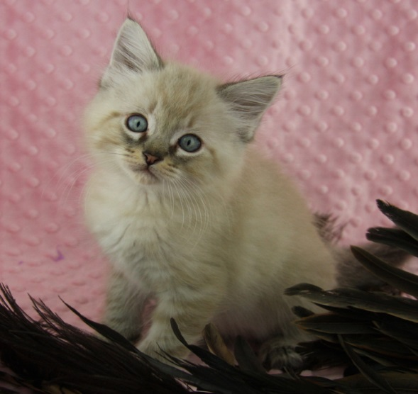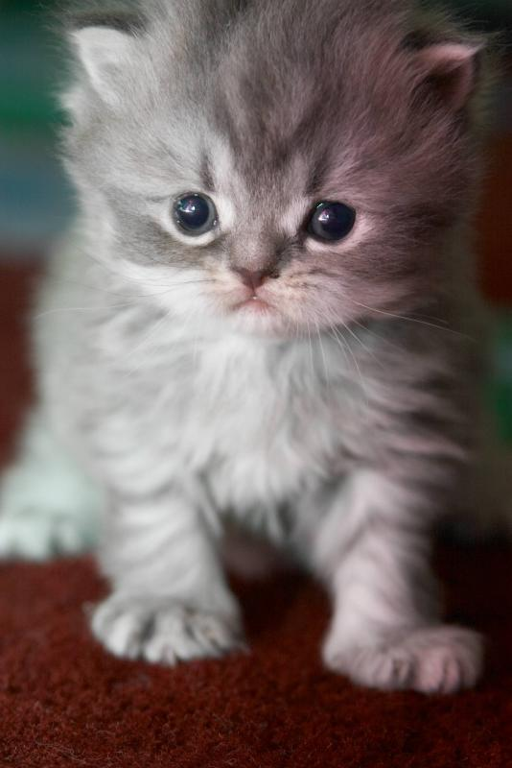

**Your Logo Here**

Contact us today to learn how YOU can foster kittens!

• FREE training and mentors

• Many foster supplies provided

• Learning experience for the whole family

• Save lives and promote pet adoption!

PHONE # • URL

Love Kittens? We do!