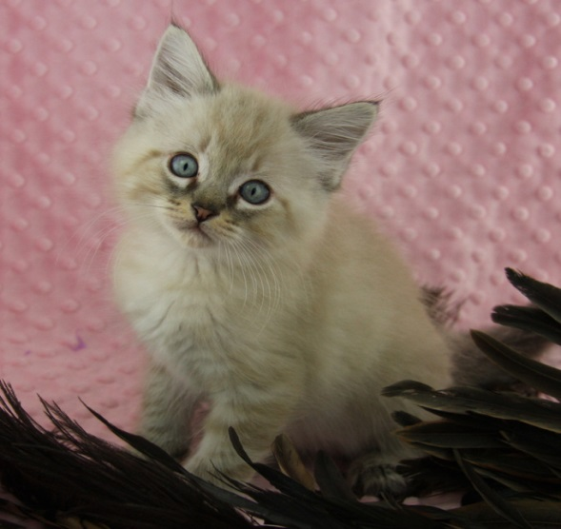

Your Organization

(555) 555-0125

URL

Your Organization

(555) 555-0125

URL

Your Organization

(555) 555-0125

URL

Your Organization

(555) 555-0125

URL

Your Organization

(555) 555-0125

URL

Your Organization

(555) 555-0125

URL

Your Organization

(555) 555-0125

URL

Your Organization

(555) 555-0125

URL

Your Organization

(555) 555-0125

URL

Your Organization

(555) 555-0125

URL

**Your Logo Here**

Contact us today to learn how YOU can foster kittens!

Love Kittens? We do!

PHONE # • URL