Let’s Throw a Virtual Kitten Baby Shower!

Timing
We suggest late March, April, or early May. These months will help you get supplies in time and get everyone excited for the imminent arrival of kittens. However, since it is virtual, you could hold it any time of year!

Gifts and Donations
An Amazon Wish List is a great way to let folks know what supplies you need. Amazon has a great ranking feature to help you indicate which items are of the greatest priority. A link can be included in any electronic communications promoting your event.

Kitten Foster Program Wish List Ideas
Royal Canin Mother and Baby Cat Dry Food | Miracle nipple for bottle babies
Gallon Size Ziploc Freezer Bags | Baby Washcloths
Royal Canin Mother and Baby Cat Wet Food | A/D Ointment- 4 oz. tube or packets
Breeder’s Edge milk-replacement powder | Snuggle Safe warming discs
Bottle Feeding Kit for Kittens | Frontline Plus for Cats
Advantage for Cats | Quick Read Digital Thermometers
Flea Combs | Pet Hair/Lint Rollers & Refills
Hand Sanitizer – 4oz bottles & refill packs | Exam Gloves
Multi-Colored Fine-Tip Sharpies | Little Noses Saline Drops
Pumpkin Powder for Cats | Cat Nail Trimmers
Digital Kitchen Scale | Chicken Baby Food
Breeder’s Edge Colostrum Supplement | Breeder’s Edge KittenLyte
Inaba Churu Treats | Cardboard Cat Scratchers
Cat Dancer Wand Toy | Baby Shampoo

Place to Post
- Instagram
- Facebook
- Tik Tok
- Website
- Twitter
- E-newsletters

Sample Posts
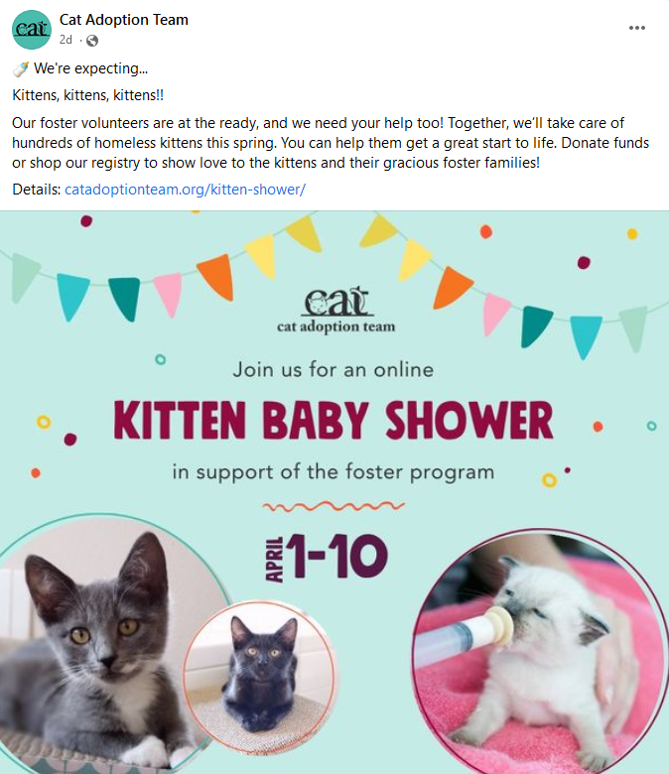
Social Media
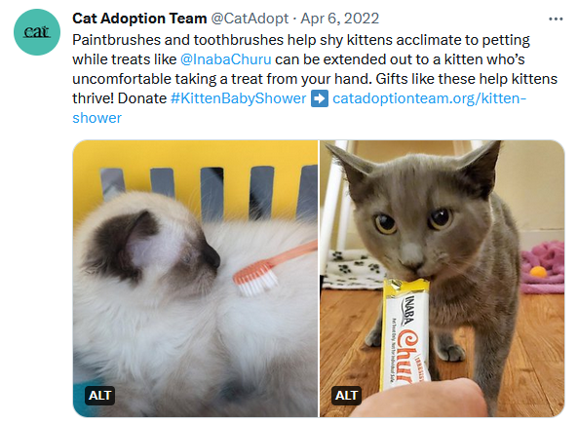
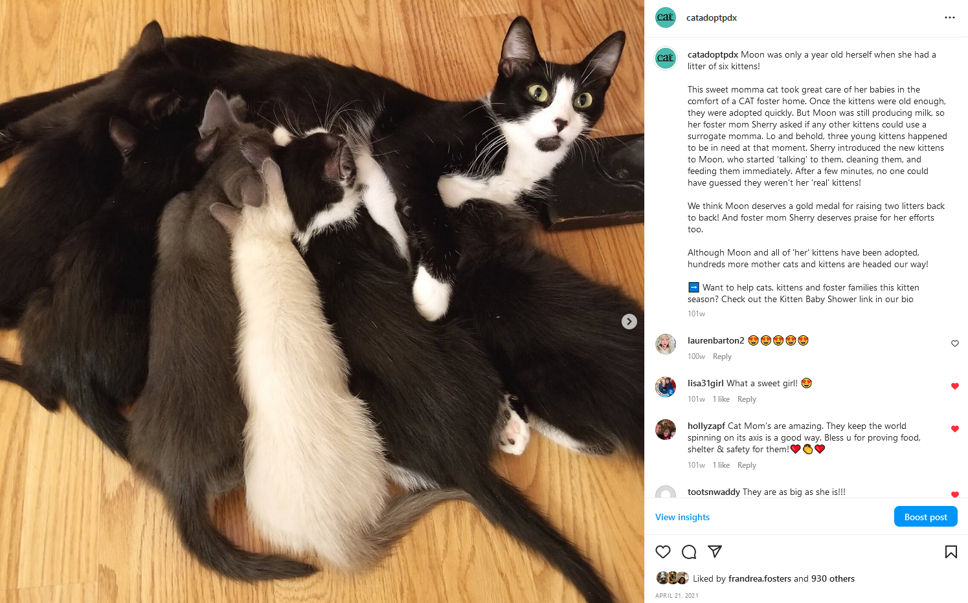
Email
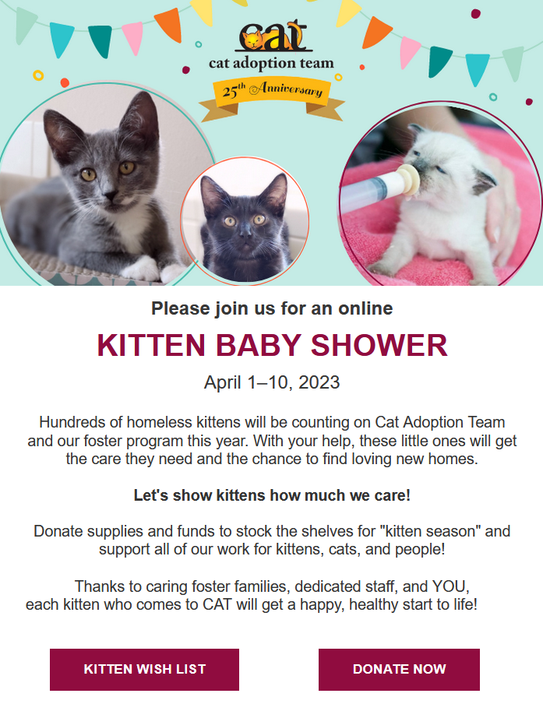

Continue to Promote
It’s important to post information about how it is going. Thank people for their donations. Ask for items that aren’t getting a lot of attention. Try to find a matching donor.
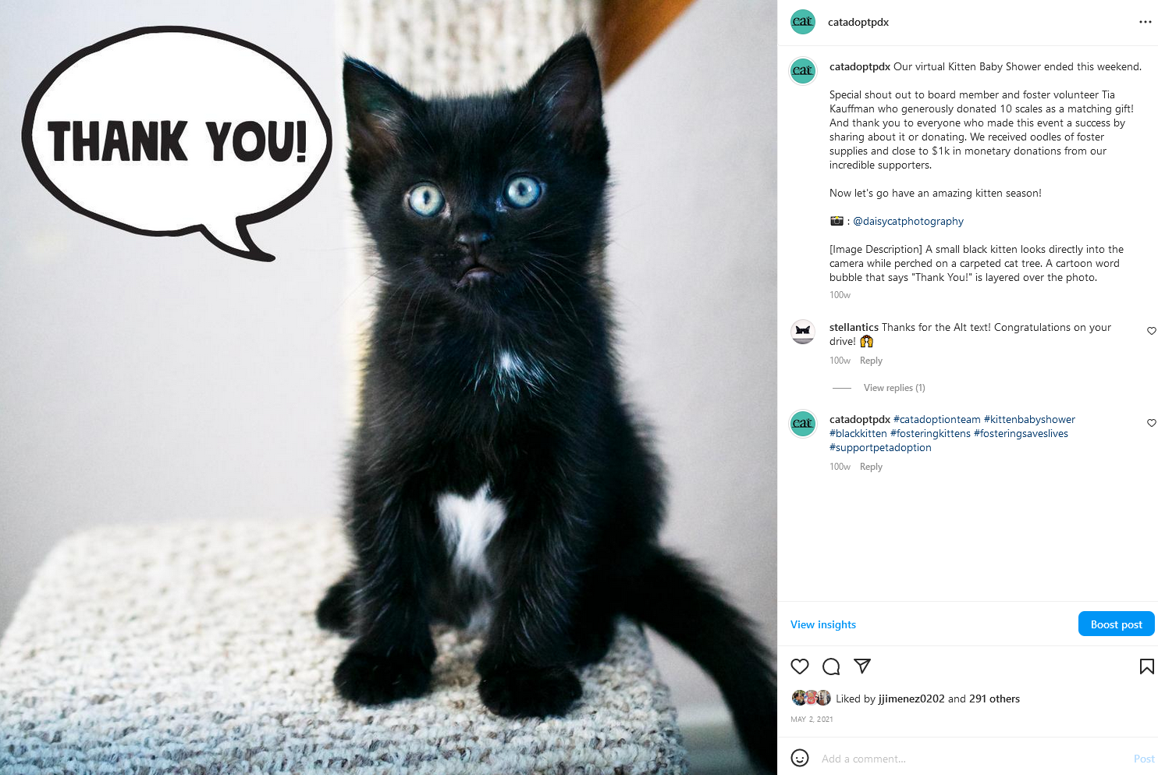

Décor for the Shelter
You can hang some baby shower décor in the lobby to let people know you're doing a donation drive for the foster program. Dollar stores and discount stores often have inexpensive decorations. Get your crafty staff and volunteers involved and have a decorating/set up party before the event.
It’s raining kittens is a great theme, and these puffy clouds make it adorable.

Collect Donations
Use a playpen or animal stroller to collect your supplies that are donated. Have the foster coordinator or other team member check it daily to remove most, but not all, of the items. You don’t want it to look empty.
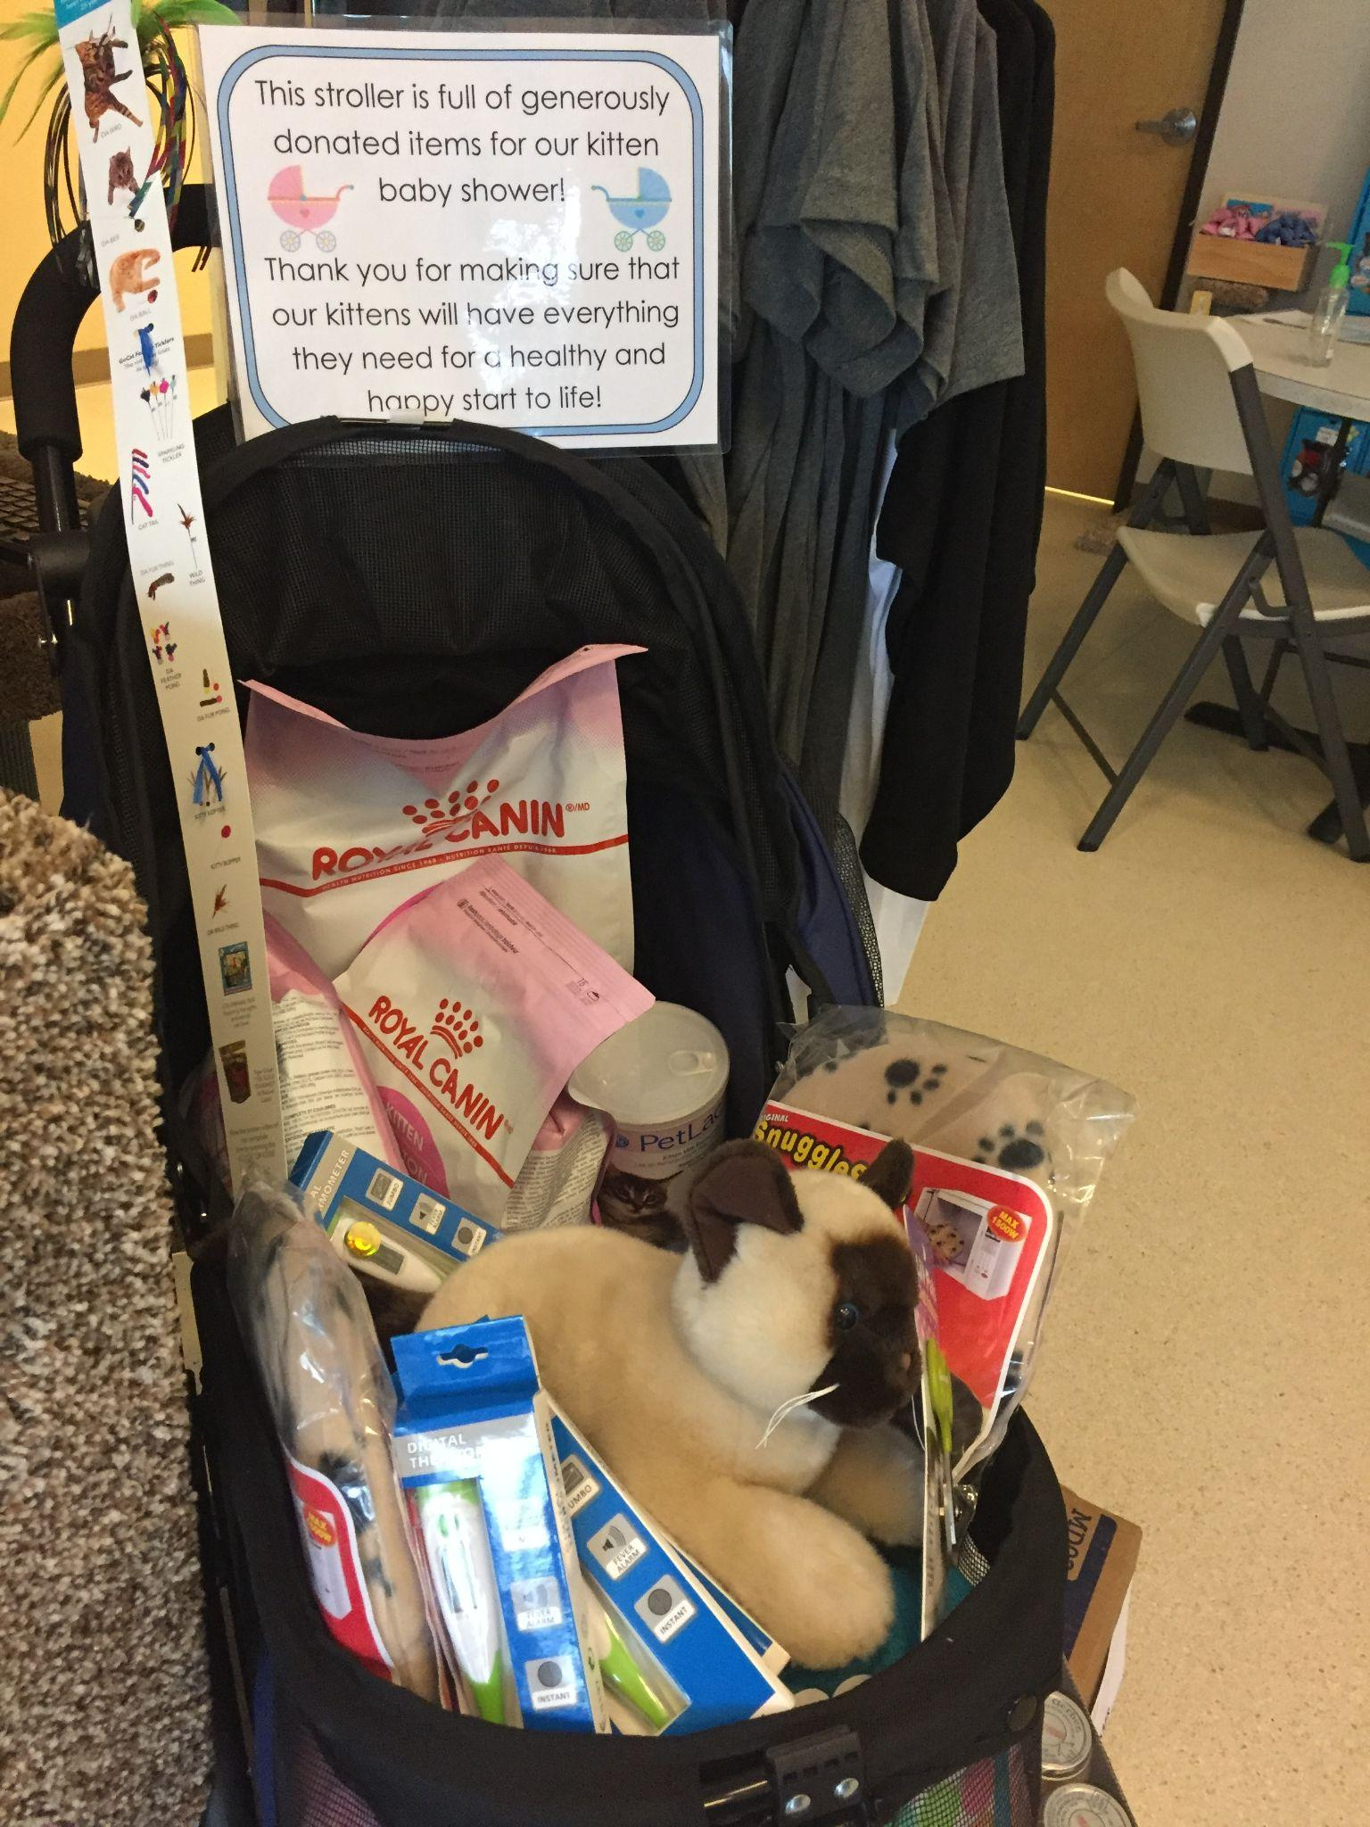

Thank You’s
If gifts are received with information about who sent it, make sure a thank you note is sent out as soon as possible. Encourage the staff to thank donors when they drop off supplies. And, don’t forget about social media. People love to see posts of gratitude - especially when it is a bunch of items that help kittens.

Retail Area
Mark items in your retail area as must-haves for the shower. Encourage anyone working with the public to stop by the retail area and pick up an item for the kittens. Use colorful, easy to recognize tags.
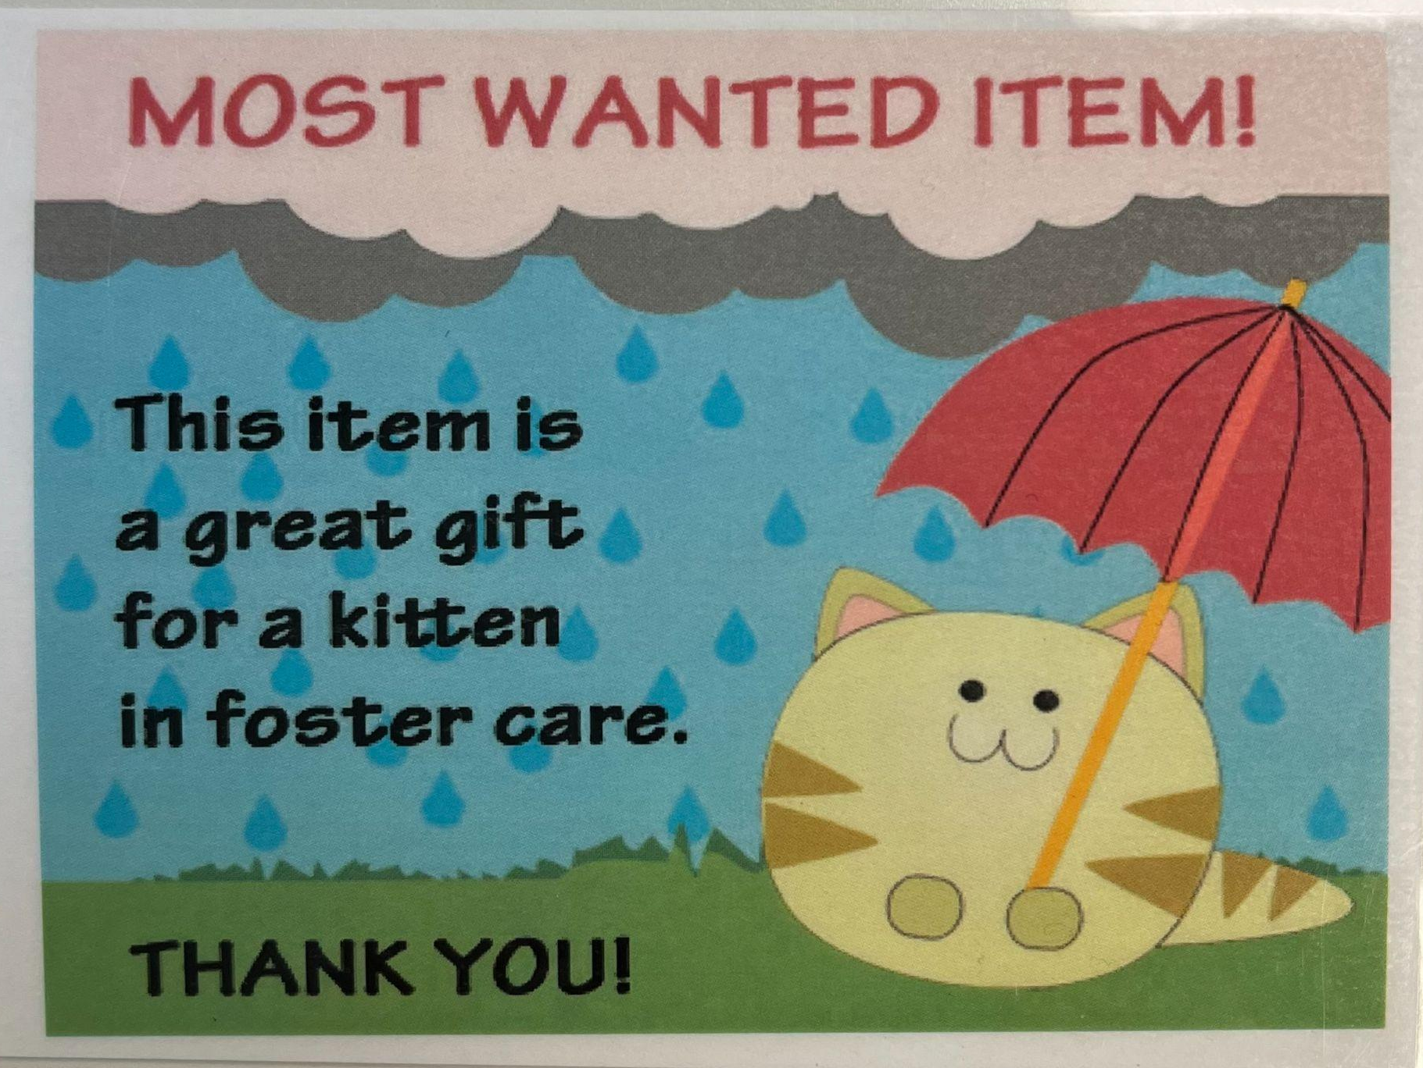

Assign Leads

Virtual Kitten Baby Shower Task Checklist
Task | Lead | Deadline | Notes
Setup
Determine dates for event | FC / DS |  | Run for one week or one month, depending on your organization resources
Put out playpen or stroller to collect gifts | FC
Send out info to staff and volunteers about the event ahead of time | FC
Find a matching donor if possible | DS |  | Donor could match a certain dollar amount or match a certain item, i.e. will donate a scale for every scale donated by someone else
Amazon Wish List | Lead | Deadline | Notes
Set up separate Kitten Shower List | FC / DS |  | Chewy, MyRegistry, and other sites also offer wish list/gift registry options
Determine items | FC
Rank items in order of importance | FC |  | Note quantities needed and share specifics about what items are used for
PR & Marketing | Lead | Deadline | Notes
Create and Send Email Invitation | CS |  | Include donors, foster volunteers, local vet clinics, and local pet supply stores on your email list
Create Facebook Event Page | CS |  | Encourage foster parents to invite their networks
Create Organization Website Event Page | CS
Post Info on Organization Website | CS
Send Event Information to Local Media | CS
Schedule Posts to Social Media | CS |  | Encourage foster parents to repost and share with their networks
Include Information in Organization Newsletters | CS
Signage | Lead | Deadline | Notes
Create Signs for Retail Area | CS |  | Mark items wanted
Create Event Sign for Front Door/Lobby | CS
During The Event | Lead | Deadline | Notes
Post Photos to Social Media | CS |  | Posts could feature a full playpen/stroller and thank donors, show off most needed items, and tell more about how your foster program saves lives
Create Thank You Post for Social Media | CS / DS
Send Thank You Notes | DS
Organize Donated Items | FC
Remove Donations Daily | FC
*FC = Foster Coordinator, DM = Development Staff, CM = Communications Staff

