Let’s Throw a Kitten Baby Shower!

When is the best time to throw a shower?
We suggest late March, April, or early May. These months will help you get supplies in time and get everyone excited for the imminent arrival of kittens. A weekend day in the late morning or early afternoon works best.

Who should be invited?
Staff, volunteers, foster families, donors, and the public. Consider including vet clinics in your area.

Where?
If you can hold the baby shower at your shelter, you can showcase your shelter to potential volunteers, donors, and adopters. Ideally, your space should be large enough to accommodate attendees and have a refreshment table, information table, gifts/donations, and a space to play games.

Food and Beverages
It’s nice to have refreshments for your guests, including beverages, cookies, cupcakes, etc. Items that do not need to be cut for serving are the easiest. Call local grocery stores and bakeries to see if they would donate baked goods for your event. You can advertise their business and make them an official “sweet treat sponsor.”
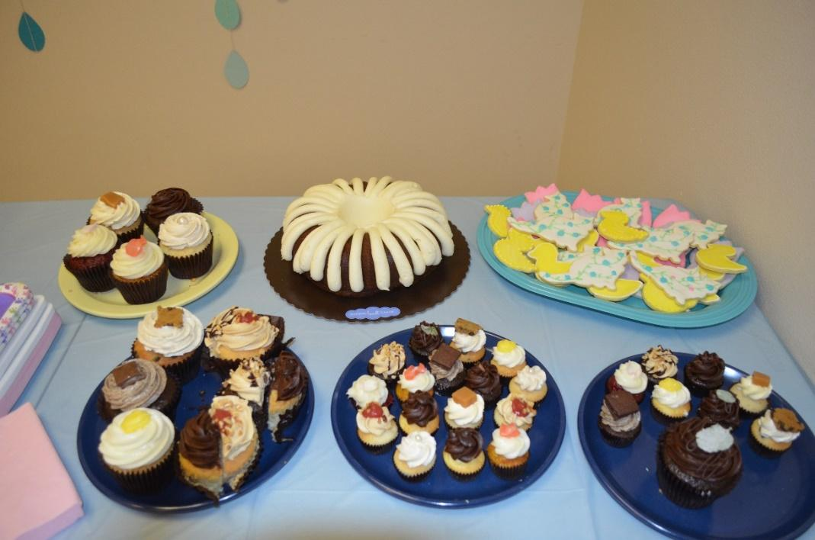

Décor
Make it a real party, and hang some baby shower décor! Dollar stores and discount stores often have inexpensive decorations. Get your crafty staff and volunteers involved and have a decorating/set up party before the event.
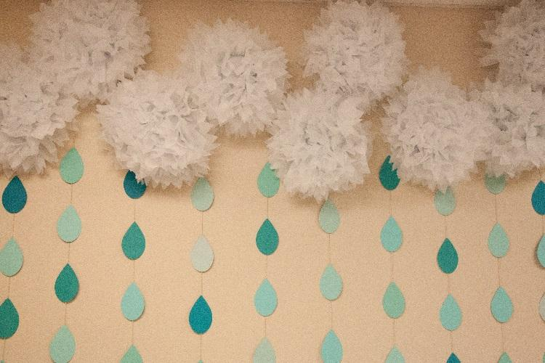
It’s raining kittens is a great theme, and these puffy clouds make it adorable.
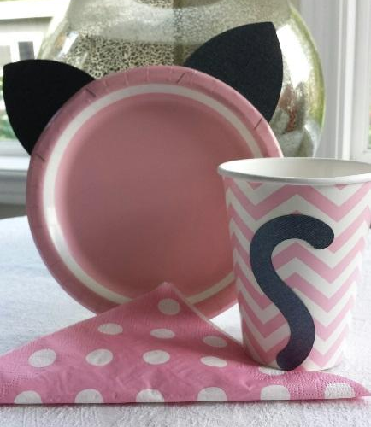
Crafty volunteers make paper plates sprout ears, and cups that have tails.

Games and Activities
Baby shower games are a great way to engage your guests. We typically do three games with small prizes. We have also held raffles to generate revenue at the shower.

Baby Shower Game Examples:

1. Pin the Nose on the Cat
- Supplies: Large poster of a cat face, multiple cat noses, pens, tape, blindfold
- Object: Participants attempt to pin the nose of the cat while blindfolded
- Play: Write the person’s name on their nose and attach the tape to the back. Spin the participant in three circles (slowly) while blindfolded. Set them straight in front of the face one to two steps away, and let them go. Do not allow them to touch the face to figure out where to put the nose.
- Winner: The winner is the person who most closely places their nose on the cat’s nose – no ties!*
- Prize: A gift card or donated prize
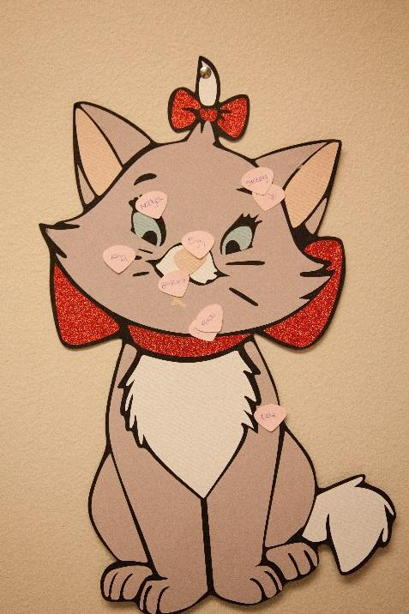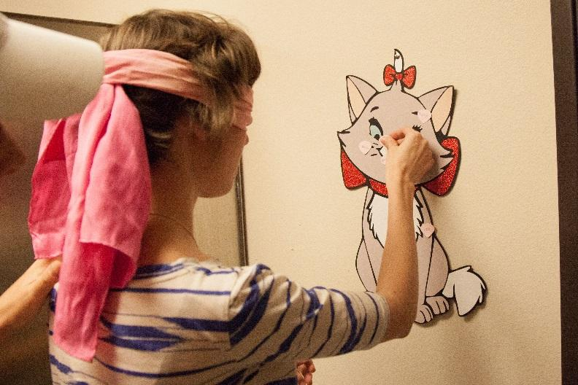

2. Kitty Name Game
- Supplies: Answer sheet, pens, answer key (do your research ahead of time)
- Object: To guess as many of the most popular cat names of the year as possible
- Winner: Whoever guesses the most names correctly is the winner – no ties!*
- Prize: A gift card or donated prize

3. Draw a Kitty
- Supplies: White paper plates, pens (sharpies work the best)
- Object: Participants will hold a paper plate on the top of their heads and attempt to draw a realistic kitty (full body, head, tail). Give participants one minute to draw.
- Winner: The person who draws the most realistic-looking kitty. Judging can be done by giving everyone one penny, and they place the penny on the plate that they think is the best.
- Prize: A gift card or donated prize
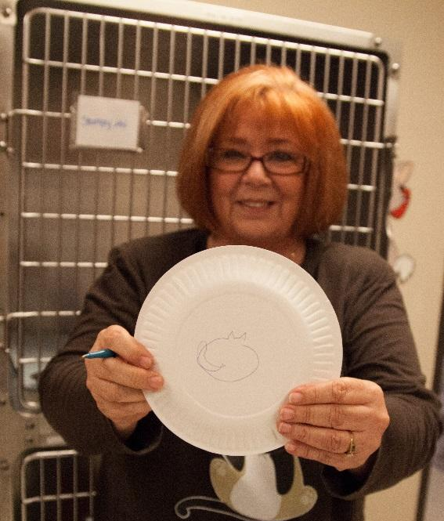

4. Guess the Number of Baby Cat Kibbles or Treats
- Supplies: Baby bottle, kitten food or treats, small guess sheets with space for name and email address, bowl to collect guess sheets, someone who knows the number of kibbles in the bottle ☺
- Object: Participants will submit a sheet of paper with their name and contact information and a guess of how many kibbles are in the bottle
- Winner: Whoever guesses closest to the actual number of kibbles without going over – no ties!*
- Prize: The bottle of treats, or a gift card or donated prize
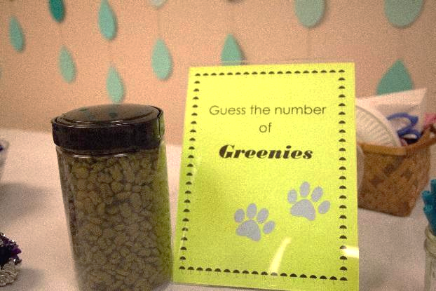
*All ties will be broken by a rousing game of rock, paper, scissors
Pinterest is also an excellent resource for finding ideas for baby shower games and décor.

Raffle and Fundraiser
Another great way to raise funds is to hold a raffle. Shower attendees can purchase tickets for a chance to win prizes.
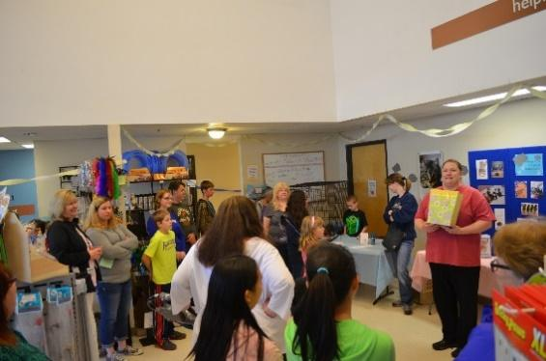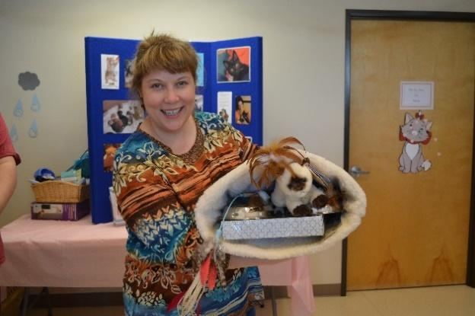

Gifts and Donations
An Amazon Wish List is a great way to let folks know what supplies you need. Amazon has a great ranking feature to help you indicate which items are of the greatest priority. A link can be included in any electronic communications promoting your event. You may also want to include a wish list in simple list form for people who do not wish to purchase online. Have a donation collection jar predominately placed at the actual event to collect more funds on the day of the event.
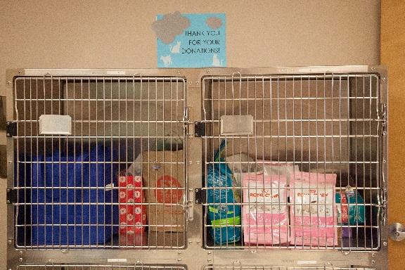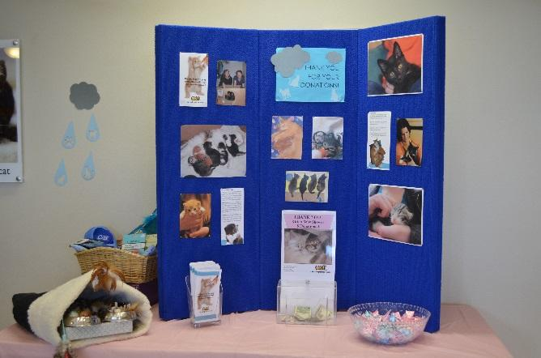

Kitten Foster Program Wish List
Royal Canin Baby Cat Dry Food | Miracle nipple for bottle babies
Gallon Size Ziploc Freezer Bags | Baby Washcloths
Avoderm Chicken Wet Food | A/D Ointment- 4 oz. size in tube
Breeder’s Edge milk-replacement powder | Snuggle Safe warming discs
Pet Nursing Kit for Kittens | Frontline Plus for Cats
Advantage for Cats | Quick Read Digital Thermometers
Flea Combs | Pet Hair/Lint Rollers & Refills
Hand Sanitizer – 4oz bottles & refill packs | Latex Exam Gloves
Multi-Colored Fine-Tip Sharpies | Little Noses Saline Drops

Information and Foster Recruitment
The baby shower event is a fantastic opportunity to educate the public about your program and recruit volunteers and foster families. Have a sign-up sheet for folks to leave their names and contact information if they are interested in learning more about the foster program. It’s also nice to have informational signs and posters about your program.
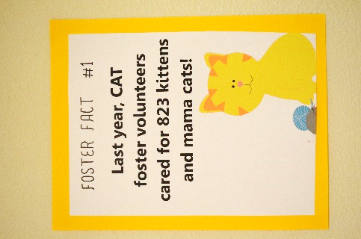 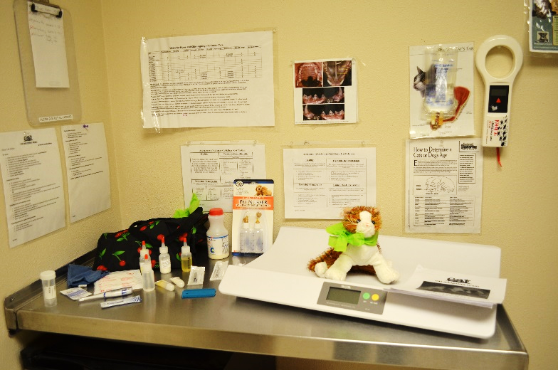
Posters around the shelter Show off an exam room with foster bag supplies

Volunteers/Staff – Who is going to run this thing?!
You will likely need a few extra hands to help your event run smoothly. The easiest way to ensure your event runs smoothly is to assign a person to each event task. The Baby Shower Task List included in this document will provide a list of tasks that need to be completed and space to assign a task lead and due date. Please see the Volunteer Jobs section of the Baby Shower Task Checklist for volunteer job descriptions.

Baby Shower Task Checklist
Task | Lead | Deadline | Notes
Setup
Remove unnecessary items from event space
Cleaning - Sweep, Mop, Dust, Garbage
Hang Decorations
Set up Tables, Signs & Info, Refreshments
Games | Lead | Deadline | Notes
Game #1 Guess the Number of Cat treats/food kibbles in a Jar
Game #2 Draw a Cat without Looking
Game #3 Guess the price
Create Guessing Slips
Procure Game Supplies
Hosting | Lead | Deadline | Notes
Greeter at Front Door
Refreshment & Donation Area
Gift & Donation Control
PR & Marketing | Lead | Deadline | Notes
Create Invitation
Create Invite List
Create Facebook Event Page
Create Organization Website Event Page
Post Invite on Organization Website
Send Event Information to Local Media
Schedule Posts to Social Media
Include Information in Organization Newsletters
Have In-Kind Donation Forms Available for Event
Signage | Lead | Deadline | Notes
Create Signs for Games
Create "Wish List" Handout
Create "Reasons to Foster" Signs
Create Event Sign for Front Door/Lobby
Donations Needed for Event | Lead | Deadline | Notes
Food & Drink Donation
Decorations
Cups, Plates, Napkins
Prizes for games
Volunteer Jobs | Lead | Deadline | Notes
Photographer - 1
Games Master - 2
Greeter - 1
Refreshment - 1
Cash Donation Monitor - 1
Set-Up - 2
Clean Up - 2
Gift Donation Manager - 1
After The Event | Lead | Deadline | Notes
Post Photos to Social Media
Create Thank You Post for Social Media
Send Thank You Notes
Remove Décor
Organize Donated Items
Move Tables & Cages Back to Proper Locations
Sweep, Empty Garbage, Clean as Necessary

