Your Logo Here

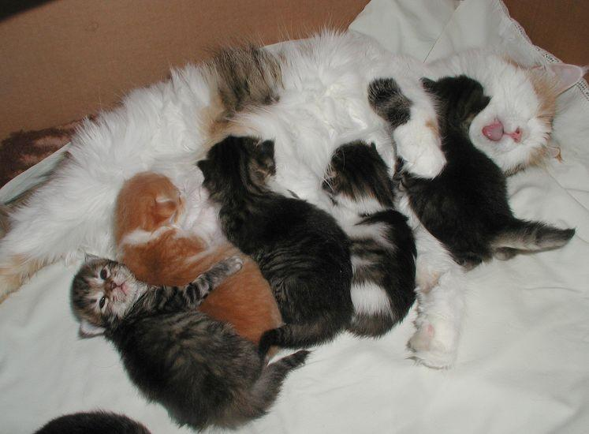
Kitten Foster Manual

Greetings, Foster Parents
Overview of Key Responsibilities and Policies
Mentors & Contact Info
Kitty-Proofing Your Foster Home
Housing
Litter Box
Expenses/Donations
Google Group and Shared Drive
Facebook Group
How to Pick Up Your Foster Cats/Kittens
Naming Your Kittens
Maternity Foster Home Guidelines
Socializing Your Foster Cats and Kittens
Undersocialized Kittens
Feeding & Growth
Bottle Feeding
Supplies
Medical Records
Kittens and Vaccinations
Vaccine Reactions
Kitten Development and Vaccine Schedule
Vaccines and Deworming Treatments
Health Concerns
Diarrhea Protocol
General and Emergency Veterinary Care
Giving Medications
Rainbow Bridge - The passing of a kitten
Cat bites
Emergency Boarding
Adoption Procedure - NOT USING ADOPETS
Adoption Procedure - USING ADOPETS
Adoption Fees
A “Free” Kitty Isn’t Actually Free
Marketing
Social Media
Foster Parent Networking
Spay/Neuter Surgery
Post-Operative Care Instructions and Pain Medication
Adoption Pickups
Cleaning Between Your Foster Groups
Shelter Buddy Database Access
Foster Program FAQ’s
Foster Care Agreement

Your Organization Thanks YOU

Thank you for opening your home and your heart to a kitten or mom cat in need. Whether you foster a kitten who needs some time to grow, a shy one that needs some socialization, or an older kitten recovering from a kitty cold, you make it possible for us to provide the very best care possible for all of our residents at Your Organization. Fostering is a messy, rewarding, stinky, adorable, and sometimes heartbreaking job. We certainly could not provide the level of care we do without valuable foster homes like yours.

From all our cats and kittens:

Thank you!

Greetings, Foster Parents!

Thank you for participating in the Your Organization Foster Care Program. We appreciate your willingness to open your heart and home to homeless mother cats and kittens. Your dedication allows our organization to rescue cats we would otherwise have to turn away due to limited space in our shelter.

The guiding mission of the Foster Care Program is to give mother cats and kittens the individualized care and socialization they need to prepare them for adoption; treat sick cats from the hospital that need a break; and house cats and kittens who need more socialization or a break from the shelter. Information gathered during the foster process helps us place cats and kittens in homes and with families who can best meet their needs. Specific goals of the program include:

- Providing a safe, healthy, nurturing environment for mother cats and kittens.
- Socializing shy or timid cats and kittens.
- Treat kittens with mild upper respiratory illness.
- Help clear space at the shelter for other cats or kittens in need.

This manual outlines the responsibilities and expectations of the Your Organization foster volunteers. It should serve as a resource throughout your foster care experience.

Before taking your assigned foster cats/kittens home, please:

- Review the foster manual and complete the scavenger hunt
- Be familiar with the key responsibilities and policies
- Complete a foster family information sheet
- Read and understand the foster care agreement

Overview of Key Responsibilities and Policies

To ensure a successful foster program, we ask that you follow our general policy guidelines to ensure that each foster home responsibly provides a wonderful home for these kittens to grow up and explore the world in. To this effect, keep in mind the following:

Keep cats/kittens inside at all times.

- Cats/kittens should always be in a carrier when leaving the house.

- Keep doors/windows closed at all times unless covered with a screen that is securely in place. The window should only be open one inch with support in place, so the window cannot be opened further. A frightened cat/kitten can escape through the tiniest holes!

- If a cat/kitten does manage to get outside, you must attempt to get the cat/kitten back inside immediately. If you delay, the cat/kitten may get frightened and run away, decreasing your chances of getting the kitty back inside. Do not chase the cat/kitten, as this may make them run further away from your home. The easiest way to get your mother cat back to your home is to put her kittens in a secure carrier by the door or window that she went out. The kittens should cry for her, and her maternal instincts will kick in, bringing her back to them. Often mother cats will come back into the house or foster room to be with the kittens. If this is not working, you can also place her litter box outside your door, so she will smell where she needs to come back. Most mother cats were strays and are familiar with being outside, but that does not mean they all have “street smarts.”Some will hide and be scared as soon as they get out. Look under bushes, decks, foundations, etc. If the mother cat is injured, she may be silently hiding so as not to attract predators. If you cannot get the kitty within 1-2 hours, call your mentor to determine a strategy to recapture the kitty. Your Organization has humane traps available for this purpose.

- When fostering a cat or kitten who hasn’t been tested for FeLV (Feline Leukemia Virus) or tested positive for FeLV, the cat must remain segregated from the other animals in your home for the duration of the stay. Your Organization usually tests for FeLV at the time of spay/neuter, so unless the cat was tested at a previous shelter or veterinarian, most cats and kittens would NOT be tested before going to foster care.

When fostering a cat or kitten who tested negative for FeLV, it is crucial to keep them separated from your other animals for at least two weeks to ensure they are healthy. A seemingly fine cat can become ill due to stress from a move. Foster kittens must not be introduced to your resident cats unless your resident cats are indoor-only. Kittens must be vaccinated for more than five days before meeting any of your household pets, and these visits should be limited and supervised. Food dishes, water bowls, and litter boxes must be picked up so they do not use each other’s boxes or bowls, or they should meet in an area where litter boxes and food/water dishes are not present.

Here are some things to remember about FeLV testing:

- The incidence of FeLV is low (1-3%)
- If a cat tests negative, we can only say that they are negative at the time they were tested.
- It takes 30 days from infection to produce a positive snap test result. When we have a cat with an unsure background, retesting in 30-60 days with the adopter's veterinarian is ideal (we will not be performing a second test at Your Organization).
- Cats with regressive FeLV might not test positive, as they may not be shedding the virus while the disease is "dormant."

Mentors

Each foster parent will be assigned a mentor. The mentor can answer questions about kitten-proofing your foster space, behavioral and dietary concerns, and basic health and medical questions.

You should contact your mentor with ANY questions or concerns you may have about your kitten’s or cat’s health or well-being. If you are worried that one of your kittens may be sick, try to get some information together before you call:

- How long have the symptoms been going on?
- Is the kitty eating, drinking, pooping, peeing, and playing?
- Any vomiting?
- Diarrhea?
- What is the kitty’s temperature? Normal temperature is 99-102 F. If you are worried but aren’t sure about the symptoms mentioned above, call your mentor anyway – that is what they are here for.

Mentor Contact Information

First and Last Name, Mentor | Phone # | Email | City
On-Call Lead Mentor

Each week (Mon-Sun), there is an assigned on-call lead mentor who is available 24 hours a day. This person’s contact information will be emailed to the group on Sunday. It will also be available to the foster parents [Based on your organization’s communication method]. The on-call lead is to be used in urgent or emergency medication situations. Please call your mentor first, and if you cannot get a hold of them, call the on-call lead mentor.

Kitty-Proofing Your Foster Room and Home

Cat-proofing and especially kitten-proofing your home is much the same as child-proofing it! That means hiding or removing cords, removing small items that kittens can choke on, etc.

To begin, your foster room should be COMPLETELY cleared out and only consist of basic cat necessities (i.e., bed, food, water, litterbox, and toys). This means removing all toiletries and decorative items from the bathtub, counters, or any other surface the kittens can access. Kittens love to play with anything they can get their paws on and could be injured by heavy or sharp items.

Make sure to put your baby bag in a separate room. Please do not leave it out for your foster kittens to get into, as the items inside can be hazardous to them. Plus, they are expensive to stock.

Once your kittens are vaccinated, have completed a 2-week quarantine, and are clear of any illness, you may decide to have them visit other areas of your home or interact with your resident pets. These visits should be short and well-supervised. DO NOT give the kittens free reign of your home unsupervised. They can get injured, lost, have accidents outside the litter box, etc.

Before introducing your kittens to other areas of your home, please do a thorough walkthrough, and keep the following concerns in mind:

- Kittens might chew on electrical cords resulting in burns or even death. Protect your electrical cords with plastic tubing or spray them with “Bitter Apple,” a bitter-tasting deterrent you can find at pet stores.

- Kittens can choke on small items. Keep rubber bands, paper clips, needles, and anything the kitty can swallow out of reach.

- Keep plastic bags, which can cause suffocation, out of reach.

- Secure any heavy items that could fall and potentially injure them.

- Refrain from using any hot appliances while the kittens are out. Kittens are naturally curious and could get burned.

- Review the toxic houseplant list at www.aspca.org/pet-care/poison-control/plants and remove all poisonous plants from your household. Or, to deter kitties from munching on poisonous and non-poisonous plants, you should spray the plants with a product sold at pet stores for this very purpose.

Housing

You must provide a clean, safe environment for your foster cats/kittens. A bathroom, unoccupied bedroom, or den works best. Please do not use a laundry room, garage, or an occupied office or bedroom. There are items in these rooms that your foster kittens should not have unsupervised access to.

If you cannot dedicate an entire room to fostering, you can use a playpen or Tespo panels to confine your foster kittens. These work best for younger/smaller litters of kittens. Larger kittens and mom cats might need more space or be able to escape.

Your Organization recommends that you start your kittens in a non-carpeted, easily sanitizable room (i.e., a bathroom) in the unlikely event that your kittens have a contagious illness that cannot be removed from the carpeting. If you end up with a contagious illness in a carpeted room, you will either have to remove the carpeting or not use that room for fostering ever again. If desired, kittens can be moved to a carpeted room after a 2-week quarantine period if they are not showing signs of illness.

Consider covering your furniture or carpets to protect them and make cleaning simpler. Kittens can be messy, especially when learning to use the litter box! Consider covering your furniture or carpets to protect them and make cleaning simpler. Some foster parents like to use interlocking foam mats or poly/paper drop cloth to cover their carpets or other porous floorings. The mats can be sanitized between groups, and the poly/paper can be tossed out. You can find these items online or at your local hardware store.

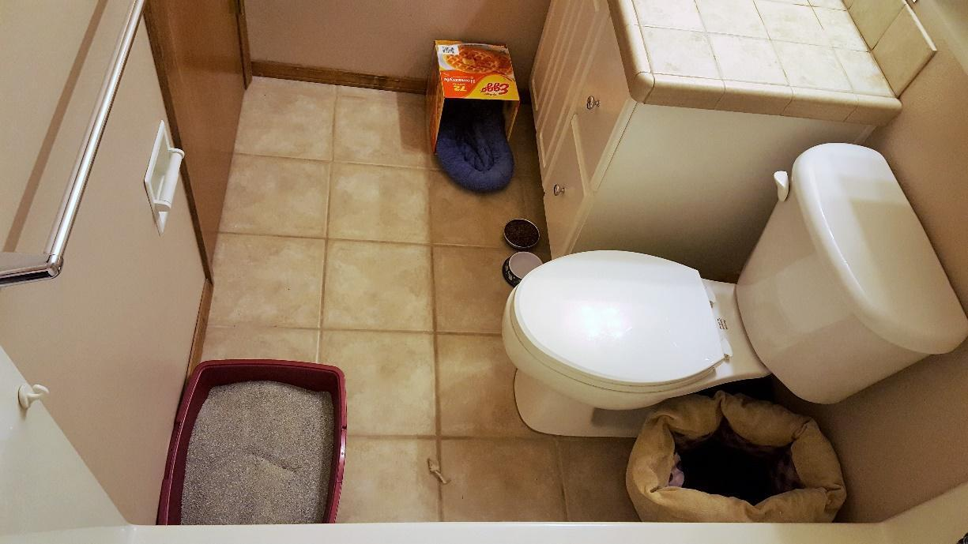

Litter Box

Kittens should be introduced to the litter box when they start eating solid foods. You can start putting a box out at about three weeks old. They need a box with shallow sides: an old cookie sheet or the leftover boxes from your canned food work great. You only need a thin layer of the litter as you dump it daily. Ensure the litter box is as far from the food and water as possible.

When you get them home (if they are old enough), show them where you have placed the litter box. While training them on the litter box, you will want to place them in the box right after they eat. They will learn how to use the litter box very quickly this way. Sometimes they learn how to use the litter box without any help from us, as they have watched mom use her box. Observe how the kittens watch mom’s actions: they find her quite fascinating and learn how to act like cats by observing her.

Keeping the box clean is very important. Daily cleaning is a must! Your Organization recommends spot-cleaning the litter box at least two times a day (just remove the poops!) and dumping the entire contents, and cleaning or wiping out any debris once a day. If the box is not kept clean, kittens can develop an aversion to using it, which can make it very difficult to find them a home.

Kittens under eight weeks old should use a natural non-clay litter such as paper pellets or sWheat scoop. Please do not use clay litter for kittens under eight weeks old, as they may eat it and get sick. Regardless of the type of litter, please watch the kittens to ensure they aren't eating the litter and only use a thin layer (~1 inch deep).

Mom cats can also use the same litter as the kittens, but please provide her with an adult-size litter box of her own.

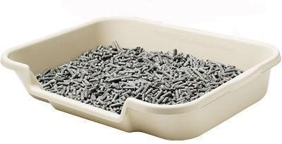
Clumping litter for older kittens. Recycled paper litter for younger kittens.

Expenses and Donations

Your Organization covers all medical care expenses for foster cats if performed at Your Organization's on-site veterinary clinic or other veterinary clinics approved in advance. Your OrganizationWe will not reimburse any personal expenses incurred by foster parents for unauthorized veterinary care; seeking veterinary care for your foster cat or kittens at a clinic other than Your Organization’s on-site hospital is not permitted without explicit Your Organization staff approval.
Items to keep track of:

Food
Litter
Litter Box
Toys
Scratchers/scratch trees
Mileage to and from the shelter or adoption events
Expenses you incur during your term as a foster parent, whether for supplies or medical care, cannot be applied to an adoption fee. These expenses, however, may be considered tax-deductible donations. Keep all receipts and ask for an in-kind donation form once your litter is adopted.

Your Organization will provide you with food for your foster kittens. It is best to keep them on the same food we feed at the shelter not to cause digestive upset.
Your Organization also has litter available to foster parents if they cannot purchase their own.

We always need more supplies for the foster program. If you are interested in helping, please check out Your Organization's foster program wishlist.

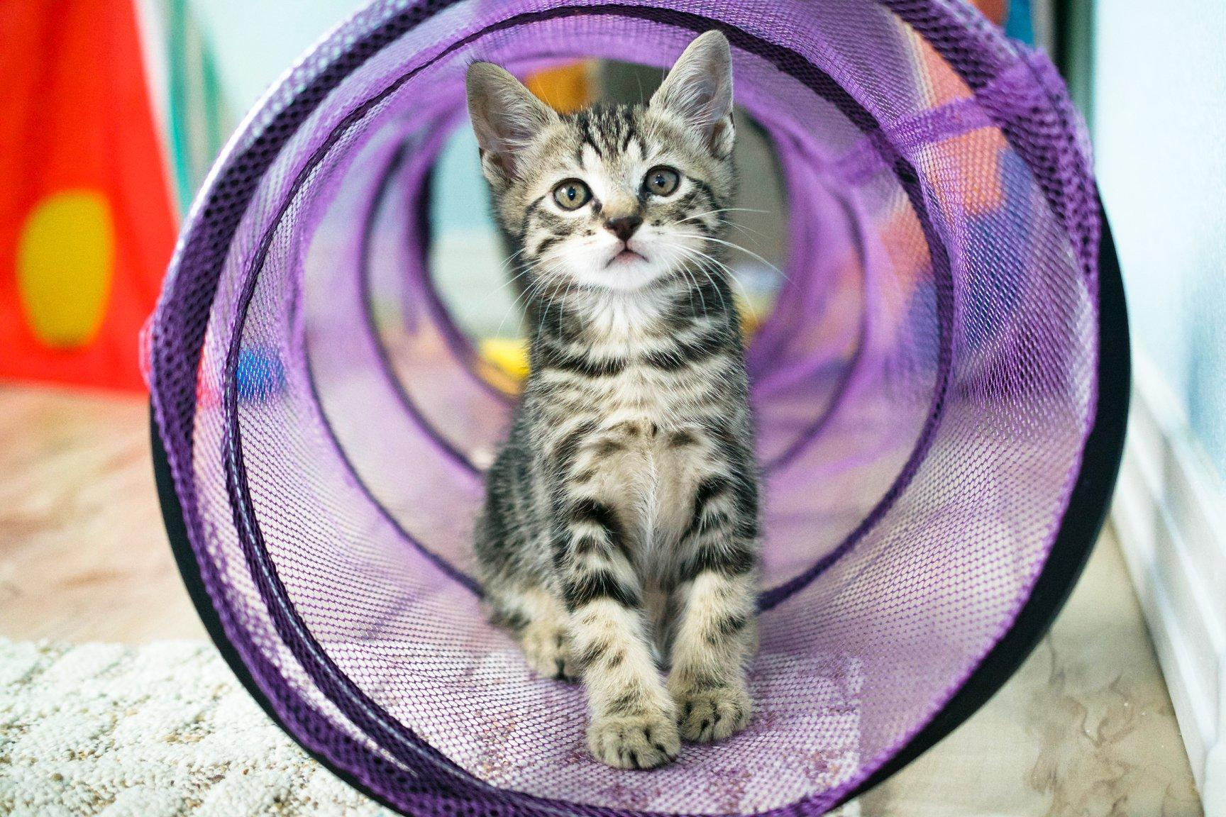

Always consult a tax professional to determine if your expenses can be used as a tax deduction.

Google Group and Shared Drive
There is a Google Group specifically for foster parents. All foster families will be added during their initial onboarding after foster training.

The Google Group is a “post-only” board, not a chat group. You will see messages from the Foster Coordinator asking for foster homes and providing important updates. All postings will be emailed to the email address you signed up with. Reply to the email to respond to the message. Some foster parents prefer to set up a separate email account just for fostering to avoid clogging their regular email with foster-related items.

Other shared google items include a Google folder with a copy of this manual and other important reference material and a Google Calendar with the current on-call lead mentor and other events. You will receive an email invite to these items during onboarding. If you have trouble accessing any of them, please contact the Foster Coordinator. If you are unfamiliar with Google’s products and how to use them, we have a Google Training Resource Guide you can refernce.

Foster groups are assigned on a first-come, first-served basis. Assignments are typically made before the cat(s) arrive at the shelter, but sometimes there are surprises. All cats and kittens needing foster care will be listed on the Foster Requests sheet. You are welcome to keep an eye on this list, but the Foster Coordinator will email everyone when new groups are added. Although assignments are first-come, first-served, we also try very hard to ensure a good fit between the foster family and the foster group. For example, first-time fosters will not be assigned a group that requires specialized training like bottle babies, under-socialized kittens, or pregnant cats.
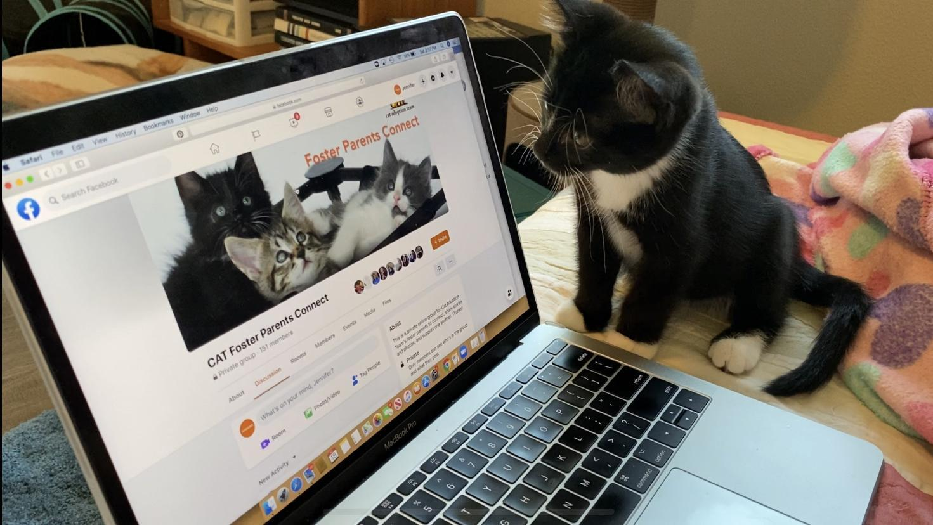
Facebook Group
You will receive an invite to join our “Your Organizations Foster Parents Connect” Facebook group during onboarding. This is a closed group (invite only) for our foster parents to socialize with each other, share stories, photos, and videos of their foster cats and kittens, and learn from each other. Please read the guidelines before joining, and remember that your mentor will still be your primary contact for most questions about your foster kittens or the foster program.
How to Pick Up Your Foster Kittens

When you arrive to pick up your kittens on the arranged day and time, please come to the clinic entrance of the shelter on the left-hand side of the building and ring the foster bell if the door is locked. The foster coordinator or another staff member will check the kittens out for you. You can park your vehicle near this entrance to load up all the wonderful supplies we send with you!

Make sure that each of these steps is completed before taking home your kittens:

- You are given a foster bag full of supplies, a carrier, and your kittens
- You are given dry and wet kitten food (+ litter, if you are unable to purchase your own).
- You are given adopter supplies if your kittens are altered (adopter bag of food, vet certificates, and cardboard carriers)

You will receive all paperwork (kennel cards, medical history form, personality profile form, and foster agreement) via email shortly after pick up. Please reply to the email with your electronically signed foster agreement within 24 hours. Information on how to e-sign the document will be included in the email.

Suppose you need to pick up more basic foster supplies (food, litter, FortiFlora, Calming Care, HydraCare, paper collars, foster drop-off forms, socialization supplies, or adopter supplies). You may drop by the shelter without notice between 9 AM and 6 PM daily, excluding major holidays. The door should be unlocked during these hours. The supply shelves are located in the KHQ lobby inside the clinic door to your left. Just take what you need! If you need items not listed above, please email the foster department ahead of time to prepare them for you.

If you need assistance picking up your foster kittens or supplies for them, we suggest reaching out to your fellow foster parents via the Facebook group on Google Maps. Coordinating trips to the shelter can save everyone a lot of time!

Naming Your Kittens

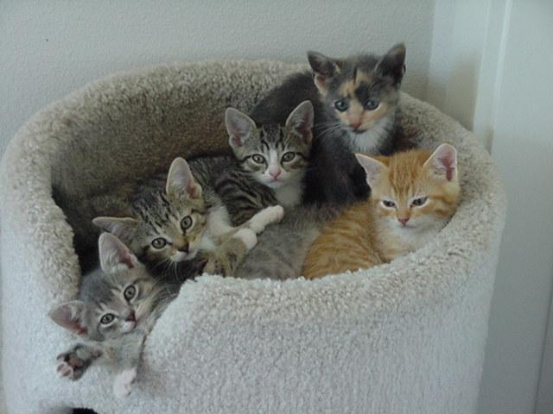
If you take home a mom with kittens, your kittens will have the mom’s name plus K1, K2, etc. Before your kittens are five weeks old, we want you to name them. Email the Foster Coordinator at insert email address once you have chosen names. Use friendly, non-offensive names and not too difficult to pronounce or spell. Try to make them unique so that we don’t have 10 Fluffies. Once you choose names, the kittens will be identified as (Mom’s name) K(number) aka (the name you choose). For example, Serena K3 aka Piper.

If you are taking home kittens without a mom, your kittens will be named for you. Please do not change their names. Please also do not change your mom cat’s name. This helps avoid any confusion when communicating with the shelter.

Quick tips on naming your kittens: Theme your kittens’ names for easier marketing. The “Cheese-Group” above was named Cheddar, Provolone, Gouda, Parmesan, and Mozzarella.

Maternity Foster Home Guidelines

We hope this experience will be as rewarding for you as it benefits the health and well-being of mom and her kittens. Most births and newborn litters are trouble-free and require only your quiet supervision. The information here will help you prepare for any complications that can although rarely do, arise. Please call your mentor if you have questions or concerns not addressed in these guidelines. Remember that these are only guidelines and are not meant to replace expert advice.

If you would like to foster a pregnant cat, please watch this training video: Pregnant Cat and Bottle Baby Training, and then complete the quiz, so we know you are trained!

Preparing For the Birth

You must have a quiet, out-of-the-way place in your home that will be warm, safe, and available for the entire time you are fostering. This means that this space will only be used for mom and her kittens when you have them in your care. Inaccessibility from other family pets, like dogs or your resident cats, must be strictly enforced. This is absolutely necessary for the health and safety of not only the litter but your resident animals as well.

New mother cats have been known to abandon or even resort to cannibalism if they feel that other animals or people threaten the well-being of their babies. This is especially true with mothers who are not well-socialized.
What to expect when she’s expecting

A cat can be in heat from 6-20 days. Pregnancy can be diagnosed by a veterinarian between 20-30 days after mating. The typical gestation period for a cat is 63 days. A cat may gain 2-3 pounds during pregnancy, depending on how many kittens she is carrying. She will require more and more food as her pregnancy progresses, and we recommend that you feed a high-quality kitten food and provide her with constant access to food before, during, and after the birth of her kittens.
New kittens are very susceptible to disease and can pick up illnesses from your seemingly healthy pets. Also, the stress of pregnancy and birth can cause the mom cat to become ill from something dormant in her system, so do not put your resident pets at risk by exposing them.

A kittening or nesting box must be provided for the expectant mother. This can usually be a cardboard box without a lid and a hole cut out of the side for the mom cat to enter and exit. Fill it with clean towels or old cloth diapers, and let her make her own nest. Change this bedding immediately after the birth and then frequently because it will become soiled – so don’t use the “good” towels.

After the birthing is over, remove the towels and replace them with fleece blankets, fleece beds, or cloth diapers. Some kittens cannot retract their claws and get caught in the loops of towels, making it difficult for them to crawl around. You can also put several layers of bedding in the nest before the birth; after the birth, you can roll the dirty upper layer off and gently move the kittens onto the clean layer underneath.

Provide a litter box, food, and water. Kitten food is recommended for pregnant and lactating females, as it has extra calories and nutrients and will help support the mom cat during this very exhausting time in her life. Let mom eat as much as she wants—after all, she is feeding a brood herself!

The Birth
A week or less before the event, mom cat may start to move about furtively, root about in the nest, and may attempt to escape the room you have designated for her in hopes of finding a linen closet or soft bedspread for her delivery. Be sure to keep your eye on her to ensure she stays in her room!

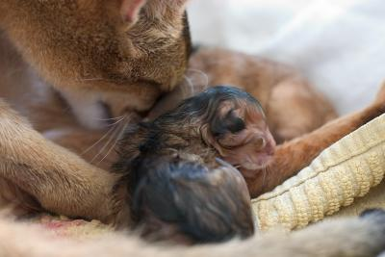
About 24 hours before delivery, you may notice her belly drop to form a “pear” shape, and her nipples start to swell with milk. A small amount of discharge from the vagina is also normal. This is usually the first sign of labor and can last up to six hours. Mom will start to breathe heavily, pant, or purr during this time. Some moms-to-be will give you clues that it is time—others will not. Some will not eat until the deliveries are finished, and some will snack in between. Some will be vocal while delivering, and some will be silent. Some will want you in the room; others will not. Let mom tell you what she needs. After all, having kittens is a natural and normal experience, and cats have been doing it for thousands of years!

Most feline births are routine and trouble-free, so try not to disturb her during the process. Make sure she has access to food and water, and replace her regular litter with shredded paper in the litter box before delivery begins. She will start the second stage of labor, straining a few hours before the first kitten is born. If, however, she has been heavily straining for 30 minutes without producing a kitten, or three or more hours pass between kittens, call your mentor.

Occasionally, first-time moms will not quite “get it.” If this is the case and she delivers a kitten and just walks away, she might not realize it is alive and needs her care. The membrane covering the kitten’s face must be removed immediately so the kitten can breathe. If mom doesn’t do this, gently tear open the sac covering the head so the kitten can breathe. After the first kitten, the mom usually figures it out and carries on as she should. Most moms will eat the afterbirth as it contains nutrients and hormones she will need to recover from the birth. She will also bite through the umbilical cord and clean the babies. After she has cleaned the kitten, she will take a rest. This rest could last 30-60 minutes before she starts labor again to give birth to the next kitten.

Signs of a Difficult Delivery
Most births proceed without incident, and your role as a foster parent is to monitor the birthing process quietly. However, call your mentor immediately if the following happens during delivery:

- The mother cat seems to be straining or pushing for 30 minutes without delivering a kitten. It is okay for her to rest for more extended periods of time between delivering kittens.
- There is an unusual discharge from the vulva under the tail. Abnormal discharge can be black, cloudy, or foul-smelling.
- The mother is not cleaning the kittens after delivery. If this occurs, use a piece of sterile gauze and remove any fluid from the nose and mouth. Then dry the kitten using a clean towel and a gentle rubbing action.
- A kitten is not breathing. If this occurs, rub him gently but vigorously with a towel for several minutes all over his body to stimulate breathing.
- Occasionally the umbilical cord will not separate from the mother and kitten. If this occurs, take a thread or floss (unwaxed, unminted), tie a knot ½ inch from the kitten’s belly and another knot one inch towards Mom, and then cut the cord with the scissors between the two knots. This will prevent bleeding if the cord tears. Don’t be surprised if the cord retracts back inside mom during a contraction. The cord and placenta will be delivered in time. Never pull on the cord to try and get it out.
- You observe any excessive bleeding (more than approximately two teaspoons).

Post-Delivery
After the delivery of the litter is finished, try to observe the family to ensure that the kittens are nursing and that the mom is not bleeding excessively from the vagina. If things are not as they should be, call your mentor. Once the event is concluded, and mom and kittens are resting comfortably, replace the soiled towels with clean fleece or cloth and let the new family rest in peace and quiet. Empty the paper out of the litter box and replace it with regular litter.

The temperature in the foster room should be kept a little warmer, especially for the first two weeks after birth. This is even more important if the kittens are orphans - ideally, the temperature should be around 80F for the first two weeks. If you cannot heat your whole room to that temperature, you can use SnuggleSafe warming discs and ensure the nesting box is well-insulated. Be sure that the mom and kittens have the option to get away from the warming disks if desired.

Handle newborns gently, but make sure to check on them at least twice a day. Are they nursing? Hanging out with mom? Crying a lot (this could indicate that they are cold or not getting enough milk). Make sure to count each time you check on them. Sometimes a mother cat will take a kitten out of the nest and leave it somewhere else in the room. If this happens, put the kitten back in the nest and call your mentor immediately. Make sure to weigh your kittens in grams each morning at the same time of day. You want to see them gain approximately 10-15 grams per day.

Umbilical Cord Care
Each newborn kitten should have its umbilical cord swabbed with an iodine tincture, an antiseptic, antibacterial agent that aids in preventing infection (sepsis) of the umbilical cord site. After the mother cat chews through the umbilical cord or you cut the cord, apply some of the tincture to the umbilicus. Repeat the swabbing for the next two days post-birth. The cord stump should dry up and fall off around day three or four. Contact your mentor or foster coordinator if you don’t have an iodine kit in your baby bag.

IMPORTANT: If you see any signs of swelling, discharge, pain, or redness at the umbilical cord site, please contact your mentor immediately.

Post-Natal Signs of Trouble
If all kittens and mom seem well, your only obligation to the mom and new kittens for the first week or so is watchful supervision. Mom will need kitten food and water at all times. Contact your mentor immediately if you observe any of the following in the mother cat:

- Acts lethargic or as if she is in pain or continues to strain
- Develops a fever or other signs of infection
- Ignores her kittens
- Continues bleeding from the vulva for more than two days
- Has painful, hard, or swollen mammary glands

Kittens should be nursing up to 3 times an hour. The mother cat should groom each kitten after feeding and licking their bottoms to stimulate elimination. Contact your mentor if you observe any of the following in the kittens:
Please email the foster coordinator as soon as possible after the birth with the following information for each kitten: color, gender, initial weight, and a simple photo.
- Constant crying and failure to stay at the nipple
- Refusal to nurse
- Feeling cold to the touch
- Withdrawing from the other kittens
- Rejected or ignored by the mother

Be careful! Mother cats can be very protective of their young and become overly aggressive toward resident pets. This means watchful attention when entering or leaving the area you have set aside for mom and her babies.

Socializing Your Foster Cats and Kittens
First and foremost, we ask that you treat your foster cats/kittens with the same love and care you give to your companion animals. Daily attention (at least one full hour a day) from you and other family members or friends makes them more people-oriented and more adoptable. This includes petting, playing, cuddling, trimming nails, and grooming.

By spending time with your foster cats regularly, you will not only increase their chances of being adopted quickly, but you will also be able to determine their likes and dislikes – this helps us place them in homes with families that best meet their needs.

You should also monitor your foster cats for behavior problems, such as inappropriate urination or scratching furniture. If problems arise, contact your mentor to discuss behavior modification strategies. Your Organization is not responsible for damages that might occur to yourself, others in your household or your personal property as a result of feline behavior problems while in foster care.

If you have “cat-friendly” dogs, please consult your mentor about proper introductions with your foster cats/kittens. Felines raised with dogs often have an advantage on adoption days!

Please also check out this great tip sheet from the ASPCA on raising confident, well-adjusted cats.

We highly recommend taking this course by Maddie’s Fund, “How to Speak Cat and Understand Cat Behavior.” It’s free and very informative!

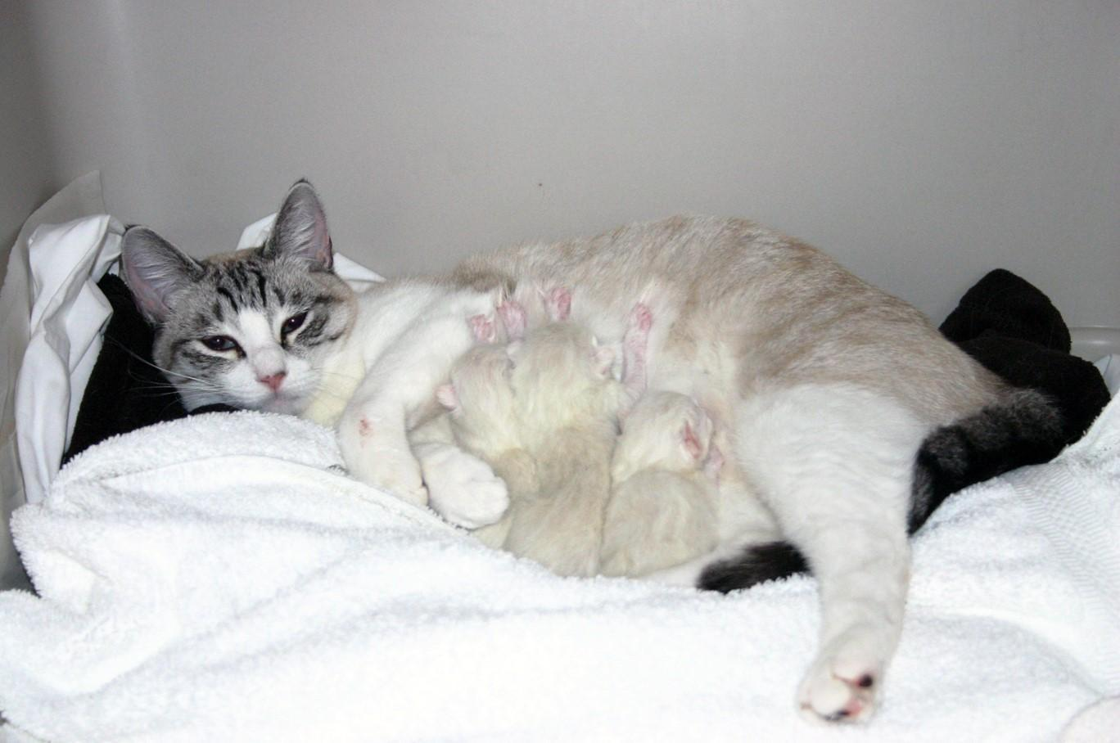
Mimzy and her Newborn Kittens
Photo by Madeleine Barker

Be careful! Children love to play with kittens, but they may not understand how to handle them properly. Please remember that children should not handle kittens under three weeks of age, and you must not allow unsupervised handling of any kitten by children under the age of 10.
Undersocialized Kittens
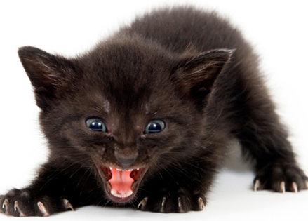
We occasionally take in kittens between the ages of 4 and 16 weeks who are undersocialized or fearful of humans. These kittens may have been born outside to a feral mom and have had limited interactions with humans. They may avoid, hiss, spit, swat, or attempt to bite when approached or handled by people.

If you would like to foster socialization kittens, please watch this training video: Kitten Socialization Training, and then complete the quiz, so we know you are trained!

Summary of Socialization Techniques
- Mama mews - example video
- Slow Blinks - Jackson Galaxy example
- Petting - with a paintbrush, then your hand
- Motivate with Food - baby food or Churu, on a spoon, then your finger
- Play therapy - wand toys, get them to run over your legs
- Pick up - start while eating, progress to carrying
- Taco of Trust - use bed to wrap and hold until they relax
- Novel changes - people, noises, rooms of your home
- Tough Love - you are in charge

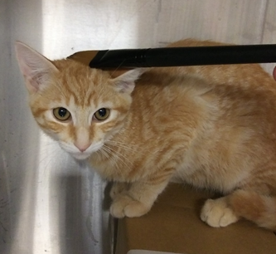
Essential Supplies
- Small room - block off hiding spaces
- Hide box - big enough to stand, and layout, but not deep enough to defend
- Paint Brush - soft long-handled brush to “paint” your kitten
- Dowel/spoon - to feed high-value food from a distance
- Feliway stuffy - calming stuffed animal for them to cuddle
- High-value food - wet food, baby food, Inaba Churu treats
- Wand toy or shoelace - make it “hop” over your legs

Important Concepts
- You are either training or un-training your kitten!
- Start on day one!
- Routine - short (5-10 min) sessions at least 3x per day, no skipping sessions or days
- Repetition - always ending on a positive note or a “win”
- Gentle Persuasion - you are the leader. Try to make progress each session
- No Coddling - it only hurts their progress

Feeding and Growth

Kittens with Mom:

The recommended diet for pregnant or nursing cats and their kittens is a premium diet of canned and dry kitten food. Your Organization feeds [Insert shelter’s food brand]. Kittens generally start showing interest in solid food around 4 or 5 weeks of age. Canned food should be fed 3-4 times daily in small amounts (1/4 of a 3 oz. wet food can). Dry food should be left out all day for them.

Kittens without Mom:

Newborn to four weeks: Rarely, unweaned kittens are brought to Your Organization without their mother. As a foster parent, you will have the double responsibility of bottle-feeding and socialization.

Bottle Feeding

If you would like to foster kittens that need to be bottle-fed, please watch this training video: Pregnant Cat and Bottle Baby Training, and then complete the quiz, so we know you are trained!

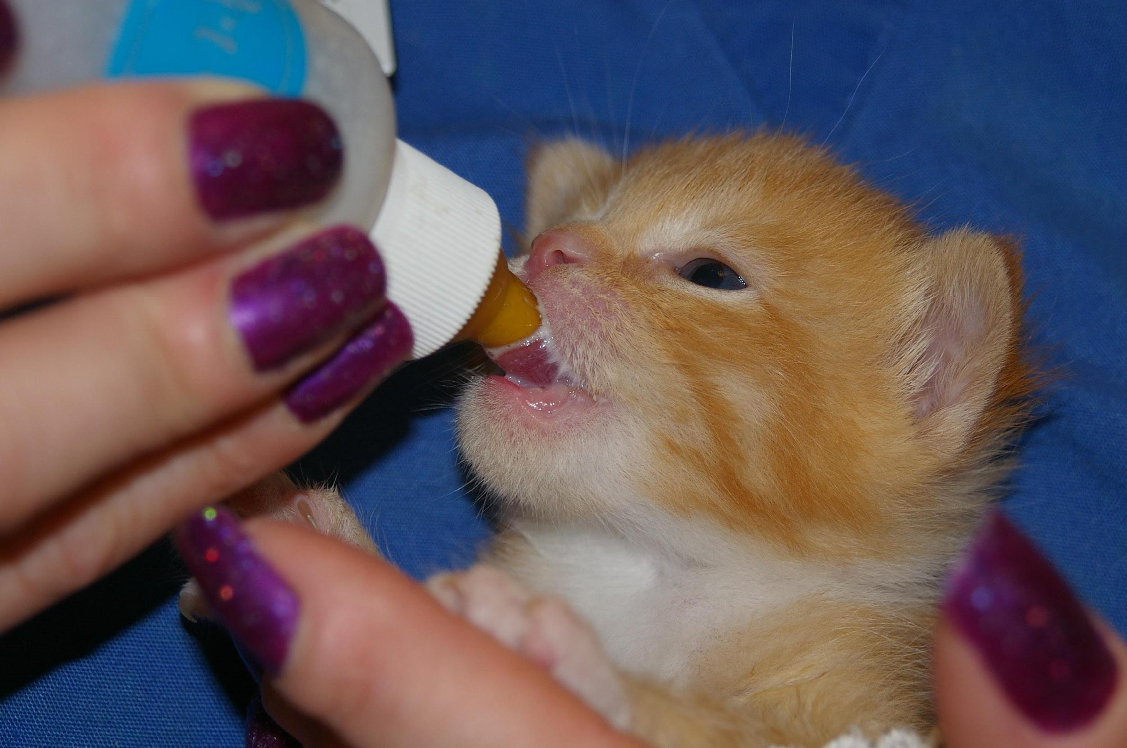
When to bottle feed a kitten: If we receive a kitten that is too young to eat on their own, has been abandoned, refuses to eat, or if the mother cat is no longer nursing her kittens, or her milk has dried up, we then need to bottle feed the kitten. A mother cat’s milk can dry up when the mother cats are sick, on medications, or too stressed (please ensure that the mother cat is getting proper care). Supplemental bottle-feeding can also be helpful when a kitten loses weight or fails to gain weight over 24 hours, even if it is still nursing on mom. In this case, you will only be “topping off” the kitten after it nurses. You must contact your mentor immediately if your kitten has lost weight in 24 hours. Contact your mentor if your kitten has not gained weight within 36 hours.
Foster parents will need the following supplies for bottle feeding:
Note: If you think your kittens need to be bottle fed or supplementally fed and you have not attended CAT’s bottle baby training class, please speak to your mentor or the foster coordinator before beginning bottle feeding. This can be a tricky process!

- SnuggleSafe warming disc (provided)
- Cat carrier or cardboard box for kitten nest
- Towels, flannel blankets, cloth diapers, etc. for bedding
- Kitten formula - Breeder’s Edge (provided)
- Nursing bottle with nipples (provided)
- Cotton balls, swabs, or toilet paper
- Thermometer (provided)
- Scale (provided)

How to bottle feed a kitten: Warmth first! Heat kittens slowly so that you do not put them into shock. You can do this with a towel that has been heated in the dryer or place them on a Snuggle Safe warming disc that is covered. While heating the kitten, gently massage the body and extremities to get the blood flowing throughout the body.
Never let a kitten lie on a heat source without a cover. Make sure they have space to crawl off the heat source if they get too warm. Constantly check the heat source's warmth to ensure it cannot burn the kitten and it is staying warm enough.

Kittens cannot maintain their body temperature. The average rectal temperature of a newborn kitten ranges between 92-97 degrees. Between 2-21 days old, a kitten’s temperature will be about 96 – 100 degrees. You will need to build the kitten a nest to keep it warm. The temperature in the nest where the kitten is kept should be 86 degrees. The temperature can be lowered 5 degrees a week after that until a mild 75 degrees is reached. To create a suitable nest, place them in a carrier and put a towel or blanket over the carrier to trap in the heat. You can also do this with a cardboard box.
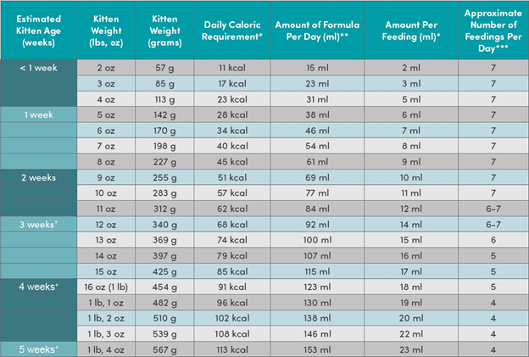
Table by Maddie’s Fund

Note: It is ideal to feed the kittens on a standard schedule throughout the day and night. Your Organization does make some exceptions for kittens one week or older that are otherwise healthy where the foster cannot get up frequently during the night. In these cases, doing one feeding in the middle of the night is okay as long as you stay on schedule during the daytime hours. Please monitor weight and health closely and return to more frequent overnight feeding if they decline.

It is important not to over-feed or under-feed your kitten. Overfeeding can cause serious health problems that begin with diarrhea and end with dehydration. One way to tell whether you’re consistently feeding too much is the appearance of grayish stool. On the other hand, a kitten who is not fed enough will cry continuously, appear restless, and then be listless. Refer to the above table for how much and how often to feed your kitten.
Check your bottle’s nipple to see if the formula drips from its tip. If it does not, you will need to widen the hole. You can do this by using a hot needle to poke a larger hole or using a razor blade to make a small “x” in the top. Do not make it too wide, though. You only want the formula to drip slowly, not pour out of the nipple.

Be sure you sterilize the bottle and nipple before each feeding (in a boiling water bath for 5 minutes), and warm the formula to no more than 100 degrees. Test the formula on your wrist – it should feel warm, not hot.

Start feeding: Place your kitten on its stomach on a towel so they can grip the towel with their nails. Lift their head to a 45-degree angle. Squeeze a small drop of formula onto the tip of the nipple. Insert the nipple into their mouth (you may have to open their mouth for them). The angle will help keep air from entering their stomach and keep milk at the front of the nipple. NEVER HOLD THE KITTEN ON THEIR BACK OR IN THE AIR WHEN YOU FEED THEM.
When your kitten is full, their tummy will be slightly rounded, and bubbles will form around their mouth. If the kitten has not finished the bottle, do not force the kitten to swallow the rest of the milk.

If the kitten is not drinking well, you can use a toothbrush to brush down their sides. This mimics a mother’s tongue and will often soothe them. They should nurse from the bottle better using this technique.

Burping your kitten:
Just like human babies, kittens need to be burped. Hold the kitten up against your shoulder, pat, and rub them gently on their back. Not all kittens will burp every time. If the kitten did not finish her bottle, you could offer it to them again.

Stimulating your kitten:
Kittens younger than three weeks old cannot eliminate by themselves. They need your help. After feeding and burping the kitten, take a washcloth or gauze moistened with warm water and rub over the kitten’s stomach and bottom. The action mimics a mother cat’s licking and stimulates the kitten to relieve themselves. Kittens need to be stimulated to eliminate after every meal. Rub until you see evidence of urine and/or stool. A kitten should urinate with every feeding, but it may only defecate once daily.
Washing your kitten after the meal:
Ensure you wash your kitten(s) after every meal. Kittens are messy and will need the stimulation of the mother’s tongue. To mimic this, you will need to get a damp, warm washcloth and stroke the kitten from head to tail with short “licks” as mom would. Make sure you gently towel dry the kitten when you are done. Never submerge your kitten in water.

More information: *For video instructions on bottle-feeding, please check out the following websites: Kitten Lady & Maddie’s Fund.

Bottle feeding kittens around the clock is a lot of work! We encourage you to enlist the help of your family so you can get some sleep. If you need a few days off, let the foster coordinator know. We can see if someone can temporarily care for them and allow you a break.
Dietary Habits with Growth

- At four weeks, you can start introducing canned food. Mix a little warm water with the canned food and place it in a container with low sides. Expect them to walk through it. No one ever said kittens were neat! You can warm the food in the microwave for about 6 seconds. Make sure to stir the food and test it with your finger. Do not give hot food to kittens.

- 5-6 weeks old: three meals a day of ⅓ can per kitten. If that is too much food initially, you can adjust accordingly. Always leave plenty of dry food out for them to eat during the day.

- 6-8 weeks of age: three meals a day of ⅓ can per kitten, and free-feed dry food. Always keep dry kibble out at all times for the kittens to eat.

- 8+ weeks of age: two meals a day of ½ can per kitten and ¼ dry per kitten. Adjust amounts if not gaining weight.

Overfeeding can cause digestive problems. Frequent small meals are preferred to large meals. All cats and kittens need fresh water at all times.

Supplies
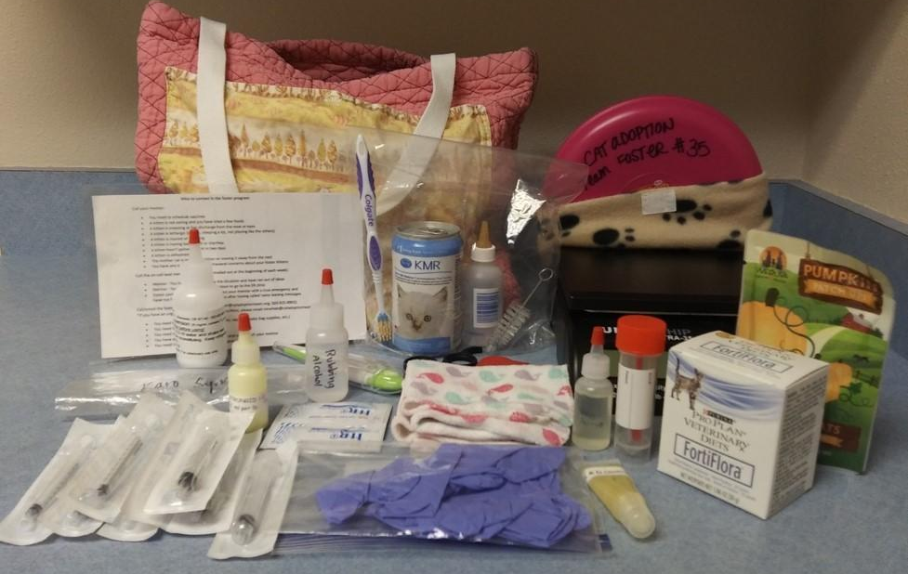

Your Organization wants you to know how much we appreciate you, and we want you to feel supported. To that end, we loan you some supplies with each foster group to use during your fostering experience, and we want to be sure you have the following information to answer frequently asked questions.

The Foster Bag

This holds all your supplies with a laminated card on the outside that tells you what number baby bag you have, what should be in it, and lists Your Organization's phone number. Please return the bag when you return your fosters so it can be cleaned, stocked, and passed on to the next foster parent!

You should find these supplies inside:
- Gloves
- Baby shampoo
- Washcloths
- Thermometer
- Alcohol
- Lubricant
- Flea comb
- Nail trimmers
- FortiFlora Probiotic Powder
- Pumpkin powder
- A&D ointment
- Fecal sample container
- Syringes
- Strongid
- Karo syrup
- Amoxicillin
- Tobramycin Eye Drops
- “Who to call When” document
- Scale
- Paper collars
- Hydracare
- Bottle feeding kit (if applicable)
- Snuggle Safe warming disc (if applicable)

The following sections will provide more information on each of these supplies, including their intended use and when to use each item.

Gloves

Some folks have trouble with the “EEEWWW” factor; these will help. Let us know if you want more.

Baby Shampoo and Washcloths

If you have to bathe your kitten, be aware that water temperature is critical! A cat’s average body temperature is between 100-102.6º F, so the water needs to be pretty warm (think bathwater warm). Try not to do full immersion baths unless absolutely necessary. If possible, try to bathe a face, bottom, or leg. To make the kitten feel more comfortable, use firm stroking motions while you wash them to imitate the firm licking motion of a mom cat’s tongue. And remember, a little shampoo goes a long way! Once you’ve finished shampooing them, rinse them twice to get off all of the shampoo. Place them in a toasty place to dry (free of drafts), and keep them there until they are completely dry. Call your mentor with any questions.

Thermometer, Alcohol, and Lubricant
Quick tips on temperature taking:
Thoroughly clean the end of the thermometer with alcohol. Next, put a small amount of lubricant on the end. Have a friend hold the kitten for you, or wrap them in a towel like a burrito to keep them still. Support their hind end while inserting the thermometer a ½ inch into their rectum or just enough to cover the metal tip. Keep the thermometer in until it starts beeping. Remove the thermometer, and clean it with alcohol. Average kitten temperatures are as follows: newborns 96-98 F, 2-4 weeks 98-100 F, 4+ weeks 99-102.5 F. Call your mentor with problems or questions.
Use distractions – kittens will almost always struggle while their temperature is taken.

- Offer a tasty treat like wet food or baby food
- Have your assistant gently tap on another part of their body, like the top of the head or bottom of the foot
- Have your assistant gently stroke their face, chin, ears, and head in a massage-like manner

Flea Comb
We will usually treat the mom with Revolution, knowing that it will rub onto the kittens because they are always near/on her. If the kittens have fleas, comb them daily with the flea comb until the fleas are gone, usually between 12-36 hours. Likewise, if the kittens are dirty, groom them first with a flea comb before attempting to bathe them, as the comb can remove a lot of debris. Contact your mentor if combing/bathing is not successful or for heavy infestations. We may be able to give Advantage (topical) or Capstar (pill).

Nail Trimmers

Please trim your kittens’ nails regularly. It will help get them comfortable with the process at a young age when they are still open to new things. You only need to trim their nail tips (the white part). Be careful not to trim the pink part (known as the quick) as it might cause them pain and bleeding.

FortiFlora or Calming Care

All cats/kittens eating solid food will receive either Fortiflora or Calming Care (a probiotic). Fortiflora will be given for the first two weeks while in foster care or for the first two weeks of weaning. Calming Care will be given to stressed cats/kittens for the duration of foster care (staff will determine which product to give). Mix it into their wet food once a day using the chart on the box (¼ packet if <2 lbs., ½ packet if 2-5 lbs., one packet if >5 lbs.). This is a preventative measure to help with diarrhea that may occur due to food changes, medications, etc. Fortiflora may be restarted during the diarrhea protocol.

Pumpkin

If we have packets of pumpkin puree or pumpkin powder in stock, we will include them in your baby bag. Please use as directed in the diarrhea protocol.

A&D Ointment

A&D Ointment can be applied to the kitten’s bottom and down their legs if they have diarrhea and are experiencing redness or loss of fur. Apply a very thin amount as a barrier. This can be applied after cleaning and as often as needed until resolved.

Fecal Sample Container

Please use this container to collect a stool sample as directed in the diarrhea protocol. Please fill out the accompanying fecal sample drop-off form.

Syringes

There should be five 1 ml syringes and three 3 ml syringes in your baby bag. These are for mixing and administering treatments and medications and syringe feeding if required. Your mentor will help you if you have to administer medication or syringe feed.

Strongid

Strongid is an oral dewormer you will give to your kittens at four weeks old and continue giving them every two weeks while they’re in foster care. The dosage is indicated on the bottle - 0.1 ml/lb (a tiny amount!). You must weigh your kittens to calculate their doses. Please ask your mentor for help if you aren’t sure how to do this. Once you have given Strongid, please report it ASAP to the appropriate contact so their medical records can be updated.

“Who to Call When” Document

This laminated document contains instructions on when to call your mentor, call the on-call lead mentor, and call or email the shelter/foster coordinator. It also has a handy fecal scoring chart on the back!

Scale
We try to provide all foster homes with a scale to weigh their kittens. You are also welcome to purchase your own to use for fostering. Most of our scales have a large surface for weighing kittens. For a small scale or a kitten who won’t sit still, you can place a bowl on top, zero the scale, and place your kitten inside the bowl to weigh them. We recommend weighing your kittens in grams. Grams are the most accurate unit for monitoring weight gain and prescribing medication. Kittens should be weighed daily for the duration of foster care.
Paper Collars

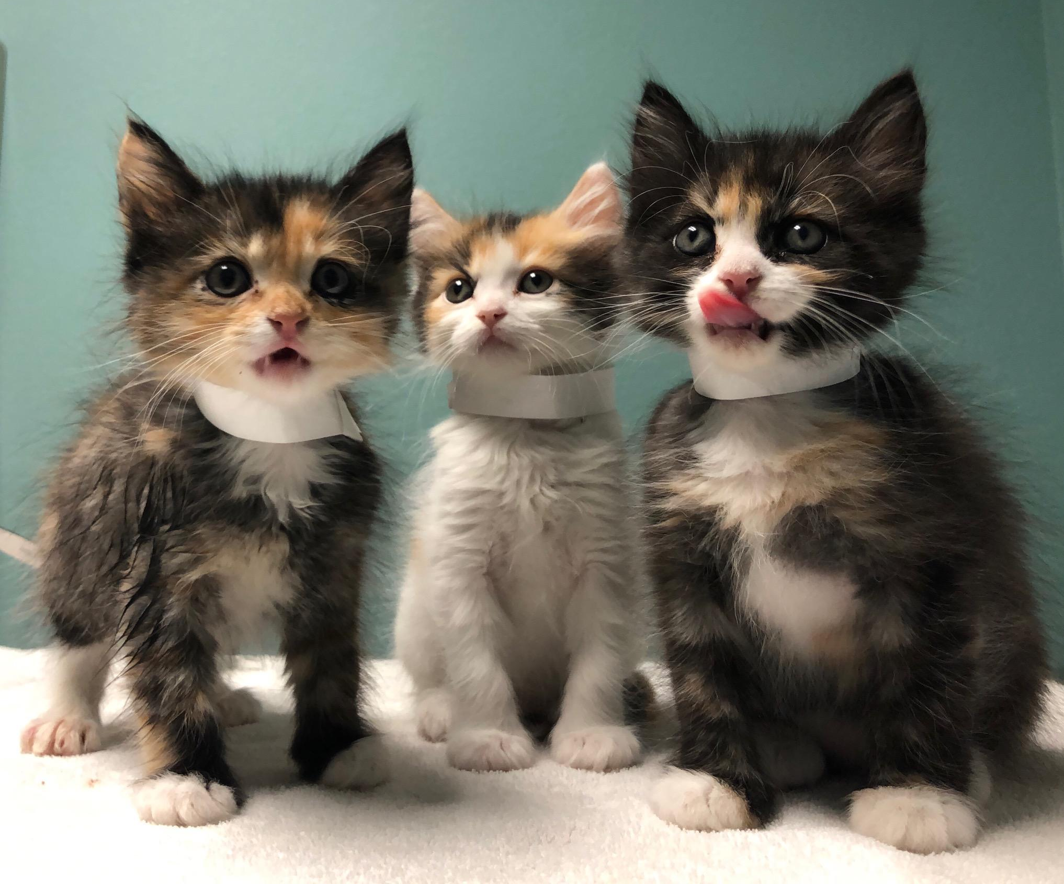
We ask you to put the paper collars on the kittens before vet and surgery appointments. This allows our hospital team to know who is who. If you use your collars for a vet appointment, be sure to request more for surgery! On the dull side of the collar, write their full name (Mimzy K1 aka Morrigan). When putting the collars on the kittens, make sure they are tight enough to prevent the kittens from getting them stuck in their mouth but loose enough to breathe still. The fit is right if you can fit two fingers between the collar and the kitten. When you’re finished securing the collars, cut off any excess paper, as the kittens will chew on it.

Hydracare

With your mentor's approval, offer this product to cats or kittens who are dehydrated, not eating well, or feverish if SQ fluids cannot be given right away.

Baby Bottles and Formula
Bottle feeding supplies will only be in your baby bag if you take home kittens under five weeks. Please contact your mentor before bottle-feeding kittens, as the process can be tricky.
Snuggle Safe Warming Disc

We will provide you with a warming disc if you take home kittens under five weeks old. Kittens under five weeks cannot maintain their body temperature well on their own. Therefore, if you have orphans under five weeks, you should keep the disc warm and with the kittens at all times, as this will be their primary heating source. If you have a mom with young kittens, keep the disc in the nest so that it remains warm for the kittens when the mom is not warming them. To warm the disc, place it in the microwave, and follow the heating instructions on the disc label. You must ALWAYS cover the disc with the sleeve provided or another cloth to prevent scalding the kittens. Likewise, you should never place your kittens directly on the disc; always provide them an escape from the disc if they get too hot. The disc will stay warm for about eight hours.

Other Supplies Available
We may have these other supplies available at the shelter if in stock:

- Playpens - for housing small litters of kittens when a room is not available
- Rolling “kitty condos” - to allow socialization kittens to “explore” your home
- Baby Cat dry and wet food- if your kittens won’t eat ProPlan
- Cardboard scratchers - the small kind that hangs on your door
- Toys - a variety of mice, balls, and other small items
- Baby food and Churu tubes - for socialization kittens or to entice the appetite
- Cooling mats- for hot summer foster rooms
- Kitten Attract Litter or Cat Attract additive to help with litter box training
- Disposable litter boxes (wet food containers)
- Snuggle Puppies (with heartbeat) for bottle babies

Medical Supplies
YOU MUST CONTACT YOUR MENTOR BEFORE USING ANY OF THESE ITEMS!

- Karo syrup (for extreme hypoglycemia)
- Amoxicillin (oral antibiotic)
- Tobramycin (eye drop antibiotic)

If your mentor has you start any medication or treatment from this list: Amoxicillin, Tobramycin, Panacur, Marquis Paste, Vitamins, or SQ Fluids, you must report it to the appropriate contact as soon as possible. This step is crucial to keep accurate, up-to-date medical records for the kitten and the adopter.
Medical Records

When you pick up your kittens, you should receive copies of their medical records (aka kennel card). These records give you an approximate date of birth, weight at the time of intake, what medical services have been done, and what things your mom cat and kittens still need to have done, such as vaccines, deworming, etc., and when these things are due. We need your help to ensure these treatments get done on time and the records are updated.

Your Organization does its best to track this, but there are usually 150 moms and kittens in foster care at any given time during kitten season. Stuff happens, and things get missed. Your responsibility as a foster parent is to help us ensure that your foster cat and kittens are vaccinated and de-wormed when they are due.

You will give the dewormer (Strongid) yourself. All the supplies you need are in your foster bag. If you need help administering it, please contact your mentor.

Your mentor or a mentor assistant will give the FVRCP vaccine. Please reach out to your mentor to set up this appointment. They may come to your home or have you bring the cat or kittens to their home. Please remember that our mentors and mentor assistants are volunteers with busy lives! You should contact them about a week before the vaccines are due to set up a date and time that works for both of you.

If your kittens are due for an FVRCP booster vaccine within one week of their scheduled spay/neuter surgery date, the vaccine can get done during surgery. If it is their first vaccine, please arrange to do it ahead of time. If you are trained to give FVRCP vaccines on your own, you may continue and are encouraged to do so!

Anytime you or your mentor gives a vaccine, Strongid, medication, or fluids, you will need to record it on the medical records sheet and fill out the appropriate document as soon as possible. We use this form to update your kittens’ medical records in our shelter software, and it is crucial to keep these records accurate and up to date!

Kittens and Vaccinations
When a kitten is born, and first nurses on the mother, the kitten receives a dose of colostrum. The colostrum is filled with good immune cells, also known as Maternally Derived Antibodies (MDA), to protect the kitten from common feline illnesses. However, MDA will interfere with the kitten’s ability to make their own protective immune cells. Between four to eight weeks of age, the kitten starts to lose protection from the MDA in the colostrum. However, the protection can last in the kitten for up to 18 weeks. Therefore, it’s difficult to predict each kitten’s exact timing of the complete loss of the protection provided by the MDA.
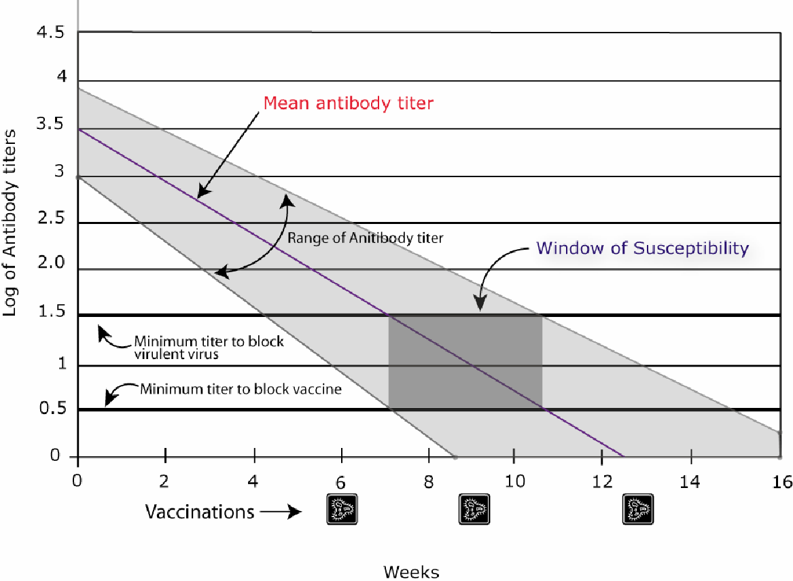
The idea of using a Modified Live Vaccine (MLV) is to stimulate the kitten’s immune system into making more protective immune cells as the MDA disappears. By giving the dose of vaccine every two to four weeks, we can minimize the “window of susceptibility,” which is when the MDA disappears and when the kitten starts to make their own immune cells to fight infectious disease. Kittens who did not receive any colostrum who are vaccinated at six weeks may benefit from the vaccine immediately. On the contrary, kittens who received a large dose of colostrum, or MDA, may not respond to the vaccine until they are 18 weeks old. Therefore, the best strategy for all kittens is to give the dose of vaccine every two to three weeks until the kittens are 18 weeks old.

Vaccine Reactions

Vaccine reactions can include, but are not limited to:
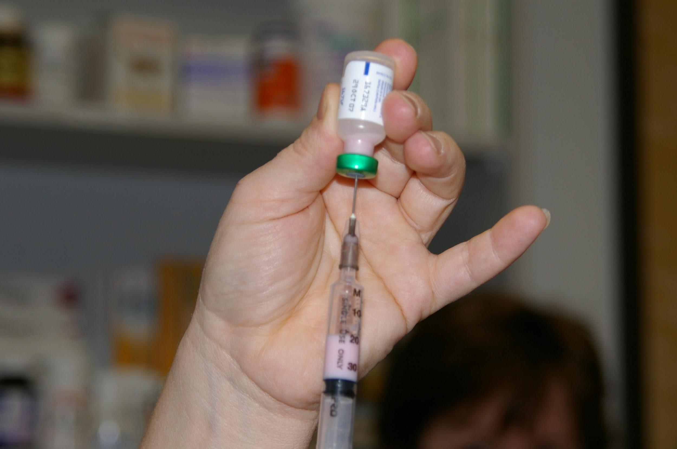
- Limping
- Not eating or drinking the normal amounts for 1-2 days
- Lethargy
- Pain at the injection site
- Unwillingness to play
- Low-grade fever

If any of these symptoms do not improve by 48 hours after the injection, please contact your mentor.

A more serious reaction happens fairly instantaneously and includes; severe vomiting, diarrhea, facial swelling, and difficulty breathing. The kitten will need to be seen by a vet IMMEDIATELY.

Kitten Development and Vaccine Schedule:
The following is general information about what to expect at each stage of kitten development. Remember, these are averages. Please weigh your kittens daily to keep an eye on their development. Kittens should gain about 113 grams or four ounces per week, on average.
Newborn | Completely dependent on mother. Eyelids closed, ears folded forward – cannot see or hear. The sense of smell is the first to develop entirely and is the most developed sense of birth.
2-3 Days | The umbilical cord falls off.
One Week | Eyes begin to open – all kittens have blue eyes. Kittens huddle together for security and warmth.
10 Days | Ears unfold, and the hearing will develop. Can move along with belly on the ground, “paddling” limbs for movement.
Two Weeks | Begin to play with littermates, learning how to socialize. They can stand and balance but cannot walk easily. Teething begins. Eyes are fully open.
16-18 Days | Incisors (tiny front teeth) breakthrough.
20-24 Days | Canine teeth break through.
Three Weeks | Mobile and eager to explore, making mock-aggressive rushes and stalking littermates. Cannot retract claws. Weigh the kittens daily to keep an eye on their development. Kittens should be played with and handled for at least 1 hour daily for good socialization.
24-28 Days | Molars begin to break through.
Four Weeks | Introduce solid food in 3-4 small meals per day. Begin litter box training. They will begin wrestling with littermates. Will receive first deworming (Strongid). Ask your mentor for help with dosing and administration.
Five Weeks | Learning to hunt by pouncing on toys and each other.
Six Weeks | Adult eye color begins to appear. First vaccination for kittens. Kittens are vaccinated against common viruses that cause upper respiratory infection and feline distemper (FVRCP). Receive second deworming.
Seven Weeks and Older | Mom and kittens need to be brought to the shelter for their scheduled surgery appointment. The exam will include: deworming if needed, spay or neuter (if weight is at least 1.5 pounds and kitten is healthy), microchip, treatment for fleas and ear mites as directed by the veterinarian, and possibly another vaccine. The second vaccination occurs 21 days after the first.

Once your cat/kittens have been vaccinated or given a dewormer, please use the google form to communicate what was given (FVRCP or Strongid). You will need the sticker from the vaccine vial to fill out the brand and serial number.

Please let the foster coordinator know if you want to learn to administer the vaccines yourself; we would love to show you! The foster coordinator’s email is foster@yourorganization.

Vaccines and Deworming Treatments

Vaccines:

FVRCP is the vaccine for Feline Viral Rhinotracheitis, Calicivirus, and Panleukopenia (URI and Distemper)

FVRCP is given starting at six weeks of age or older depending on when they went through admissions. It may be given earlier by other shelters.

2nd FVRCP is given 21 days after the first FVRCP. At this point, cats 18 weeks and older (i.e., mom cats) will be done with their vaccination series for a year.
3rd FVRCP is given 21 days after the second FVRCP. The third vaccination is for kittens 18 weeks or younger only.
4th FVRCP is given 21 days after the third FVRCP. The fourth vaccination is for kittens 18 weeks or younger only.
Worming:

Strongid is for roundworms. You might see these pass in the stool after treatment - they look like spaghetti.

Strongid is given at four weeks of age or older depending on when they went through admissions.

2nd Strongid is given 14 days after the first dose. This series is repeated every two weeks until the kittens are spayed/neutered. Mom cats and kittens eight weeks and older will get treated for roundworms with Revolution and will not need Strongid.

Droncit is for Tapeworms. You will see rice-looking segments in their stools.

Droncit is given at surgery if needed (noted by the admissions associate or the foster parent). Tapeworms usually do not cause significant problems and may be treated at the time of altering.

Health Concerns

The following is a list of medical issues you may encounter as a foster parent with your mother cat and/or kittens. This information is not extensive; it just gives you an idea of what common ailments may look like and how they might be resolved. This is not a substitute for the expert advice of a trained medical professional.

If your foster kitten displays any of these symptoms, call your mentor immediately:

- Sneezing and/or congestion with green or yellow discharge from the nose and/or eyes.
- Coughing, wheezing, or heavy breathing.
- Diarrhea or vomiting – this can be life-threatening to tiny kittens!
- Straining to urinate or defecate – straining to urinate can be life-threatening for male cats!
- Bleeding from any part of the body.
- Lethargy – kitten seems sleepy/cuddly all the time.
- Fever.
- Paralysis.
- Extreme change in attitude or behavior.
- Not eating or drinking regularly.
- Temperature too low (below 99ºF) or too high (above 102ºF).

Please have specifics ready to give when contacting your mentor. You will also need to take your kitten’s temperature before you call.

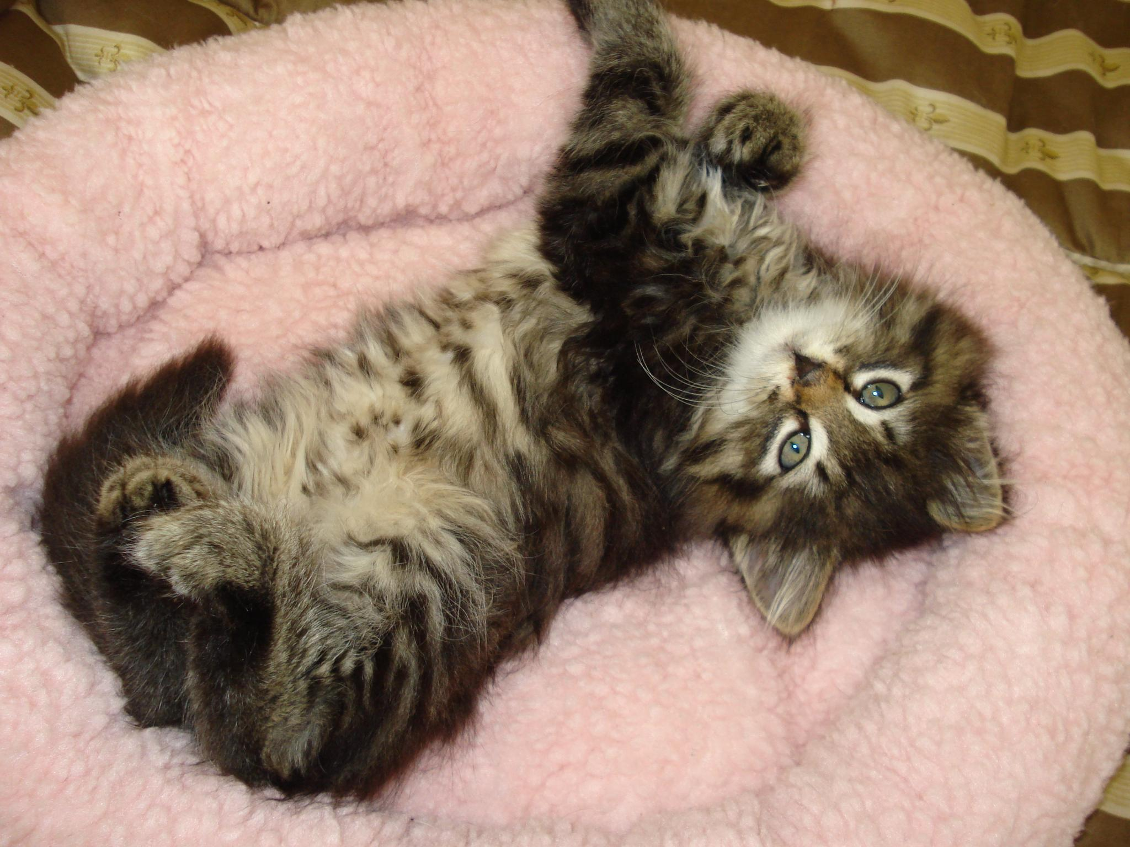

Photo by Barbara Pirk

Common Ailments

Upper Respiratory Infection

Upper respiratory tract infections (URI) or “kitty colds” are common occurrences in shelters. The majority are caused by one of two viruses, although they can have some bacterial components. Signs of URI include congestion, excessive sneezing, fever, discolored (green or yellow) nose or eye discharge, and/or a fever.

Please contact your mentor if you suspect your kitten(s) of having an Upper Respiratory Infection. They may be able to advise you to start the kittens on amoxicillin. DO NOT ADMINISTER AMOXICILLIN WITHOUT BEING ADVISED TO DO SO. If your mentor has you start Amoxicillin, please report it on the Google Form as soon as possible. If symptoms do not resolve after seven days of amoxicillin, please contact your mentor.

If your foster cat/kitten shows signs of URI, please do the following:

- Make sure the cat/kitten is eating. Cats who are congested often won’t eat because they can’t smell the food. If they are not eating well, warm up a strong-smelling canned food, and offer it to them. You can also provide them with several different options to ensure there is one they like.
  - Cats and kittens should be eating at least 50% of the food offered to them
  - After 24 hours of not eating or eating less than 50%, please give SQ fluids (you or your mentor). Continue this daily until the appetite resumes to more than 50%.
  - If a kitten does not eat for the next meal after the initial SQ fluids, you or your mentor should begin supplemental force-feeding and schedule an appointment with the shelter hospital. Only force feed if you have been trained.
  - If an adult cat does not eat for an additional 24 hours after the initial SQ fluids, contact your mentor, and schedule an appointment with the shelter hospital.
- If the cat/kitten has eye or nose discharge, clean their nose/eyes at least twice daily with a wet, warm washcloth. Gently wipe the eye from the nose side out to the side of the face.
- If the cat/kitten is congested, place them in a room with a humidifier or in a carrier in a bathroom with the hot shower running (steam) to aid congestion. You can also hold the kitten on your lap. Nothing should ever be added to the water like Vic’s Vapor Rub, or similar products should ever be added to the water. Also, never leave a kitten alone in a bathroom with the hot shower running unless it is in the carrier.
  - Place nasal saline drops in the cat/kitten’s nose to aid congestion (1 drop per nostril, 2-3 times daily). Discontinue if a bloody nose develops.
  - A “Little Noses” product can also be used on URI kittens. This product can be used as long as needed and used in both nostrils p to three times daily. Please use Little Noses without decongestant (saline-only solution). Discontinue if a bloody nose develops.
- Provide supplemental warmth, especially for young kittens (rice sock, Snuggle Safe warming disc, etc.)

Conjunctivitis

Conjunctivitis is characterized by swelling and/or yellow or green discharge around the eyes. Tobramycin eye drops are typically prescribed to treat the infection. DO NOT ADMINISTER WITHOUT BEING ADVISED TO DO SO. If your mentor has you start Tobramycin, please report it on the Google Form as soon as possible. To administer eye drops, hold the kitten’s eye open and let the drop fall into the inside corner of the eye near the tear duct. Open and close the eye a few times to get the drops worked into the eye.
To clean the kitten’s eyes, use a cotton ball or gauze that is clean with warm water. If the eye is sealed shut, you will need to use the warm cotton ball as a compress and hold it against the eyelid for a few minutes. This will soften the crusted material around the eye. Once it is soft and pliable, you can wipe it from the eye. Start at the area closest to the nose and wipe outward. Don’t force the material off of the eye. You may need to continue to let the cotton ball sit on the eyelid to soften the material. Once you clean the discharge from around the eye, you can administer eye medications. It is helpful to the kitten if you can gently wipe the eye clean multiple times per day. If you do not have a cotton ball or gauze square. Make sure you use a clean washcloth each time, and never share washcloths between kittens.
Vomiting

Vomiting can be very dangerous for kittens because they dehydrate so quickly. Vomiting is not as common as diarrhea, so it’s troubling, especially if the kitten is repeatedly vomiting. If the kitten just ate a big meal and vomited it back up once, it’s probably okay to monitor - we call this a “scarf and barf.” If they can’t keep any food down and lose weight/low energy.

Dehydration

Dehydration can kill a tiny kitten quickly. Mentors should train you on how to do a skin tenting test. With smaller kittens, another way to test hydration is to feel the gums. If they are sticky instead of slippery, the kitten is dehydrated. Also, look at the color of the gums. If it is white with no color, please report this when you call your mentor.

Diarrhea

A few things to remember when examining your kitten’s poop:

- A little bit of bright red blood on poop is ok. So is a little bit of bright red blood on the kitten's bottom. It’s usually a reaction to something they ate, new food, stress, new location, etc.

- A lot of blood is not ok.

Diarrhea is probably the most common problem with kittens. Runny poop seems to be a kitten’s preferred response to almost all stress or illness. It can be dangerous for kittens because the water lost in the stool tends to dehydrate them rapidly.

Diarrhea Protocol
All foster cats/kittens will be sent home from Your Organization with a supply of FortiFlora. This is an oral supplement that helps with digestive health. Mom cats and kittens should be given FortiFlora or Calming Care (mixed into wet food) for the first two weeks of foster care or the first two weeks of weaning. You should feed only one type of canned and dry kitten food (preferably the Purina ProPlan we send home with you). If the cat or kitten develops diarrhea after the FortiFlora has been discontinued, restart the FortiFlora for another seven days. FortiFlora and Calming Care can be used together in cases of diarrhea.
If diarrhea persists for three days, inform your mentor, who will have you do the following:
- Get current weights on all of your kittens so that appropriate doses of medication can be made up. You will need to pick up the following from your mentor or the shelter if your mentor is unavailable.
  - Panacur (fenbendazole). This is an oral prescription medication.
  - Marquis Paste (ponazuril). This is an oral prescription medication.
  - Vitamin supplement. This is a simple vitamin supplement that helps replenish nutrients that are lost and boost the appetite.
**Please report the medications on the Google Form as soon as possible so we can get their medical records up to date**
- Optional: In addition to medication, give each kitten one teaspoon of canned pumpkin daily, mixed into their wet food. Be sure to use plain canned pumpkin only, not pumpkin pie or spiced pumpkin mix. If available, we will stock the baby bag with a packet of pumpkin puree or powder.

If no improvement in diarrhea is seen after three more days (six days total), then do the following:
- Obtain a fecal sample in the provided container.
- The ideal sample is at least the size of a Milk Dud or about a teaspoon.
- Make sure the sample has very little or no litter.
- Collect the sample within 1 hour of bowel movement and bring it in immediately.
  - It can be refrigerated for up to 12 hours if necessary
- Bring the sample to the shelter.
- Fecal samples can be received at the hospital during the following days and times. Mon-Fri is preferred for a complete analysis.
  - Your organization’s available days/hours
- Complete the “Fecal Sample Drop Off Form” located in your baby bag. Please include your email address so you can be contacted with the results.
- You do not need to call ahead but be advised that results may not be available until later or the following day.
- If the kitten is very sick, call the front desk to schedule a vet appointment at 503-555-1234.
- Results
- The hospital staff will contact you if any parasites are found in the fecal test and prescribe any additional medications.
- If your foster kittens need medication, you must return to the shelter to pick up medication.
- If you can’t return for necessary medications in the next few days, please contact your fellow foster parents or your mentor for transportation assistance.
- If you have not received results within 24 hours or have questions about your results, please contact the foster coordinator.

If no parasites are found on the fecal test, and there is still no improvement in diarrhea, then:
- Schedule a vet appointment by calling the front desk at 503-925-8903.
- If the kittens are eating well, gaining weight, being active, and not dehydrated, the diarrhea may not need treatment and might be something the kittens just need to outgrow as their immune system matures.

Please note that any time during this protocol, if your kittens are vomiting or dehydrated, have liquid (not forming) diarrhea, diarrhea dripping from their bottoms, are refusing to eat for more than 8 hours, or acting lethargic, you should immediately alert your mentor.
General and Emergency Veterinary Care
Your Organization covers all approved medical expenses for the cats and kittens in the shelter’s foster program. General medical care for Your Organization foster cats is provided at the direction of the veterinarian and veterinary technician at Your Organization’s on-site hospital. You should call your mentor before calling the hospital for an appointment.

Once a foster cat or kitten is in your care, you are responsible for transporting them to the shelter veterinarian for necessary medical care. Always use a secure carrier (the one we provide) explicitly designed for companion animals when transporting cats.

Foster parents must not medicate or shave any cats in their care without prior approval from their mentor.

If the onsite veterinarian is not available, then you may be able to seek emergency medical care. Emergency care must be approved PRIOR to the vet visit. Call your mentor for guidance and approval. Otherwise, Your Organization will not reimburse the veterinary expenses. Upon approval, you will be directed to one of the following emergency clinics. Upon arrival at the emergency vet clinic, you MUST tell the veterinary staff that you cannot approve any treatment or charges. The on-call manager will authorize all treatments over the phone.

Name of Emergency Clinic Phone Number
Street address, Town, State, Zip 555-555-5555

Giving Medication
You may be asked to give oral medication to your foster cat or kitten. Most medications come in a liquid form and can be easily squirted into the cheek pocket of the mouth. You can wrap squirmy kittens in a towel or blanket first. You can also dip the tip of the syringe into baby food or wet food to disguise the taste of the medication.

Some medications will be in pill form. Cornell’s Veterinary Medicine program created a series of videos on youtube called “Giving your cat a pill or Capsule.”We recommend watching these before attempting to give your foster cat or kitten a pill. It can be a tricky process, and we want to make sure you are prepared!

*Note: We do not recommend dipping the pill directly into your household stick of butter. You can, however, apply some butter to the pill. We also recommend flushing pills with 3 ml of water for a kitten and 5 ml of water for an adult.

Rainbow Bridge - The passing of a kitten

Despite providing high-quality care and wonderful homes for all of our foster kittens, some kittens will pass away while in our care.

If this happens to a foster kitten in your home, please wrap the kitten up in a blanket or towel and place them in a plastic zip-lock bag in your refrigerator. Please bring them to the shelter at the next possible opportunity (within 24 hours is preferred), so our veterinarian can do a necropsy if indicated and dispose of the remains properly.

Necropsies may not be performed in all cases, and even if performed, they may not give us a cause of death.

Cat Bites
A bite is considered an event in which an animal's teeth break human skin, and their saliva comes into contact with blood, regardless of their intent.
If you are bitten by one of your foster cats/kittens, report it to the shelter as soon as possible. Oregon law mandates that we report all bites that break the skin and cause bleeding.

When a cat bites, they are placed on a 10-day bite quarantine, during which they cannot be handled or adopted. Generally, they can remain in foster during their bite quarantine. A staff person will give you directions on conducting a proper quarantine in your home if you are interested in keeping your foster cats/kittens.

Please remember that cat bites become a permanent part of that cat’s behavior history and can slow their socialization and adoption. Please try to prevent bites as much as possible.

Tips on how to avoid being bitten or scratched by your foster cat or kittens:

- Don’t try to pull a cat out of its carrier or hiding space. Allow them to come out on their own. If you need to move them right away, use a blanket or towel.
- Scared cats might run from you or escape their foster room. Don’t try to grab them with your hands. Use a large towel or blanket to cover and wrap them or encourage them back into their room with a wand toy.
- If your foster cat gets into an altercation with a resident animal, do not put your bare hands into the situation. Throw a large towel or blanket over the animals, then try to wrap one of them up into it and place them back in their foster room.
- Mom cats are prone to boredom, overstimulation, and adverse reaction to resident animals. Watch them closely for signs of overstimulation (freezing, tail twitching), and if they are sensitive to touch, pet them in “safe” areas like the head and only for short periods of time. Provide ample play time and block all visual access to your resident animals.
- Use two people when administering fluids, vaccines, or taking temperatures. One person should control the cat or kitten’s head to prevent them from turning and biting. If you must do it on your own, wrap the kitten tightly in a towel or blanket.
Adoption Procedure - Not using Adopets
For Foster Moms & Kittens
- Kittens are available for adoption after six weeks of age as long as they are at least 1.5 pounds, healthy, and spayed/neutered.
- The counselor who approved the adoption performs adoption follow-ups. Foster parents may inquire with the counselor about how their former foster cat(s)/kitten(s) are doing in their new homes. They are not, however, allowed to contact adopters directly.
- Foster parents who wish to adopt their foster cats must pay the adoption fee and go through the adoption process.

Pre-Adoption Procedure - Not using Adopets
- Kittens must be AT LEAST FIVE WEEKS old, 1.25 lbs., healthy, and social before they can be viewed by a potential adopter and placed on the Kitten List and Petfinder. A kitten is not considered pre-adopted until the adopter meets or video chats with the foster parent and the kitten, attends adoption counseling, signs the contract, and pays the adoption fee. This is on a first-come, first-served basis.
- The foster coordinator will email you around the kitten’s 5-week birthday to check in on their weight, health, and sociability. If they are ready for pre-adoption, we will schedule surgery and proceed with the marketing. **Please indicate at this time if you do NOT want to pick your group up after surgery and do adoption pickups from your home. We will need to ensure we have kennel space for them at the shelter or schedule adopter pickups from the shelter.
- Please only show a kitten to one interested party at a time. If the party indicates they would like to pre-adopt the kitten, they have until the shelter's close of the next day to complete the paperwork. If they complete the pre-adoption, the front desk staff will notify you via email. If you don’t receive confirmation the pre-adoption occurred, you may show the kitten to the next interested person.
- We suggest setting up an email account specifically for fostering. You can use the vacation responder to auto-reply to any inquiries so that you don’t have to respond to each individual email. For more information on setting this up, see the document in the shared Google folder entitled “How to Set Up a Foster Email Auto-Responder.”
- If you live close to one of our offsite outreach locations, you can send adopters to the location instead of the shelter to complete their paperwork and adoption counseling and pay the adoption fee. You must pre-approve this with the site coordinator by emailing them to ensure an adoption counselor will be available the day you are showing your kittens. PetSmart donates money to Your Organization based on the number of adoptions completed at their stores, so please encourage adopters to use this service if it is convenient!
  - PetSmart Location, Street Address, City, Zip
    - Offsite Coordinator, email
- THERE ARE NO HOLDS IN FOSTER CARE. Only pre-adoptions.

Kitten List
To promote pre-adoption and prevent foster kittens from returning to the shelter for adoption, we provide a public list of all kittens in foster care who are available for pre-adoption. If your kittens are at least six weeks old and healthy, we will post them to the list with your name, area of town, and contact email, so that potential adopters can schedule appointments to meet them. If you do not want your contact information listed, you must notify the foster coordinator before your kittens turn five weeks (or when you pick up your kittens from the shelter). You can find the list on the main page of our website or by clicking this link.

Showing Kittens at Your Organization Offsite Adoption Sites
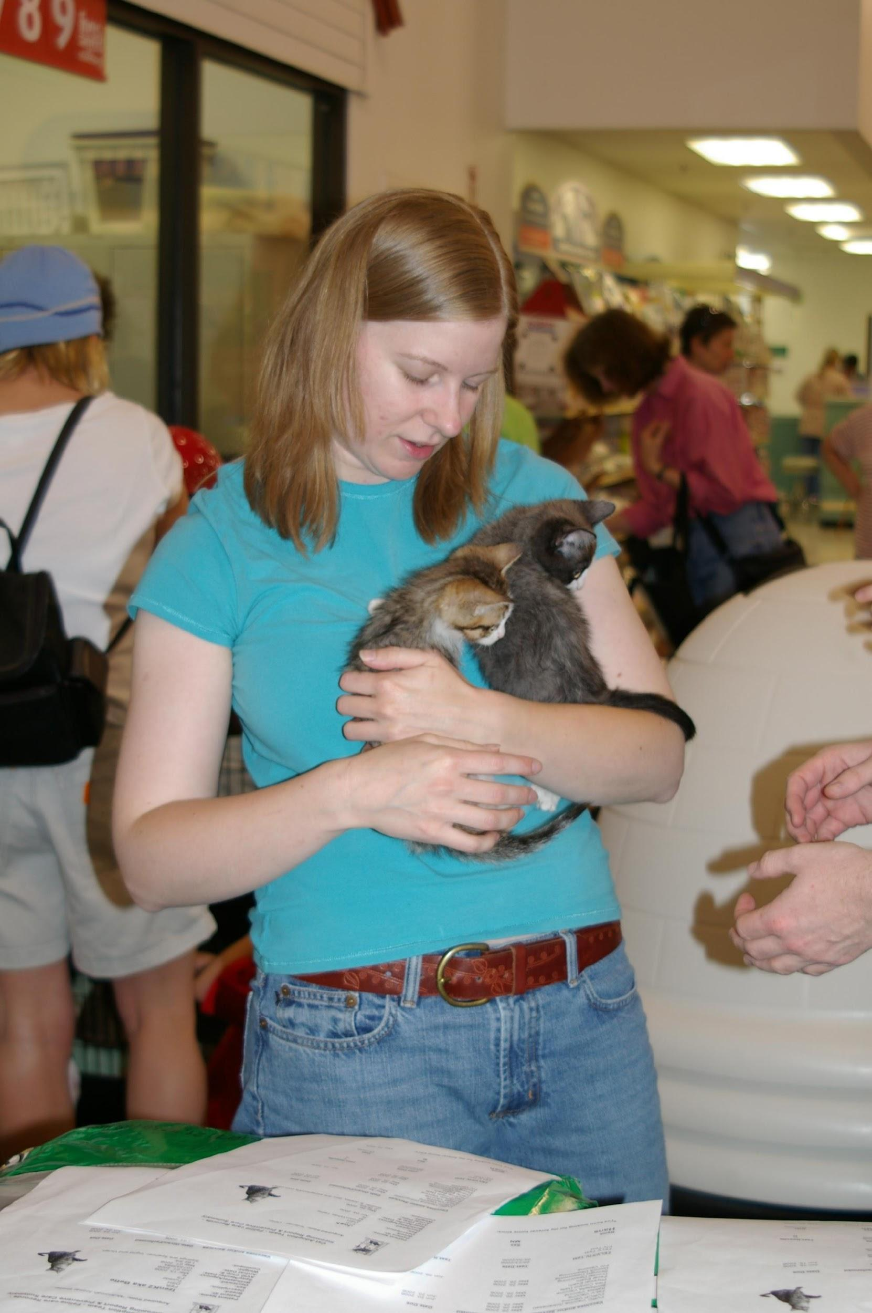
Foster families may want to show their kittens at the various offsite locations to facilitate pre-adoption. We recommend kittens be around 2 lbs. and have been vaccinated for at least five days before going out in public. They cannot be on any medications and will need to be off medications for at least three days before going out. The foster coordinator will post on the Google group when offsite opportunities arise. Please note these opportunities are currently very limited, and we highly encourage pre-adoption from your home instead.

When you bring your foster cats to Your Organization for adoption purposes, it is important to have a brief write-up about each cat’s personality and the kind of household that would be most suitable. You can fill this information out on the Personality Profile we gave you when you picked up your kittens from the shelter. Please keep the write-ups positive, highlighting the best traits of your kittens. If you have photos of your foster kittens, please consider providing those as well. Some foster parents like to provide a note with their contact information and possibly a link to their social media accounts so that the new family can follow up.

Petfinder
Petfinder is an online gallery of pets that are available for adoption. Users can search by location, age of pet, breed, etc. It’s a handy tool for adopters, and it is estimated that one out of three visitors has already browsed Petfinder before visiting the shelter or offsite locations. Your Organization shelter software sends pictures and bios about each cat to our website’s adoption page, which feeds to Petfinder and other adoption websites.

Kittens posted on Petfinder have the highest rate of pre-adoption simply because adopters can view them before they arrive at the shelter. Why is this important? If a kitten can be adopted directly from your home or on the day of their spay/neuter surgery, the time spent in close contact with other kittens is greatly diminished. Less contact equals less exposure to germs equals fewer kitty colds (upper respiratory infections).

Meet and Greets - Not Using Adopets

We require either a virtual or an in-person meet and greet as part of the adoption process. Virtual meet and greets can be conducted over the phone, over email, or via a video call (zoom, facetime, google meets)
In-person meet and greets will happen at your home. You are welcome to set any safety protocols you would like for in-person meet and greets (i.e., masks/social distancing/COVID vaccine verification). Please indicate your preferences in your foster cat/kittens’ online bio so adopters are prepared in advance (see Marketing section).

Please note that the meet and greet is primarily for the interested party to get to know the cat/kitten and not an “interview” or “screening” of them or their household. We do, however, ask that you discuss Your Organization’s adoption policies (see next section).

We also ask that you share any known medical conditions (indicated by an Indemnity/Waiver in their medical records) with the interested party during or after the meet and greet so they aren’t surprised by it at the AC session. If your foster cat or kittens have a medical condition (this is uncommon), we will provide you with updated medical records prior to adoption starting. You can pass these along to the interested party for them to read on their own, or you can discuss them during the meet and greet.

Adoption Policies

Your Organization supports open adoptions and a conversation-based approach to adoptions rather than rigid screening or requirements. We want all members of our community to be able to adopt a cat, regardless of their previous experience or knowledge. Our adoption counselors will provide all the information they need to become a great home for a kitty! Please check out this video about Removing Barriers to Adoption for more information about why we approach adoptions in this way!

Your Organization typically adopts to indoor-only homes. We believe cats live longer, safer lives indoors and can be happy and active inside! There are rare exceptions where the shelter determines that a cat can be adopted to an indoor-outdoor home.

- If your adopter wants an indoor-outdoor or outdoor-only kitty, first try to educate them on the benefits of indoor only.
- If they won’t agree to this policy or the conversation goes beyond your level of comfort, reach out to the shelter at Your organization’s contact information for assistance. Please do not “decline” an adopter without involving the shelter.

Your Organization will not adopt to a person who is planning on declawing their cat.

- If the adopter says they plan to declaw, first try to educate them on the painful process and safe alternatives.
- If they won’t agree to this policy or the conversation goes beyond your level of comfort, reach out to the shelter at Your organization’s contact information for assistance. Please do not “decline” an adopter without involving the shelter. If someone is interested in a declawed cat, the staff or adoption counselor will often direct them to the cats in our care that have been previously declawed.

Your Organization has a first-come, first-serve adoption process. This means that the first person to apply for a cat or kitten that agrees to our policies will have the first chance to adopt that kitten. If the cat or kitten has unique behavioral or medical concerns, we may place more restrictions on their adoption (i.e., no young children, no other cats, no dogs, etc.). If you think your foster cat or kitten needs special restrictions, please contact the foster coordinator [contact information] for approval.

While we encourage adopters to take two kittens, we do not require it. Cats can lead happy lives as singletons, with an older cat friend, or even with a dog friend! Some adult cats (1 yr +) will be “bonded,” meaning they are known friends and need to be placed together, but we do not “bond” kittens.

The adoption counselor (AC) performs adoption follow-ups. Foster parents may inquire with the AC about how their former foster cat(s)/kitten(s) are doing in their new homes; however, they cannot contact adopters directly. If you are interested in seeing updates on Your Organization alumni, consider joining our Google chat group called “Your Organization alumni updates for volunteers.”

Adoption Counseling (AC)

Our adoption counseling (AC) sessions are comprehensive and allow adopters to learn about all important aspects of cat care and any specific behavior or medical information about the cat/kitten they are adopting. If you are interested in seeing one in action, please check out this Example AC Session video.
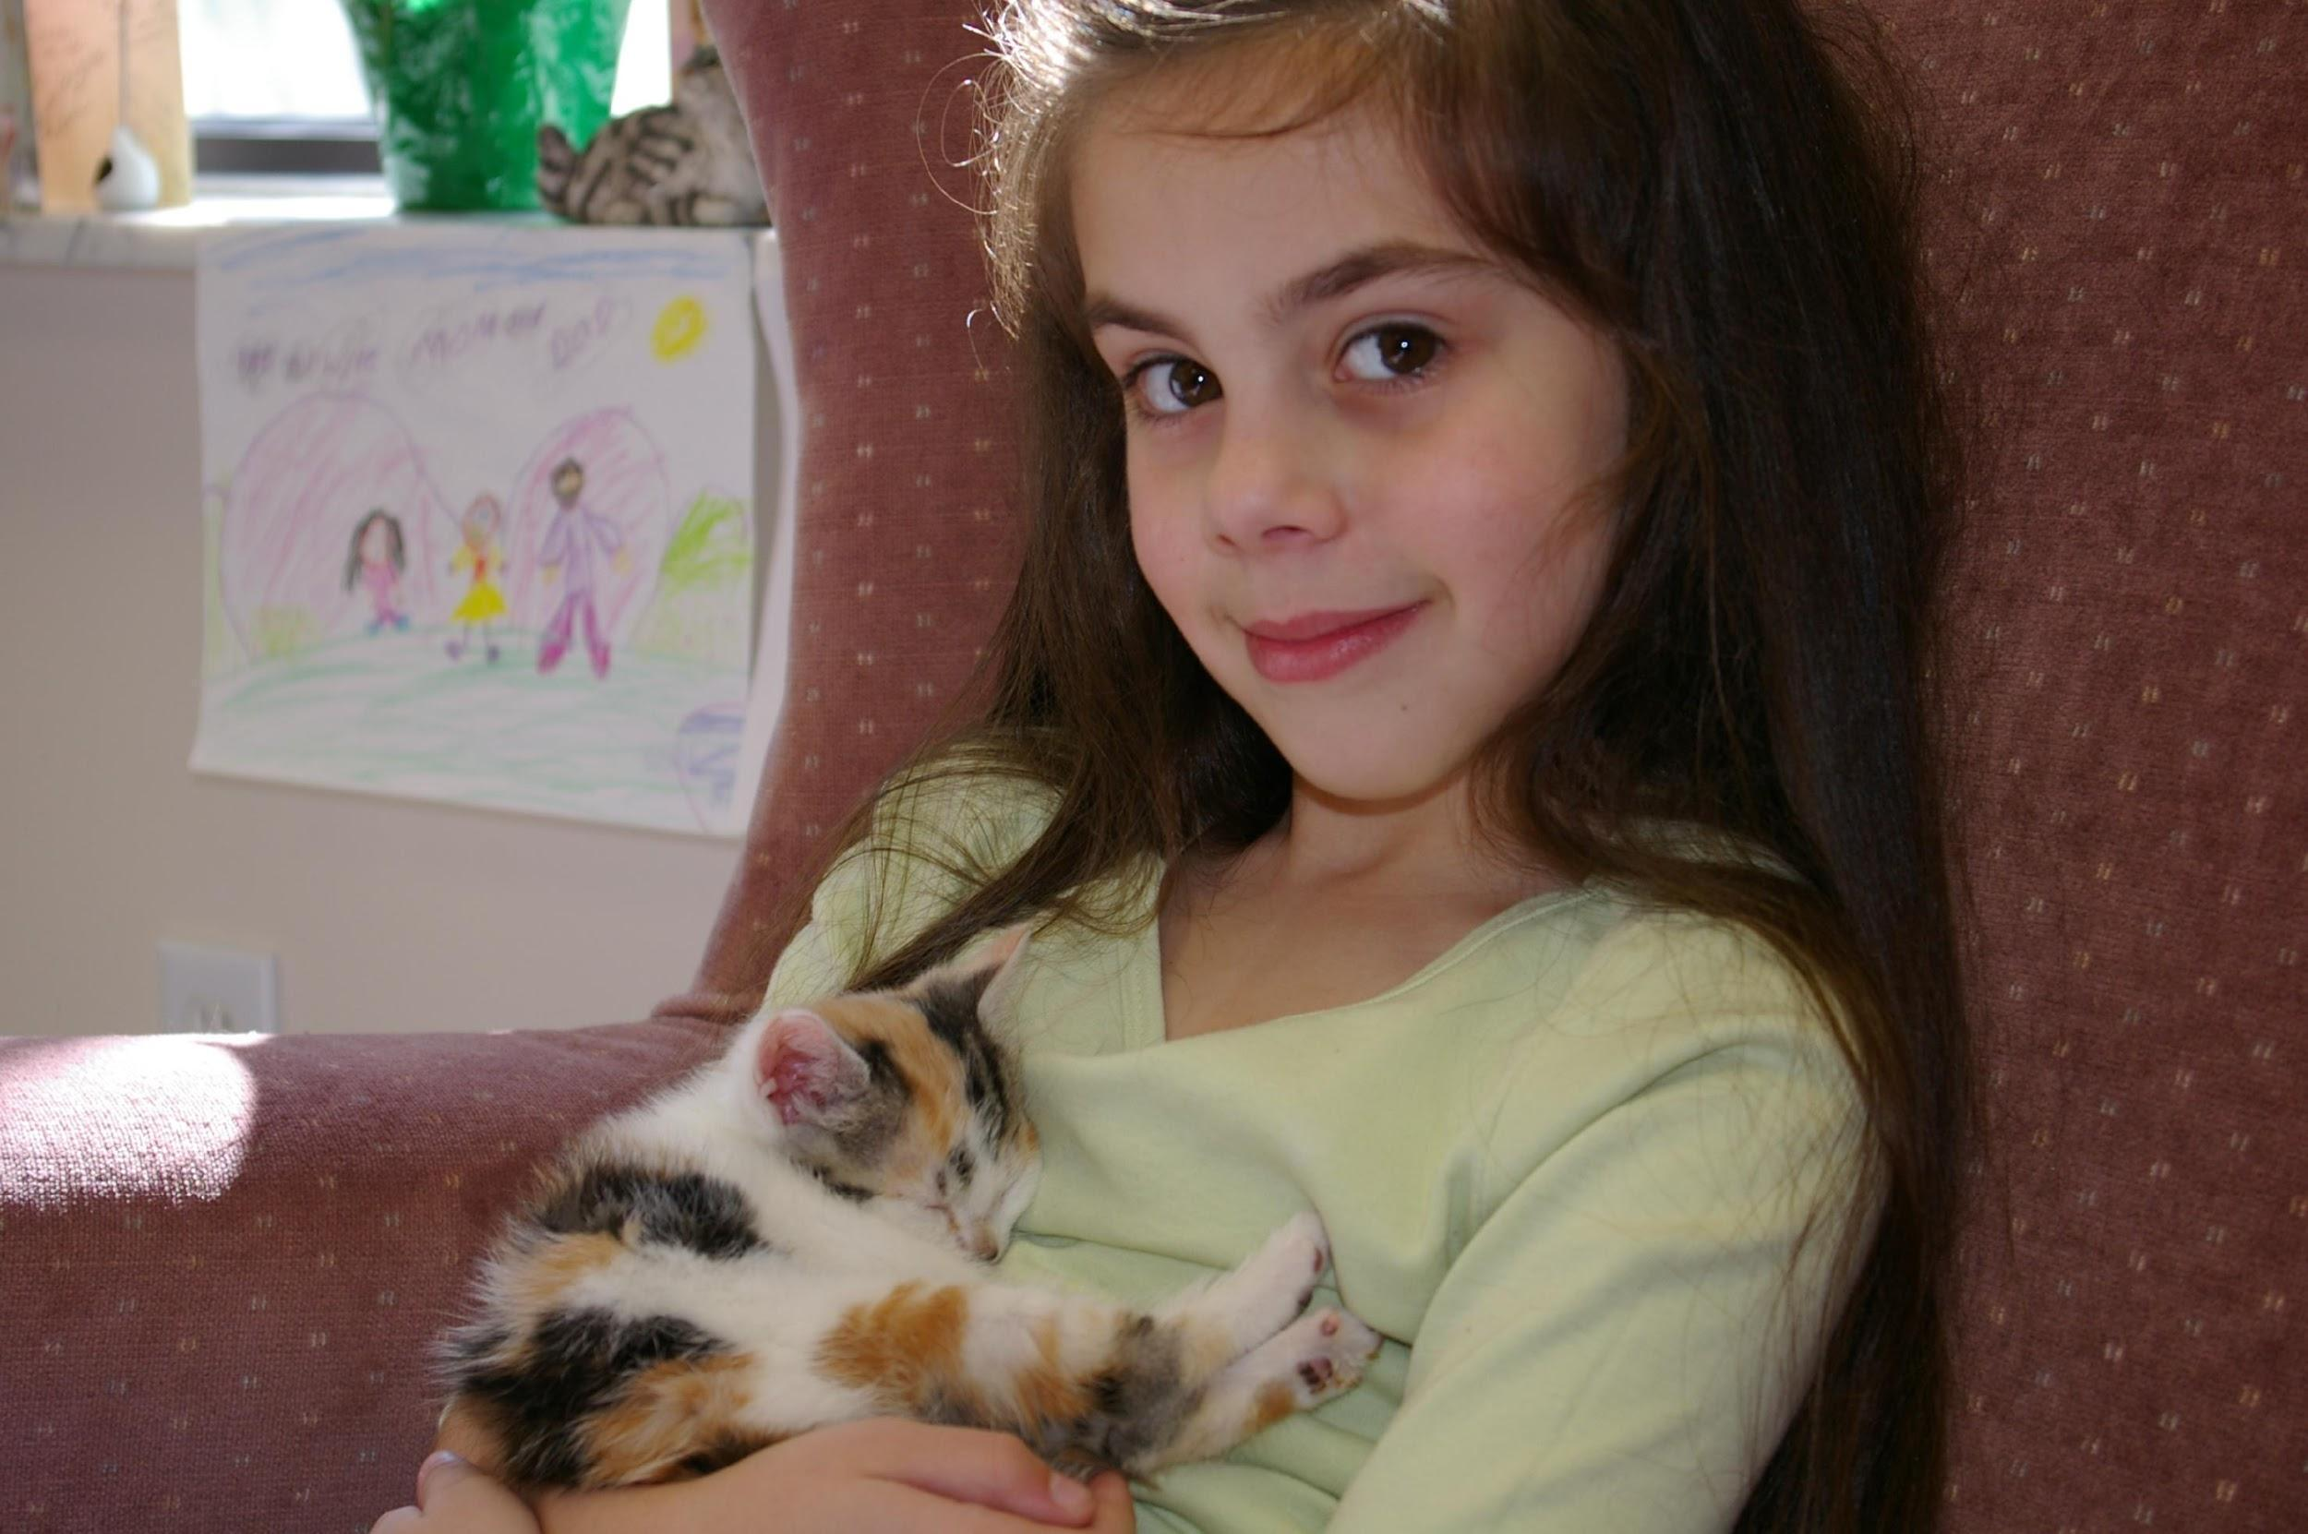

“Pickup” Instructions Email

Once the adoption process is complete, you and the adopter will receive a “pickup” email. The email will indicate if the adopter has chosen to bring their cat/kitten carrier. If not, you will use one of the cardboard carriers, and they will be charged.

Please work with the adopter to schedule a day and time for the cat/kitten to be picked up from your home.

(End non-Adopets section here)

Adoption Procedure - Using Adopets Online Adoption System
“Test Driving” a Kitten
While some people may want to take a kitten home and first see how it works in their household, “trial adoptions” are not allowed. The entire adoption process must be completed before a cat/kitten is taken to an adoptive home. Your Organization’s open return policy assures adopters that they may bring the cat/kitten back to the shelter within 60 days should the adoption not work out.

Kittens and their mom cats can be available for adoption when the kittens turn six weeks of age as long as they are completely weaned, weigh more than 1.5 lbs. with a good body condition score, are healthy, social, and spayed/neutered. Most kittens will not reach this milestone until closer to 8 weeks of age.

Kittens and their mom cats are available for “pre-adoption” after five weeks of age as long as they are 1.25 lbs., healthy, and social. The only difference for a pre-adoption is that the cat or kitten is not yet spayed/neutered and cannot go home until that happens.

The foster coordinator will email you around the kitten’s 5-wk birthday to check in on their weight, health, and sociability. If they are ready for pre-adoption, we will schedule surgery and proceed with the marketing.

**Please indicate at this time if you do NOT want to pick your group up after surgery and do adoption pickups from your home. We will need to make sure we have kennel space for them at the shelter or schedule adopter pickups from the shelter.**

A kitten is not considered pre-adopted/adopted until the adopter fills out an online application, has a virtual or in-person meet and greet with the cat or kitten, attends an adoption counseling session, signs the adoption contract, and pays the adoption fee. You will be notified by a “pickup instructions” email once this process is complete. Pre-adopted kittens will not go to their adoptive home until after they are spayed/neutered. Adopted kittens will already be spayed/neutered and can go home immediately.

In general, we expect each step in the adoption process to be completed in a timely manner (24-48 hours), so we aren’t holding up the adoption process. If an adopter requests a delay of more than 72 hours at any point in the process (meet and greet, AC session, pickup), please reach out to the shelter for assistance by emailing insert contact info here.

Private Party Adoptions

The foster team will reach out to you before pre-adoptions begin, usually around five weeks of age. At that time, we will ask if you have anyone already interested in your foster cat or kittens - perhaps yourself, a friend or family member, or a follower on your social media.

If you do have potential adopters, we will provide you with the private links as well as a template email with the AC scheduling link. These cats and kittens will NOT be available on our website for adoption. Please note that the meet and greet should happen before you send the interested party the provided template email with the private adoption application link and AC session scheduling link.

**Private links are ONLY available if you ALREADY have interested parties. We cannot hold up the adoption process while you market your cat/kittens privately. If you don't have someone already interested, we do need to get them up on the website.**

Website Adoptions

If you do not have potential adopters, we will put them on our website for adoption. Applications will be taken on a first-come, first-served basis on our website only.

You will be notified via email once an application has been submitted for one or more of your foster cats/kittens. The shelter will send you and the interested party an email with detailed instructions on the process and ask you to set up the meet and greet. The shelter will send a separate email only to you with the AC session link. Please send this link to the interested party once the meet and greet is complete so they can schedule their AC session.

Adopets/Adoption Software Training

We encourage you to learn our adoption software and assist in processing your foster cat/kitten(s) adoption applications online. This saves the staff a lot of time, speeds up the process, and allows you to access all the information available on an adopter’s application. Please look at the Adopets Application Guide for Fosters. When your foster group is ready for adoption, we will ask you if you would like to help with this part of the process!

Meet and Greets

We require either a virtual or an in-person meet and greet as part of the adoption process. Virtual meet and greets can be conducted over the phone, over email, or via a video call (zoom, facetime, google meets)

In-person meet and greets will happen at your home. You are welcome to set any safety protocols you would like for in-person meet and greets (i.e., masks/social distancing/COVID vaccine verification). Please indicate your preferences in your foster cat/kittens’ online bio, so adopters are prepared in advance (see Marketing section).

Please note that the meet and greet is primarily for the interested party to get to know the cat/kitten and not an “interview” or “screening” of them or their household. We do, however, ask that you discuss Your Organization’s adoption policies (see next section).

We also ask that you share any known medical conditions (indicated by an Indemnity/Waiver in their medical records) with the interested party during or after the meet and greet, so they aren’t surprised by it at the AC session. If your foster cat or kittens have a medical condition (this is uncommon), we will provide you with updated medical records prior to the adoption starting. You can pass these along to the interested party for them to read on their own, or you can discuss them during the meet and greet.

Adoption Policies

Your Organization supports open adoptions and a conversation-based approach to adoptions rather than rigid screening or requirements. We want all members of our community to be able to adopt a cat, regardless of their previous experience or knowledge. Our adoption counselors will provide all the information they need to become a great home for a kitty! Please check out this video about Removing Barriers to Adoption for more information about why we approach adoptions in this way!

Your Organization typically adopts to indoor-only homes. We believe cats live longer, safer lives indoors and can be happy and active inside! There are rare exceptions where the shelter determines that a cat can be adopted to an indoor-outdoor home.

- If your adopter wants an indoor-outdoor or outdoor-only kitty, first try to educate them on the benefits of indoor only.
- If they won’t agree to this policy or the conversation goes beyond your level of comfort, reach out to the shelter at Your organization’s contact information for assistance. Please do not “decline” an adopter without involving the shelter.

Your Organization will not adopt to a person who is planning on declawing their cat.

- If the adopter says they plan to declaw, first try to educate them on the painful process and safe alternatives.
- If they won’t agree to this policy or the conversation goes beyond your level of comfort, reach out to the shelter at Your organization’s contact information for assistance. Please do not “decline” an adopter without involving the shelter. If someone is interested in a declawed cat, the staff or adoption counselor will often direct them to the cats in our care that have been previously declawed.

Your Organization has a first-come, first-served adoption process. This means that the first person to apply for a cat or kitten that agrees to our policies will have the first chance to adopt that kitten. If the cat or kitten has unique behavioral or medical concerns, we may place more restrictions on their adoption (i.e., no young children, no other cats, no dogs, etc.). If you think your foster cat or kitten needs special restrictions, please contact the foster coordinator [contact information] for approval.

While we encourage adopters to take two kittens, we do not require it. Cats can lead happy lives as singletons, with an older cat friend, or even with a dog friend! Some adult cats (1 yr +) will be “bonded,” meaning they are known friends and need to be placed together, but we do not “bond” kittens.

The adoption counselor (AC) performs adoption follow-ups. Foster parents may inquire with the AC about how their former foster cat(s)/kitten(s) are doing in their new homes; however, they cannot contact adopters directly. If you are interested in seeing updates on Your Organization alumni, consider joining our Google chat group called “Your Organization alumni updates for volunteers.”

Adoption Counseling (AC)

Our adoption counseling (AC) sessions are comprehensive and allow adopters to learn about all important aspects of cat care and any specific behavior or medical information about the cat/kitten they are adopting. If you are interested in seeing one in action, please check out this Example AC Session video.

“Pickup” Instructions Email

Once the pre-adoption or adoption process is complete, you and the adopter will receive a “pickup” email.

Please work with the adopter to schedule a day and time for the cat/kitten to be picked up from your home. We prefer this to happen as soon as possible to free up the foster home for another cat in need. If your adopter cannot pick up within 48 hours, please contact the shelter at [Your organization's contact information] for assistance.

You must email the shelter at Your organization’s email once the cat or kitten has been picked up so we can finalize the adoption.

Adoption Fees

Kittens in foster are usually $225. They will occasionally be $150 if they are older or more challenging to find homes for (i.e., socialization kittens).

Mom cat’s adoption fees range from $85-$150.

Kittens and cats at the shelter can have adoption fees ranging from $15-$225, depending on their age, health, and behavior.

You can find the adoption fee for your foster cat or kitten listed on their kennel card under the Comments section.

Adopters will receive a $20 discount when they adopt two kittens or cats together. Individuals 62 and over receive 20% off of the adoption fee when the cat is 12 months or older.

A “Free” Kitty is Never Free!

A “Free” Kitten: | A Kitten from Your Organization
–Average Costs –  - New Patient Vet Exam - $85  - Spay/Neuter - $428/$299  - FeLV Testing - $41  - Microchip (and Registration) - $65  - FVRCP Vaccinations - $41  - Rabies Vaccination - $41  - Treatment for Parasites (Fleas,  worms, etc.) - $47  - 3lb. bag of cat food - 17 | – Included in the Adoption Fee –  - Health Exam  - All Medical Care Prior to Adoption  - Spay/Neuter Surgery  - Testing for FeLV  - Microchip, including registration  - FVRCP Vaccinations  - Rabies Vaccination*  - Treatment for Parasites (Fleas, Worms, Ear Mites, etc.)  - You and Your New Kitten Handbook  - Sample of Food  - Free Vet Exam Certificate  - Advice Line  - 60-day Return Policy  *For cats over 16 weeks of age
TOTAL:  $636-765  (updated April 2023) | TOTAL:  Adult Cat: $0-$225  Teenager: $225  Kitten: $225  Discounts for multiple cat/kitten adoptions.
Marketing

Kittens with good marketing are pre-adopted the quickest! Why is this important? With the flood of kittens during kitten season and limited space at the shelter and in foster care, we prefer to place our kittens in their adoptive homes as soon as they are spayed/neutered. That allows us to help more kittens waiting to be accepted into our program.

How do you send in your marketing information?

Email your photos, bios, and videos to petfinder@yourorganization.com. Please send separate emails for each cat or kitten so as not to confuse our volunteers.

What type of information?

Full Name: (i.e., Missy K1 aka Sweety)

Bio: We need three keywords plus 1-3 sentences describing them. Tell us about your cat or kitten. What do they like or not like? Are they dog-friendly? Kid-friendly? Other cats friendly? Highlight the best and most unique aspects of your cat or kitten’s personality. Please see Foster 4 Rockstars Bio Writing Guide for information on how to write an excellent bio, even if your foster cat or kitten has some challenging behaviors or medical issues.

Personality Profile: Fill out and attach the document to your email.

Patient ID: The patient ID number is needed to access the cat or kitten’s profile. It can be found on their kennel card. The ID number is five digits long and located at the top of the card underneath their name, where it is labeled patient ID.

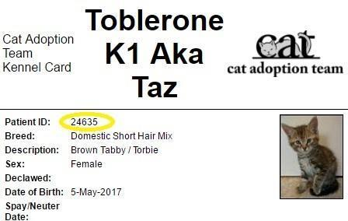

Contact Information: You are welcome to include your social media links like an Instagram handle or public Facebook page. If you would like to include your email, you may, but keep in mind that applications will be first-come, first-serve on the website, so you may be talking with a potential adopter that is not the first in line for the cat.

Meet and Greet Preferences: Please indicate your preference for in-person or virtual meet and greets. Please note your preferences for masks, social distancing, and/or vaccine card verification for in-person meet and greets.

We cannot post kittens without all of the information above. Please note that profiles may take multiple days to be posted. Kittens and mom cats are not posted until kittens are at least five weeks old, healthy, and socialized.

What kind of photos and videos?

Group photos or videos, singles, or kittens with mom are all acceptable. Try to crop just around the cat itself. Please make sure the background is free of clutter. You don’t need posed shots, but they do help. It’s also great to show kittens with a resident dog or maybe being held by a child. This helps adopters immediately identify which animals are most compatible with their own families.

Please send the photos or videos as attachments in the email. If the video file is too large to email, you can upload the video to [your organization]and send an email to petfinder@yourorganization.com alerting us that you uploaded the file. Video files should be named after the cat with a number to indicate if there are multiple videos for the same cat (i.e., Sailor2.mov. Sailor2.mp4).

Social Media

Many of our foster parents are active on social media sites like Instagram and Facebook. They often have accounts dedicated entirely to fostering activities where they post photos and videos, and keep their followers updated on their foster kittens’ lives. They also promote their kittens for adoption using these platforms. In the height of the “kitten season,” with all the competition from other adoptable kittens, those with active social media accounts are the most likely to get their kittens pre-adopted before they even hit the website!

We highly recommend starting your own Instagram account and tagging @yourorganization in your posts. You can also DM (or direct message) Your organization’s social media team @yourorganization if you would like your foster cat or kitten to be featured on Your organization’s Instagram. This can be helpful if you are having trouble finding an adopter for a mom cat or a slow-moving kitten! For more information on creating and effectively using an Instagram account, please see the Social Media Training video and our Marketing Resource Guide.

Maddie’s Fund also has free online courses, including Using Social Media to Help Shelter Pets Shine and Marketing a Foster Pet. HeartSpeak also has some great resources in this google drive folder on using Instagram to effectively market your foster pet. They also have a wonderful webinar: Bio Writing to Build Connection.

We have a list of all known foster parent social media accounts on our website - Foster Family Social Media List. We recommend following your fellow foster parents to learn from each other and help each other out!

Here are some other tips from foster parents on how they successfully market their kittens:

“Get your photos and bios right away. Write personal and positive bios. Respond to inquiries right away.” - Katie Jaye S.

“Post in different feeds - neighborhood Facebook groups or NextDoor. Tag people and ask them to share. Use video!” -Leah H.

Foster Parent Networking

We have an opt-in Google map of the foster parent, mentor, and mentor assistant locations. You can take a look at it here. It is only shared with other Your Organization foster program members, not the public. It is a great way to network with your foster parent neighbors. You can help each other out with supply pick up, medicating kittens, etc. Please let the foster coordinator know if you want to be added to the map.

Spay/Neuter Surgery

Spay/neuter appointments are made 2-3 weeks in advance. The foster coordinator will contact you with some suggested surgery dates when your kittens turn five weeks old. If your kittens are all over 1.5 lbs. and you do not have a surgery date set yet, please email the foster coordinator to request one. If you need to cancel an appointment, please email the foster coordinator with as much notice as possible.

Kittens need to be at least 682 grams (1.5 lb), healthy, on an upward weight trend and have a Body Condition Score of 3.5/9 or above to qualify for surgery. If you are unsure if your kittens meet these criteria, please watch this training on surgery qualifications. If your kittens do not meet these criteria, email the foster coordinator to reschedule surgery and contact your mentor to address the concerns.
Put the paper collars on your kittens at home. Write their full name, “Valerie k1 aka Polly.” This will help us if we have two kittens with the same name in our care. If you do not have collars with you, you will need to put them on once you reach the shelter. Please see the section on paper collars to see how to fit them on your kittens properly.
Remove any food from your foster room first thing in the morning (by 6 am). You can keep water in the room, but do not feed your kittens breakfast, as the anesthesia can make them sick. If a kitten vomits while under anesthesia, they can choke on their vomit, which can be life-threatening.

Mom cats and kittens over four months old cannot have food after 10 pm the night before surgery. This means you will need to house mom separately from the kittens overnight. It is okay for them to ride together in the same carrier to the shelter in the morning. All foster cats and kittens should always have access to fresh water.

You will drop them off between 7:30 am and 8:30 am at the front entrance to Your organization’s surgery times. If you cannot make it during this time window, please make arrangements through the shelter ahead of time to drop off your foster cat/kitten(s) the night before surgery.

If you pick up your foster cat/kittens(s) after surgery, you will need to pick them up that same afternoon between Your organization’s pickup times. At pick up, you will receive adoption supplies (cardboard carriers, adopter bags of food, vet certificates, and rabies certificates, if applicable).

Fill out the Foster Drop-Off Form completely. This will only take a couple of minutes.

If you aren’t picking your foster cat/kittens back up after surgery, please hand in your foster bag at this time.

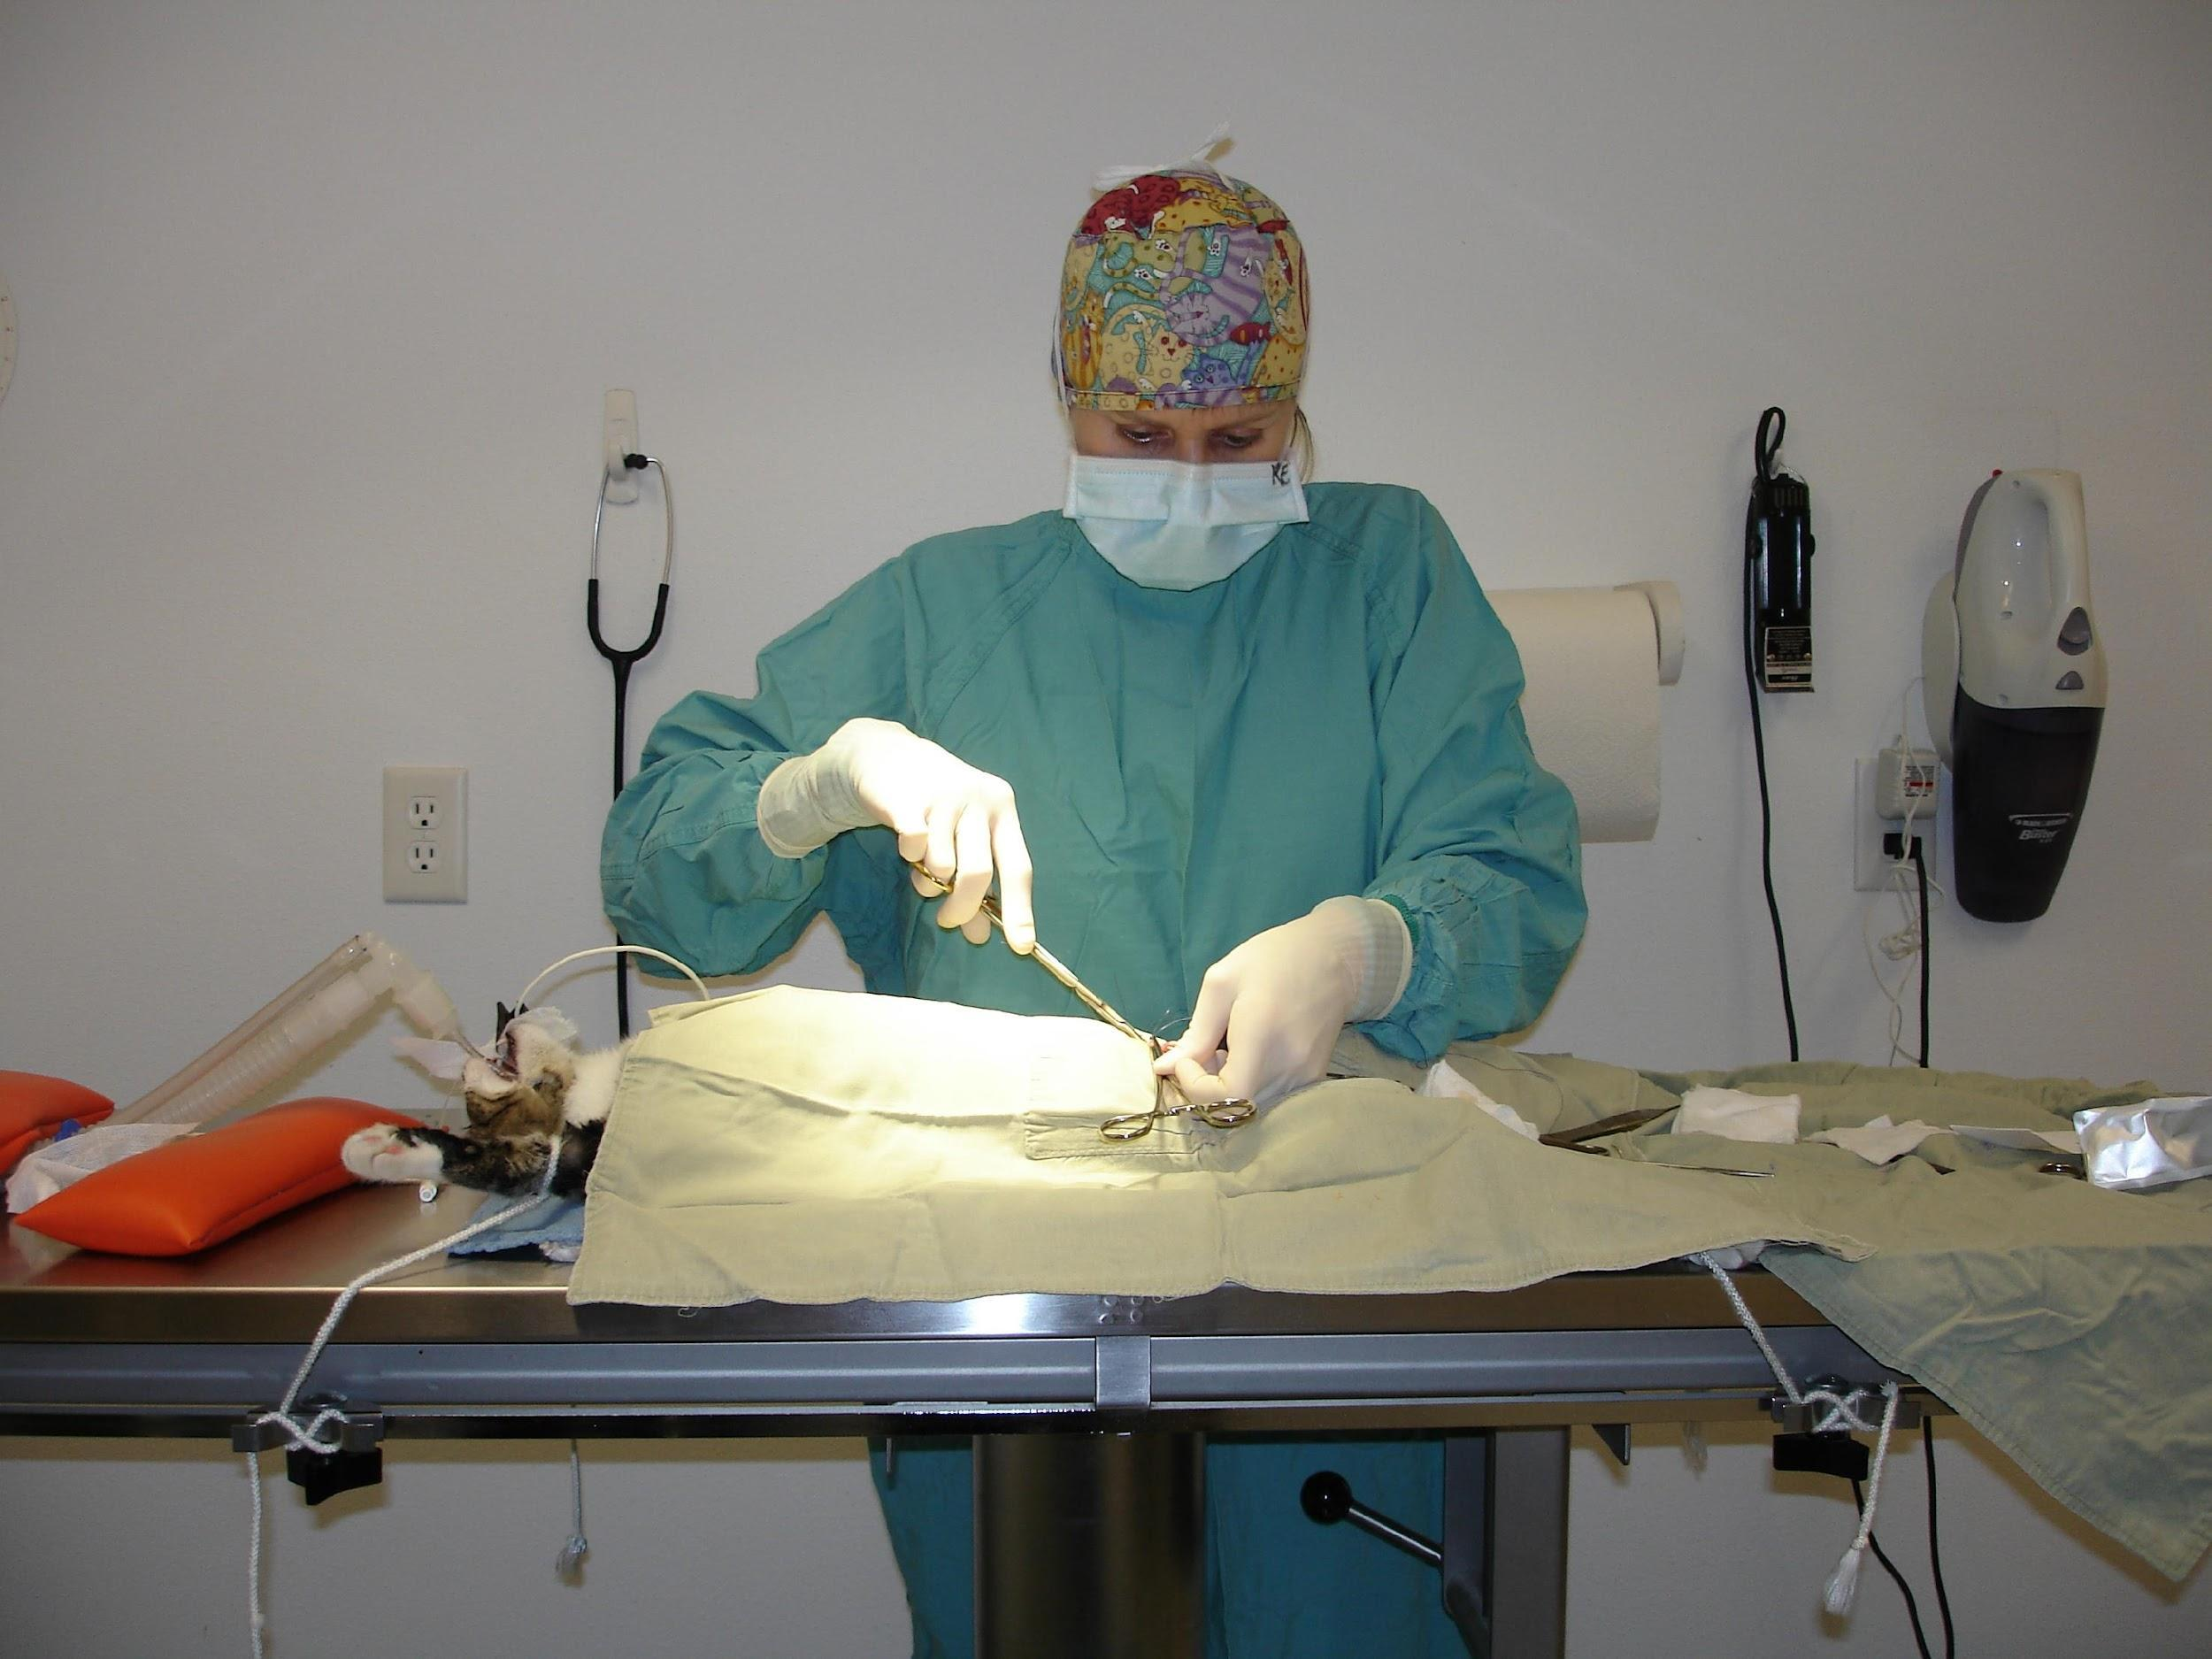
Photo by Debbie Brusius

Post-Operative Care Instructions and Pain Medication

If you pick up your foster cat/kittens after spay/neuter surgery, you will need to provide their post-operative care and pain medication. If the cat/kitten is not pre-adopted by the time of surgery, a single dose of pain medication is provided and is to be given by the foster parent ONLY and not sent with an adopter. If the cat or kitten is pre-adopted and the adopter has opted to pay for pain medication, three doses will be provided and should be passed along to the adopter. Please read the labels carefully to know whether or not the medication can be given to the adopter. *Note: If your cat/kitten is preadopted at the time of surgery and your pre-adopter did not opt for pain medication during their adoption counseling session, you will not receive any pain medication for them at pickup.

Post-Operative Care Instructions

These instructions are applicable for ten days following surgery.

- It is recommended to keep your foster cat/kitten confined to a small room for ten days following surgery. Do not allow excessive playing, jumping, or running, which may delay the healing process.
- If your foster cat/kitten had surgery today, offer small amounts of food and water upon arriving home. Excessive amounts of food and water may cause vomiting. If vomiting occurs, restrict further water and food and try again in 12 hours.
- Do not bathe for ten days. If needed, use a wet washcloth or baby wipe to clean the cat/kitten while ensuring the incision site remains clean and dry.
- Do not allow your foster cat/kitten to lick or chew at the incision site. An e-collar is recommended if this occurs. Contact the shelter to pick one up if needed.
- Monitor the incision site daily for redness, swelling, odor, or discharge. Please contact your mentor if you see any of these signs.
- Monitor your foster cat/kitten for signs of pain following surgery. These may include lack of grooming, sleeping a lot, decreased interest in food/water, lethargy, weakness, vomiting, growling or hissing when touched, and reduced social interaction. Please contact your mentor if you feel your cat/kitten is painful.
- There are no sutures to be removed. Females have internal sutures that will dissolve. All cats/kittens received a green tattoo on their abdomen to ensure the cat/kitten is not put through surgery again.
Post-Operative Pain Medication Information - Buprenorphine (cats 3.9 pounds and under)
A pain relief medication called buprenorphine may be prescribed for your foster kitten. Buprenorphine is an opiate analgesic often used for short-term pain relief. For the best effect, it should be administered by squirting under the tongue or in the cheek pouch. The doses are tiny for this potent drug, so ensure that you give the exact amount your veterinarian has prescribed. Sedation is the most common side effect, so ensure your foster kitten is confined to a place s/he can’t get hurt by jumping on/off objects when you’re not around.
- Make sure you understand how much of the drug to give, how frequently, and for how long. If you are unsure, ask your mentor.
- Always give the medication with or after food. Feed canned food in addition to dry, as maintaining fluid intake is important.
- If your cat does not eat, DO NOT give the medication. Contact your mentor.
- Never give your cat any other medication at the same time without first speaking to your mentor.
- If you have concerns or see any potential adverse effects at any stage, STOP giving the medication and contact your mentor immediately.
Safety first: If you are in any doubt, STOP the medication and TALK to your mentor.

Post-Operative Pain Medication Information - Meloxicam (cats 4 pounds and over)
Controlling your foster cat’s pain is crucial for its welfare. A pain relief medication called meloxicam, a non-steroidal anti-inflammatory drug (or NSAID) may be prescribed for your foster cat. These drugs are commonly used in humans and animals to help relieve pain, fever, and inflammation. Signs of pain in your foster cat may include decreased activity, decreased mobility, decreased grooming, loss of appetite, and/or altered personality. Meloxicam’s anti-inflammatory properties make it a good choice for post-operative pain, but it is not safe in young kittens.
- Make sure you understand how much of the drug to give, how frequently, and for how long. If you are unsure, ask your mentor.
- Always give the medication with or after food. Feed canned food in addition to dry, as maintaining fluid intake is important.
- If your cat does not eat, DO NOT give the medication. Contact your mentor.
- Never give your cat any other medication at the same time without first speaking to your mentor.
- If you have concerns or see any potential adverse effects at any stage, STOP giving the medication and contact your mentor immediately.
Are NSAIDs safe in cats?
NSAIDs play a vital role in therapy for many cats. Still, differences between cats and other animals mean you should only ever use a drug that has been specifically prescribed for your cat by your veterinarian. Many human drugs such as aspirin, ibuprofen, and acetaminophen can be highly toxic to cats – administering these is life-threatening. Adverse effects can be seen with NSAIDs, just as with all drugs. Some patients may be at increased risk of adverse effects (e.g., older cats and cats with certain other diseases).
What adverse effects should I look out for?
Licensed NSAIDs are safe for use in cats. However, adverse effects can still occur. Most are mild, but some can be serious – as in other species, they may involve the gastrointestinal tract, kidneys, cardiovascular system, or liver. Adverse effects may lead to a number of signs, including: loss of appetite, nausea or vomiting, lethargy, dullness/depression, altered thirst and/or urination, diarrhea and/or black-colored feces, and yellowing of the skin, gums, or whites of the eyes.
Safety first: If you are in any doubt, STOP the medication and TALK to your mentor.

Adoptions Pickups

Adoption pick-ups should occur from your home within 24 hours of spay/neuter surgery or within 24 hours of the “pickup instructions'' email for altered cats/kittens. If your adopter is requesting a pick-up more than 72 hours later, please reach out to the shelter for assistance.

If you or your adopter have requested a shelter pickup after the spay/neuter, we will arrange that at this time. Please note that the default/preferred option is for the adopter to pick up from your home, not the shelter. Arrangements will need to be made in advance for a shelter pickup.

Please make sure to send the following items with the adopter:

- adopter bag of food (kitten or adult)
- vet certificate (fill out with adopter’s name and date)
- rabies vaccine certificate (for cats 4-months or older) if available
- any active prescription medications or food
- any adopter-purchased post-operative pain medication

If a medication was started in foster care AFTER the adopter completed their counseling session, you must email foster@yourorganization.org so we can counsel the adopter on the medications and get them updated medical records.

If you haven’t already, we ask that you return your foster bag and foster carrier to the shelter as soon as possible so that they can be used for another group.

Finally, you will need to email the shelter at adopt@catadoptionteam.org to let us know that your cats/kittens have gone to their adoptive homes, so we can finalize the adoption.

Cleaning Between Your Foster Groups

The joy of letting go of one foster group is knowing that they will be going to loving homes while you are able to take in another that may not otherwise be able to find shelter to grow in such a loving environment. Please follow these guidelines for cleaning between groups.
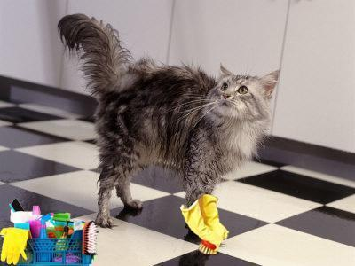
You will need to remove all bedding and fabric toys and wash them in hot water with bleach added. Follow your machine's guidelines for adding bleach to the wash load.

You will also need to clean the litter box. Empty all of the contents, and wash with hot soapy water. Rinse well, spray with a bleach water solution (1 part bleach to 32 parts water or Clorox Cleanup with bleach), and let sit for 10 minutes. Rinse and dry well. If the litter box has been well used (with grooves in the plastic from scratching), you will need to throw it out.

For food and water dishes and plastic toys, you can run them through the dishwasher. Or, you can clean them as you did the litter box if you don’t have a dishwasher. Follow the same guidelines as the litter box - if the plastic no longer has a smooth surface, it’s time for it to get thrown out.

If you have carpeted floors, you will need to vacuum well and spot-clean any areas that need it. If you have a carpet cleaner, you should use it between groups. If you do not have carpet, sweep and mop the floor. Once the floor is dry, mop again with a bleach water solution (1 cup bleach to one gallon of water or Clorox Cleanup with bleach) and let it sit for ten minutes. Afterward, you will want to rinse it with water and then let it dry.

You will need to wipe down all other surfaces with a bleach water solution or Clorox Cleanup with bleach. You should also wipe the walls down. You do not have to do all of the walls but at least the bottom three feet.

If you have a bed in the room, change the covering on it. If you have a chair or couch in the room, you will need to vacuum it and spot-clean it if needed. Ideally, your foster room will be void of anything covered in material like a chair or couch unless it is covered with a plastic sheet designed to protect them.

*Note: if you prefer not to use bleach, you can also order a product called “Rescue” online. This is the disinfectant we use at the shelter. It is a bit more effective because it doesn’t require that all organic material is removed, but it is also more expensive. If you decide to go this route, contact the foster coordinator for information on diluting it properly.

Shelter Buddy Database Access

If you are interested in learning more about a potential or current foster kitten or cat, you can access their record in our online database, called Shelter Buddy. Please refer to the Shelter Buddy Guide for Foster Parents document for instructions.

Foster Program FAQ
How do I become a foster parent?
You will need to fill out Your organization’s online interest form. Our volunteer coordinator will set you up for general volunteer orientation and specific training for the foster program. More information can be found at Your Organization’s website: www.yourorganization.com.

What is required of me as a foster parent?
You provide a safe, ‘kitten-proofed’ room in your home containing the kittens’ necessities; food, water, bedding, litter box, toys, etc. You are responsible for ensuring that your kitten receives any scheduled medical treatments on time, is healthy, and is well-socialized.
I found a litter of kittens. Can I foster them through your program?
Yes, with approval and appointment. We will try to work with you on setting an appointment if you are the foster parent. If you cannot foster this litter, it may take us some time to find a foster home. We will do our best to work with you.

What are the requirements for a foster room?
The foster room needs to be a designated place for your foster kittens to live the entire time. This room will need to be ‘kitten-proofed’ and have plenty of space for a litter box, food, and water dishes, as well as sleep and play areas. Your organization recommends a bathroom for ease of cleaning. A spare bedroom or other room could work as well. Either way, you should always start your kittens in a bathroom while ensuring they are not harboring any illnesses.
What supplies do I need to provide myself?
Your organization will provide you with a baby bag full of essential medical supplies and all vaccines and medication necessary for your kittens. We will also provide you with a high-quality dry and wet kitten food diet and kitten-appropriate pellet litter. Foster parents generally supply a litter box, food dishes, toys and scratching implements, bedding, and other small incidentals. However, if you need help with some of these supplies, we will do our best to help you.
How do I get a group of foster kittens?
After you have completed foster training, you will be added to Your organization's Google Group. As foster kittens become available, the foster coordinator will post a plea for a foster home to the Google group. Whoever responds first, and is the best match for the foster kittens, will get the group. The foster coordinator will then send further information with specifics on arrival and pick-up information.

How much do I need to supervise my foster group?
You must do welfare checks on your foster group three times a day. This is to make sure everyone is healthy, eating, and using the litter box. You need to spend about 1-2 hours per day interacting with your foster group so that they become well-socialized.

Can my foster kittens and mom cat interact with my resident pets?
Yes, after a 2-week quarantine and only if your kittens have had their first FVRCP vaccine on board for at least five days. If your foster kittens or resident animals are sick, then they may not interact. If your kittens were not tested for FeLV, they should not interact with your resident cat. All interactions must be directly supervised. Be aware that mom cats are very protective of their kittens and will likely not want to interact in a friendly manner with your resident pets.
Can my children interact with the foster kittens?
We encourage your children to have supervised interaction with foster kittens. Caution and direct supervision are a must! Children should not be permitted to handle newborn kittens.
Do we bottle-feed kittens?
Your organization does occasionally take in kittens needing to be bottle-fed. There are also times when you may be asked to supplementally bottle feed a nursing kitten who isn’t getting enough to eat. Bottle feeding is a tricky process, so we ask that you work with your mentor and attend our pregnant / bottle-baby training class before attempting to bottle-feed a kitten.
How will people know that I have kittens?
Kittens will be posted to our website for adoption when they are six weeks old and healthy/socialized. You may also consider marketing them yourself through friends/family and/or social media.
Do I have to have people come to my home?
Having prospective adopters come to your home is encouraged as it helps to see the kittens in a relaxed home environment. However, it is not required. You are welcome to do virtual meet and greets instead.
Do I need to give my own vaccines? Can I learn?
Our mentors and mentor assistants are trained to do this for you. You will make appointments with them to ensure kittens get their vaccines on time. We encourage foster parents to learn to give vaccines and offer clinics at the shelter for those interested.

Who do I call for help?
Each foster family is assigned a mentor. Your mentor will be your first point of contact for any questions or concerns you may have about your group.
If my foster kittens get sick, do I take them to my vet?
All veterinary care will be provided through Your organization. Foster parents are not permitted to seek veterinary care from outside clinics. Any visits to outside veterinarians that are not pre-approved will be the financial responsibility of the foster parent.
What do I do if my cats get sick?
Your kittens should be kept separately from your resident cats. However, we do recognize that cross-contamination can happen. If your resident cats get sick, it is your responsibility to seek veterinary treatment. Remember, there is always an inherent risk of disease when you bring new animals into your home. This is why we require that all animals in the home are current on vaccinations.
Do my resident pets have to be up to date on their vaccines?
For everyone’s protection and safety, your resident pets are required to be up to date on vaccines.
Do my resident pets have to be spayed or neutered before I foster kittens?
Yes. Your organization can help you set up an appointment to have this done through our on-site clinic.
Can my resident pets come to Your organization for care? Is there a discount?
We do offer discounted vaccines to our volunteers. Please inquire at the front desk for pricing and appointment availability.
What if I have to leave out of town unexpectedly?
Contact the foster coordinator as soon as possible so that we can find an alternate placement for your kittens.
What do I do if I don’t like or get along with my mentor?
We encourage you to form a good relationship with your mentor and keep communication open. If you have an issue you feel you cannot resolve independently, please contact the foster coordinator for help.
Foster Care Agreement
Please Read and Sign

- I understand the goals and mission of Your organization, and as a Your organization volunteer, I agree to work toward these goals and represent this mission within the community on behalf of the organization. My commitment includes abiding by Your organization’s foster care guidelines, as outlined in Your organization’s Foster Program Manual, which I have received. This includes, but is not limited to:

  - A commitment to keep Your organization’s foster cat(s)/kitten(s) indoors and not expose them to other cats with access to the outdoors.
  - A commitment to follow Your organization’s instructions concerning medical care.
  - A commitment to keep detailed, dated medical records (which will be made available for adopters) and ensure that an up-to-date copy is also on file at Your organization’s facility.
  - Moms and kittens must be housed separately in their own room.
  - Adult foster cats must be housed separately in their own room for at least the first ten days.

- I understand that only the Your organization’s Foster Coordinator, Director of Operations, and the Executive Director have the authority to make exceptions/changes to program guidelines.

- I understand that Your organization is the sole guardian of cats/kittens in foster care and that fostered cats/kittens must be returned to Your organization at Your organization’s request. I understand that Your organization has the right to terminate this foster care agreement and relationship at will.

- As a foster volunteer, I understand that I must go through the standard Your organization’s adoption process if I want to adopt any of my foster cat(s)/kitten(s). I also understand that I cannot send any of my foster cat(s)/kitten(s) to an adoptive or potential adoptive home until the cat(s)/kitten(s) has been altered, the adoption process has been completed by a trained Adoption Counselor and the Foster Coordinator has been informed. Furthermore, I must have permission from the Foster Coordinator before sending my foster cat(s)/kitten(s) to another approved Your organization foster home. I also understand that expenses for food, litter, treats, scratch posts, etc., cannot be applied toward adoption fees should I adopt a cat(s)/kitten(s).

- I understand that foster cat(s)/kitten(s) need to be taken to Your organization’s on-site Veterinary Hospital for any medical care and can be reached at [Your organization's contact information]. Your organization funds all medical care, and in the event of a medical emergency after hours or on the weekend, approval is needed by the Foster Coordinator, Foster Mentor, Your organization’s on-site Vet or Vet-Tech, and only if the medical care is provided at a Your organization’s approved veterinary clinic or hospital. I understand that if I choose to take my foster cat(s)/kitten(s) to a non-approved veterinary clinic or if I take my foster cat(s)/kitten(s) to an emergency veterinary hospital without prior approval, Your organization will not reimburse me for the expenses incurred.
- I understand that there is a possibility of health or injury risk when caring for cats. I also understand that pregnant women and people with suppressed immune systems need to know that a parasite, sometimes found in feces, could cause toxoplasmosis. Special care needs to be taken if such persons plan to come in contact with used litter pans. I will not hold Your organization liable for any injury or illness, whether to animals or humans in my home, which may result from my foster activities.

- If I need to leave town during my foster period, I need to give a two-week notice when possible to the Foster Coordinator for my kittens to be permanently rehomed to another Your organization foster home.

_____________________________ ________________________________ ___________________
Printed Name of Foster Parent Signature Date

_____________________________ ___________________ Your organization Representative Date
_____________________________ ___________________
Foster Coordinator Date
Name(s) of foster cat(s)/kitten(s) sent to foster on this date:____________________________________
_____________________________________________________________________________________________

Your Organization –Address-Phone Number-Website

